AI Agent Project Handover Guide
Architecture, implementation and Windows setup
Prepared for Nimish Yadav and internship mentors | 22 October 2026
Yeh guide existing project ko samajhne, demo dene aur doosre Windows computer par run karne ke liye hai. Project ab ek general AI assistant hai: user ek hi chat mein questions, documents, tables, images aur public links de sakta hai.

What we built
A goal-based, tool-using multi-agent assistant. An orchestrator delegates work to specialist agents. LangChain connects models and tools; LangGraph controls the agent/tool workflow and state. Local processing handles calculations and file extraction. External APIs provide language generation, vision, search and travel results.

Project snapshot
Item | Current implementation
User interfaces | Streamlit unified chat and a terminal entry point
Main model | Groq openai/gpt-oss-20b; compatible configured backups
Persistence | Local SQLite chat history, graph checkpoints and preferences
File handling | Session attachments; multiple supported formats, not every file type
Web capability | Search results plus actual reading of supplied public URLs
Not implemented | Gmail sending, email approval workflow, bookings and payments

Read this guide in order
2 Architecture diagram 3 Pipeline and agents 4 Libraries and frameworks
5 Models and external services 6 Windows installation
7 Configuration and demo checks 8 File map
9 Troubleshooting and handover
Project location on the development machine:
E:\PROJECT\Internship Projects\ai-research-agent
Another computer may use any suitable folder; run commands from that project root.

Architecture diagram
One chat coordinates specialists. The same underlying LLM can serve several roles; each role has its own instructions and tools.
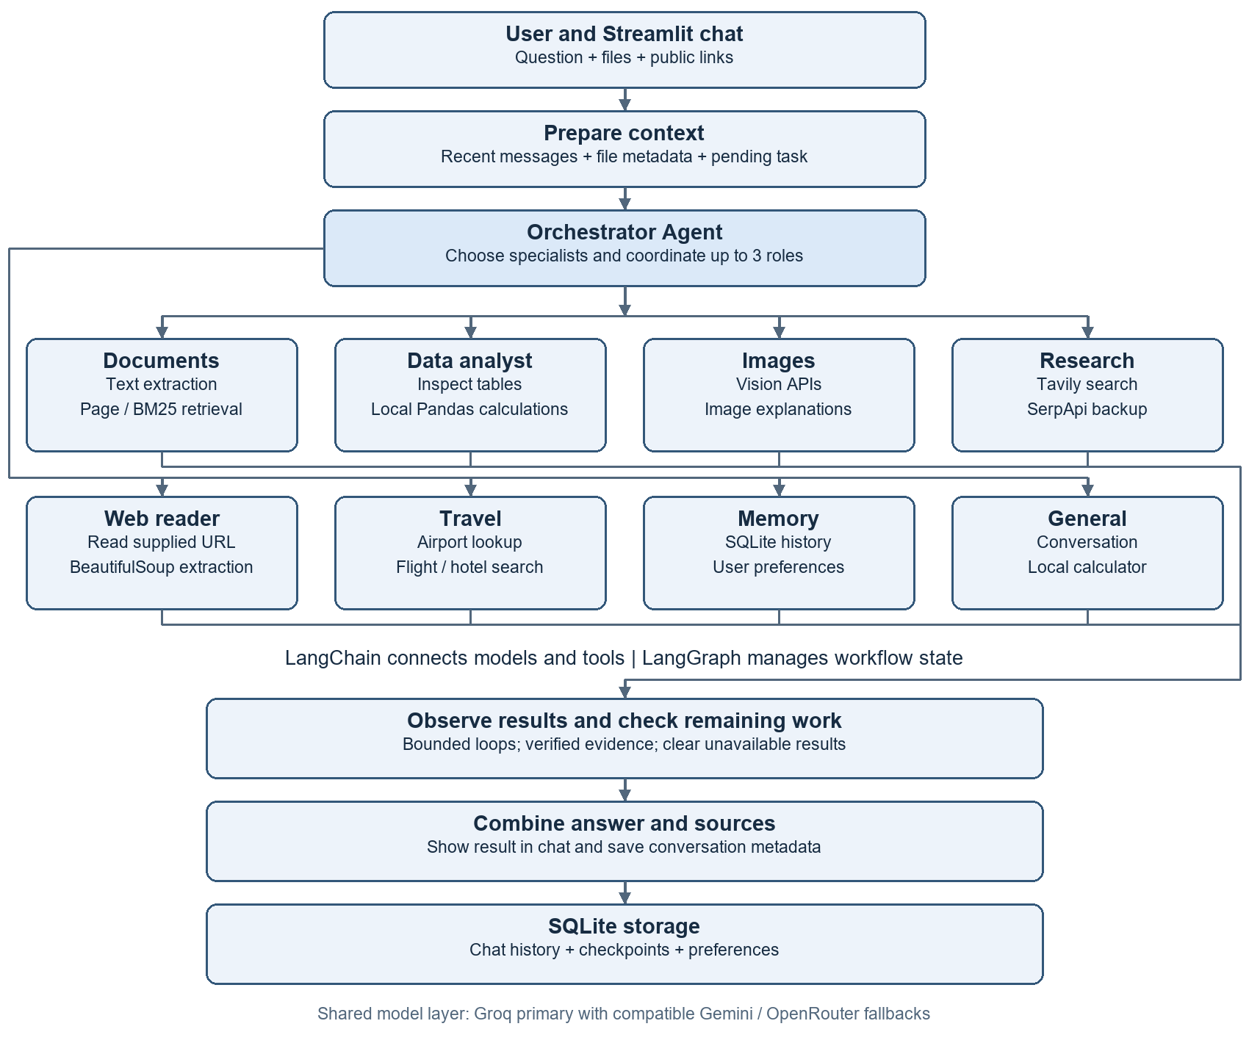
Routing is bounded, not an infinite autonomous loop. The orchestrator chooses the required roles; workflow code enforces evidence, limits and supported actions. Arrows summarize execution; not every branch runs for every request.

Pipeline and specialist responsibilities
User input -> prepare context -> orchestrator delegation -> specialist tools -> observe results -> check remaining work -> combine answer and sources -> persist history.
Specialist | What happens and why
General | Answers ordinary chat; uses the local calculator for arithmetic.
Documents | Retrieves actual uploaded text. Exact PDF page requests use page lookup; relevant passages use local BM25. This is not a vector database pipeline.
Data analyst | Inspects worksheet/column metadata, plans a supported operation, and executes it through Pandas. The LLM does not invent totals.
Images | Sends normalized images to a compatible vision model; observations may be imperfect.
Research | Searches the web with Tavily and SerpApi backup; returns evidence and source links.
Web reader | Reads up to two supplied public URLs. Extracts HTML/text/readable PDF evidence and summarizes selected excerpts.
Travel | Plans trips and accesses airport/flight/hotel search tools. Quotes are observations, not guaranteed bookings.
Memory | Retrieves relevant saved conversations and preferences; supports explicit preference save/delete tools.

Example compound request
Question: PDF page 1 ka title aur Excel ka total Tax (USD) batao, sirf 2 lines mein.
Orchestrator assigns Documents and Data. Document retrieval reads page 1; Data inspects the actual tax column and performs a local sum. Results are combined with evidence. If the column is ambiguous or a page has no text, the app should explain the limitation instead of guessing.

State and memory are different
State = current workflow messages, tool results and progress. History = saved transcripts across conversations. Preferences = useful user facts/settings. Relevant prior information is retrieved; every old message is not sent on every request. Raw attachments live in the current browser session and may need reattachment after restart.

Frameworks and libraries
Package or module | How and why it is used
LangChain core | AIMessage, HumanMessage, SystemMessage and ToolMessage represent conversation/tool data. @tool defines tool schemas; bind_tools exposes them to models.
LangGraph | StateGraph, nodes, conditional edges and START/END coordinate agent/tool loops. langgraph-checkpoint-sqlite persists checkpoints.
Streamlit | Chat UI, uploader, session state, previous chats, sources and tool activity. Its browser frontend internally uses JavaScript.
langchain-groq | ChatGroq model integration.
langchain-google-genai | ChatGoogleGenerativeAI integration for Gemini.
langchain-openai | ChatOpenAI connects to OpenRouter through an OpenAI-compatible URL. This does not imply a paid OpenAI API.
python-dotenv | Loads local environment configuration from .env.
pandas and openpyxl | Tabular processing/calculations and XLSX reading.
xlrd, pyxlsb, odfpy | Readers for legacy XLS, XLSB and OpenDocument spreadsheets.
pypdf | Readable PDF text extraction; image-only scans need OCR, which this pipeline does not guarantee.
python-docx and python-pptx | Extract text from supported Word documents and PowerPoint slides.
Pillow and pillow-heif | Read/normalize images and support HEIF/HEIC decoding where available.
beautifulsoup4 | BeautifulSoup parses HTML and extracts useful webpage text.

Python built in modules
sqlite3 stores local data; json serializes API/tool payloads; pathlib/os handle paths and environment settings; re matches patterns. unittest and unittest.mock verify behavior. These are standard-library modules and do not require separate pip installation.
Framework = structure for an application. Library = reusable functions/classes. Model = trained inference system. API provider = external service hosting a capability. SQLite = database. VS Code = editor; pip = installer; virtual environment = isolated dependencies.

Models services and webpage reading
Role | Configured model or service
Main text and orchestration | Groq: openai/gpt-oss-20b
Text fallback | Google: gemini-3.1-flash-lite, then OpenRouter free routing when configured and compatible
Spreadsheet planning | OpenRouter: openrouter/free first, with text-provider backups. Actual calculation is local Pandas.
Image understanding | Groq: qwen/qwen3.8-27b
Image backups | OpenRouter: google/gemma-4-26b-a4b-it:free, then compatible Gemini vision
Web search | Tavily primary; SerpApi backup
Travel results | SerpApi flight/hotel search and airport lookup
Model names above are the project configuration snapshot, not a guarantee of current provider availability. openrouter/free is a router and can select different underlying models. Limits, eligibility and prices depend on providers. Configure valid keys and check provider dashboards; no unlimited free quota is promised.

How the scraper works
Given URL -> public address validation -> robots.txt policy -> bounded HTTP request -> optional gzip decompression -> HTML/text/PDF extraction -> selected excerpts -> LLM summary and source. It does not execute JavaScript or bypass login, CAPTCHA or paywalls.
Built in modules | Purpose
http.client, socket, ssl | HTTP transport, DNS and HTTPS certificate verification. Public IP validation and pinned connections reduce unsafe local-network access.
ipaddress, urllib.parse | Block private/local addresses; parse/normalize URLs and check redirects.
RobotFileParser | Read robots.txt automated-access policy.
gzip and io.BytesIO | Decompress bounded compressed bytes in memory without saving a temporary download.
time, datetime, timezone, re | Timeout/cache timing, fetch timestamps and relevant text patterns.
Efficiency: five-minute webpage cache; at most two supplied URLs per message; up to about 4,200 excerpt characters per page; 2 MB response limit. The reader is not a whole-site crawler. Failure after fetching can return verified excerpts instead of a generated explanation.

Install and run on Windows
Prerequisites: Windows, Python 3.11 or newer, internet, VS Code if desired, and a valid Groq key for the default configuration. The development environment used Python 3.13. A new dependency installation can differ because many packages are not pinned.

1 Copy the project
Copy the source folders, main.py, requirements.txt, .env.example and .streamlit folder. Do not copy .venv-standard, .venv, .env, API credentials or personal data by default. The recipient creates a new environment and their own keys.

2 Open a PowerShell terminal in the project root
Set-Location -LiteralPath 'E:\PROJECT\Internship Projects\ai-research-agent'
py --version
py -3.13 -m venv .venv-standard
If Python 3.13 is not installed, replace -3.13 with an installed supported version such as -3.11. Folder names containing spaces must stay quoted.

3 Install dependencies
.\.venv-standard\Scripts\python.exe -m pip install --upgrade pip
.\.venv-standard\Scripts\python.exe -m pip install -r requirements.txt
Using the environment executable directly avoids PowerShell activation-policy problems. In VS Code, choose this executable with Python Select Interpreter.

4 Create configuration
Copy-Item -LiteralPath .env.example -Destination .env
notepad .env
Only run the copy command on a fresh setup; preserve any existing working .env. Fill in the required key and optional services using the next page. Every variable must occupy one complete line.

5 Start the app
.\.venv-standard\Scripts\python.exe -m streamlit run app/ui/streamlit_app.py
Open http://127.0.0.1:8502/ . The project config uses port 8502. If it is busy, append --server.port 8503 and open that address. Stop the server with Ctrl+C.
# Optional terminal interface
.\.venv-standard\Scripts\python.exe main.py

Configuration and demo checks
Use placeholders below as names only; replace locally with your own credentials. Keys are secrets. Never paste them into chat, screenshots or source control. Restart the app after changing .env.
LLM_PROVIDER=groq
GROQ_API_KEY=your_real_groq_key
GROQ_MODEL=openai/gpt-oss-20b
GOOGLE_API_KEY=your_real_google_key
GEMINI_MODEL=gemini-3.1-flash-lite
OPENROUTER_API_KEY=your_real_openrouter_key
EXCEL_MODEL=openrouter/free
CHAT_BACKUP_MODEL=openrouter/free
TAVILY_API_KEY=your_real_tavily_key
SERPAPI_API_KEY=your_real_serpapi_key
Default startup requires Groq credentials. Gemini and OpenRouter add compatible backups. To use Gemini as the primary instead, set LLM_PROVIDER=gemini and provide a valid GOOGLE_API_KEY. Search/travel require their respective optional keys. Scraping itself needs no new API key; generated summaries still use the existing LLM layer.

Short functional demo
Try this | What to verify
Calculate 125 * 37 + 450 / 9. | Calculator tool result should be 4675.
Upload a readable PDF and ask for page 1 title. | Answer is grounded in the actual first page; no random-page example.
Upload Excel and ask for the total of an exact numeric column. | Tool activity shows inspection/calculation; compare against Excel SUM.
Upload an image and ask for a one-line description. | Vision result refers to the real image; no unsupported certainty.
https://www.python.org/doc/ Summarize in one line. | Actual webpage evidence and source URL appear, or a clear access failure.
Open a previous chat from the sidebar. | Saved transcript loads. Reattach raw files if the session has restarted.

Run automated checks
.\.venv-standard\Scripts\python.exe -B -m unittest discover -s tests -q
The last verified scraper integration run passed 97 tests. Rerun on the recipient machine; this historical result is not a fresh verification of their installation.

Source file map
Paths below are relative to the project root. Start with streamlit_app.py for UI and multi_agent/system.py for active orchestration.
File or folder | Change or inspect here when
app/ui/streamlit_app.py | Changing chat layout, uploader, chat history selection or session wiring.
app/multi_agent/system.py | Changing specialist delegation, active tool loops, completion checks or evidence handling.
app/multi_agent/requests.py | Changing page/length/request interpretation helpers.
app/llm/client.py | Changing text models, model construction and fallback order.
app/llm/fallback.py | Changing cooldown, compatible retry/fallback handling and provider events.
app/config/settings.py | Checking environment variables and required configuration.
app/attachments/store.py | Changing file normalization, supported extensions or current-chat file state.
app/attachments/vision.py | Changing vision models and image API calls.
app/rag/documents.py | Changing document extraction, exact-page lookup or BM25 retrieval.
app/spreadsheet/analysis.py | Changing header detection, table reading or local operations.
app/spreadsheet/planner.py | Changing the Excel planning model or allowed plan handling.
app/integrations/web_search.py | Changing Tavily/SerpApi requests, limits and search caching.
app/integrations/web_reader.py | Changing URL checks, HTML extraction, robots policy or webpage cache.
app/integrations/travel_prices.py | Changing airport/flight/hotel API integration.
app/history/store.py and app/memory/store.py | Changing persistent transcripts or preference storage.
app/agent/ and app/tools/ | Shared conversation graph, state, tool wrappers and execution helpers.
main.py and tests/ | Terminal entry point and automated regression checks.
.streamlit/config.toml | Theme, local host, port 8502 and upload setting.

Troubleshooting and project handover
Problem | What to do
ModuleNotFoundError | Install requirements using .venv-standard\Scripts\python.exe and run Streamlit with that same executable.
API key or configuration error | Check one VARIABLE=value per line. Model variables contain model IDs, not keys. Avoid duplicate variables and restart after edits.
Quota or rate limit | Check provider dashboard and wait for reset or configure a compatible independent backup. Switching keys in one quota pool may not add quota.
Failed to fetch dynamically imported module | Restart server, close stale tabs and hard-refresh. Verify current port 8502; if cached assets remain, use a fresh port such as 8503.
Uploaded PDF has no usable text | Use a text-based PDF. Scans need a separate OCR capability.
Excel has Unnamed columns or ambiguous tax | Check sheet and header row; select the actual column. Never accept a guessed total.
Website blocked or empty | Login, robots policy, CAPTCHA or JavaScript-only content may prevent reading. Use a readable public source or upload supported content.
Old chat opens but files unavailable | Raw attachments are session-local. Reattach them; transcript history is a separate persistent store.

Storage and sharing
data/chat_history.sqlite3 stores transcripts; data/chat_checkpoints.sqlite3 stores graph checkpoints; data/memory.sqlite3 stores preferences. Stop the app before copying databases for backup. A clean handover should exclude data/ unless the user intentionally transfers their own history. The app is a local prototype: profiles are not authenticated accounts and it should not be exposed publicly as a secure multi-user service.

How to explain the project to a mentor
Humne ek goal-based multi-agent assistant banaya hai. User ek chat mein request deta hai. Orchestrator relevant specialist ko kaam deta hai. LangChain models aur tools connect karta hai; LangGraph workflow aur state handle karta hai. Tools real evidence fetch karte hain aur Pandas calculations locally karta hai. Results sources ke saath combine hote hain. History SQLite mein save hoti hai, aur compatible model failure par backup try hota hai.

Current boundary
This handover documents the current general assistant. Gmail integration, approved email sending, automatic bookings, unlimited recall, all-site scraping and all-file-format support are not implemented guarantees. Keep .env private; rotate any previously exposed credentials through provider dashboards.

