AI Agent Visual Overview
A single chat for documents, web questions, spreadsheets, images, research and travel.
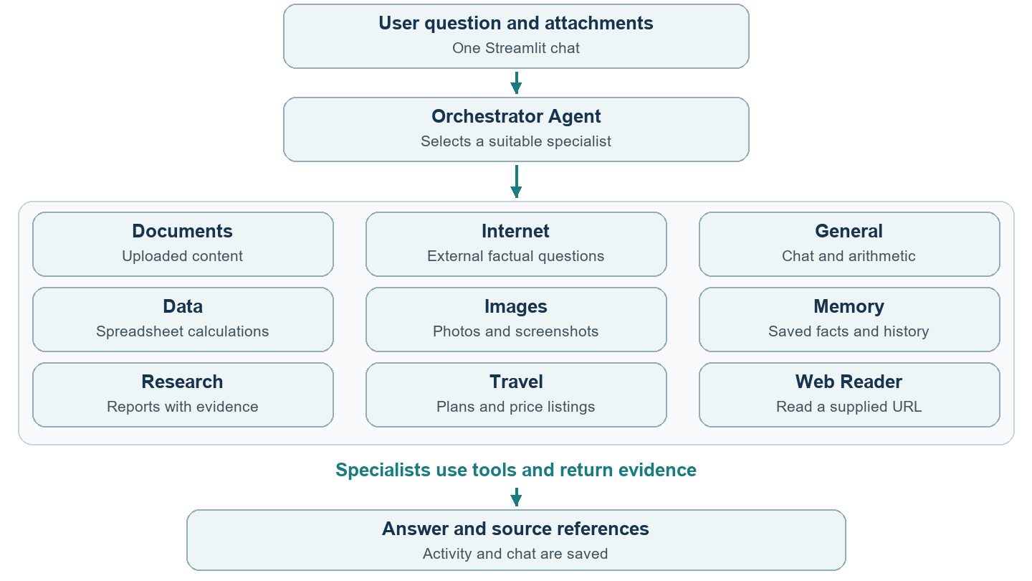

How a tool is selected
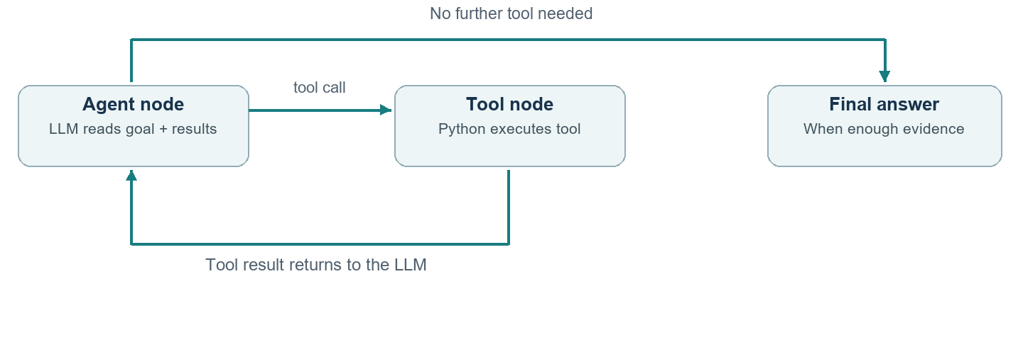
LangChain exposes tool descriptions and argument schemas. The LLM selects a tool; LangGraph executes the model → tool → result loop.

2 Document questions and internet questions
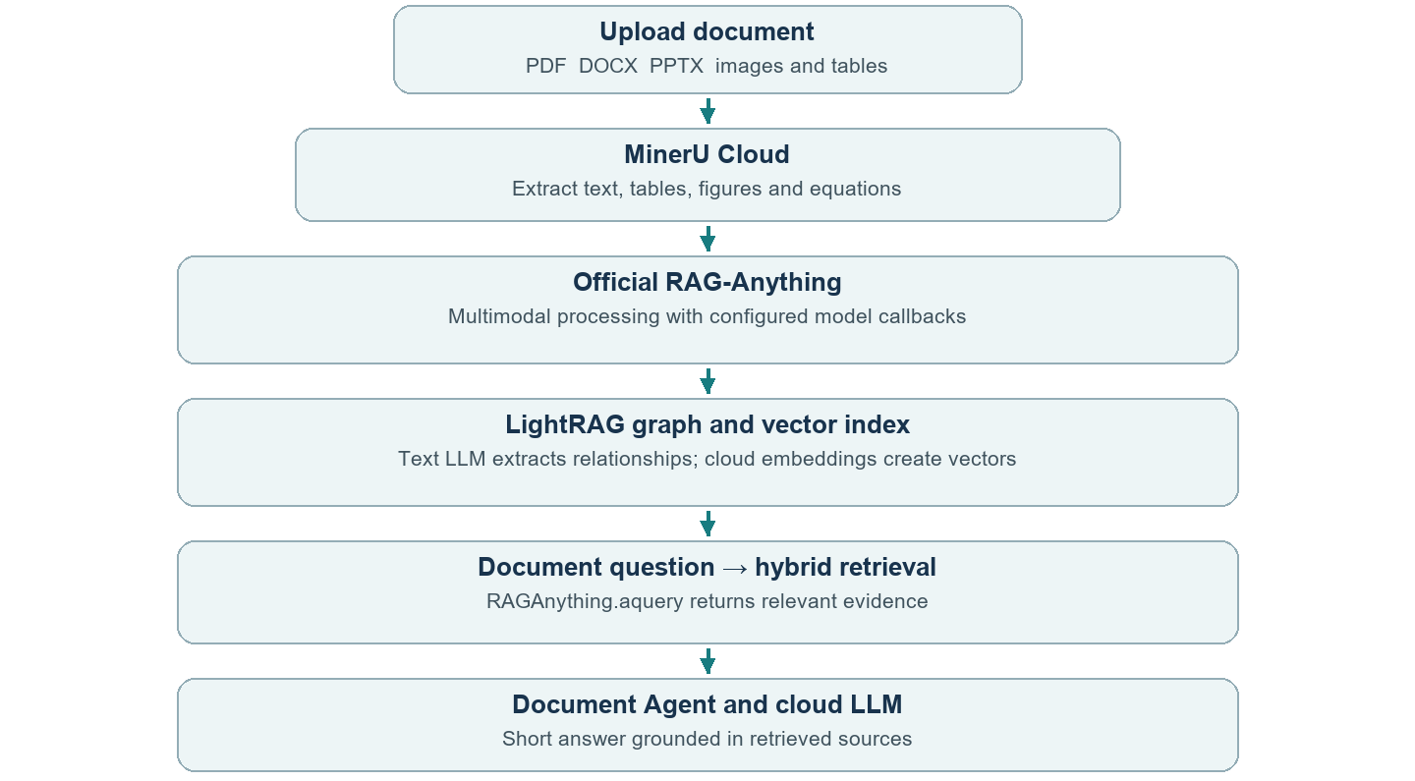
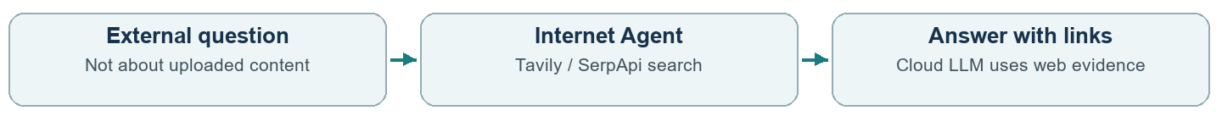
Document question: “Explain this PDF briefly.” External question: “Search current solar news.” Only relevant evidence is used; parsing/indexing can be reused.
If a document does not answer a question, internet follow-up is labeled separately. “Only the PDF” prevents web fallback. Exact PDF-page requests use scoped page lookup.

3 Models APIs and storage
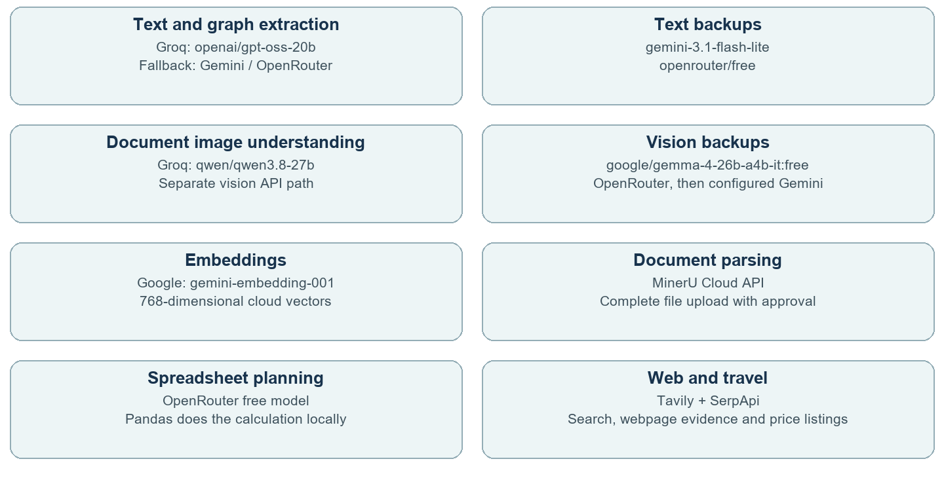
RAG-Anything is the framework, not a single model. LightRAG provides its internal graph/vector retrieval. No Ollama is configured; the old FAISS adapter has been removed.

What stays local
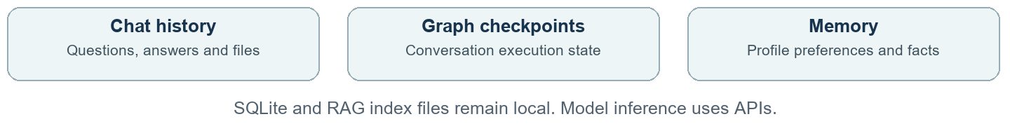
Backups are tried when needed. Availability and quotas can affect results. Activity shows actual tool use and clearly labels fallback when hybrid retrieval cannot finish.

4 Code map and technology stack
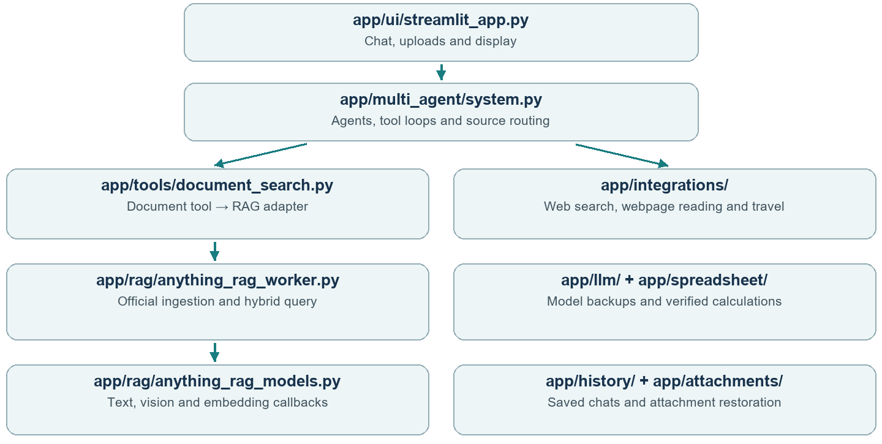
Component | Role
Python and Streamlit | Application logic and unified chat UI.
LangChain and LangGraph | Model/tool interfaces and stateful agent orchestration.
RAG-Anything and LightRAG | Official multimodal indexing and hybrid retrieval.
Pandas and openpyxl | Spreadsheet loading and verified local calculations.
BeautifulSoup and Pillow | Webpage text extraction and image preparation.
pypdf python-docx python-pptx | PDF, Word and PowerPoint text support/fallbacks.
SQLite and python-dotenv | Persistent data and local environment-based configuration.

Demo: ask a PDF question, ask an external question, then open “Agents and tools used”. Cloud file processing requires consent; keys stay in local .env. Bookings, email sending and image generation are not implemented.

5 Detailed project architecture
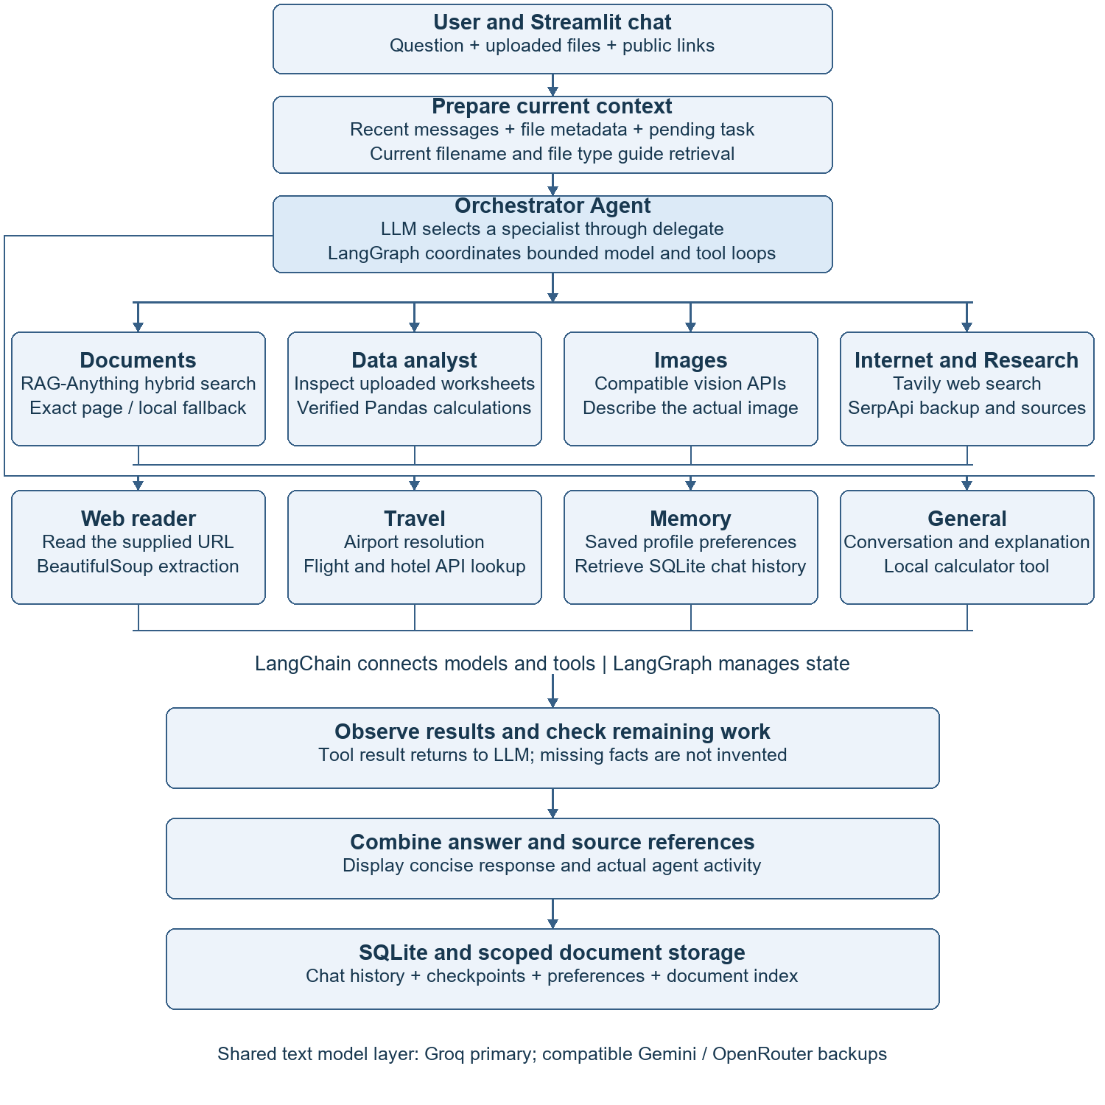
The orchestrator selects specialists as needed. The specialist boxes are alternative routes, not a fixed sequence. Each specialist observes tool results before the final response.

6 Complete RAG Anything flow
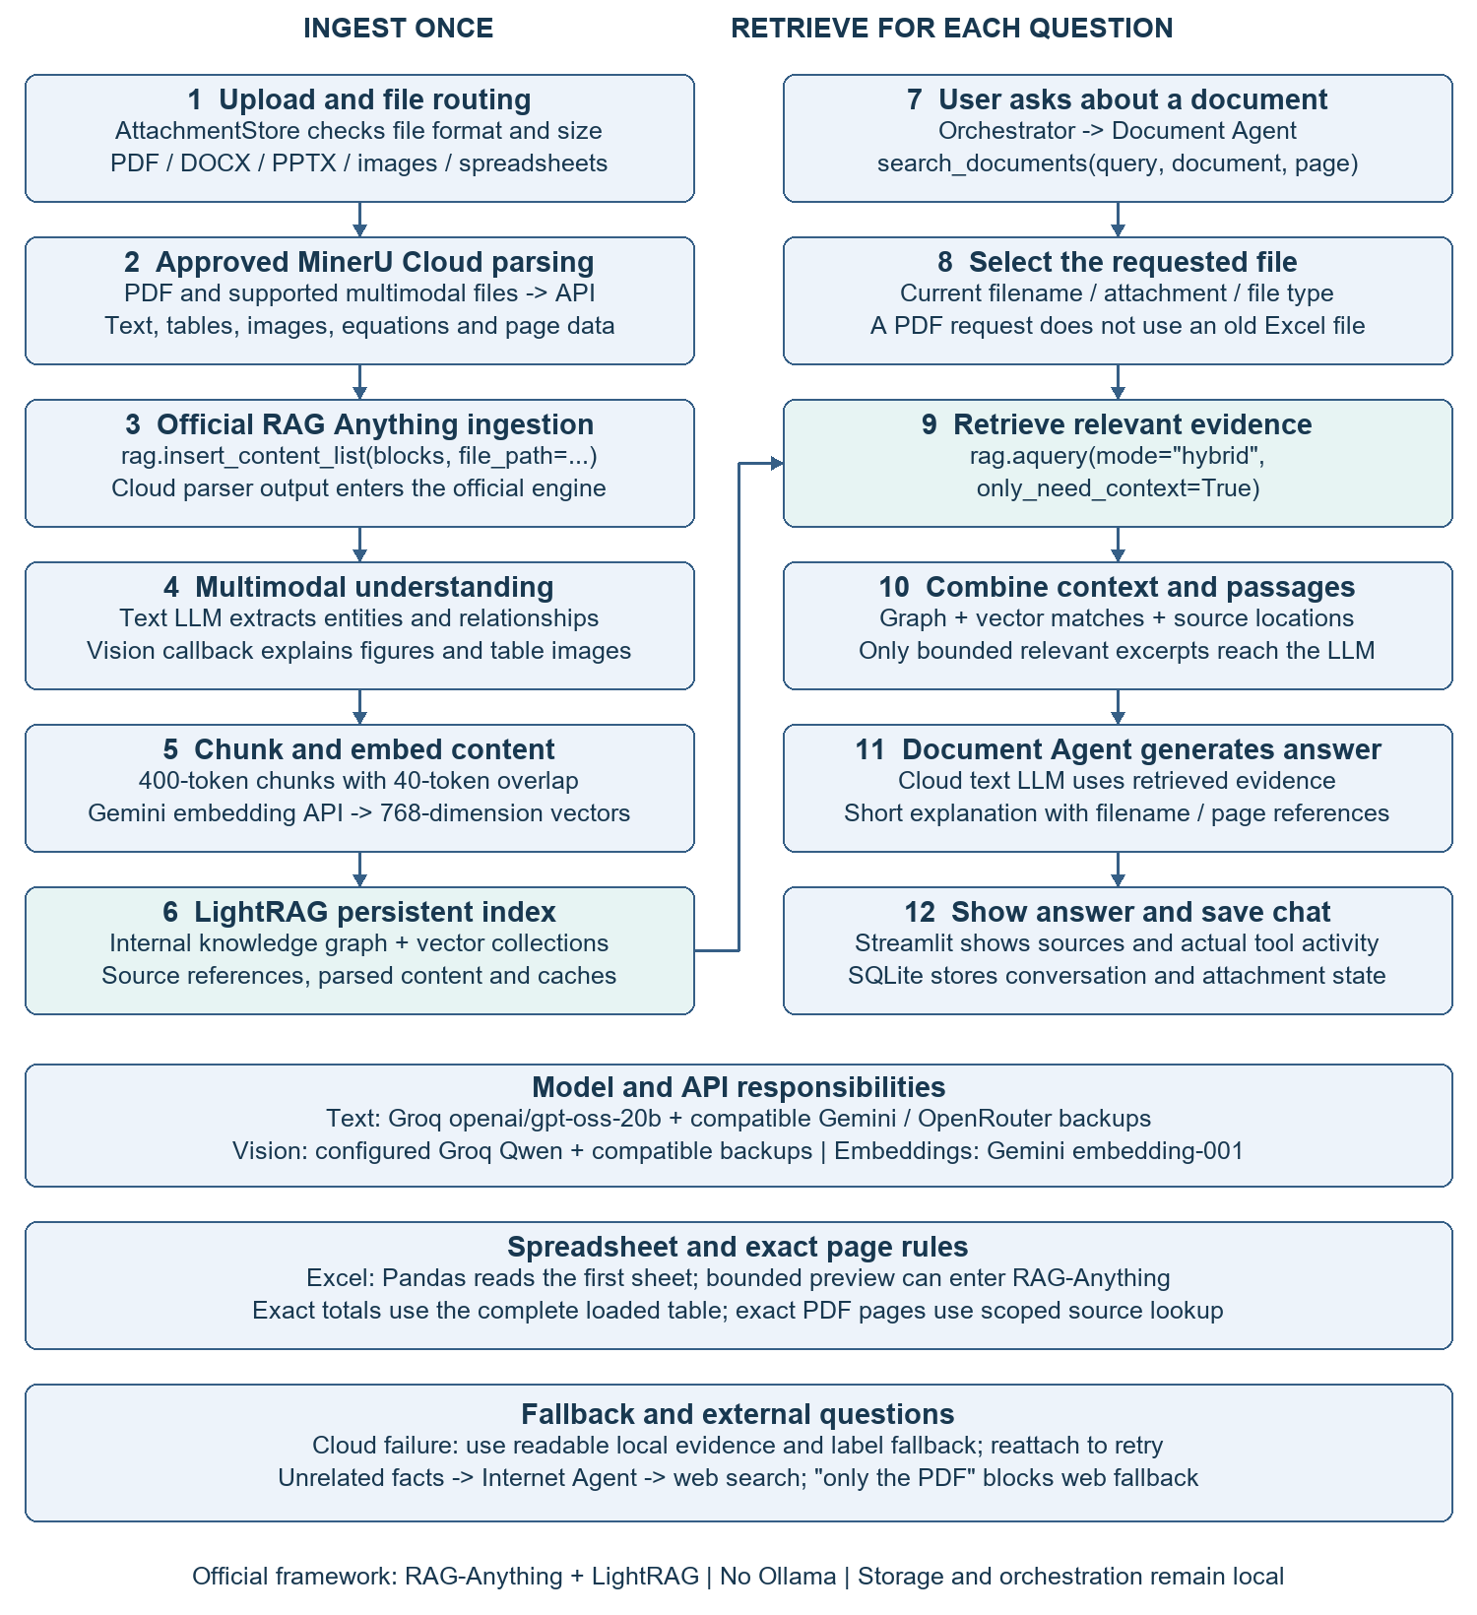
Left: document preparation and indexing. Right: question answering from the selected document. Parsing and indexes are reused when available. RAG-Anything returns evidence; the Document Agent writes the final answer.

