Spread sheet

1. Enter the data in Excel Sheet, as per the following structure

REGIONAL SALES PROJECTION

|  |  |  |  |  |  |  |  |  |
| --- | --- | --- | --- | --- | --- | --- | --- | --- |
| State | Qtr1 | Qtr2 | Qtr3 | Qtr4 | Qtr Total | Rate | Amount | Total average |

(a) Apply Formatting as follow:

i. Title in TIMES NEW ROMAN

ii. Font Size - 14

iii. Remaining text - ARIAL, Font Size -10

iv. State names and Qtr. Heading Bold, Italic with Gray Fill Color.

v. Numbers in two decimal places.

vi. Qtr. Heading in center Alignment.

vii. Apply Border to whole data.

(b) Calculate State and Qtr. Total

(c) Calculate Average for each quarter

(d) Calculate Amount = Rate * Total.

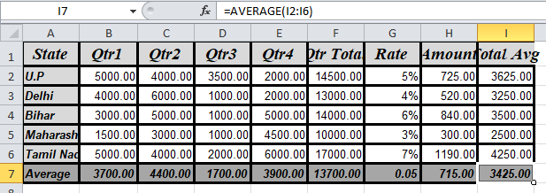

2. Given the following worksheet

**A B C D**

1 Roll No. Name Marks Grade

2 1001 Sachin 99

3 1002 Sehwag 65

4 1003 Rahul 41

5 1004 Sourav 89

6 1005 Har Bhajan 56

Calculate the grade of these students on the basis of following guidelines:  If Marks Then Grade

>= 80 A+

>= 60 < 80 A

>= 50 < 60 B

< 50 F

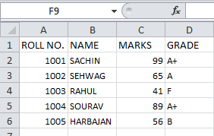

3. Given the following worksheet for storing salesman(alphanumeric) and sales for four  quarters.

|  |  |  |  |  |  |  |
| --- | --- | --- | --- | --- | --- | --- |
| Salesman | Sales(in INR) | | | |  |  |
| No. | Qtr1 | Qtr2 | Qtr3 | Qtr4 | Total  Sales | Commission |

Calculate the commission earned by the salesman on the basis of following  candidates:

25

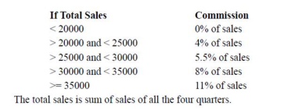

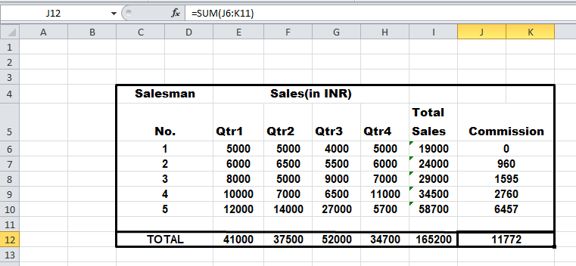

4. A company XYZ Ltd. pays a monthly salary to its employees which consists of basic  salary, allowances & deductions. The details of allowances and deductions are as follows:

Allowances

**•** HRA Dependent on Basic

30% of Basic if Basic <=1000

25% of Basic if Basic>1000 & Basic<=3000

20% of Basic if Basic >3000

**•** DA Fixed for all employees, 30% of Basic

**•** Conveyance Allowance Rs. 50/- if Basic is <=1000

Rs. 75/- if Basic >1000 & Basic<=2000

Rs. 100 if Basic >200012

• Entertainment Allowance NIL if Basic is <=1000

 Rs. 100/- if Basic > 1000

Deductions

**•** Provident Fund 6% of Basic

**•** Group Insurance Premium Rs. 40/- if Basic is <= 1500

Rs. 60/- if Basic > 1500 & Basic <= 3000

Rs. 80/- if Basic > 3000

Calculate the following:

Gross Salary = Basic + HRA + DA + Conveyance + Entertainment

Total deduction = Provident Fund + Group Insurance Premium

Net Salary = Gross Salary – Total Deduction

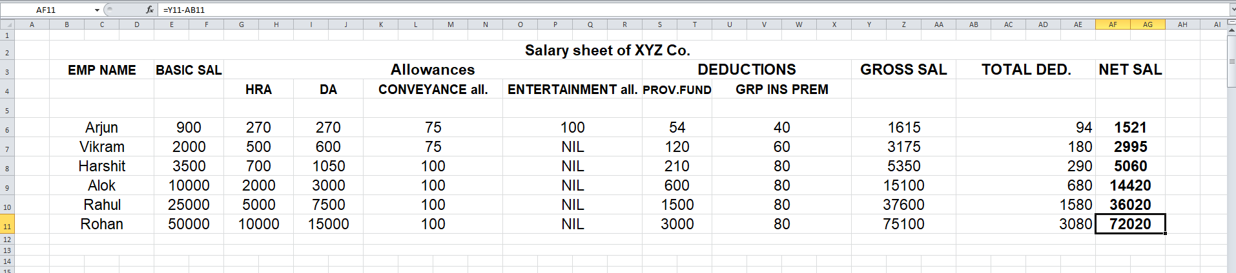

5. Create Payment Table for a fixed Principal amount, variable rate of interests and time in  the format below:

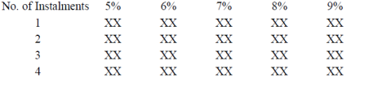

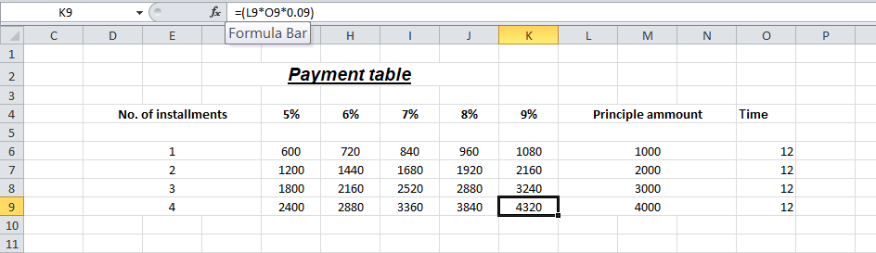

6. Use an array formula to calculate Simple Interest for given principal amounts given the  rate of Interest and time

26

Rate of Interest 8%

Time 5 Years

|  |  |  |
| --- | --- | --- |
| Principal | Simple Interest | Compound Interest |
|  |  |  |
|  |  |  |

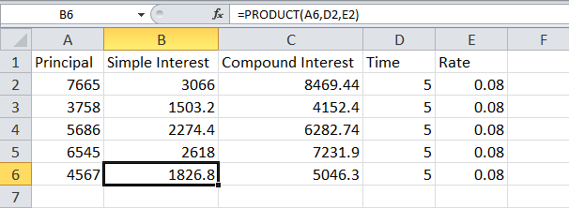

7. The following table gives year-wise sale figure of ten salesmen in INR.

|  |  |  |  |  |  |
| --- | --- | --- | --- | --- | --- |
| Salesman | 2000 | 2001 | 2002 | ……….. | 2009 |
| S1  S2  .  .  .  . | . . . . |  |  |  |  |

(a) Calculate total sale year wise.

(b) Calculate the net sale made by each salesman

(c) Calculate the maximum sale made by the salesman

(d) Calculate the commission for each salesman under the condition.

(*i*) If total sales >4,00,000 give 5% commission on total sale made by the salesman.  (*ii*) Otherwise give 2% commission.

(*e*) Draw a bar graph representing the sale made by each salesman.13

(f) Draw a pie graph representing the sale made by salesman in 2000.

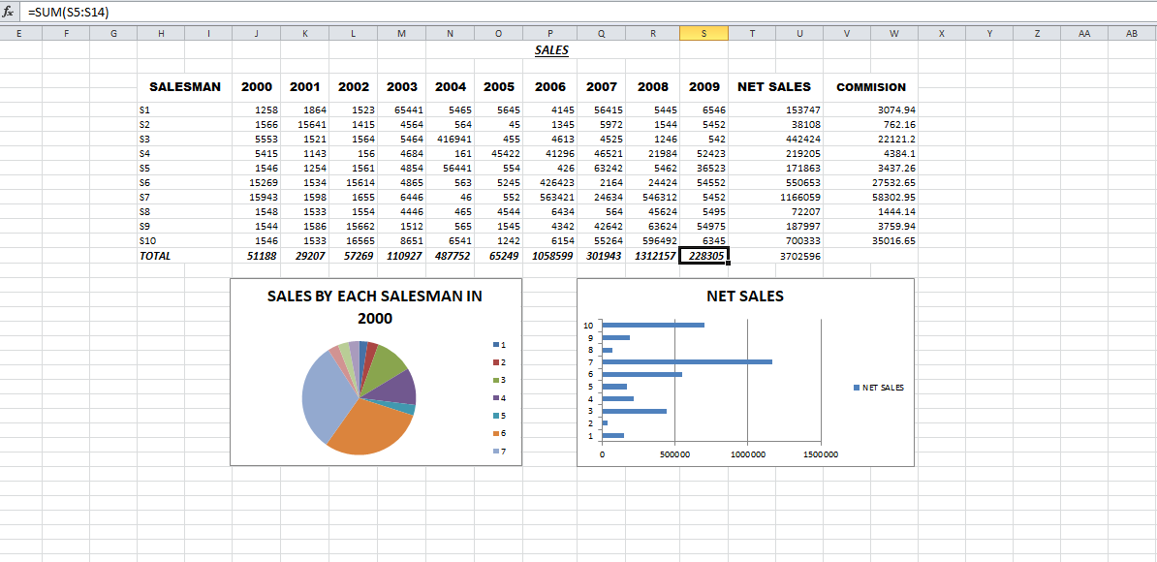

|  |  |  |  |  |  |
| --- | --- | --- | --- | --- | --- |
| 8. Design an Excel Sheet for storing the following data:  Expenses | Jan | Feb | March | Quarter  Total | Quarter  Average |
| Telephone Rent  .  .  . | 600  50  .  .  . | …. | …. |  |  |

Given, monthly income is 1,475 INR

(a) Calculate Quarter total and Quarter average.

(b) Calculate Monthly total.

(c) Surplus = Monthly income - Monthly total.

(d) What would be total surplus if monthly income is 1500.

(e) How much does telephone expense for March differ from quarter average.  (f) Create a 3D column graph for telephone and utilities.

(g) Create a pie chart for monthly expenses.

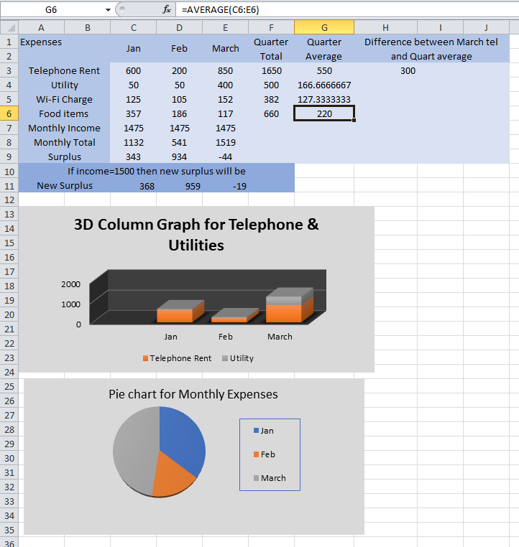

**9.** Create an excel sheet for storing revenue earned(yearly) as given in the following sample:

27

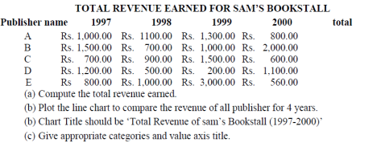

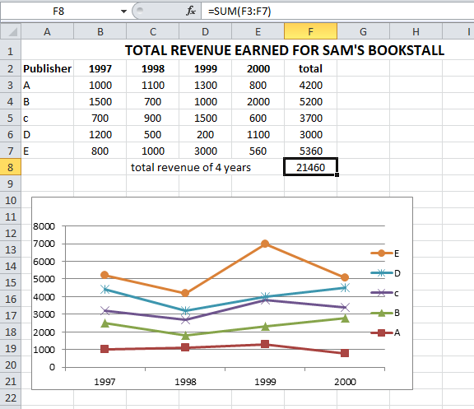

10. Generate 25 random numbers between 0 & 100 and find their sum, average and count.  How many no. are in range 50-60?

