c. Design a Garage Sale sign.

Garage

!!!For Sale!!!

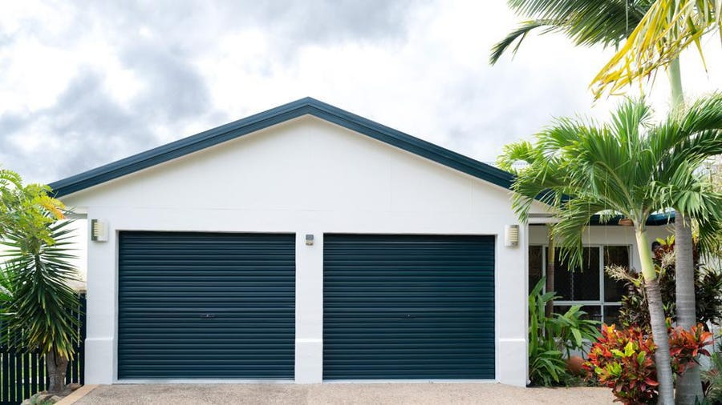

* Spacious Garage for sale
* At least 3 Cars can be parked
* Features Dim Lighting
* Small additional workshop

**Address:**

New Delhi, Wall Street, India

**For more details contact:**

Ph. No: 7905570261