6. Create the following documents:

a. A newsletter with a headline and 2 columns in portrait orientation, including at least  one image surrounded by text

**BLOCK CHAIN**

**TECHNOLOGY**

**What is Block Chain?**

Block chain is a growing immutable list of records, (immutable ledger) called blocks that are linked together using cryptography. Each block contains cryptographic hash values of the previous block, a timestamp, and transaction data.

**A type of digital currency in which a record of transactions is maintained and new units of currency are generated by the computational solution of mathematical problems, and which operates independently of a central bank.**

**Ethereum is a platform that is intended to allow people to easily write decentralized applications (Đapps) using block chain technology.**



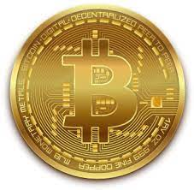

**Its main purpose is transfer of value.**

**It is said to be developed by a person named Sathoshi Nakamoto.**

**Bitcoin has a market cap value of about £343 billion.**

**Ethereum block chain can be alternately described as a block chain with a built-in programming language Protocol that actually handles internal state and computation.**

**It was developed by Vitalik Buterin.**