**Q. Check whether the given string is palindrome or not.**

**Code:**

**//to check whether the string is palindrome or not.**

**#include <stdio.h>**

**#include <string.h>**

**int main(){**

**char string1[20];**

**int i, length;**

**int flag = 0;**

**printf("Enter a string:");**

**scanf("%s", string1);**

**length = strlen(string1);**

**for(i=0;i < length ;i++){**

**if(string1[i] != string1[length-i-1]){**

**flag = 1;**

**break;**

**}**

**}**

**if (flag) {**

**printf("%s is not a palindrome", string1);**

**}**

**else {**

**printf("%s is a palindrome", string1);**

**}**

**return 0;**

**}**

**Output:**

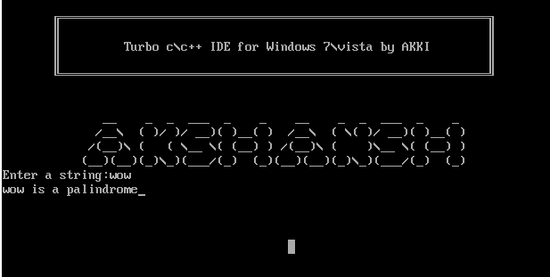

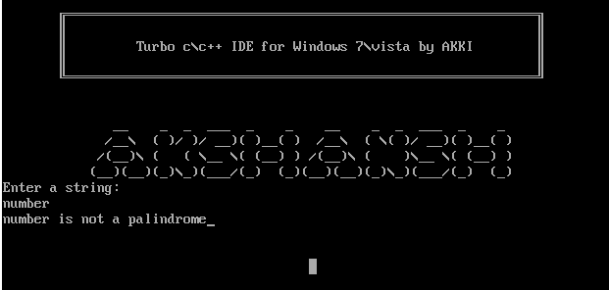

**Q.** **A cloth showroom has announced the following festival discounts on purchase of items:**

|  |  |  |
| --- | --- | --- |
| **Amount of purchase** | **Discount in %** | |
|  | **Mill Cloth** | **Handloom items** |
| **Less than Rs. 1000** | **2%** | **5%** |
| **Rs 1000 to Rs. 5000** | **20%** | **25%** |
| **Rs. 5001 to Rs.10000** | **40%** | **50%** |
| **Above 10000** | **50%** | **60%** |

**WAP to compute the net amount paid by the customer. Assume all required values to be inputted by the user.**

**Code:**

**#include<stdio.h>**

**#include<conio.h>**

**void main(){**

**float a1,a2,d;**

**float b1,b2,t;**

**printf("Enter amount of Mill cloth:");**

**scanf("%f",&a1);**

**printf("\nEnter amount of Handloom items:");**

**scanf("%f",&a2);**

**if (a1<=1000)**

**{d=0.02*a1;**

**b1=a1-d;**

**}**

**else if (a1>1000 && a1<=5000){**

**d=0.2*a1;**

**b1=a1-d;}**

**else if (a1>5000 && a1<=10000){**

**d=0.4*a1;**

**b1=a1-d;}**

**else {**

**d=0.5*a1;**

**b1=a1-d;}**

**//For calculating Handloom discount**

**if (a2<=1000)**

**{d=0.05*a2;**

**b2=a2-d;**

**}**

**else if (a2>1000 && a2<=5000){**

**d=0.25*a2;**

**b2=a2-d;}**

**else if (a2>5000 && a2<=10000){**

**d=0.5*a2;**

**b2=a2-d;}**

**else {**

**d=0.6*a2;**

**b2=a2-d;**

**}**

**t=b1+b2;**

**printf("Total amount is:%f",t);**

**getch();**

**}**

**Output:**

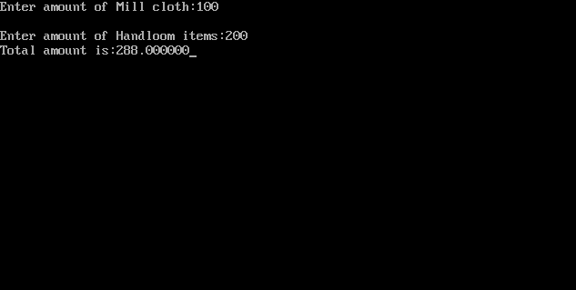

**Q. Write a program to print all Armstrong numbers between 1 to 1000.**

**Code:**

**#include<stdio.h>**

**#include<conio.h>**

**#include<math.h>**

**void main()**

**{**

**int a,b,c,d,f, g;**

**a=0;**

**for(a=1;a<1001;a++){**

**g=0;**

**b=0;**

**c=a;**

**f=a;**

**while(f>0){**

**g++;**

**f=f/10;}**

**while (c>0){**

**d=c%10;**

**b=b+pow(d,g);**

**c=c/10;**

**}**

**if (b==a){**

**printf("%d\n",a);**

**}}**

**getch ();}**

**Output:**

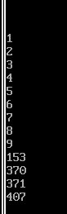

**Q. Write a program to print the following series:**

**1!+2!+3!.....n!**

**Take a user defined input for the range of the series.**

**Code:**

**#include<stdio.h>**

**int main()**

**{**

**int a=0, b=1, range, c, sum=0;**

**printf("Enter the range of Fibonacci series: ");**

**scanf("%d",&range);**

**printf("The fibonacci series is: \t");**

**while( a <= range )**

**{**

**printf("%d\t",a);**

**sum += a;**

**c = a + b;**

**a = b;**

**b = c;**

**}**

**printf("\nTheir sum is = %d", sum);**

**return 0;**

**}**

**Output:**

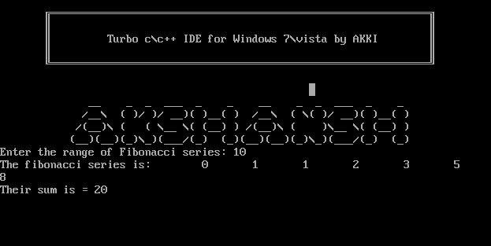

**Q. Write a program to print Fibonacci series using recursion.**

**Code:**

**#include<stdio.h>**

**void printFibonacci(int m){**

**static int m1=0,m2=1,m3;**

**if(m>0){**

**m3 = m1 + m2;**

**m1 = m2;**

**m2 = m3;**

**printf(“%d “,m3);**

**printFibonacci(m-1);**

**}**

**}**

**int main(){**

**int m;**

**printf(“Please enter your preferred number of elements here: “);**

**scanf(“%d”,&m);**

**printf(“The Fibonacci Series will be: “);**

**printf(“%d %d “,0,1);**

**printFibonacci(m-2); //We have used m-2 because we have 2 numbers already printed here**

**return 0;}**

**Output:**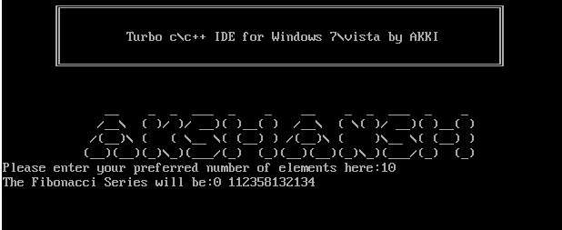

**Q. Swap the values stored in a variable by using call by value.**

**Code:**

**#include <stdio.h>**

**#include <conio.h>**

**void swap (int a, int b)**

**{**

**a=a+b;**

**b=a-b;**

**a=a-b;**

**printf("After swap : a=%d, b=%d.",a,b);**

**}**

**void main()**

**{**

**int a,b;**

**printf("Enter a = ");**

**scanf("%d",&a);**

**printf("Enter b = ");**

**scanf("%d",&b);**

**printf("Before swap: a=%d,b=%d.\n",a,b);**

**swap(a,b);**

**getch();**

**}**

**Output:**

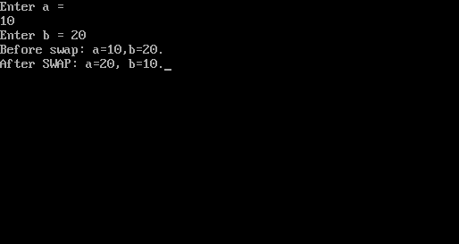

**Q. Write a menu driven program to input a 1D array for taking 6 numbers and perform following operations as per user’s choice:**

**(a) Find the sum of elements of array.**

**(b) To print the alternate elements of an array.**

**(c) To print difference between first and last the element.**

**(d) To print the palindrome numbers if found any.**

**Code:**

**#include<stdio.h>**

**#include<conio.h>**

**//declaring functions**

**void sum(int x[5]);**

**void alternate(int x[5]);**

**void diff(int x[5]);**

**void pall(int x[5]);**

**void main()**

**{**

**int i,num[5],pick;**

**printf("Enter 6 numbers:\n");**

**for(i=0;i<=5;i++){**

**scanf("%d",&num[i]);**

**}**

**printf("\n");**

**printf("Enter 1 to print sum of numbers\n");**

**printf("Enter 2 to print alternate elements\n");**

**printf("Enter 3 to print difference between 1st and last elemnt\n");**

**printf("Enter 4 to print the pallindrome numbers if found any\n");**

**printf("Choice:");**

**scanf("%d",&pick);**

**printf("\n");**

**switch(pick){**

**case 1:sum(num);**

**break;**

**case 2:alternate(num);**

**break;**

**case 3:diff(num);**

**break;**

**case 4:pall(num);**

**break;**

**default:printf("Invalid Input");**

**}**

**getch();**

**}**

**//defining the sum function**

**void sum(int x[5]){**

**int i,sum=0;**

**for(i=0;i<=5;i++){**

**sum=sum + x[i];**

**}**

**printf("Sum of all no: %d",sum);**

**getch();**

**}**

**//defining the alternate function**

**void alternate(int x[5]){**

**int i;**

**printf("Alternate numbers:");**

**for(i=0;i<=5;i++){**

**if(i%2==0){**

**printf("%d ",x[i]);**

**}**

**} }**

**//defining the diff function**

**void diff(int x[5]){**

**printf("Difference of first and last element: %d",x[5]-x[0]);**

**}**

**//defining the pallindrome function**

**void pall(int x[5]){**

**int i,rem,rev,a;**

**for(i=0;i<=5;i++){**

**a=x[i];**

**rev=0;**

**while(a>0){**

**rem=a%10;**

**rev=rev*10+rem;**

**a=a/10;**

**}**

**//check if pallindrome**

**if(rev==x[i]){**

**printf("%d is pallindrome\n",x[i]);**

**} } }**

**Output:**

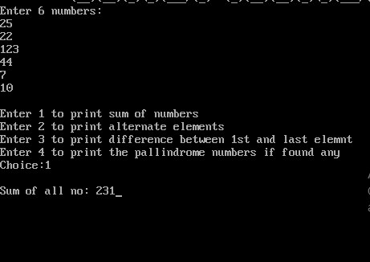

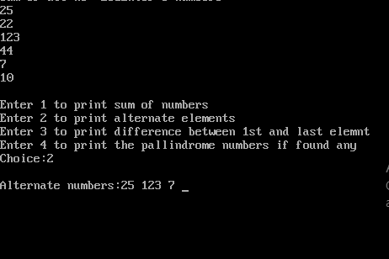

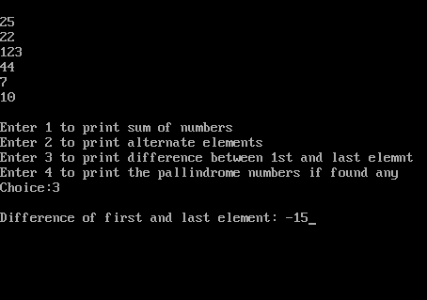

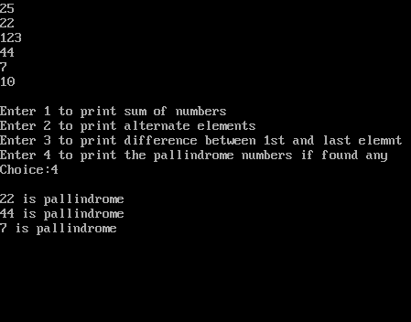

**Q. Write a program to calculate the sum of the following series:**

**1+11+111.....nth term and print the sum.**

**Take the range from the user.**

**Code:**

**#include <stdio.h>**

**#include <conio.h>**

**void main()**

**{**

**int n,i;**

**long int sum=0;**

**long int t=1;**

**clrscr();**

**printf("Input the number of terms : ");**

**scanf("%d",&n);**

**for(i=1;i<=n;i++)**

**{**

**printf("%ld",t);**

**if (i<n)**

**{**

**printf("+");**

**}**

**sum=sum+t;**

**t=(t*10)+1;**

**}**

**printf("=%ld",sum);**

**getch();**

**}**

**Output:**

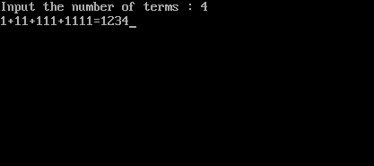

**Q. Write a menu driven program to take an integer input from the user and based on user’s choice check whether it is a prime number or a strong number.**

**Code:**

**#include<stdio.h>**

**#include<conio.h>**

**int fact(int a);**

**int strong(int b);**

**int prime(int c);**

**//main funtion**

**int main(){**

**int num,choice;**

**clrscr();**

**printf("Enter a number:");**

**scanf("%d",&num);**

**printf("\nPress 1 for checking Prime number\nPress 2 for checking Strong number\nChoose:");**

**scanf("%d",&choice);**

**switch(choice){**

**case 1: prime(num);**

**break;**

**case 2: strong(num);**

**break;**

**}**

**getch();**

**return 0;**

**}**

**//defining strong function**

**int strong(int b){**

**int ans=0,x,sep;**

**x=b;**

**while(x>0){**

**sep=x%10;**

**ans=ans+fact(sep);**

**x=x/10;**

**}**

**if(ans==b){**

**printf("\n%d is a strong number",b);**

**}**

**else{**

**printf("\n%d is not a strong number",b);**

**}**

**return 0;**

**}**

**//defining prime function**

**int prime(int c){**

**int alert=0,i;**

**for(i=2;i<c;i++){**

**if(c%i==0){**

**alert=1;**

**break;**

**}**

**}**

**if(alert==0){**

**printf("\n%d is a prime number",c);**

**}**

**else{**

**printf("\n%d is not a prime number",c);**

**}**

**return 0;**

**}**

**//defining factorial function**

**int fact(int a){**

**if(a==0){**

**return 1;**

**}**

**else{**

**return a * fact(a-1);**

**}}**

**Output:**

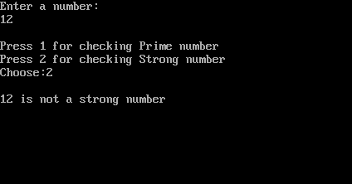

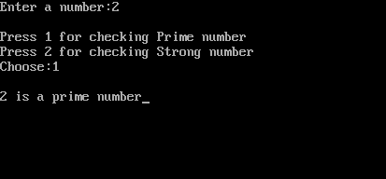

**Q. Write a program to print the following pattern:**

**\***

**\* * \***

**1 2 1**

**1**

**Code:**

**#include<stdio.h>**

**#include<conio.h>**

**int main(){**

**int i,j,num,a=0;**

**//clrscr();**

**printf("Enter a number:");**

**scanf("%d",&num);**

**for(i=0;i<=num;i++){**

**for(j=1;j<=num-i;j++){**

**printf(" ");**

**}**

**for(j=1;j<=2*i-1;j++){**

**printf(" * ");**

**}**

**printf("\n");**

**}**

**for(i=0;i<num;i++){**

**for(j=0;j<i;j++){**

**printf(" ");**

**}**

**for(j=1;j<=num-i;j++){**

**printf(" %d ",j);**

**}**

**a=i+1;**

**for(j=num-a;j>0;j--){**

**printf(" %d ",j);**

**}**

**printf("\n");**

**}**

**getch();**

**return 0;**

**}**

**Output:**

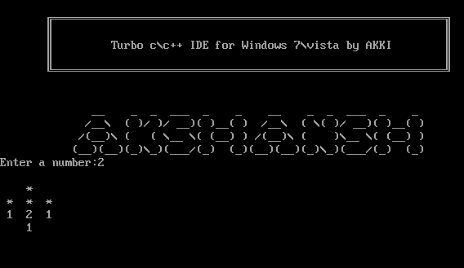

**Q. 2D Array**

**Code:**

**#include<stdio.h>**

**#include<conio.h>**

**void main(){**

**int ar[3][3];**

**int arr[3][3];**

**int a,b,c,d,e,f;**

**char g;**

**clrscr();**

**for(a=0;a<3;a++){**

**for(b=0;b<3;b++){**

**printf("\n Enter %d,%d element of 1st matrix=",a+1,b+1);**

**scanf("%d",&ar[a][b]);**

**printf("\nEnter %d,%d element of 2nd matrix=",a+1,b+1);**

**scanf("%d",&arr[a][b]);**

**}}**

**printf("\n Enter 0 for sum of matrix\n Enter 1 for subtraction\n Enter 2 for Multiplication \n Enter 3 for sum of diagonals \n Enter 4 for Transpose of each matrix=");**

**scanf("%d",&c);**

**if(c>=0 || c <=3){**

**for(d=0;d<3;d++){**

**printf("\n");**

**for(e=0;e<3;e++){**

**if(c==0){**

**printf("%d\t",ar[d][e]+arr[d][e]);}**

**else if(c==1)**

**printf("%d\t",ar[d][e]-arr[d][e]);**

**else if(c==2){**

**f=(ar[d][0]*arr[0][e]+ar[d][1]*arr[1][e]+ar[d][2]*arr[2][e]);**

**printf("%d\t",f);}**

**else if(c==3){**

**if(d==e)**

**printf("%d",ar[d][e]+arr[d][e]);**

**}}}**

**if(c==4){**

**for(a=0;a<3;a++){**

**printf("\n");**

**for(b=0;b<3;b++){**

**printf("%d\t",ar[b][a]);}}**

**printf("\n");**

**for(a=0;a<3;a++){**

**printf("\n");**

**for(b=0;b<3;b++){**

**printf("%d\t",arr[b][a]);}}**

**}**

**else**

**printf("Invalid choice");**

**getch();}**

**}**

**Output:**

