Q15-Read a line of lowercase text and store its uppercase equivalent to the data file.

#include<stdio.h>

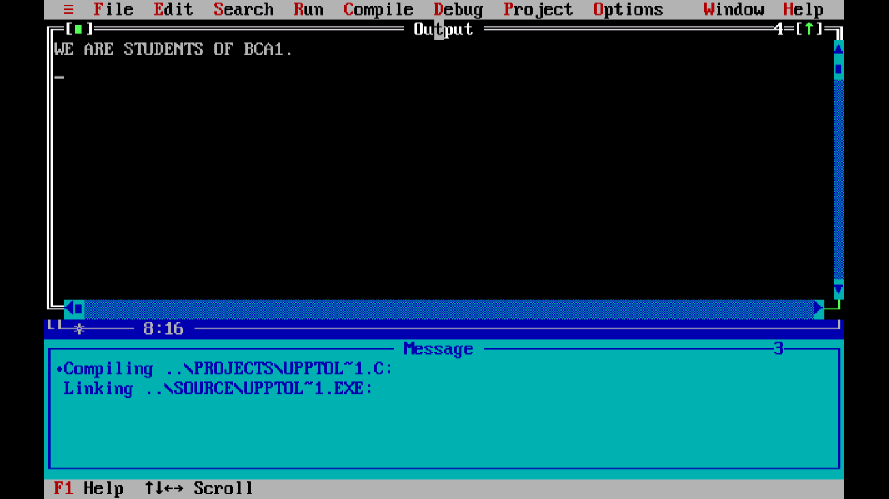

#include<conio.h>

int main()

{

FILE \*fp1, \*fp2;

char ch;

fp1 = fopen("source.txt", "r");

if (fp1 == NULL)

{

puts("File does not exist..");

exit(1);

}

fp2 = fopen("target.txt", "w");

if (fp2 == NULL)

{

puts("File does not exist..");

fclose(fp1);

exit(1);

}

while((ch=fgetc(fp1))!=EOF)

{

ch = toupper(ch);

fputc(ch,fp2);

}

printf("\nFile successfully copied..");

return 0;

}