Q17.Read the contents of a file and copy it to another file character by character..

#include <stdio.h>

int main(){

FILE *sourceFile;

FILE *destFile;

char sourcePath[100];

char destPath[100];

char ch;

printf("Enter source file path: ");

scanf("%s", sourcePath);

printf("Enter destination file path: ");

scanf("%s", destPath);

sourceFile = fopen(sourcePath, "r");

destFile = fopen(destPath, "w");

if (sourceFile == NULL || destFile == NULL) {

printf("\nUnable to open file.\n");

printf("Please check if file exists and you have read/write privilege.\n");

exit(EXIT_FAILURE);}

ch = fgetc(sourceFile);

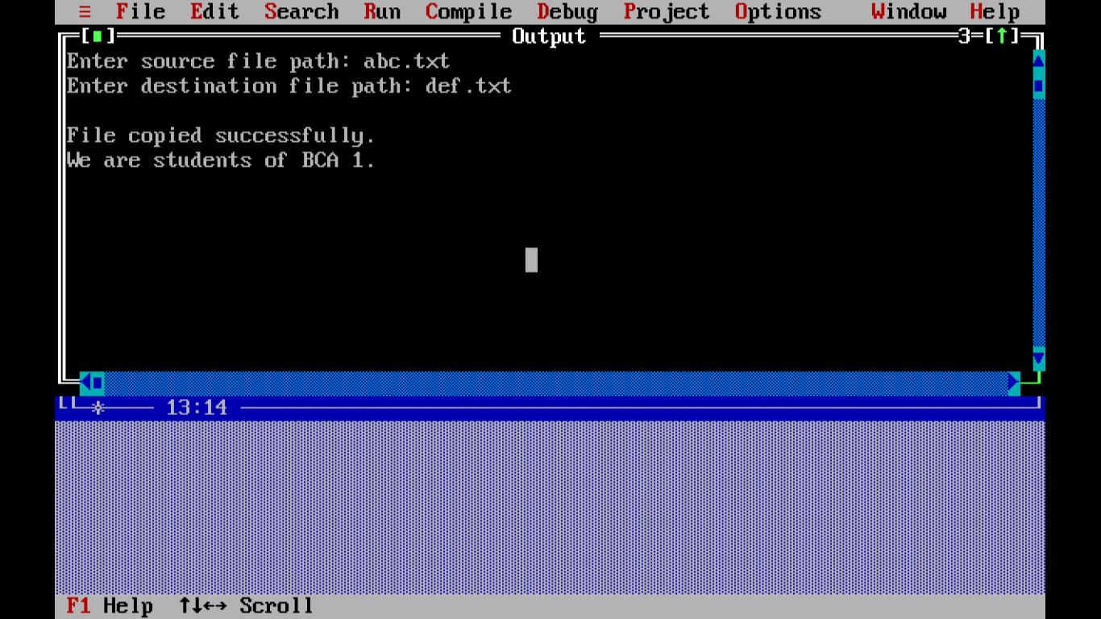

while (ch != EOF){

fputc(ch, destFile);

ch = fgetc(sourceFile);}

printf("\nFiles copied successfully.\n");

fclose(sourceFile);

fclose(destFile);

return 0;

}