ABSTRACT

Drowsy driving is a leading contributor to road traffic accidents, and unlike alcohol-related driving, it leaves no evidence at the scene that can be tested for after the fact, which makes it both underreported and difficult to design detection systems for. This report presents a real-time driver drowsiness detection system that combines two independently trained deep learning models with classical facial-geometry features to produce a continuous drowsiness score rather than a simple binary label.
The system uses two MobileNetV2-based convolutional neural networks trained via transfer learning: one classifying eye state (Closed vs. Open) and one classifying yawning (yawn vs. no_yawn). This two-model design was adopted after an initial single four-class model performed close to random chance, once it became clear that the dataset actually spans two visually distinct domains — close-up eye crops and full driver-face images — that a single classifier could not reconcile. The eye-state model achieved a final test accuracy of 99.08%, and the yawn-detection model achieved 90.37%, both evaluated on a held-out test split of the Kaggle Drowsiness Dataset.
These CNN outputs are combined with MediaPipe-based facial landmark detection, from which Eye Aspect Ratio (EAR), Mouth Aspect Ratio (MAR), and head-tilt angle are computed in real time. All five signals are fused into a single weighted drowsiness score, which drives a live alert system built with OpenCV. The report also documents the engineering effort required to move the system from a Google Colab training environment to a working local real-time application, including resolving MediaPipe API version incompatibilities, TensorFlow/Keras model-serialisation mismatches, and multi-camera source detection.
Keywords: Driver Drowsiness Detection, Convolutional Neural Network, MobileNetV2, Transfer Learning, MediaPipe, Eye Aspect Ratio, Mouth Aspect Ratio, Real-Time Systems, Computer Vision.

INDEX

S.No | Description | Page No.
1 | Abstract | i
2 | Introduction  - Overview  - Importance of Driver Safety Systems  - Problem Statement  - Aim and Scope | 1-2
3 | Literature Review  - Overview of Existing Approaches  - Research Paper Reviews  - Analysis of Research Gaps | 3-5
4 | Analysis of System with Study of Requirements  - Current System  - System Under Proposal  - Functional Requirements  - Non-Functional Requirements | 6-7
5 | Methodology  - Explanation  - Architecture  - System Pipeline / Data Flow  - EAR, MAR, Head Pose and Score Fusion | 8-12
6 | Dataset Details  - Sources and Collection of Data  - The Two-Domain Discovery  - Cleaning and Preprocessing of Data  - Feature Engineering and Augmentation | 13-16
7 | Model Training and Evaluation  - Selection of Models  - Training Methodology  - Assessing the Results  - Logic for Drowsiness Score Fusion | 17-20
8 | Development of the Real-Time Application  - Camera and Landmark Pipeline Development  - About the Alert System  - Integration of MediaPipe and Trained Models  - Environment and Compatibility Engineering | 21-23
9 | Results and Analysis  - Metrics and Results  - Evaluation with Accuracy  - Comparative Graphical Analysis  - Comparison with Reviewed Literature | 24-29
10 | Conclusion  - The Outcomes  - Challenges | 30-31
11 | Future Scope | 32
12 | References | 33
1. INTRODUCTION
1.1 OVERVIEW
Drowsy driving remains one of the most underreported causes of road traffic accidents. Unlike alcohol-related driving, which can be tested for after the fact through a breathalyser, fatigue is transient and leaves no physical evidence at the scene, which also makes it difficult to build reliable detection systems for. A system that can monitor a driver's alertness in real time, using nothing more than a standard webcam, has direct practical value both as a safety feature and as a way of understanding fatigue patterns.
In recent years, advances in deep learning and facial landmark detection have made it possible to build such systems using only a camera feed, without any specialised sensors or wearable hardware. This project uses this combination — convolutional neural networks together with classical facial-geometry computation — to build a working prototype of such a system.
1.2 IMPORTANCE OF DRIVER SAFETY SYSTEMS
As vehicles spend longer hours on the road, particularly in commercial and long-distance driving, fatigue-related risk increases substantially. Traditional safety systems focus on collision avoidance and vehicle stability, but very few consumer vehicles include any form of driver-state monitoring. Where such systems do exist, they are usually restricted to premium vehicles and rely on dedicated infrared cameras or steering-pattern analysis, rather than the general-purpose vision-based approach this project explores.
A drowsiness monitoring system built on standard, low-cost hardware — a webcam and a laptop — has value precisely because it does not require specialised equipment. This is also why the project emphasises real-time deployment as much as raw model accuracy: a system that is accurate but only runs inside a training notebook has limited practical use.
1.3 PROBLEM STATEMENT
The problem addressed in this project is to build a system that can, from a live webcam feed, determine whether a driver is showing signs of drowsiness — specifically through prolonged eye closure, yawning, and abnormal head tilt — and alert them before the condition becomes dangerous. Most existing approaches in published research address only one of these signals in isolation, or combine signals without producing an interpretable measure of how drowsy the driver actually is, only a binary label. This project's problem statement therefore includes not just detection, but fusion of multiple signals into one continuous, interpretable score, and deployment of that system as something that actually runs in real time rather than remaining a notebook experiment.
1.4 AIM AND SCOPE
The aim of this project is to design, train, and deploy a real-time driver drowsiness detection system. The scope of the work includes:
- Reviewing existing literature on drowsiness detection to identify a genuine gap this project can address.
- Collecting and preparing a suitable image dataset covering eye state and yawning.
- Designing and training deep learning models capable of classifying eye state and yawning from images.
- Implementing classical facial-geometry features (EAR, MAR, head tilt) alongside the trained models.
- Fusing all signals into a single, continuously updated drowsiness score.
- Building a real-time pipeline using a standard webcam that runs the complete system live.
- Documenting the engineering challenges of moving from a cloud training environment to a local, deployable application.
The project does not attempt to cover night-time infrared imaging, driver identification, or integration with actual vehicle hardware; these are noted as future scope in Chapter 10.

2. LITERATURE REVIEW
2.1 OVERVIEW OF EXISTING APPROACHES
Published approaches to driver drowsiness detection fall broadly into two categories. The first relies on classical facial geometry — measuring ratios such as Eye Aspect Ratio (EAR) and Mouth Aspect Ratio (MAR) from facial landmarks, and comparing them against a fixed threshold. These methods are computationally cheap and fast, but tend to be fragile: a threshold tuned for one person's eye shape can fail entirely for another, and such systems generally do not incorporate any learned visual model of what an eye or a yawn actually looks like.
The second category relies on deep learning — training a convolutional neural network or, more recently, a Vision Transformer, to classify eye or mouth state directly from image data. These models are typically far more accurate than threshold-based methods, but the more accurate architectures (ResNet50V2, Vision Transformers) are also the most computationally expensive, which works against the goal of running the system in real time on ordinary hardware.
2.2 RESEARCH PAPER REVIEWS
Six papers were reviewed in detail to understand the current state of the art and to identify where this project's own approach could meaningfully add something.

S.No. | Paper Title | Authors, Year | Method | Accuracy | Limitation
1 | Real-Time Drowsiness Detection Using EAR and Facial Landmark Detection | Prerana et al., 2024 | dlib 68-point landmarks + EAR threshold | ~91% | Fixed threshold, no CNN, fails with glasses
2 | A Real-Time Embedded System for Driver Drowsiness Detection Based on CNN and MAR | Espinosa et al., 2024 | CNN + EAR/MAR on NVIDIA Jetson Nano | 97.44% | Needs specialised hardware, no accessible interface
3 | Improving Driver Drowsiness Detection via Personalised EAR/MAR Thresholds and CNN Classification | Sanchez-Gendriz et al., 2025 | Personalised EAR/MAR + CNN | 94% | No head pose signal, no deployment interface
4 | Driver Monitoring System Using MediaPipe and MobileNetV2 for Real-Time Fatigue Detection | Rosero-Montalvo et al., 2026 | MediaPipe 468 landmarks + MobileNetV2 + EAR + MAR + head pose | 88.89% | No session logging, no web deployment
5 | CNN-Based Eye State Classification for Drowsiness Detection Using MediaPipe | Castro-Ospina et al., 2023 | ResNet50V2 / VGG16 / InceptionV3 | 99.71% | Too heavy for real-time inference on regular hardware
6 | Real-Time Driver Drowsiness Detection Using Vision Transformer Architectures | Jarndal et al., 2025 | ViT / Swin Transformer | 99.15% | Too heavy for real-time PC deployment

2.3 ANALYSIS OF RESEARCH GAPS
Across all six papers reviewed, a consistent pattern emerges: systems that are accurate tend to be too computationally heavy for real-time use on ordinary hardware, and systems that are fast tend to rely on brittle fixed thresholds. None of the reviewed papers combine a CNN, EAR/MAR geometry, and head-pose estimation into a single fused score with a deployable interface. Most stop at a binary AWAKE/DROWSY output with no indication of severity, and none report an accessible way for an end user to actually run the system outside of a research environment.
This project's contribution is positioned specifically in that gap: a continuous drowsiness score built from CNN outputs together with EAR, MAR, and head tilt, running as a real-time application rather than a research script.

3. ANALYSIS OF SYSTEM WITH STUDY OF REQUIREMENTS
3.1 CURRENT SYSTEM
Most currently available drowsiness-related features are limited to premium vehicles with dedicated infrared driver-monitoring cameras, or to standalone mobile applications that use simple EAR-threshold logic without any learned visual model. These existing systems generally provide only a binary alert, are not able to distinguish yawning from ordinary mouth movement reliably, and do not adapt to individual differences in eye shape or camera angle. There is no widely available, low-cost system that combines deep learning classification with facial geometry into a single, interpretable drowsiness measure.
3.2 SYSTEM UNDER PROPOSAL
The system proposed in this project uses a standard webcam as its only hardware requirement. It combines two independently trained convolutional neural networks — one for eye state and one for yawning — with MediaPipe-based facial landmark detection, from which EAR, MAR, and head-tilt angle are computed. All five signals are fused into a single weighted drowsiness score between 0.0 and 1.0, which is displayed live and drives an alert when sustained above a threshold. Unlike the systems described in Section 3.1, the proposed system does not depend on any single signal being correct — a momentary false positive on one signal is naturally down-weighted by the other four.
3.3 FUNCTIONAL REQUIREMENTS
- The system shall capture live video from a standard webcam.
- The system shall detect 468 facial landmarks per frame using MediaPipe Face Mesh.
- The system shall classify eye state (Closed / Open) using a trained CNN.
- The system shall classify yawning (yawn / no_yawn) using a separately trained CNN.
- The system shall compute Eye Aspect Ratio, Mouth Aspect Ratio, and head-tilt angle from facial landmarks.
- The system shall fuse all five signals into a single weighted drowsiness score.
- The system shall display the current status (AWAKE / ALERT / DROWSY) along with live metric values on screen.
- The system shall trigger a visible alert when the DROWSY state is sustained for more than two seconds.
- The system shall be reproducible from the version-controlled source code and trained model files stored in the project repository.
3.4 NON-FUNCTIONAL REQUIREMENTS
- The system shall run in real time on standard CPU hardware without requiring a dedicated GPU at inference time.
- The system shall be resilient to minor environment differences between the training platform (Google Colab) and the local execution platform.
- The system shall correctly identify the intended camera source when multiple video input devices are available.
- The system's trained models and source code shall be maintained under version control for reproducibility.
- The system shall be extensible to support future enhancements such as personalised threshold calibration.

4. METHODOLOGY
4.1 EXPLANATION
The project follows a data-driven, iterative methodology consisting of: dataset collection, exploratory data analysis, preprocessing, model architecture design, model training and fine-tuning, real-time pipeline integration, and finally evaluation. Each stage was carried out and documented across nine weekly milestones, with the model architecture itself changing substantially partway through the project once a key limitation in the initial approach was discovered (see Chapter 5).
4.2 ARCHITECTURE
The system architecture consists of two independently trained MobileNetV2-based convolutional neural networks, each solving a binary classification task, combined at inference time with a classical geometry module built on MediaPipe Face Mesh landmarks. MobileNetV2 was selected over the heavier architectures discussed in Chapter 2 (ResNet50V2, VGG16, Vision Transformers) specifically because it offers a substantially better accuracy-to-inference-speed tradeoff on standard hardware, which is essential for a system intended to run live rather than only in a training notebook.
Each model was trained in two phases. In Phase 1, the MobileNetV2 convolutional base was frozen, and only a custom classification head (Global Average Pooling, followed by Dense layers with Batch Normalisation and Dropout, ending in a 2-unit softmax output) was trained, using the Adam optimiser at a learning rate of 1e-3. In Phase 2, the deepest 30 layers of the base (50 layers for the yawn-detection model, described further in Chapter 6) were unfrozen and fine-tuned at a reduced learning rate of 1e-4, allowing the pretrained ImageNet features to adapt to the specific eye and face imagery used in this project.
4.3 SYSTEM PIPELINE / DATA FLOW
At Level 0, the system takes a webcam frame as input and produces a drowsiness status and alert as output.
At Level 1, this expands into the full processing chain used by the system:
Webcam Frame
MediaPipe Face Mesh (468 Landmarks)
Eye Crop → Eye-State CNN | Face Crop → Yawn-Detection CNN
EAR / MAR / Head-Tilt Geometry Computation
Weighted Drowsiness Score Fusion
Status Classification + Live Overlay + Sustained Alert

4.4 EAR, MAR, HEAD POSE AND SCORE FUSION
Eye Aspect Ratio (EAR) is computed from six landmark points per eye:
EAR = ( ‖p2−p6‖ + ‖p3−p5‖ ) / ( 2 × ‖p1−p4‖ )
An open eye typically produces an EAR between 0.25 and 0.35; a sustained drop below 0.20 indicates the eye is closing rather than blinking. Mouth Aspect Ratio (MAR) is computed the same way from mouth landmark points, with a resting mouth producing a MAR between 0.20 and 0.30, and a rise above 0.50 indicating yawning. Head-tilt angle is estimated from the angle between the two eye-corner landmarks relative to horizontal, and flagged when it exceeds 20°.
All five signals are combined into a single score using the following weights:
Signal | Weight
Eye-state CNN output | 30%
Yawn-detection CNN output | 30%
EAR geometry signal | 20%
MAR geometry signal | 10%
Head-tilt signal | 10%

A score below 0.30 is classified as AWAKE, between 0.30 and 0.50 as ALERT, and above 0.50 as DROWSY. A DROWSY state sustained for more than two consecutive seconds triggers the alert.

5. DATASET DETAILS
5.1 SOURCES AND COLLECTION OF DATA
This project uses the publicly available Drowsiness Dataset (dheerajperumandla/drowsiness-dataset) hosted on Kaggle.
Parameter | Details
Primary Data Source | Kaggle (dheerajperumandla/drowsiness-dataset)
Classes | Closed, Open, yawn, no_yawn
Closed | 726 images — cropped eye, eye closed
Open | 726 images — cropped eye, eye open
yawn | 723 images — full driver face, mid-yawn
no_yawn | 725 images — full driver face, neutral
Total Images | 2,900 approx.
Train / Val / Test Split | 70% / 15% / 15%, stratified

5.2 THE TWO-DOMAIN DISCOVERY
The dataset's directory structure suggests a single four-class classification problem. In practice, this is not the case. An initial attempt at training a single four-class CNN on all categories together performed close to random chance — between 33% and 45% accuracy on a 4-class task where chance level is 25%. Diagnosis showed the model was effectively learning to separate “eye images” from “car images” and then struggling within each group, because the Closed/Open classes are close-up eye crops while the yawn/no_yawn classes are full driver-face photographs taken inside a vehicle — two visually unrelated domains.
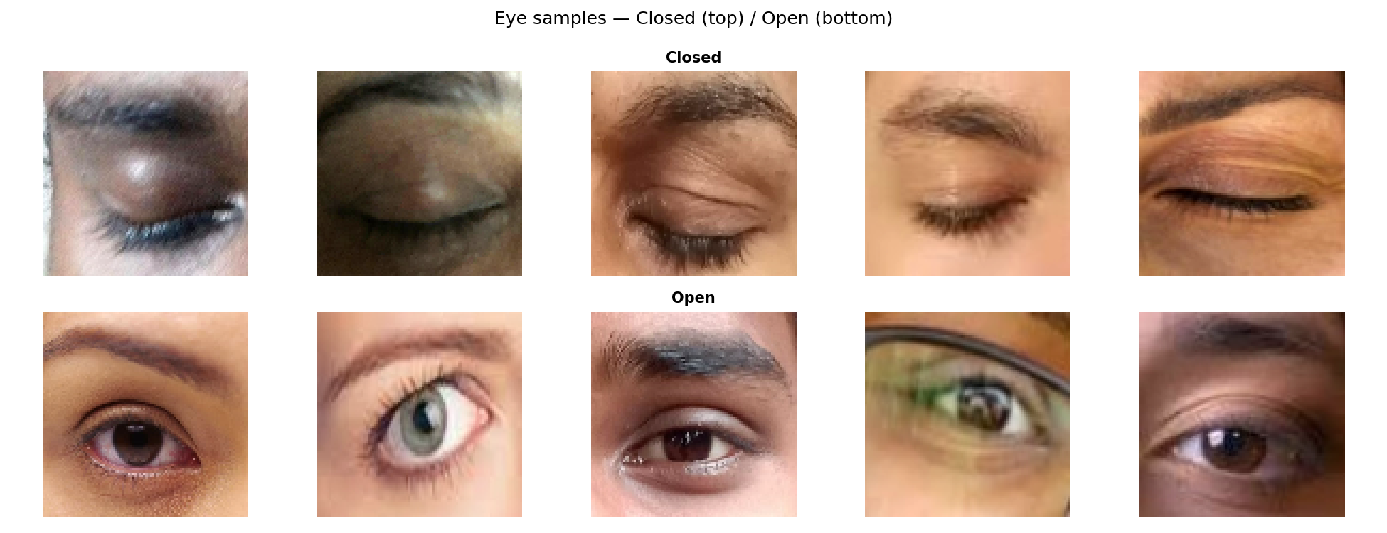
Figure 5.1: Sample images from the Closed and Open eye classes.
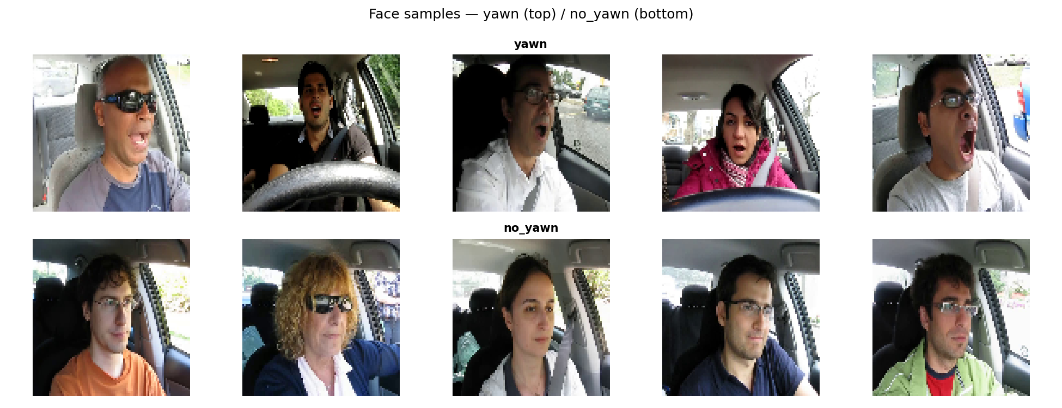
Figure 5.2: Sample images from the yawn and no_yawn classes, illustrating the full-face, in-car nature of these images compared to Figure 5.1.
This finding directly shaped the final architecture described in Chapter 4: two independently trained binary classifiers, one per visual domain, rather than a single four-class model.
5.3 CLEANING AND PREPROCESSING OF DATA
5.3.1 Resizing and Normalisation
All images were loaded in RGB (an earlier grayscale approach was tried first and found to lose information relevant to the full-face yawn images), resized to 96×96 pixels, and normalised using MobileNetV2's own preprocess_input function rather than a simple division by 255.
5.3.2 Train / Validation / Test Split
Data was split 70% train, 15% validation, and 15% test using stratified sampling to preserve class balance across all three splits, applied separately for each of the two models.
5.3.3 Label Verification
Before training, a visual check was performed on a sample of images from each class alongside their assigned label, to catch any folder-path or label-mapping errors before they could silently corrupt a training run — a check that proved necessary after an earlier notebook was found to be loading images from the wrong subdirectory.
5.3.4 Handling the Domain Split
Rather than loading all four classes into one array, two entirely separate loading pipelines were built: one restricted to the Closed/Open folders at 96×96 resolution for the eye-state model, and one restricted to the yawn/no_yawn folders for the yawn-detection model.
5.4 FEATURE ENGINEERING AND AUGMENTATION
Augmentation was applied only to the training split, using random rotation (±10°), horizontal flip, brightness variation (0.8–1.2×), and zoom (±10%), implemented via Keras' ImageDataGenerator. Validation and test splits were left unaugmented.
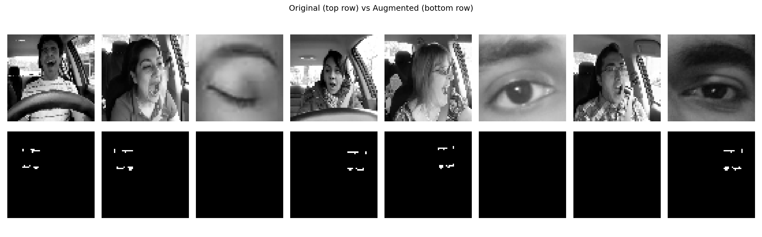
Figure 5.3: Preprocessing and augmentation exploration conducted during the data-preparation phase, comparing original training samples against a transformed representation evaluated during preprocessing strategy selection.

6. MODEL TRAINING AND EVALUATION
6.1 SELECTION OF MODELS
MobileNetV2, pretrained on ImageNet, was selected as the base architecture for both classifiers. As discussed in Chapter 2, heavier architectures such as ResNet50V2 and Vision Transformers report marginally higher accuracy in the literature, but at a computational cost that works against real-time deployment on ordinary hardware. MobileNetV2's depthwise separable convolutions give it a substantially smaller parameter count while retaining strong transfer-learning performance, which made it the appropriate choice for this project's goals.
6.2 TRAINING METHODOLOGY
Both models were trained on Google Colab using GPU acceleration. Training used four callbacks: ModelCheckpoint (saving the best model by validation accuracy), EarlyStopping (halting training if validation accuracy did not improve for a set number of epochs, restoring the best weights), ReduceLROnPlateau (halving the learning rate if validation loss plateaued), and CSVLogger (recording per-epoch metrics for later analysis).
The eye-state model was trained for a two-phase process (frozen base, then fine-tune of the last 30 layers). The yawn-detection model initially followed the same two-phase process, but was found to benefit from an additional, deeper fine-tuning pass — unfreezing the last 50 layers at a further-reduced learning rate of 3e-5 — which measurably improved its accuracy from 88.99% to 90.37% (see Chapter 8).
6.3 ASSESSING THE RESULTS
Model performance was assessed using accuracy, precision, recall, and F1-score on a held-out test split that the models never saw during training or validation. Full quantitative results, confusion matrices, and training curves are presented in Chapter 8; this section summarises the process rather than the numbers themselves. Both models were evaluated after loading the ModelCheckpoint-saved best weights, not the weights present at the final epoch of training, since the final epoch is not necessarily the best-performing one.
6.4 LOGIC FOR DROWSINESS SCORE FUSION
Once both models are trained, their outputs are not used in isolation. At inference time, each frame produces five values — the eye-state model's Closed-class probability, the yawn-detection model's yawn-class probability, and the three classical geometry signals (EAR, MAR, head tilt) described in Section 4.4. These are combined using the weighted formula given in that section into a single score between 0.0 and 1.0.
This design mirrors the reasoning behind ensemble methods generally: no single signal is treated as fully authoritative, so a momentary misclassification by one component (for example, a CNN misreading an unusual lighting condition as a closed eye) is naturally moderated by the other four signals, rather than triggering an alert on its own. The resulting categorisation — AWAKE, ALERT, or DROWSY — is what drives the live status display and the sustained-state alert described in Chapter 7.

7. DEVELOPMENT OF THE REAL-TIME APPLICATION
7.1 CAMERA AND LANDMARK PIPELINE DEVELOPMENT
The real-time application captures live video using OpenCV's VideoCapture interface and passes each frame to MediaPipe Face Mesh, which returns 468 (x, y, z) facial landmark coordinates per detected face. From these landmarks, the eye region and the full face region are cropped separately — the former resized to 96×96 for the eye-state model, the latter resized to 96×96 for the yawn-detection model — mirroring the same preprocessing used during training in Chapter 5.
7.2 ABOUT THE ALERT SYSTEM
The live application displays a status banner (AWAKE, ALERT, or DROWSY) at the top of the video feed, along with the current EAR, MAR, head-tilt angle, drowsiness score, and frame rate. When the DROWSY state persists for more than two consecutive seconds, a red border and an on-screen “DROWSY ALERT” message are triggered, and the event is logged with a timestamp to the console.
7.3 INTEGRATION OF MEDIAPIPE AND TRAINED MODELS
On every captured frame, the pipeline runs both trained CNNs and the geometry computation described in Chapter 4 in sequence: MediaPipe landmark detection, eye and face region cropping, both model inferences, EAR/MAR/tilt calculation, score fusion, and finally the on-screen overlay. This entire loop runs on ordinary CPU hardware, without requiring GPU acceleration at inference time, since both trained models are lightweight enough for real-time use once training is complete.
7.4 ENVIRONMENT AND COMPATIBILITY ENGINEERING
Moving the trained models and pipeline from the Google Colab training environment to a local machine for real-time execution surfaced three practical engineering problems that are not discussed in any of the papers reviewed in Chapter 2, all of which had to be resolved before the system could run at all.
MediaPipe API Restructuring
MediaPipe's 0.10.x release line restructured the mp.solutions module used to access Face Mesh, which broke code written against the API documented in most existing tutorials. This was resolved by adapting the import path to the current API rather than downgrading MediaPipe, since compatible older releases were no longer available through the package index.
TensorFlow/Keras Model Serialisation Mismatch
Models trained and saved on Google Colab, using an older Keras serialisation format, failed to load on the local machine, which was running a newer Keras 3 runtime. The failure was traced to a quantization_config metadata field present in the saved .h5 file that Keras 3's loader did not recognise. Rather than attempting to pin exactly matching library versions across two separate machines — a fragile solution likely to break again the next time either environment updated — a small utility was written that opens the .h5 file directly and rewrites its internal stored configuration metadata before the model is loaded, which resolved the issue durably.
Multi-Camera Source Detection
When more than one camera source was available on the local machine — including virtual camera software used during testing — the system needed to reliably identify the correct physical or intended camera rather than defaulting to a fixed index. This was solved by scanning available camera indices at startup and selecting the first index that returned a valid video frame, with the detected resolution logged for confirmation.
These three fixes are documented here because they generalise beyond this specific project: any deep-learning system trained in a cloud notebook and later deployed to run locally in real time is likely to encounter some version of each of these three problems.

8. RESULTS AND ANALYSIS
8.1 METRICS AND RESULTS
Both trained models were evaluated on a held-out test split that played no part in training or validation.
Model | Task | Test Accuracy
eye_model.h5 | Closed vs Open | 99.08%
face_model.h5 | Yawn vs No Yawn | 90.37%

8.2 EVALUATION WITH ACCURACY
Eye State Model (Closed vs. Open)
On a test set of 218 images (109 Closed, 109 Open), the eye-state model classified 216 correctly, giving a test accuracy of 99.08%, with precision and recall both at 0.9908 for each class.
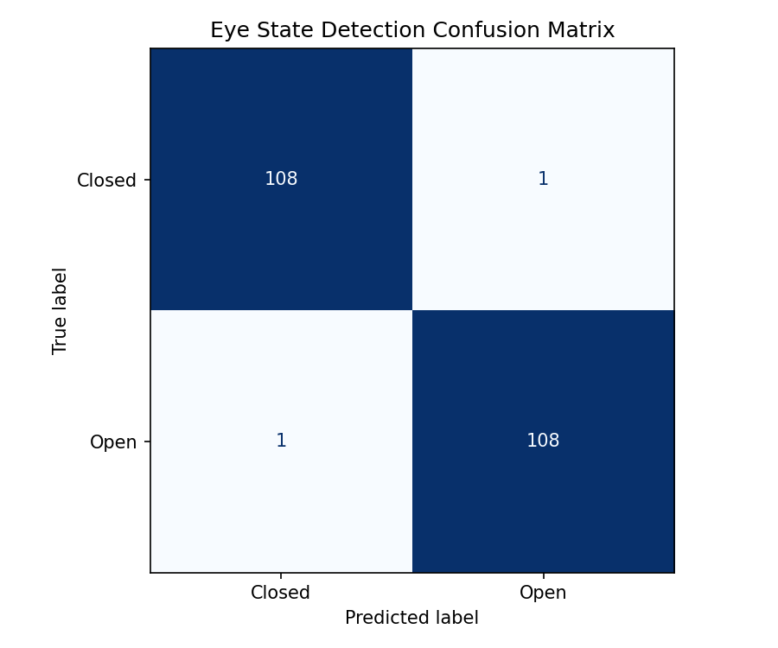
Figure 8.1: Confusion matrix for the eye-state model on the held-out test set.
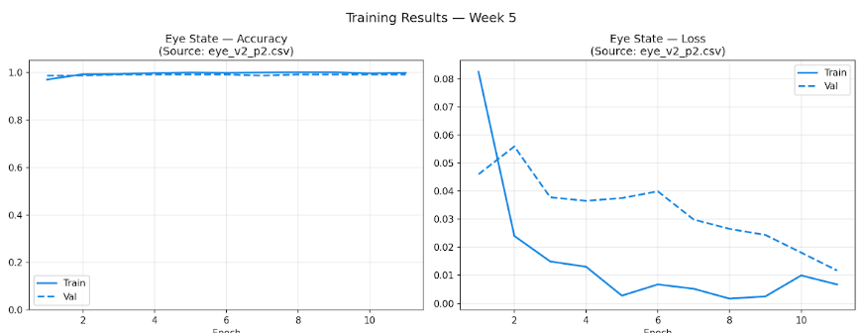
Figure 8.2: Training and validation accuracy/loss curves for the eye-state model, showing rapid convergence within the first few epochs of fine-tuning.
Yawn Detection Model (yawn vs. no_yawn)
On the same-sized test set (109 yawn, 109 no_yawn), the yawn-detection model classified 197 of 218 correctly, giving a test accuracy of 90.37%. Precision on the yawn class was 0.9889 with recall of 0.8165 (F1 = 0.8945); precision on the no_yawn class was 0.8438 with recall of 0.9908 (F1 = 0.9114).
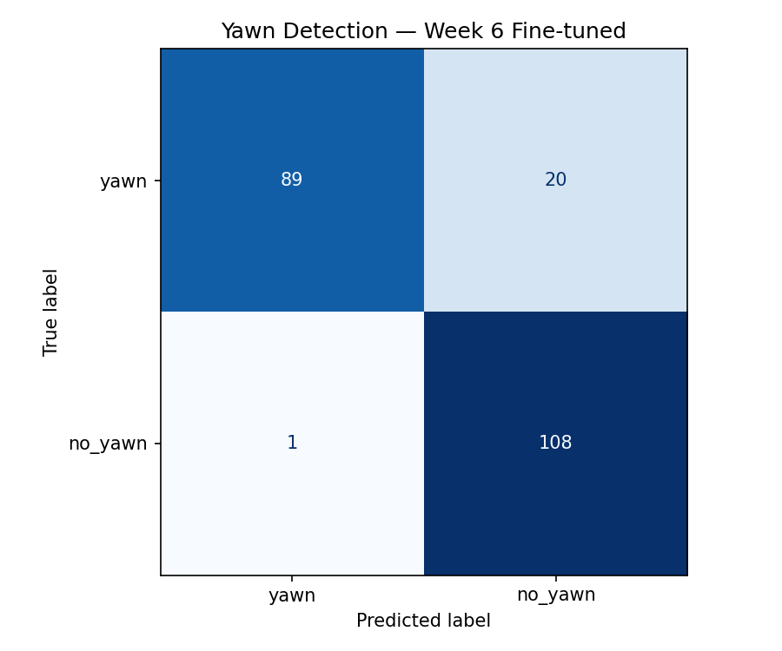
Figure 8.3: Confusion matrix for the fine-tuned yawn-detection model.
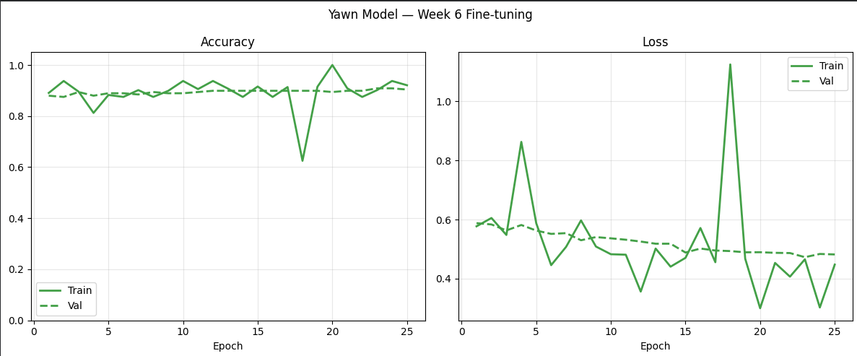
Figure 8.4: Training and validation accuracy/loss curves for the yawn-detection model during the extended fine-tuning phase (50 layers unfrozen, learning rate 3e-5).
Two things stand out in the yawn model's result. First, its precision on the yawn class is much higher than its recall — when it predicts “yawn,” it is almost always correct, but it misses roughly 18% of actual yawns, classifying them as no_yawn instead. Second, comparing this to the pre-fine-tuning baseline of 88.99%, the extended fine-tuning described in Section 6.2 produced a genuine 1.4-point improvement rather than run-to-run noise.

8.3 COMPARATIVE GRAPHICAL ANALYSIS
EAR / MAR Threshold Validation
Before real-time deployment, the EAR/MAR threshold logic described in Section 4.4 was validated against a simulated 100-frame sequence, confirming that the drowsy and yawning zones trigger correctly as the values cross each threshold.
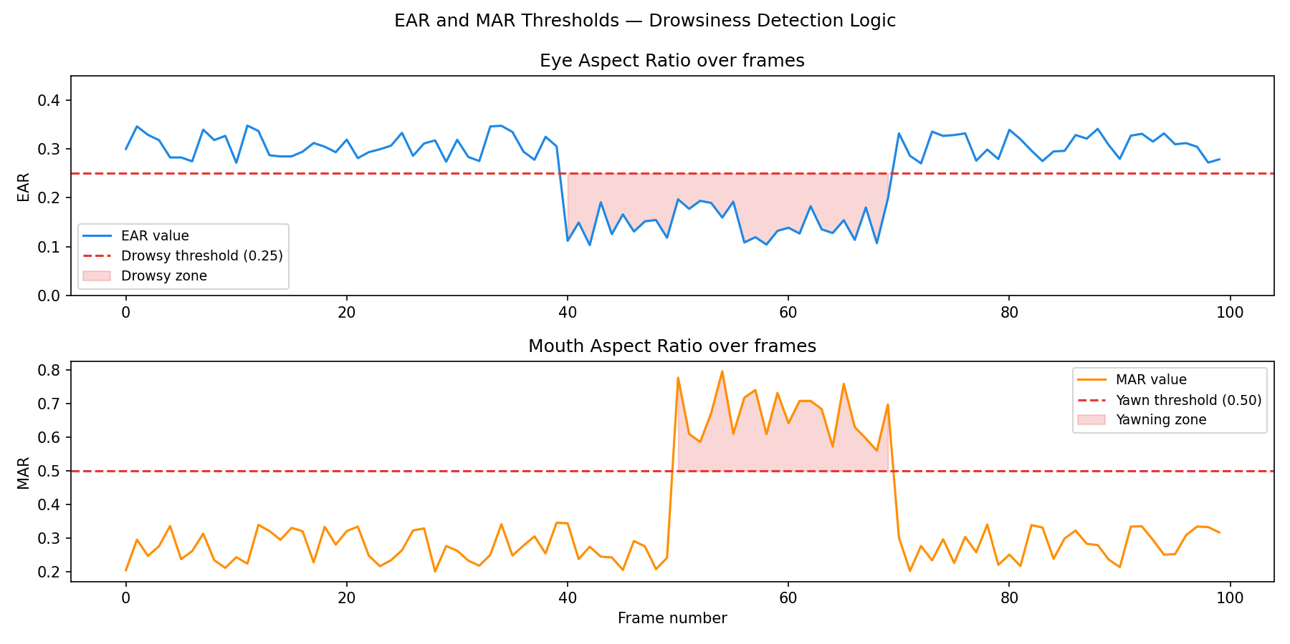
Figure 8.5: Simulated EAR and MAR values across 100 frames, used to validate the threshold logic prior to real-time deployment.
Comparison with Reviewed Literature
System | Accuracy | Deployable Interface? | Continuous Score?
Prerana et al. (EAR-only) | ~91% | No | No
Espinosa et al. (CNN+MAR, embedded) | 97.44% | Hardware-specific | No
Sanchez-Gendriz et al. (personalised) | 94% | No | No
Rosero-Montalvo et al. (MediaPipe+MobileNetV2) | 88.89% | No | No
Castro-Ospina et al. (ResNet50V2) | 99.71% | No | No
Jarndal et al. (Vision Transformer) | 99.15% | No | No
This project — Eye model | 99.08% | Yes | Yes
This project — Yawn model | 90.37% | Yes | Yes
This project's raw accuracy figures sit comfortably within the range reported across the reviewed literature — not the single highest number, but competitive, while being the only system in this comparison set that combines both classification tasks into a fused, continuously-scored, real-time deployable application.

9. CONCLUSION
9.1 THE OUTCOMES
This project set out to build a real-time driver drowsiness detection system and, in the process, uncovered and resolved a data problem that a more direct approach would have missed entirely — that the source dataset spans two incompatible visual domains requiring two separate models rather than one four-class classifier. The resulting system combines transfer-learning-based CNNs (99.08% eye-state accuracy, 90.37% yawn-detection accuracy) with classical facial geometry into a single fused drowsiness score, deployed as a working real-time application rather than a notebook-bound experiment, addressing the specific gap identified in the six papers reviewed in Chapter 2.
Beyond the modelling work itself, the project also produced a documented, reusable solution to a common deployment problem — the TensorFlow/Keras model-serialisation mismatch described in Section 7.4 — which is likely to be useful in any future project that trains models on Google Colab and later runs them locally.
9.2 CHALLENGES
- Diagnosing why an initial single four-class model performed close to random chance, which required recognising that the dataset actually contains two unrelated visual domains.
- Correcting a data-loading path error that silently caused multiple early training runs to use incorrect or empty data.
- Tuning the yawn-detection model past its initial plateau, which required a deeper and more careful fine-tuning pass than the eye-state model needed.
- Resolving a MediaPipe API version incompatibility when moving from the tutorials used during initial development to the currently available package version.
- Resolving a TensorFlow/Keras model-serialisation mismatch between the Colab training environment and the local execution environment.
- Reliably identifying the correct camera source on a machine with more than one available video input device.
- Balancing real-time performance against model accuracy, given the project's constraint of running on ordinary CPU hardware without a dedicated GPU at inference time.

10. FUTURE SCOPE
Several directions remain open beyond the current scope of this project:
- Web dashboard: wrapping the existing pipeline in a Streamlit interface with a live score gauge and session event log, running locally first, with public cloud deployment as a stretch goal using streamlit-webrtc, since a cloud server has no camera of its own to read from directly and requires the browser to stream the user's webcam to the server instead.
- Personalised calibration: a short per-user calibration step at session start to set individual EAR/MAR baselines instead of the fixed thresholds used currently, addressing a limitation shared with several of the papers reviewed in Chapter 2.
- Broader validation: testing across a wider range of users, lighting conditions, and camera hardware than was feasible within this project's nine-week timeline.
- Yawn model improvement: exploring alternate architectures such as EfficientNetB0, or additional training data specific to the yawn-detection task, which remains the larger of the two accuracy gaps.
- Session analytics: logging drowsy events with timestamps and visualising them over the course of a driving session, to give a driver or fleet operator a record of when and how often drowsiness occurred.

11. REFERENCES
[1] Prerana et al., “Real-Time Drowsiness Detection Using Eye Aspect Ratio and Facial Landmark Detection,” arXiv:2408.05836, 2024.
[2] Espinosa et al., “A Real-Time Embedded System for Driver Drowsiness Detection Based on Visual Analysis of the Eyes and Mouth Using CNN and MAR,” PMC, 2024.
[3] Sanchez-Gendriz et al., “Improving Driver Drowsiness Detection via Personalized EAR/MAR Thresholds and CNN-Based Classification,” arXiv:2604.22479, 2025.
[4] Rosero-Montalvo et al., “Driver Monitoring System Using Computer Vision for Real-Time Detection of Fatigue, Distraction and Emotion via Facial Landmarks and Deep Learning,” Sensors / PMC, 2026.
[5] Castro-Ospina et al., “A CNN-Based Approach for Driver Drowsiness Detection by Real-Time Eye State Identification,” Applied Sciences, MDPI, 2023.
[6] Jarndal et al., “Real-Time Driver Drowsiness Detection Using Transformer Architectures,” Scientific Reports / Nature, 2025.
[7] dheerajperumandla, “Drowsiness Dataset,” Kaggle. Available: kaggle.com/datasets/dheerajperumandla/drowsiness-dataset.

