NEXORA
AN AGENTIC AI PLATFORM FOR PERSONALIZED MOCK INTERVIEW AND ASSESSMENT PREPARATION
MINOR PROJECT DOCUMENTATION
Submitted in partial fulfilment of the requirements for the degree of\nBachelor of Technology in Computer Science and Engineering
Submitted by\nNimit Gupta (10323210072)\nLovleen (10323210118)\nHirendra (10323210117)\n\nUnder the supervision of\nMrs. Preeti, Assistant Professor\n\nDepartment of Computer Science & Engineering\nSRM University Delhi-NCR\nAcademic Year 2026-27

CERTIFICATE
This is to certify that the Minor Project titled “Nexora: An Agentic AI Platform for Personalized Mock Interview and Assessment Preparation” has been carried out by the students named on the title page under the supervision of Mrs. Preeti, Assistant Professor, Department of Computer Science & Engineering.

DECLARATION
We declare that this documentation describes our project work. The technical details are based on the supplied synopsis, presentation and source repository; external sources are acknowledged in the references.

ACKNOWLEDGEMENT
We thank our supervisor and the Department of Computer Science & Engineering for their guidance and support.

ABSTRACT
Nexora is an agentic AI platform for personalized technical-interview preparation. It accepts a PDF/DOCX resume, builds a candidate profile, retrieves relevant context and generates adaptive questions. Answer evaluation provides diagnostic metrics that influence subsequent difficulty and a final study roadmap. The backend uses FastAPI, typed schemas, service modules and LangGraph workflows for resume parsing, question generation, evaluation, roadmap creation and research. MongoDB, Redis/ARQ, vector retrieval and object-storage abstractions support persistence and background processing. The current scope is text-based software-engineering interviews; voice, OCR, a doubt-solving chatbot and behavioral-only tracks are future work.

TABLE OF CONTENTS
Update this field in Microsoft Word using References → Update Table.

LIST OF FIGURES
Figure 1. Resume parse workflow\nFigure 2. Interview/question-generation workflow\nFigure 3. Roadmap-generation workflow

CHAPTER 1: INTRODUCTION

1.1 Background
Static question banks and fixed courses do not account for a candidate’s resume, projects, target role or weak areas. Nexora connects resume ingestion, retrieval, adaptive questioning, evaluation and study planning in one closed-loop system.

1.2 Problem Statement
Candidates preparing for the same role can have very different needs, but conventional systems often expose them to identical questions and difficulty. Human-mediated practice introduces scheduling and cost constraints. The project addresses the need for resume-grounded questions, live adaptation, diagnostic feedback and an actionable roadmap.

1.3 Objectives
- Parse PDF/DOCX resumes into structured profiles.
- Generate RAG-grounded questions for the candidate and target role.
- Evaluate answers and adapt difficulty in real time.
- Convert weaknesses into a prioritized study roadmap.
- Keep agent capabilities modular and independently testable.

1.4 Scope and Limitations
The current implementation covers text-based software-engineering interviews, resume ingestion, RAG-oriented generation, evaluation, roadmap creation and company/topic research. Voice, OCR, a general chatbot and behavioral-only tracks are outside scope. Results depend on resume quality, retrieval coverage and external LLM quality, latency and cost.

CHAPTER 2: LITERATURE REVIEW

2.1 Existing Approaches
Approach | Strength | Limitation
Question banks | Curated practice | Fixed and not resume-grounded
Human interviews | Conversational depth | Scheduling and cost
Fixed curricula | Structured learning | Same path for many learners
Nexora | Grounding, adaptation, roadmap | Depends on LLM/retrieval quality

2.2 RAG and Agentic Systems
RAG combines document loading, chunking, embeddings, vector storage and retrieval before generation. Agentic workflows separate responsibilities and coordinate stateful steps, making the system more inspectable and testable.

CHAPTER 3: METHODOLOGY

3.1 Technology Stack
Layer | Components
API | Python, FastAPI, Pydantic
Orchestration | LangGraph and LangChain utilities
Persistence | MongoDB and workflow state
Async jobs | Redis and ARQ
Retrieval | Embeddings and vector store/Qdrant-oriented services
Storage | S3, Cloudinary and R2 abstractions
Testing | Pytest unit, integration and E2E suites
Deployment | Docker Compose

3.2 Five-Agent Pipeline
Resume Parse builds the candidate profile and index; Question Generation creates role- and skill-aware questions; Evaluation scores answers; Roadmap converts gaps to a study plan; Research retrieves company/topic context. The loop is Resume → Profile → Question → Answer → Evaluation → Roadmap → Practice.

CHAPTER 4: SYSTEM DESIGN

4.1 Architecture
The API layer exposes authenticated REST routes. The orchestration layer runs agentic graphs. The data layer stores users, resumes, sessions, roadmaps, checkpoints, vectors and artifacts. Background workers handle expensive processing.

4.2 Workflow Figures
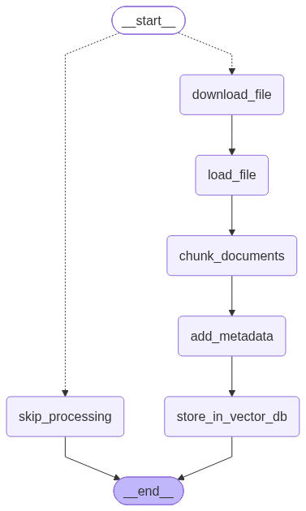
Figure 1: Resume parse workflow
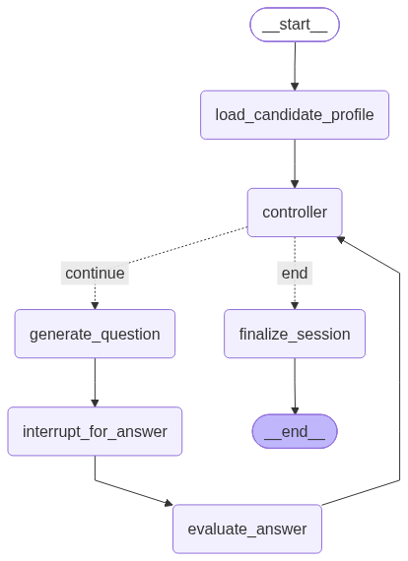
Figure 2: Interview question-generation workflow
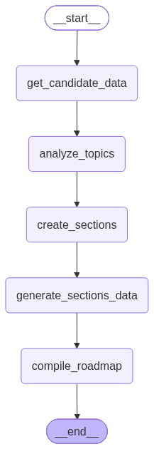
Figure 3: Roadmap generation workflow

4.3 API Design
Resource | Representative routes | Purpose
Auth | POST /api/v1/auth/register, /login, /refresh | Authentication
Resumes | POST/GET /api/v1/resumes | Upload and inspect resumes
Interviews | POST /api/v1/interviews; POST /{uuid}/answer | Run sessions
Roadmaps | POST/GET /api/v1/roadmaps | Create and retrieve plans
Health | GET /api/v1/healthz | Liveness

CHAPTER 5: IMPLEMENTATION

5.1 Repository Structure
The server contains app for API, configuration, database and services; Agentic_wf for agents, graphs and utilities; and tests for unit, integration and end-to-end behavior. Docker Compose, a Dockerfile and pyproject.toml describe execution and dependencies.

5.2 Workflow Nodes
Workflow | Stages
Resume parse | download_file → load_file → chunk → metadata → vector store
Interview | load profile → controller → generate → answer interrupt → evaluate → finalize
Roadmap | candidate data → analyze topics → create sections → compile

5.3 Deployment
The documented startup path uses Docker Compose with environment configuration in the server directory. FastAPI exposes Swagger UI at /docs in development.

CHAPTER 6: TESTING AND RESULTS

6.1 Strategy
The repository contains import checks, unit tests for graph builders and utilities, integration tests for workflow execution and an end-to-end interview-session test.
Level | Focus | Repository evidence
Unit | Nodes, parsers, metrics and routing | server/tests/unit
Integration | Agent workflow execution | server/tests/integration
E2E | Interview lifecycle | server/tests/e2e
Smoke | Imports and application startup | server/tests

6.2 Functional Test Cases
ID | Case | Expected result
TC-01 | Register/login | Protected API access works
TC-02 | Upload resume | Accepted and processed asynchronously
TC-03 | Start interview | Session and first question returned
TC-04 | Submit answer | Next question or summary returned
TC-05 | Generate roadmap | Weak topics become study sections
TC-06 | Unauthorized resource access | Ownership check rejects request

6.3 Results and Limitations
The supplied materials include test organization and workflow graph artifacts but no consolidated coverage report, benchmark dataset or measured accuracy/latency results. This report therefore records implemented evidence without inventing percentages. Final submission should add Swagger screenshots, running-application screenshots, representative outputs and measured evaluation results.

CHAPTER 7: CONCLUSION AND FUTURE WORK

7.1 Conclusion
Nexora connects resume understanding, retrieved context, adaptive interviewing, diagnostic evaluation and roadmap generation. Its modular FastAPI and LangGraph design supports inspection, testing and future extension.

7.2 Future Work
- RAG-based doubt-solving assistant.
- OCR for notes, diagrams and whiteboards.
- Voice interviews and speech-aware evaluation.
- Broader company, system-design and behavioral simulations.
- Human evaluation and benchmarks for relevance, fairness, adaptation, latency and cost.

REFERENCES
[1] LeetCode, https://leetcode.com/.
[2] HackerRank, https://www.hackerrank.com/.
[3] Pramp, https://www.pramp.com/.
[4] Interviewing.io, https://interviewing.io/.
[5] LangGraph Documentation, https://langchain-ai.github.io/langgraph/.
[6] FastAPI Documentation, https://fastapi.tiangolo.com/.
[7] Qdrant Documentation, https://qdrant.tech/documentation/.
[8] Project synopsis, presentation and source repository supplied by the authors, 2026.

