A
SYNOPSIS REPORT
On
NEXORA: AN AGENTIC AI PLATFORM FOR PERSONALIZED MOCK INTERVIEW AND ASSESSMENT PREPARATION
Submitted in partial fulfilment of the requirements of the degree of
Bachelor of Technology
In
COMPUTER SCIENCE AND ENGINEERING

Submitted by
Nimit Gupta (10323210072)
Lovleen (10323210118)
Hirendra (10323210117)
Under Supervision of
Mrs. Preeti
Assistant Professor
Department of Computer Science & Engineering
Faculty of Engineering and Technology
SRM University Delhi-NCR
39, Rajiv Gandhi Education City, Sonepat, Haryana – 131029
OCTOBER 2026

1. Group Name, Details and Title of the Project
Title of the Project: Nexora: An Agentic AI Platform for Personalized Mock Interview and Assessment Preparation
Group No.: 174 Supervisor: Mrs. Preeti, Assistant Professor
Name (Role) | Enrolment No. | Branch / Sem | College Email ID
Nimit Gupta (Agentic AI) | 10323210072 | CSE / 7th | 10323210072@stu.srmuniversity.ac.in
Lovleen (Backend) | 10323210118 | CSE / 7th | 10323210118@stu.srmuniversity.ac.in
Hirendra (Frontend) | 10323210117 | CSE / 7th | 10323210117@stu.srmuniversity.ac.in
Alternative titles: AI-Powered Personalized Interview Preparation Platform; Resume-Grounded Adaptive Mock Interview System.
2. Problem Statement
Candidates preparing for technical interviews and online assessments mostly rely on static, one-size-fits-all resources: fixed question banks, generic mock tests and pre-recorded courses. Two candidates targeting the same role at the same company start from different resumes, projects, strengths and weak areas, yet most platforms serve both the same questions in the same order.
Existing tools fall into three groups, each with a gap. Question-bank platforms such as LeetCode, HackerRank and CodeSignal [1]–[3] offer well-curated problems, but the sets are fixed: they are not generated from the candidate’s resume or target role, and difficulty does not adapt within a session. Human-mediated platforms such as Pramp and Interviewing.io [4], [5] give real conversational depth, but bring scheduling friction, dependence on peer availability and, for professional interviewers, a per-session fee. Curriculum-based platforms such as Big Interview [6] deliver a course that is authored once and delivered identically to every learner.
What is missing is a closed-loop system that reads the candidate’s actual resume, generates questions grounded in that profile and the target role, adapts difficulty to live performance, and converts the outcome into a prioritized study roadmap instead of a bare pass/fail verdict. Nexora is motivated by this specific, well-scoped gap.
3. Objective and Scope of the Project
Objective: to design and build Nexora, an agentic multi-agent platform that turns a candidate’s resume and target role into a personalized, adaptive mock interview and a prioritized study roadmap. Specifically, the project aims to:
- parse a PDF/DOCX resume into a structured candidate profile (skills, experience, projects);
- generate interview and assessment questions grounded in that profile and the target role using retrieval-augmented generation (RAG);
- evaluate every answer with quantified, diagnostic metrics and adjust question difficulty in real time;
- convert the pattern of identified weaknesses into a personalized, prioritized study roadmap;
- implement the system as modular, independently testable agents rather than one monolithic prompt.
Final outcome and benefit to the end user: the candidate uploads a resume, takes an adaptive mock session on demand, and receives a concrete roadmap of what to study next, so no two candidates preparing for the same role are given the same preparation path.
Scope: resume ingestion (PDF/DOCX); text-based mock interviews and assessments for software-engineering roles; live adaptive difficulty; RAG-grounded question generation using the candidate’s profile, prior answers and company/domain context; automatic roadmap generation; and a research agent for company- and topic-specific retrieval.
Out of scope (current version): voice-based interviews, OCR of handwritten or whiteboard input, a doubt-solving RAG chatbot, and behavioural-only tracks (see Section 6).
4. Methodology
Nexora is a multi-agent system coordinated through agentic workflow graphs built with LangGraph [7], [8], rather than a single LLM call that parses, questions, evaluates and plans together. Each capability is a separately testable, independently improvable agent, and the agents cooperate through structured workflows.
4.1 System Architecture
The system has three layers. The API Layer uses FastAPI [9] with separate routers, Pydantic schemas and core configuration. The Orchestration Layer runs the LangGraph workflows that coordinate the agents. The Data & Storage Layer persists candidate profiles and session state in a database, and keeps resume files and generated artifacts in object storage (S3 / Cloudinary / R2). The core pipeline is a closed loop: Parse Resume → Generate Questions → Evaluate Answers → Build Roadmap, then back to practice.
4.2 The Five-Agent Pipeline
- Resume Parse Workflow – parses an uploaded resume and builds the structured candidate profile and its vector index.
- Question Generation Agent – produces questions around the candidate’s skills and target role, escalating or easing difficulty as the session proceeds.
- Evaluation Agent – scores each answer with diagnostic metrics and drives the real-time difficulty adjustment.
- Roadmap Agent – converts the gaps found by the Evaluation Agent into a prioritized, actionable study roadmap.
- Research Agent – retrieves company- and topic-specific context (e.g. a target company’s typical interview focus) for question generation.
4.3 Workflow Graphs (Process Description)
Figures 1–3 show the LangGraph workflows implemented for the three core stages of the pipeline. Solid arrows are fixed transitions; dotted arrows are conditional routes.
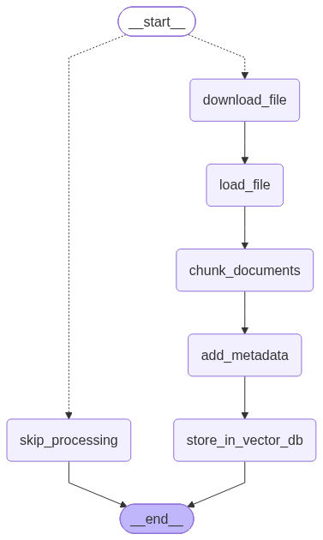 | 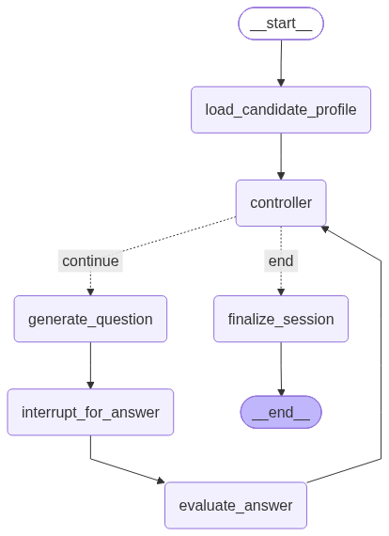 | 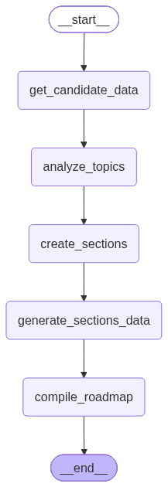
Fig. 1: Resume parse workflow | Fig. 2: Interview session workflow | Fig. 3: Roadmap generation workflow

- Fig. 1 (resume ingestion): a conditional entry point either skips processing or runs download_file → load_file → chunk_documents → add_metadata → store_in_vector_db. The resume is chunked, tagged with metadata and indexed in the vector store that later powers retrieval.
- Fig. 2 (interview session): load_candidate_profile feeds a controller node that routes each turn. On “continue” it runs generate_question → interrupt_for_answer (the graph pauses for the candidate’s answer) → evaluate_answer and returns to the controller; on “end” it runs finalize_session.
- Fig. 3 (roadmap): get_candidate_data → analyze_topics → create_sections → generate_sections_data → compile_roadmap, turning evaluation results into an ordered, sectioned study plan.
4.4 RAG-Grounded Question Generation
Question generation is grounded in retrieval rather than a bare prompt [10]. The pipeline follows the standard stages: Documents → Chunking → Embeddings → Vector Store → Retrieval, over the candidate’s parsed skills, prior answers in the session, and company/domain material from the Research Agent. The retrieved context is passed to the Question Generation Agent before each question, making questions specific to the candidate and less repetitive or hallucinated than with a fixed bank or an ungrounded prompt.
4.5 Real-Time Adaptive Difficulty and Resume-to-Roadmap Loop
Within a session, the Evaluation Agent scores each answer as it is submitted; the controller feeds this score back so the next question is harder when the candidate performs well and easier when they struggle. Scores accumulate into the Roadmap Agent’s input, giving the loop Resume → Candidate Profile → Evaluation Metrics → Study Roadmap → next practice session. Personalization is therefore structural to the pipeline, not a cosmetic layer on a shared question bank.
5. Hardware and Software to be Used (Resources and Limitations)
5.1 Software Resources
Layer | Technology
API Layer | Python, FastAPI (routers, Pydantic schemas, core configuration)
Orchestration | LangGraph (agentic workflow graphs, multi-agent coordination), LangChain
Retrieval / RAG | Embedding models and a vector store for chunked skills, prior answers and company/domain context
Data & Storage | Database for candidate profiles and session state; S3 / Cloudinary / R2 for resumes and artifacts
Resume Parsing | PDF/DOCX parsing libraries feeding the resume parse workflow
Frontend | Web interface for resume upload, live mock-interview sessions and roadmap display
Infrastructure | Cloud-native deployment with a CI/CD pipeline for automated testing and deployment
5.2 Hardware and Other Requirements
- Standard laptop/desktop with internet access; no specialised hardware, since LLM inference and storage are cloud-based.
- LLM API access (question generation, evaluation, roadmap), a vector database/embedding service, and an object-storage account.
5.3 Limitations
- Output quality depends on the external LLM’s accuracy, latency and API cost; automated answer scoring may occasionally be inaccurate.
- Personalization depends on resume-parsing quality and the coverage of retrieved company/domain context.
- The first version is text-only and limited to software-engineering roles; it cannot replicate the conversational nuance of a live human interviewer.
- Question relevance, adaptation accuracy and roadmap usefulness are still to be validated through user testing (planned in Week 15).
6. Application and Future Scope of the Project
Applications: Nexora gives students and job seekers on-demand, resume-specific interview practice at no per-session human cost, removing both the zero personalization of static question banks and the scheduling and cost bottleneck of human-interviewer platforms. It can also serve college placement cells and training institutes. To our knowledge from the platforms surveyed, none combines resume personalization, real-time adaptive difficulty and roadmap generation in one integrated, inspectable pipeline; the modular agent design also lets each capability be tested or swapped independently.
Future scope:
- RAG chatbot – a doubt-solving assistant grounded in the same retrieved context, for follow-up questions on feedback and roadmap.
- OCR processing – handwritten notes, diagrams and whiteboard-style problems as input.
- Voice-based interviews – spoken mock interviews for a more realistic simulation.
- Wider research agent and multi-round simulation – more companies and roles, and full technical, system-design and behavioural loops.
7. Project Timeline (Gantt Chart)
The project is planned over 16 weeks (indicative; to be finalised with the supervisor). Shaded cells mark the weeks in which each activity is carried out.
Activity \ Week | 1 | 2 | 3 | 4 | 5 | 6 | 7 | 8 | 9 | 10 | 11 | 12 | 13 | 14 | 15 | 16
Requirement finalisation and competitive study
API layer, database schema, LangGraph design
Resume parse workflow and profile extraction
RAG pipeline and Question Generation Agent
Evaluation Agent and adaptive difficulty loop
Roadmap and Research Agents; integration
Frontend development and end-to-end integration
Testing and evaluation (relevance, adaptation, roadmap)
Documentation and project demonstration
Conclusion
Nexora shows that interview preparation can be personalized end to end. Its main innovations are resume-grounded, RAG-based question generation; real-time difficulty adaptation driven by per-answer evaluation; automatic conversion of evaluation results into a prioritized study roadmap; and a modular LangGraph multi-agent architecture whose workflows are explicit and inspectable. Together these close the practice → evaluate → learn → practice loop that static question banks, human-interviewer platforms and fixed curricula leave open, which is what makes the system stand out.
8. References / Bibliography
[1] LeetCode, “LeetCode – Practice Coding Interview Questions,” [Online]. Available: https://leetcode.com/
[2] HackerRank, “HackerRank – Technical Skills Assessment and Interview Solutions,” [Online]. Available: https://www.hackerrank.com/
[3] CodeSignal, “CodeSignal – Technical Assessment and Interview Platform,” [Online]. Available: https://codesignal.com/
[4] Pramp, “Pramp – Free Peer-to-Peer Mock Interviews,” [Online]. Available: https://www.pramp.com/
[5] Interviewing.io, “Interviewing.io – Practice Interviews with Engineers from Top Companies,” [Online]. Available: https://interviewing.io/
[6] Big Interview, “Big Interview – Interview Training and Practice Platform,” [Online]. Available: https://biginterview.com/
[7] LangChain Inc., “LangGraph Documentation,” [Online]. Available: https://langchain-ai.github.io/langgraph/
[8] LangChain Inc., “LangChain Documentation,” [Online]. Available: https://www.langchain.com/
[9] FastAPI, “FastAPI Documentation,” [Online]. Available: https://fastapi.tiangolo.com/
[10] P. Lewis et al., “Retrieval-Augmented Generation for Knowledge-Intensive NLP Tasks,” in Advances in Neural Information Processing Systems (NeurIPS), vol. 33, 2020. [Online]. Available: https://arxiv.org/abs/2005.11401

