Project Management

* Project Planning

Project Goals

* Software Development Life Cycle (SDLC)

- SDLC includes 6 phases which are as follow:

1. Requirement gathering and analysis:

Requirement was to create an ONLINE EXMINATION SYSTEM which will assists the applicant. During analysis phase we found manual system in which users are maintaining books to store the information like Student Details, Instructor Details, Schedule Details and feedbacks about students who attempted exam as per schedule.

1. Design:

Here, layout designing, and database designing are prepared which represents entire structure of the system. HTML, CSS, Bootstrap components are used for layout designing and MySQL is used for database designing.

1. Implementation or coding:

This is the longest phase of SDLC. Work is divided into small units like student, faculty and admin. For implementation PHP (front-end) and MySQL (back-end) is used.

1. Testing:

Modules which are created in 3rd phase are tested to find out error likely to occur and to see whether the requirements are fulfilled or not. Various type of testing is done like unit testing, integration testing, system testing and acceptance testing.

1. Deployment:

After successful testing the product is delivered to the institutes for their use.

1. Maintenance:

Once the user starts using developed system after sometimes some problems may arise so to solve that maintenance is required.

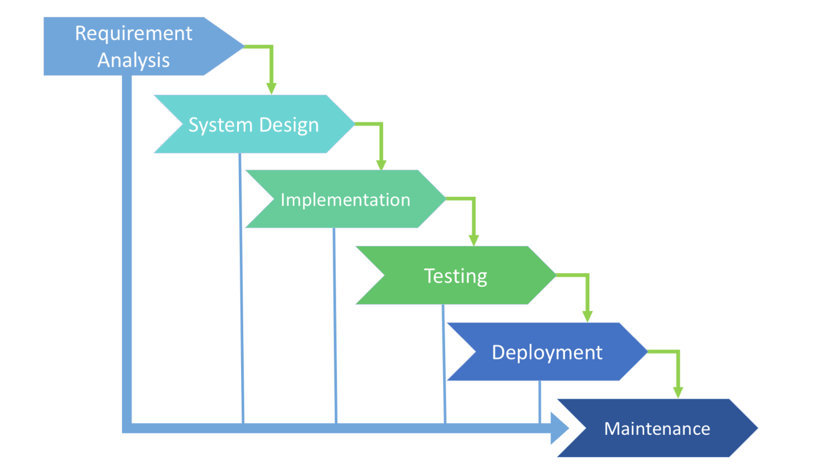

* Project scheduling

|  |  |  |  |  |
| --- | --- | --- | --- | --- |
| Index | Task Name | Start | Finish | Duration |
|  |  |  |  |  |
|  |  |  |  |  |
| 1. | Requirement | 8th February,2016 | 24th | 17 Days |
|  | gathering & |  | February,2016 |  |
|  | Analysis |  |  |  |
|  |  |  |  |  |
| 2. | Rough layout | 25th | 11th March,2016 | 18 Days |
|  | design | February,2016 |  |  |
|  |  |  |  |  |
| 3. | Detail design | 12th March,2016 | 27th March,2016 | 16 Days |
|  |  |  |  |  |
| 4. | Coding | 28th March,2016 | 20th April,2016 | 24 Days |
|  |  |  |  |  |
| 5. | Testing | 21st April,2016 | 25th April,2016 | 5 Days |
|  |  |  |  |  |