SYSTEM DESIGN

* Data Flow Diagram

A DFD is a graphical representation of the system. It is used by the system analyst to explain the flow of the data in the system. The following is the description of the elements.



Process:

Entity:



Dataflow:



Table :

**Level: 0**

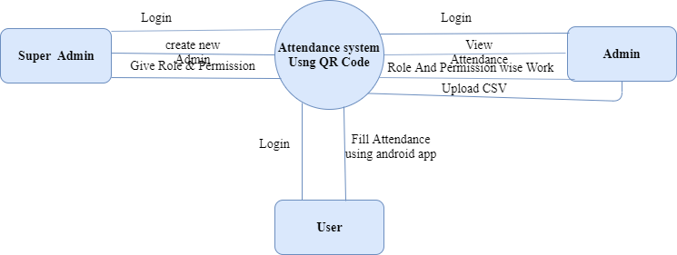

**Level 1: Admin**

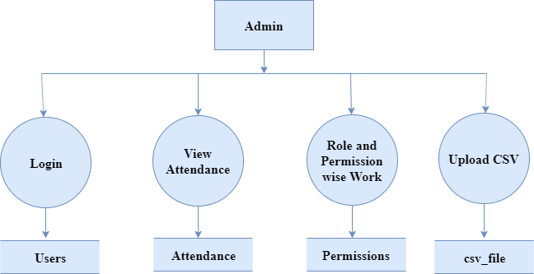

**Level 1 : Super Admin**

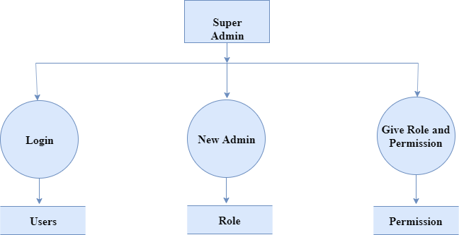

**Level : 1 User**

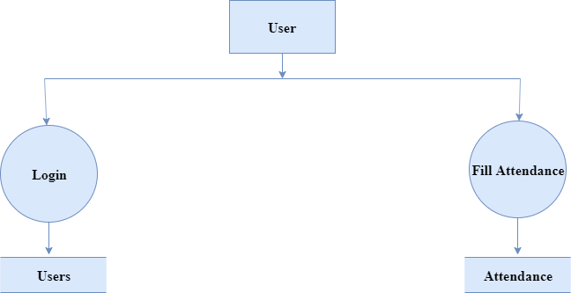

* E- R Diagram

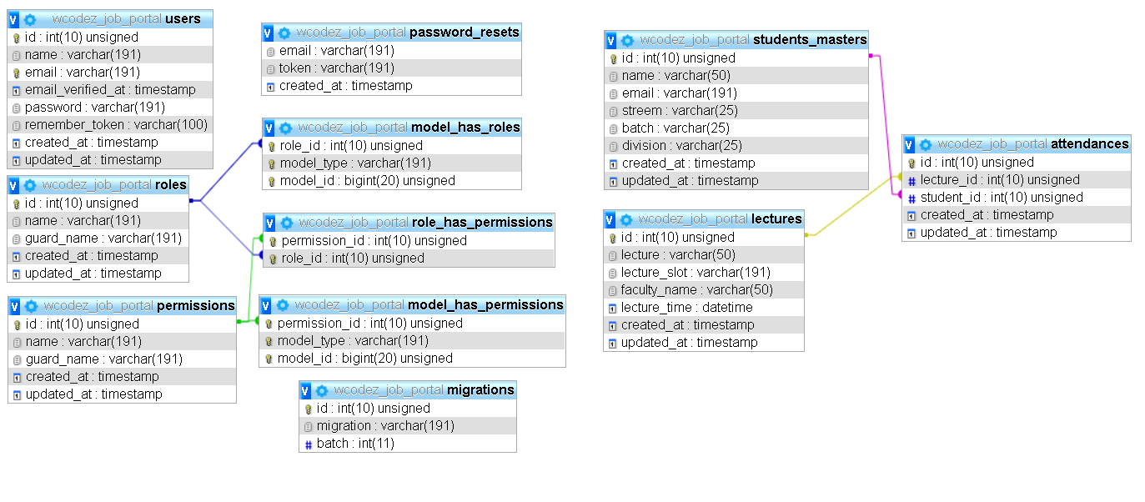

* Data – Dictionary

1. Attendance

|  |  |  |  |
| --- | --- | --- | --- |
| Column | **Type** | **Null** | **Default** |
| ***id*** | int(10) | No |  |
| lecture_id | int(10) | No |  |
| student_id | int(10) | No |  |
| created_at | timestamp | Yes | NULL |
| updated_at | timestamp | Yes | NULL |

1. Lectures

|  |  |  |  |
| --- | --- | --- | --- |
| Column | **Type** | **Null** | **Default** |
| ***id*** | int(10) | No |  |
| lecture | varchar(50) | No |  |
| lecture_slot | varchar(191) | No |  |
| faculty_name | varchar(50) | No |  |
| lecture_time | datetime | No |  |
| created_at | timestamp | Yes | NULL |
| updated_at | timestamp | Yes | NULL |

1. model_has_permissions

|  |  |  |  |
| --- | --- | --- | --- |
| Column | **Type** | **Null** | **Default** |
| ***permission_id*** | int(10) | No |  |
| ***model_type*** | varchar(191) | No |  |
| ***model_id*** | bigint(20) | No |  |

1. model_has_roles

|  |  |  |  |
| --- | --- | --- | --- |
| Column | **Type** | **Null** | **Default** |
| ***role_id*** | int(10) | No |  |
| ***model_type*** | varchar(191) | No |  |
| ***model_id*** | bigint(20) | No |  |

1. password_resets

|  |  |  |  |
| --- | --- | --- | --- |
| Column | **Type** | **Null** | **Default** |
| email | varchar(191) | No |  |
| token | varchar(191) | No |  |
| created_at | timestamp | Yes | NULL |

1. permissions

|  |  |  |  |
| --- | --- | --- | --- |
| Column | **Type** | **Null** | **Default** |
| ***id*** | int(10) | No |  |
| name | varchar(191) | No |  |
| guard_name | varchar(191) | No |  |
| created_at | timestamp | Yes | NULL |
| updated_at | timestamp | Yes | NULL |

1. roles

|  |  |  |  |
| --- | --- | --- | --- |
| Column | **Type** | **Null** | **Default** |
| ***id*** | int(10) | No |  |
| name | varchar(191) | No |  |
| guard_name | varchar(191) | No |  |
| created_at | timestamp | Yes | NULL |
| updated_at | timestamp | Yes | NULL |

1. role_has_permissions

|  |  |  |  |
| --- | --- | --- | --- |
| Column | **Type** | **Null** | **Default** |
| ***permission_id*** | int(10) | No |  |
| ***role_id*** | int(10) | No |  |

1. students_master

|  |  |  |  |
| --- | --- | --- | --- |
| Column | **Type** | **Null** | **Default** |
| ***id*** | int(10) | No |  |
| name | varchar(50) | No |  |
| email | varchar(191) | No |  |
| streem | varchar(25) | No |  |
| batch | varchar(25) | No |  |
| division | varchar(25) | No |  |
| created_at | timestamp | Yes | NULL |
| updated_at | timestamp | Yes | NULL |

1. users

|  |  |  |  |
| --- | --- | --- | --- |
| Column | **Type** | **Null** | **Default** |
| ***id*** | int(10) | No |  |
| name | varchar(191) | No |  |
| **email** | varchar(191) | No |  |
| email_verified_at | timestamp | Yes | NULL |
| password | varchar(191) | No |  |
| remember_token | varchar(100) | Yes | NULL |
| created_at | timestamp | Yes | NULL |
| updated_at | timestamp | Yes | NULL |