**Task 1:Write a Map Reduce program to filter out the invalid records. Map only job will fit for this context.**

The jar file - Assignment4Task1.jar is present in /home/acadgild

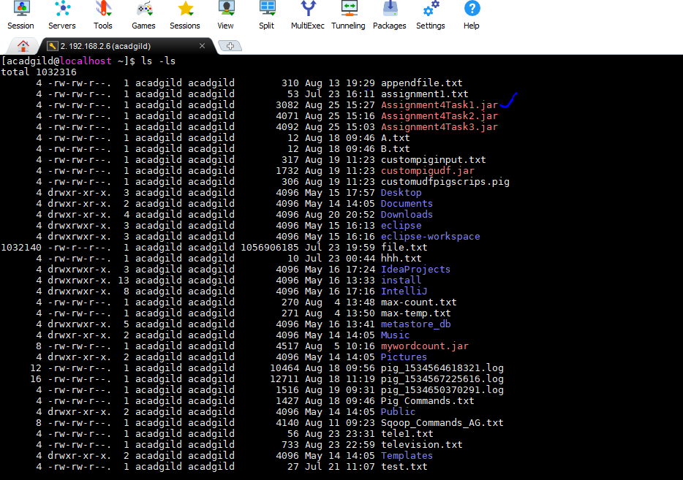

Input file location : /hadoopdata/hdfs/television.txt

Command to check the content of the input file

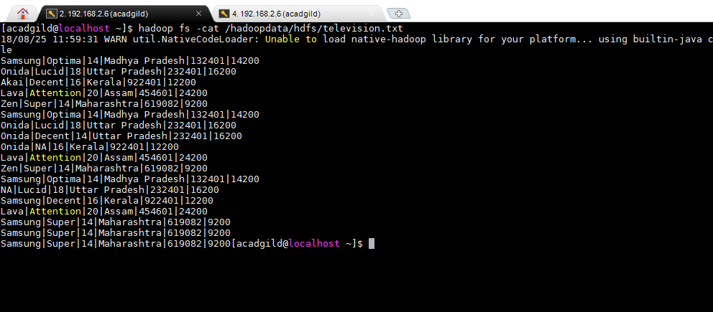

Output file location : /hadoopdata/hdfs/Task1Output.txt

To execute the program , run the following command

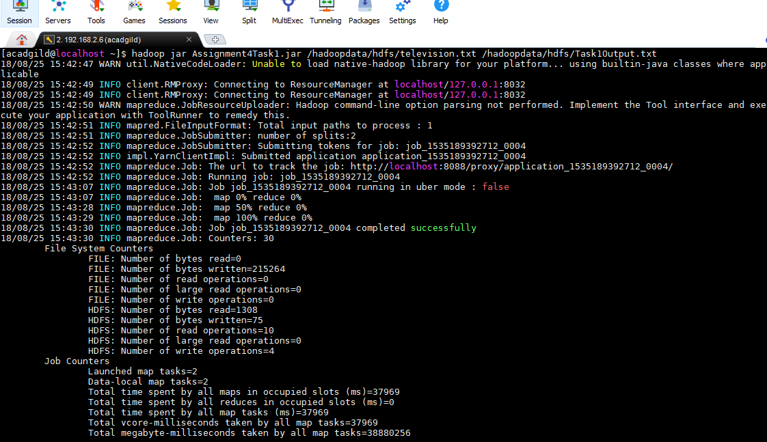

To check the output below command needs to be executed

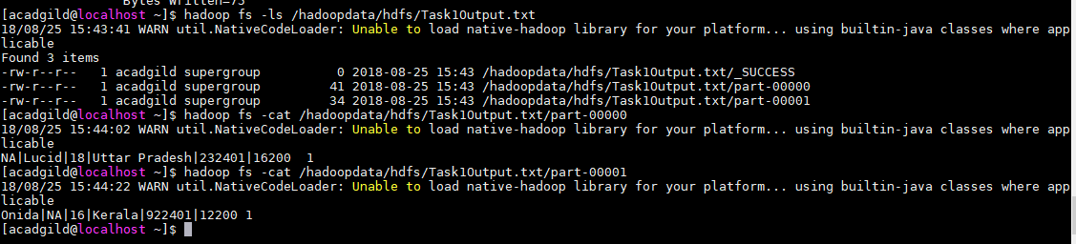

We can also check in explorer using ‘localhost:19888’ for the number of mappers and reducers used to execute the program by clicking on the corresponding job is

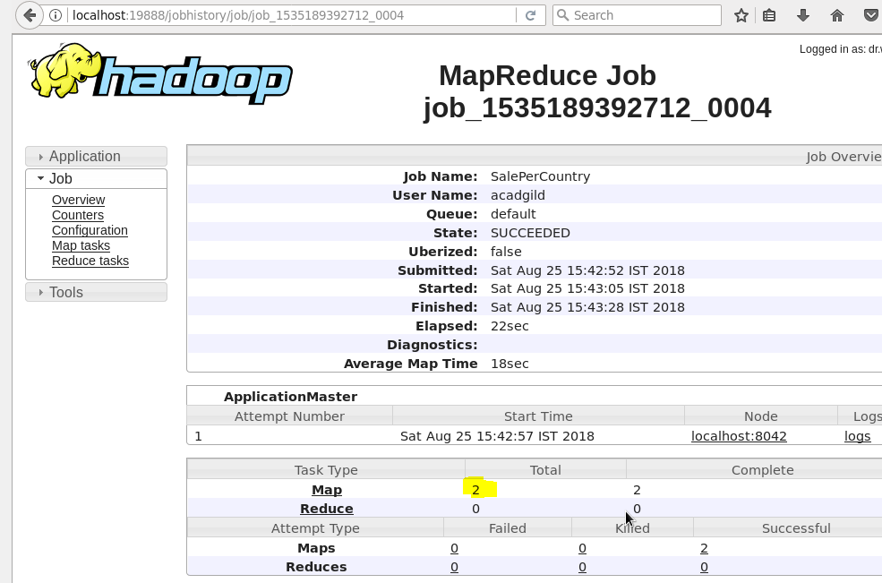

**Task 2: Write a Map Reduce program to calculate the total units sold for each Company.**

The jar file - Assignment4Task2.jar is present in /home/acadgild

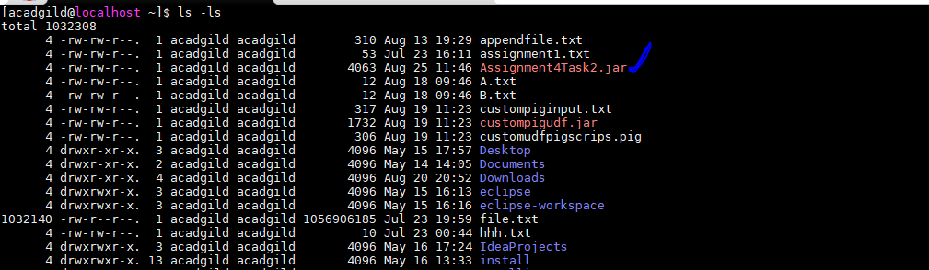

Input file location : /hadoopdata/hdfs/television.txt

Command to check the content of the input file



Output file location : /hadoopdata/hdfs/Task2Output.txt

To execute the program , run the following command

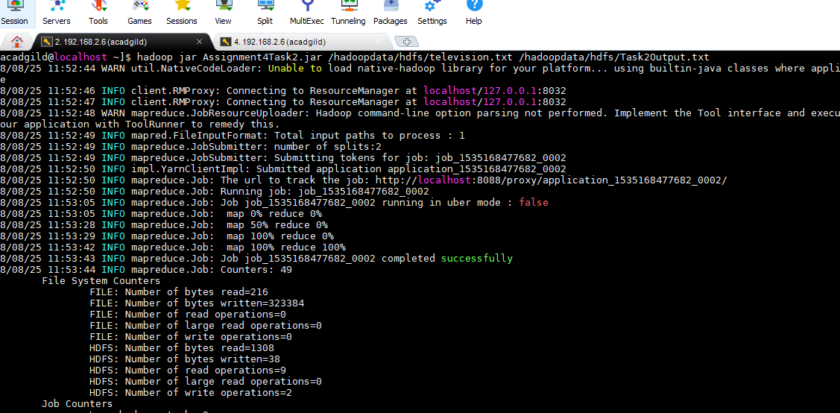

To check the output below command needs to be executed( **removed the invalid records- records which contain 'NA' in either Company Name or Product Name.)**

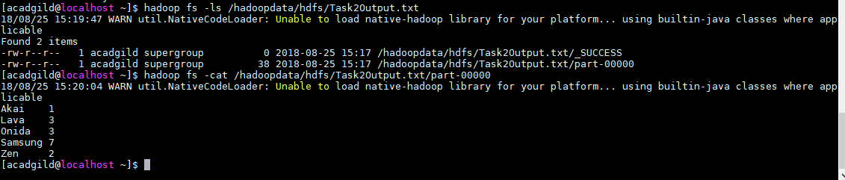

**Task 3: Write a Map Reduce program to calculate the total units sold in each state for Onida company.**

The jar file - Assignment4Task3.jar is present in /home/acadgild

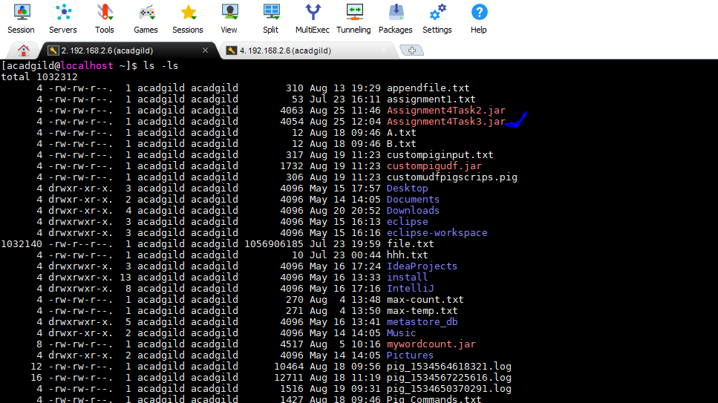

Input file location : /hadoopdata/hdfs/television.txt

Command to check the content of the input file



Output file location : /hadoopdata/hdfs/Task3Output.txt

To execute the program , run the following command

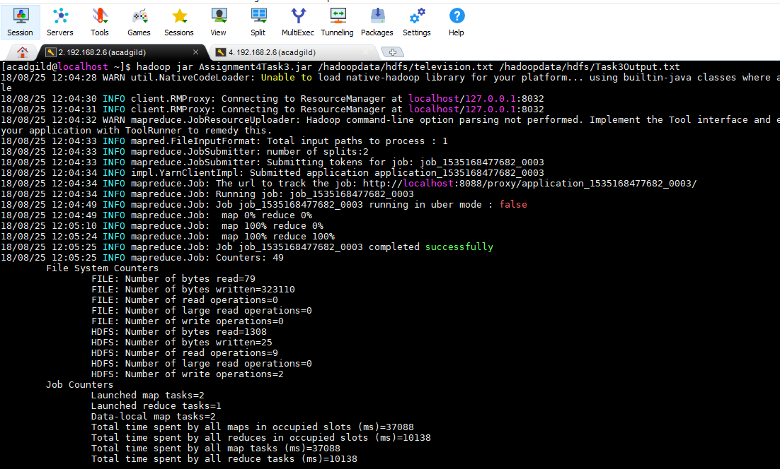

**To check the output – removed the invalid records(records which contain 'NA' in either Company Name or Product Name.**

