Input file : Present in location /hadoopdata/Assignments/musicdata.txt in HDFS

Command to read the file:

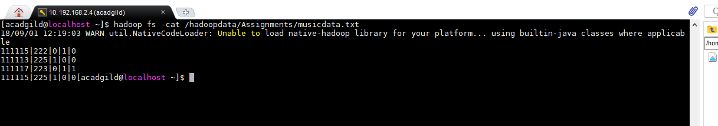

**Task 1: Find the number of unique listeners in the data set.**

The jar file – Assignment5Task1.jar is present in /home/acadgild

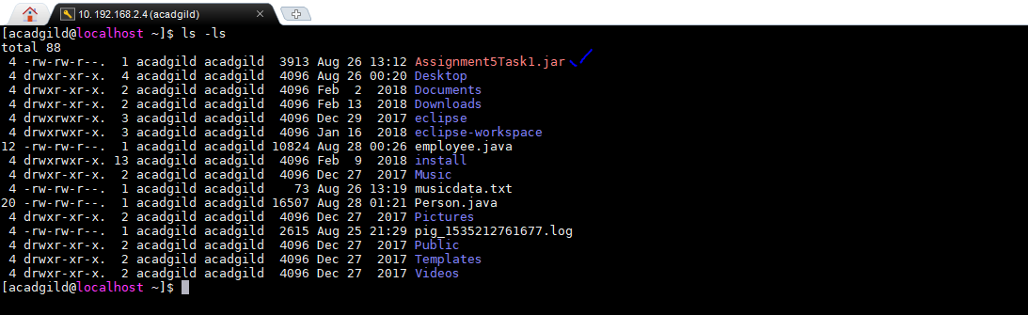

Output file location : /hadoopdata/Assignments/Ass5Task1.txt

To execute the program, run the following command

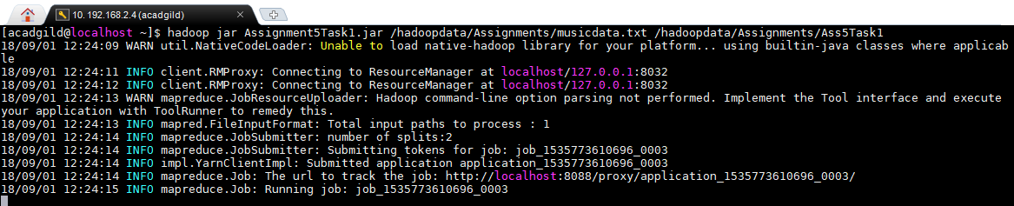

To check the output below command needs to be executed

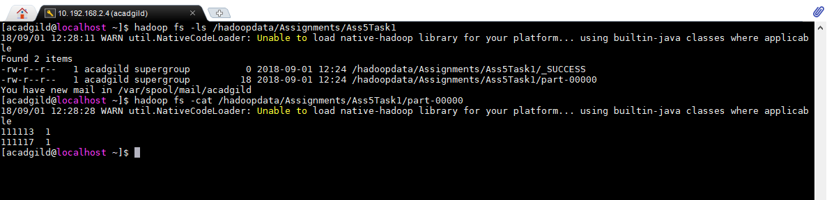

111113 and 111117 are the two unique listeners.

**Task 2: What are the number of times a song was heard fully.**

The jar file – Assignment5Task2.jar is present in /home/acadgild

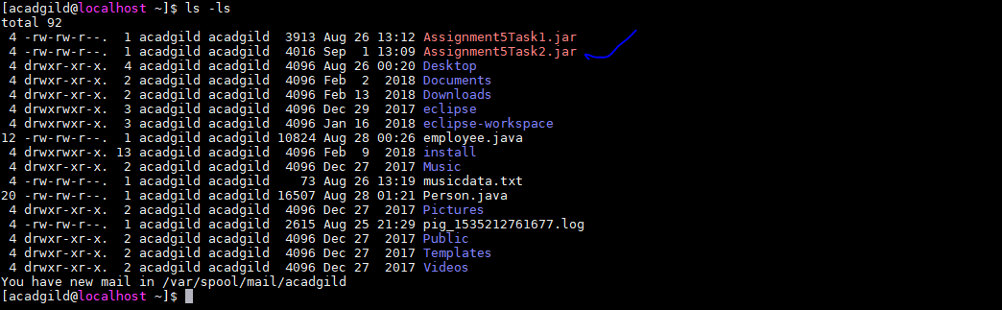

Output file location : /hadoopdata/Assignments/Ass5Task2.txt

To execute the program , run the following command

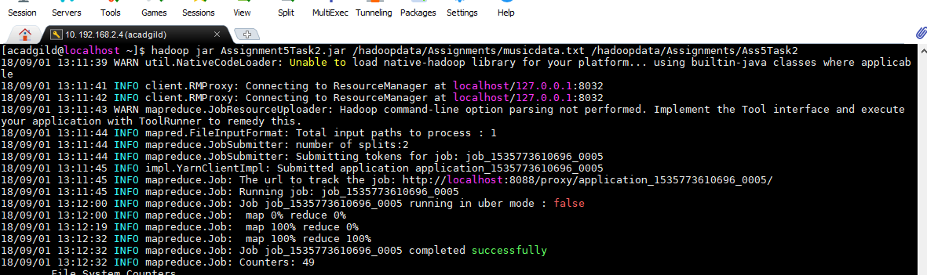

To check the output below command needs to be executed

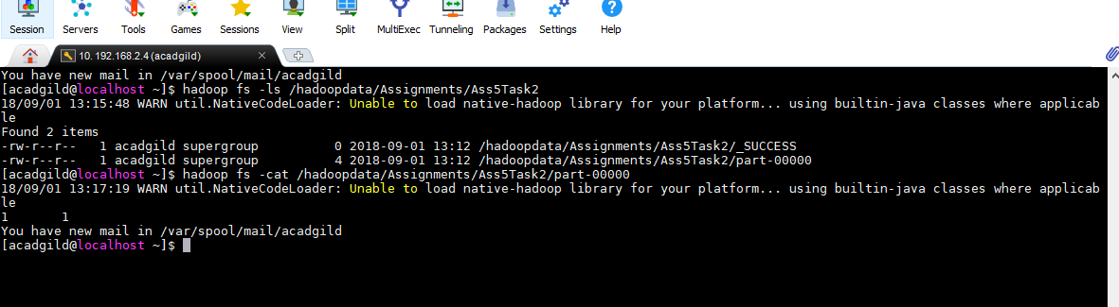

**The first value 1 shows the 5th column in the input file which shows “fully heard” option.**

**The second value 1 shows the number of times the song was fully heard**

**Task 3 : What are the number of times a song was shared.**

The jar file – Assignment5Task3.jar is present in /home/acadgild

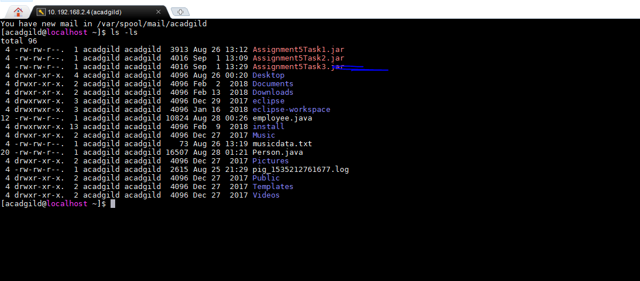

Output file location : /hadoopdata/Assignments/Ass5Task3.txt

To execute the program , run the following command

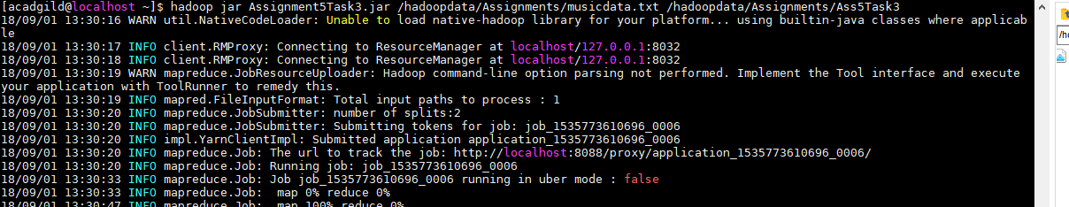

To check the output below command needs to be executed

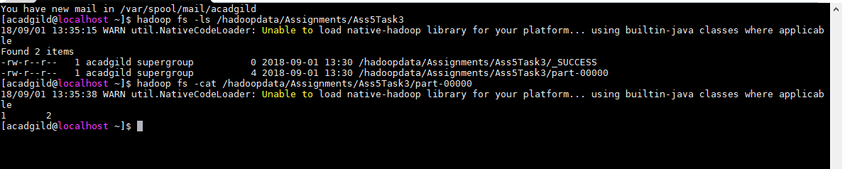

**The first value 1 shows the 3rd column in the input file which shows “song was shared” option.**

**The second value 2 shows the number of times the song was shared**