* Create Table Person and insert the rows as explained in Demo of Import Table

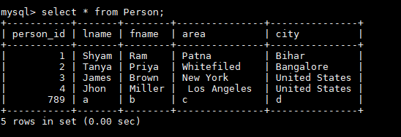

* Run the below command for importing the table from RDBMS to HDFS (to sqoopout)

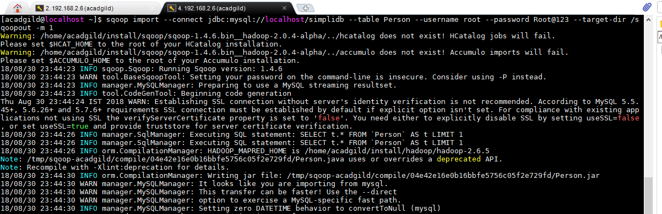

**Task 1: Use Sqoop tool to export data present in SQOOPOUT folder made while demo of Import table**

To check the contents of the file

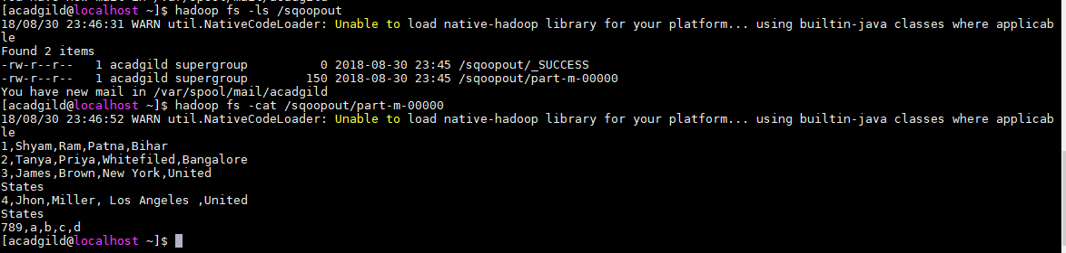

Truncate the table before exporting the data from HDFS

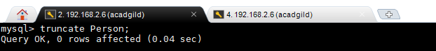

Export query

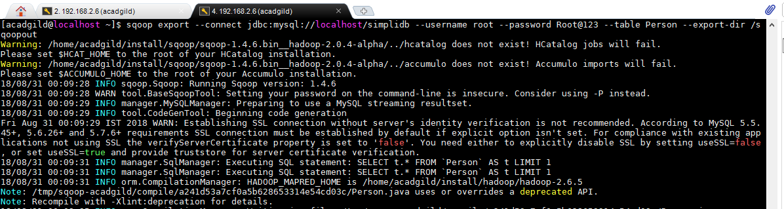

Check the Person table for exported data

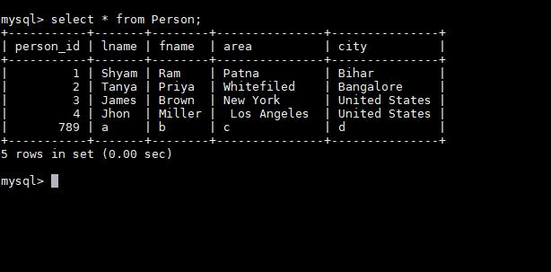

**Task 2: Use Sqoop tool to import data to SQOOPOUT folder made with parameter person_id =3.**

**Run the below command to import only the record with person_id = 3**

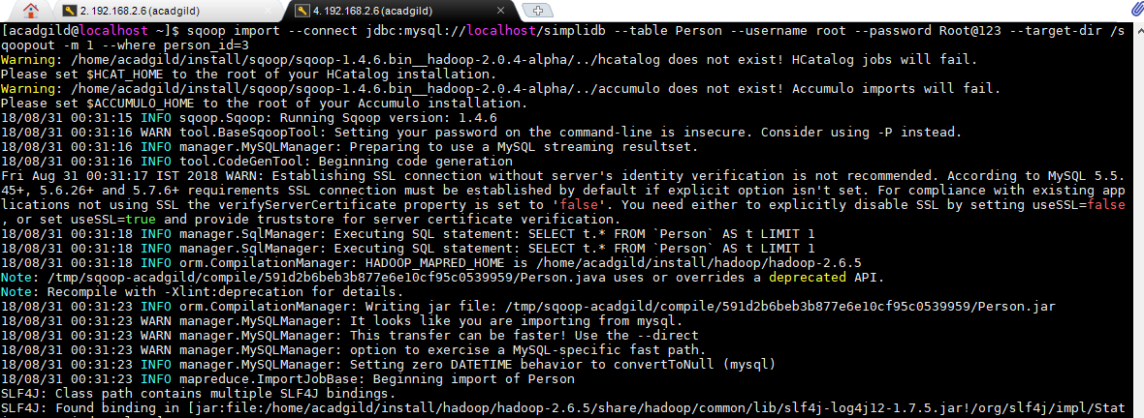

**To check the content of the SQOOPOUT folder**

