Task 1:

Create a kafka topic named KeyLessTopic.

A Kafka topic with name KeyLessTopic has been created using command as shown in the below screenshot.
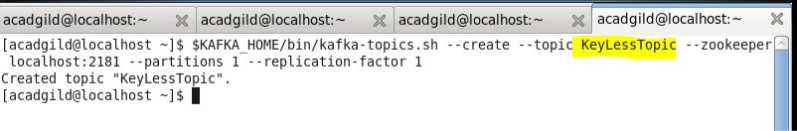

The topic created is shown in the below screenshot using the “List” command.
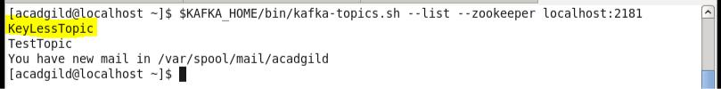

Inserting data into producer as keyless topic.
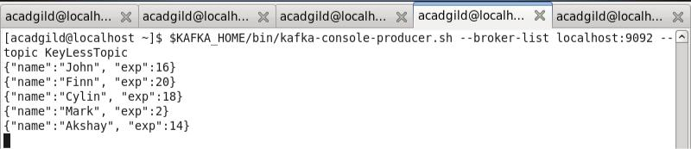
Task 2:

Create a console consumer that reads KeyLessTopic from beginning

A console consumer has been created which reads the data from producer from the beginning.
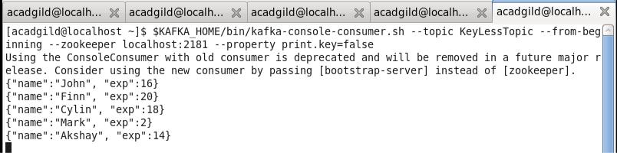
Task 3:

Create a kafka topic named KeyedTopic. Inside KeyedTopic insert following data:

The part before comma(,) should be treated as key and after comma(,) should be treated as value

{"name":"John"},{"exp":16}

{"name":"Finn"},{"exp":20}

{"name":"Cylin"},{"exp":18}

{"name":"Mark"},{"exp":2}

{"name":"Akshay"},{"exp":14}

A Kafka topic with name “KeyedTopic” has been created as shown in the below screenshot.
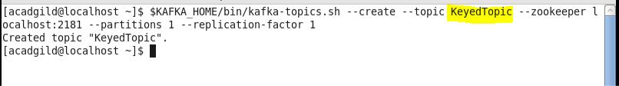

Created topic is viewed using the list command as shown in the below screenshot.
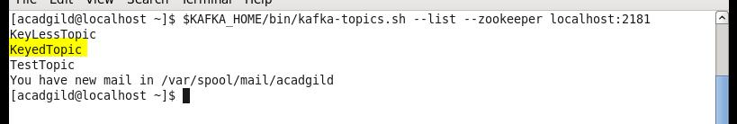

Inserting data into the producer as keyed topic.
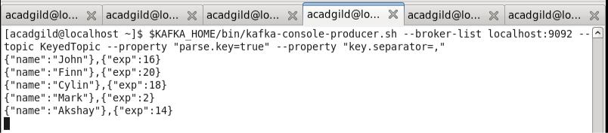
Task 4:

Create a console consumer that reads KeyedTopic from beginning. The key and value should be separated by '-'

Created a console consumer which reads the KeyedTopic from the beginning and the output is separated by “-“as shown in the below screenshot.
