For this task we need to start zookeeper and kafka broker

Starting Zookeeper

$KAFKA_HOME/bin/zookeeper-server-start.sh $KAFKA_HOME/config/zookeeper.properties
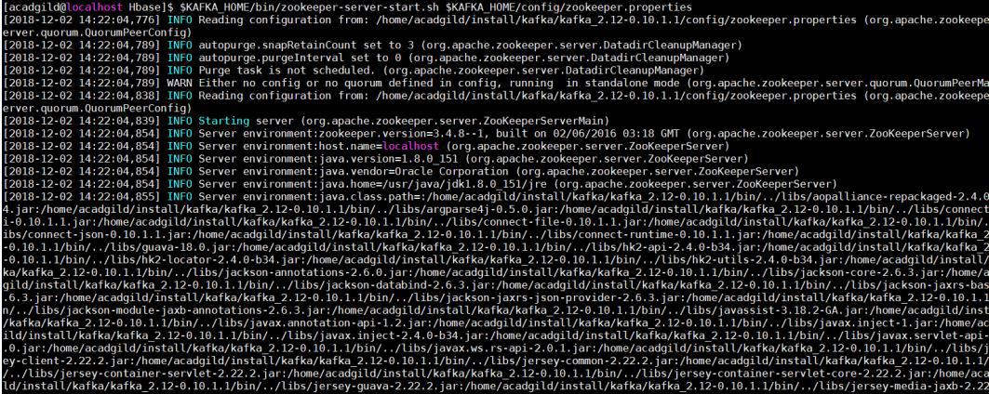

- Starting broker

$KAFKA_HOME/bin/kafka-server-start.sh $KAFKA_HOME/config/server.properties
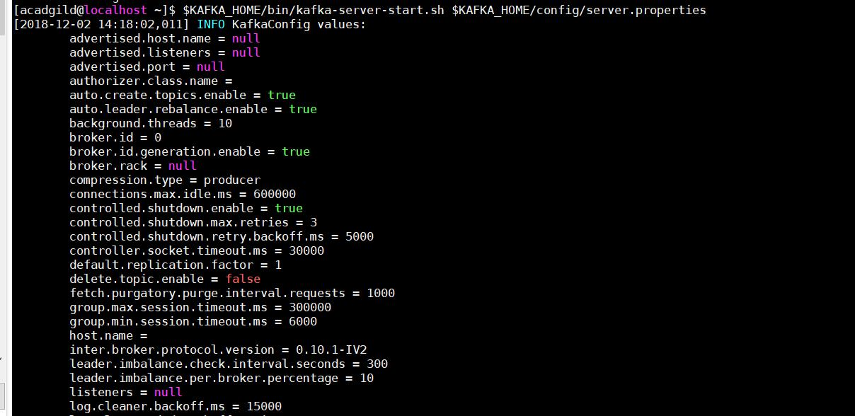
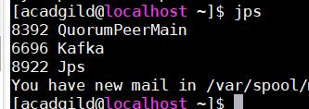
Task 1:

Create a java program MyKafkaProducer.java that takes a file name and delimiter as input arguments. It should read the content of file line by line. Fields in the file are in following order

- Kafka Topic Name

- Key

  - value

For every line, insert the key and value to the respective Kafka broker in a fire and forget mode. After record is sent, it should print appropriate message on screen. Pass dataset_producer.txt as the input file and - as delimiter

Below is the data file
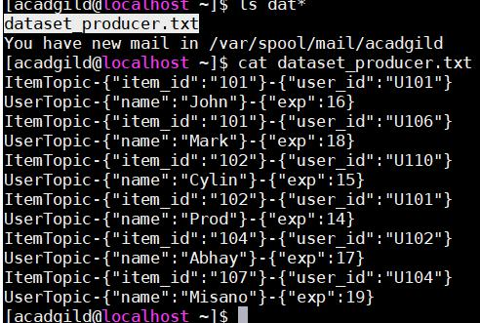

Below screenshot is the Java program MyKafkaProducer.java
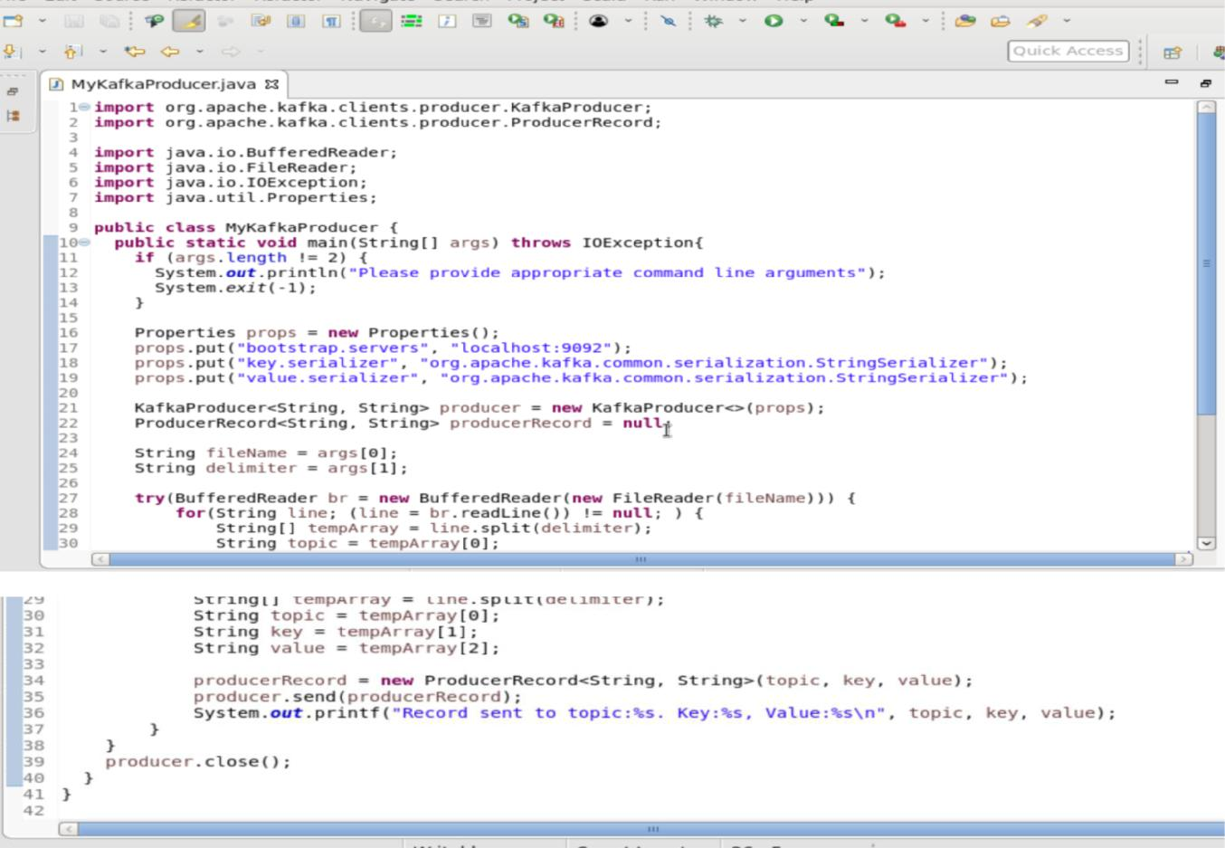

Output
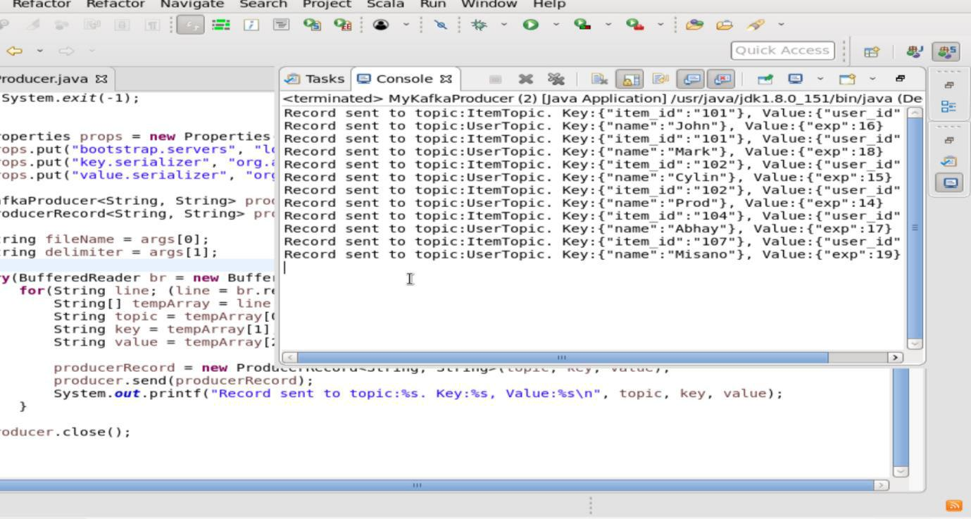
List the topics you can find ItemTopic and UserTopic

$KAFKA_HOME/bin/kafka-topics.sh --list --zookeeper localhost:2181
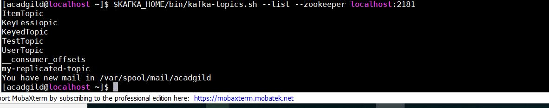

Running the jar file

java -cp $KAFKA_HOME/share/java/kafka/*:/home/acadgild/Desktop/my.jar producer.MyKafkaProducer /home/acadgild/dataset_producer.txt -
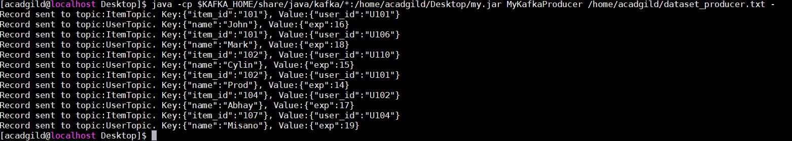

Item topic consumer

$KAFKA_HOME/bin/kafka-console-consumer.sh --topic ItemTopic --from-beginning -- zookeeper localhost:2181 --property print.key=true
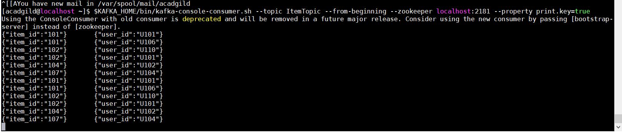
User topic consumer

$KAFKA_HOME/bin/kafka-console-consumer.sh --topic UserTopic --from-beginning -- zookeeper localhost:2181 --property print.key=true
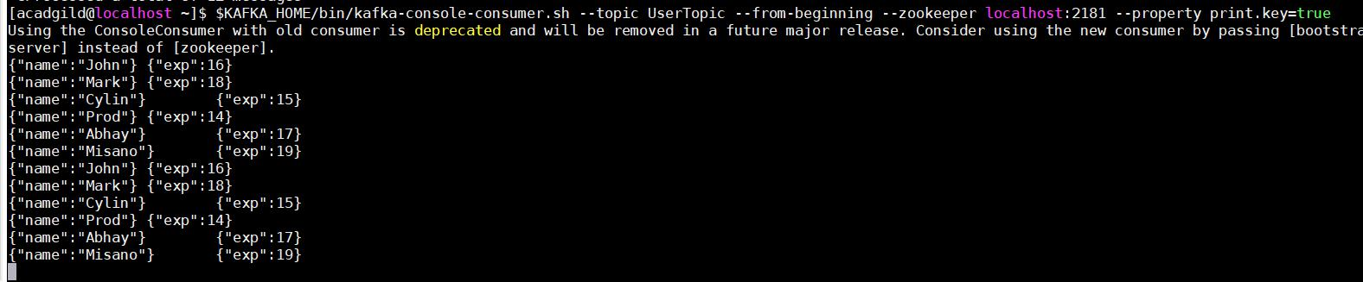
Task 2:

Modify the previous program MyKafkaProducer.java and create a new Java program KafkaProducerWithAck.java. This should perform the same task as of KafkaProducer.java with some modification. When passing any data to a topic, it should wait for acknowledgement. After acknowledgement is received from the broker, it should print the key and value, which has been written to a specified topic. The application should attempt for three retries before giving any exception. Pass dataset_producer.txt as the input file and - as delimiter.

Below screenshot is the MyKafkaProducer.java Code (original code attached)
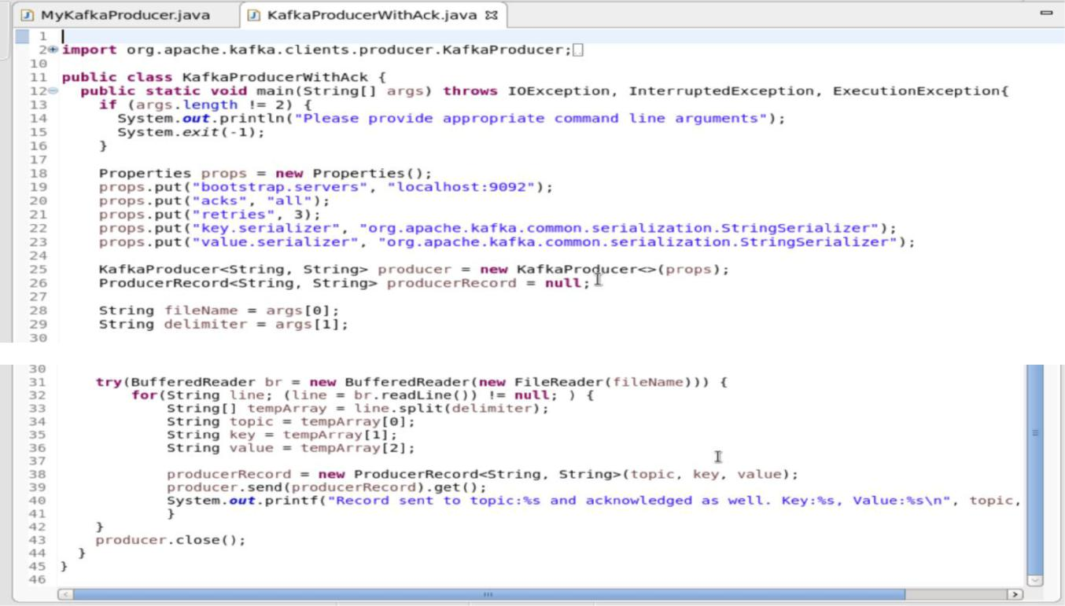

Output
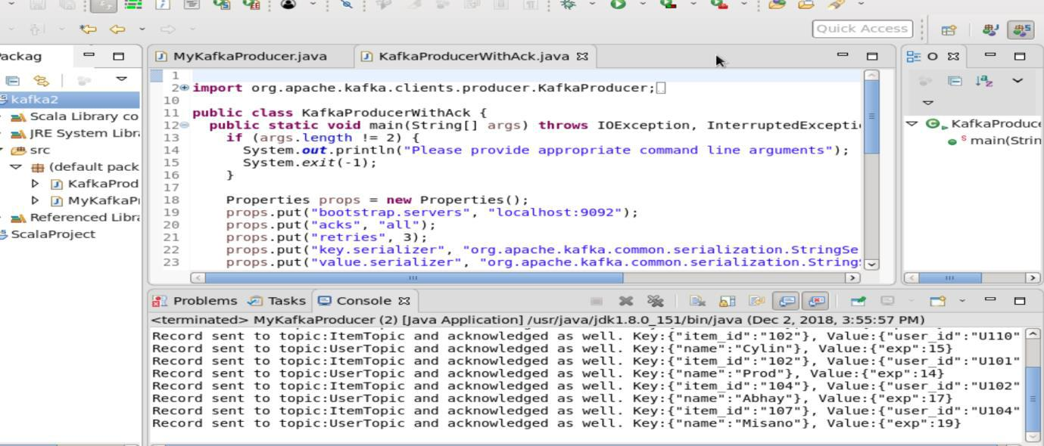
Running the Jar

java -cp $KAFKA_HOME/share/java/kafka/*:/home/acadgild/Desktop/my.jar KafkaProducerWithAck /home/acadgild/dataset_producer.txt -
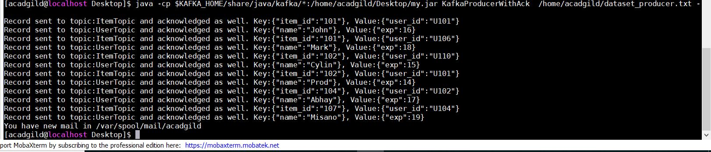

User Topic output

$KAFKA_HOME/bin/kafka-console-consumer.sh --topic UserTopic --from-beginning -- zookeeper localhost:2181 --property print.key=true
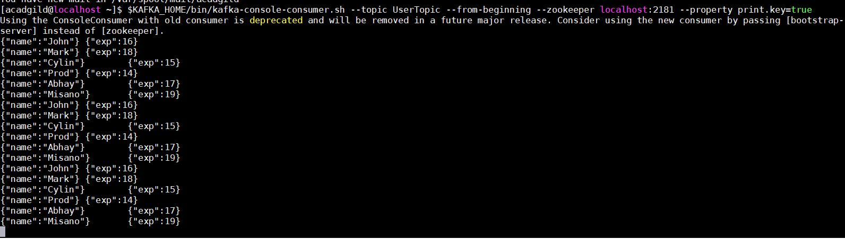

Item Topic output

$KAFKA_HOME/bin/kafka-console-consumer.sh --topic ItemTopic --from-beginning -- zookeeper localhost:2181 --property print.key=true
