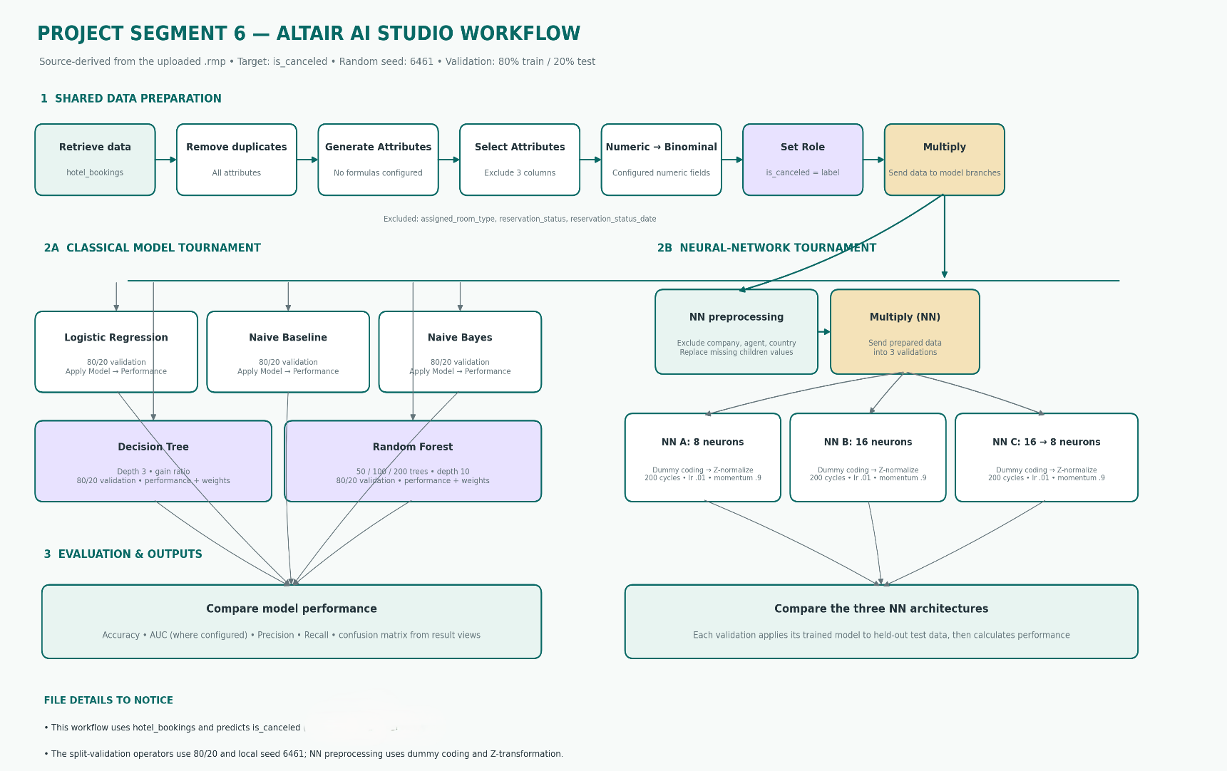

Final Leaderboard:
Model | Accuracy | Precision | Recall | AUC | FP | FN
Naive Baseline (majority class) | 72.51% | undefined | 0.00% | 0.500 | 0 | 4,805
Logistic Regression (Segment 3) | 77.63% | 57.17% | 74.26% | 0.850 | 2,673 | 1,237
Naive Bayes (defaults) | 76.02% | 55.44% | 65.12% | 0.806 | 2,515 | 1,676
Decision Tree (max depth 15) | 78.57% | 66.47% | 44.47% | 0.791 | 1,078 | 2,668
Random Forest (200 trees, depth 10) | 75.50% | 88.05% | 12.57% | 0.804 | 82 | 4,201
Neural Net C (2 layers: 16, 8) | 78.44% | 65.66% | 45.24% | 0.802 | 1,137 | 2,631

