Cyber Security Task 01: Personal Security Audit & Cyber Awareness Assessment

Part A: Device Security Assessment Perform a security assessment of your personal computer or laptop.
Operating System - Windows 11 Home Single Language
OS Version - Version 22H2 (OS Build 22621.1848)
Is the system updated? – No unable to check successfully
Antivirus Installed? (Yes/No) - Yes
Firewall Enabled? (Yes/No) – Partially
Part B: Password Security Review
Answer the following:

1. What Makes a Strong Password?
A strong password has several key characteristics:
- Length — At least 12–16 characters long. Longer = harder to crack.
- Complexity — Mix of uppercase letters, lowercase letters, numbers, and special characters (e.g. @, #, !, $).
- Unpredictability — No dictionary words, common phrases, or keyboard patterns like qwerty or 123456.
- Randomness — Ideally generated randomly, not based on personal patterns.
Example of a weak password: nimitha2004
Example of a strong password: Tr#9mK!vZ2@pLq

2. Why Should Passwords Be Unique?
Every account should have its own distinct password because:
- If one account is breached, attackers try the same password on other sites — this is called a credential stuffing attack.
- A single reused password can give hackers access to your email, bank, social media, and more simultaneously.
- Data breaches happen frequently; unique passwords contain the damage to just one account.

3. What is Multi-Factor Authentication (MFA)?

Multi-Factor Authentication (MFA) is a security method that requires two or more verification steps before granting access to an account. These factors fall into three categories:
Factor | Description | Example
Something you know | A password or PIN | Your login password
Something you have | A physical device | Phone receiving an OTP code
Something you are | Biometrics | Fingerprint or Face ID
Even if a hacker steals your password, MFA blocks them because they still can't pass the second verification step.

4. What Are the Risks of Password Reuse?
Reusing passwords is one of the most dangerous habits in cybersecurity:
- Credential stuffing — Attackers use leaked passwords from one breach to break into other accounts automatically.
- Chain of breaches — One compromised password can expose your email, which then exposes every account that uses "Forgot Password."
- Widespread data leaks — Billions of passwords are already available on the dark web from past breaches.
- No containment — You lose control over multiple accounts at once instead of just one.
- Delayed detection — You may not realize multiple accounts are compromised until serious damage is done.

5. Password Policy — 8 Best Practices
A password policy is a set of rules designed to improve security by encouraging strong password habits.
Best Practice |  | Why It Matters
Use at least 12 characters |  | Longer passwords take exponentially longer to crack by brute force
Use uppercase and lowercase letters |  | Increases the number of possible combinations
Include numbers and special characters |  | Adds further complexity (e.g. P@ssw0rd! is stronger than Password)
Avoid personal information |  | Names, birthdays, and pet names are easy to guess or find on social media
Enable MFA whenever possible |  | Adds a second layer of protection even if your password is stolen
Never reuse passwords across accounts |  | Prevents one breach from compromising all your accounts
Use a password manager |  | Safely stores and generates unique strong passwords so you don't have to memorize them
Change passwords after a suspected breach | Limits exposure time if your credentials are ever compromised

Part C: Online Account Security
Account | MFA Enabled? | Strong Password? | Recovery Email Configured? | Security Rating
Google | No | No | No | Weak
Instagram | No | No | No | Weak
GitHub | No | No | No | Weak
Part D: Cyber Threat Research

1. Phishing

Definition
Phishing is a type of cyber attack where criminals disguise themselves as trustworthy sources such as banks, companies, or even friends to trick people into revealing sensitive information like passwords, credit card numbers, or personal details. It usually happens through fake emails, text messages, or websites that look legitimate.

Real-World Example
In 2016, a Google Docs phishing attack spread rapidly across the internet. Millions of users received an email that looked like a legitimate Google Docs sharing invitation. When users clicked the link, it directed them to a fake Google login page that stole their credentials. The attack spread so fast that Google had to shut it down within an hour.

Prevention Methods
- Always check the sender's email address carefully before clicking any links
- Never enter your password on a website you reached through an email link
- Look for spelling errors or strange formatting in emails claiming to be from official companies
- Enable spam filters on your email account
- When in doubt, go directly to the official website by typing it in your browser

2. Malware

Definition
Malware, short for malicious software, is any program or code that is intentionally designed to damage, disrupt, or gain unauthorized access to a computer system. It comes in many forms including viruses, trojans, spyware, and worms. Malware can steal data, slow down your device, or give attackers full control over your system.

Real-World Example
In 2017, the WannaCry malware infected over 200,000 computers across 150 countries. It spread through a vulnerability in Windows operating systems and affected major organizations including hospitals in the UK, forcing them to cancel thousands of appointments and operations because their systems were completely locked down.

Prevention Methods
- Install reputable antivirus software and keep it updated
- Never download files or software from unknown or untrusted sources
- Keep your operating system and apps updated to patch security vulnerabilities
- Avoid clicking on suspicious links or email attachments
- Regularly back up your files so you can recover them if malware strikes

3. Ransomware

Definition
Ransomware is a specific and dangerous type of malware that encrypts the victim's files, making them completely inaccessible. The attacker then demands a ransom payment, usually in cryptocurrency, in exchange for the decryption key to unlock the files. It can target individuals, businesses, hospitals, and even government systems.

Real-World Example
In 2021, the Colonial Pipeline in the United States was hit by a ransomware attack carried out by a group called DarkSide. The attack forced the company to shut down its pipeline operations, which supplied nearly half of the fuel for the US East Coast. The company ended up paying approximately 4.4 million dollars in ransom to regain access to their systems.

Prevention Methods
- Back up all important files regularly to an offline or cloud storage location
- Never pay the ransom — it does not guarantee you will get your files back and encourages further attacks
- Keep all software updated to close known security gaps
- Restrict access permissions so employees only access what they need
- Use endpoint protection software that can detect ransomware behavior before it spreads

4. Social Engineering

Definition
Social engineering is a manipulation technique where attackers psychologically trick people into revealing confidential information or performing actions that compromise security. Instead of hacking systems technically, the attacker exploits human trust, fear, urgency, or curiosity. It is considered one of the most effective attack methods because it targets human behavior rather than software.

Real-World Example
In 2020, Twitter suffered a major social engineering attack where hackers called Twitter employees pretending to be from the IT department. They convinced staff to hand over internal credentials and access tools. Using this access, the attackers hijacked high-profile accounts including those of Elon Musk, Barack Obama, and Apple to run a Bitcoin scam that collected over 100,000 dollars in just a few hours.

Prevention Methods
- Always verify the identity of anyone requesting sensitive information, even if they seem official
- Be suspicious of urgent or pressure-filled requests asking you to act immediately
- Never share passwords, PINs, or access credentials over the phone or email
- Organizations should train employees regularly on how to recognize social engineering tactics
- Establish clear internal procedures for verifying identity before granting access

5. Data Breach

Definition
A data breach occurs when unauthorized individuals gain access to confidential or protected information stored by an organization. This can include personal details, passwords, financial records, or medical information. Breaches can happen due to hacking, weak security practices, insider threats, or accidental exposure of data.

Real-World Example
In 2013, Yahoo suffered one of the largest data breaches in history. Hackers gained access to the personal information of all 3 billion Yahoo user accounts. The stolen data included names, email addresses, phone numbers, dates of birth, and security questions and answers. Yahoo did not publicly disclose the full extent of the breach until 2016, three years after it occurred.

Prevention Methods
- Use strong and unique passwords for every account to limit damage if one is breached
- Organizations must encrypt stored data so stolen information is unreadable without a key
- Enable MFA on all accounts so stolen passwords alone are not enough to gain access
- Regularly monitor accounts for unusual activity or unauthorized login attempts
- Companies should conduct regular security audits to identify and fix vulnerabilities before attackers do

Part E: Cyber Security Awareness Poster
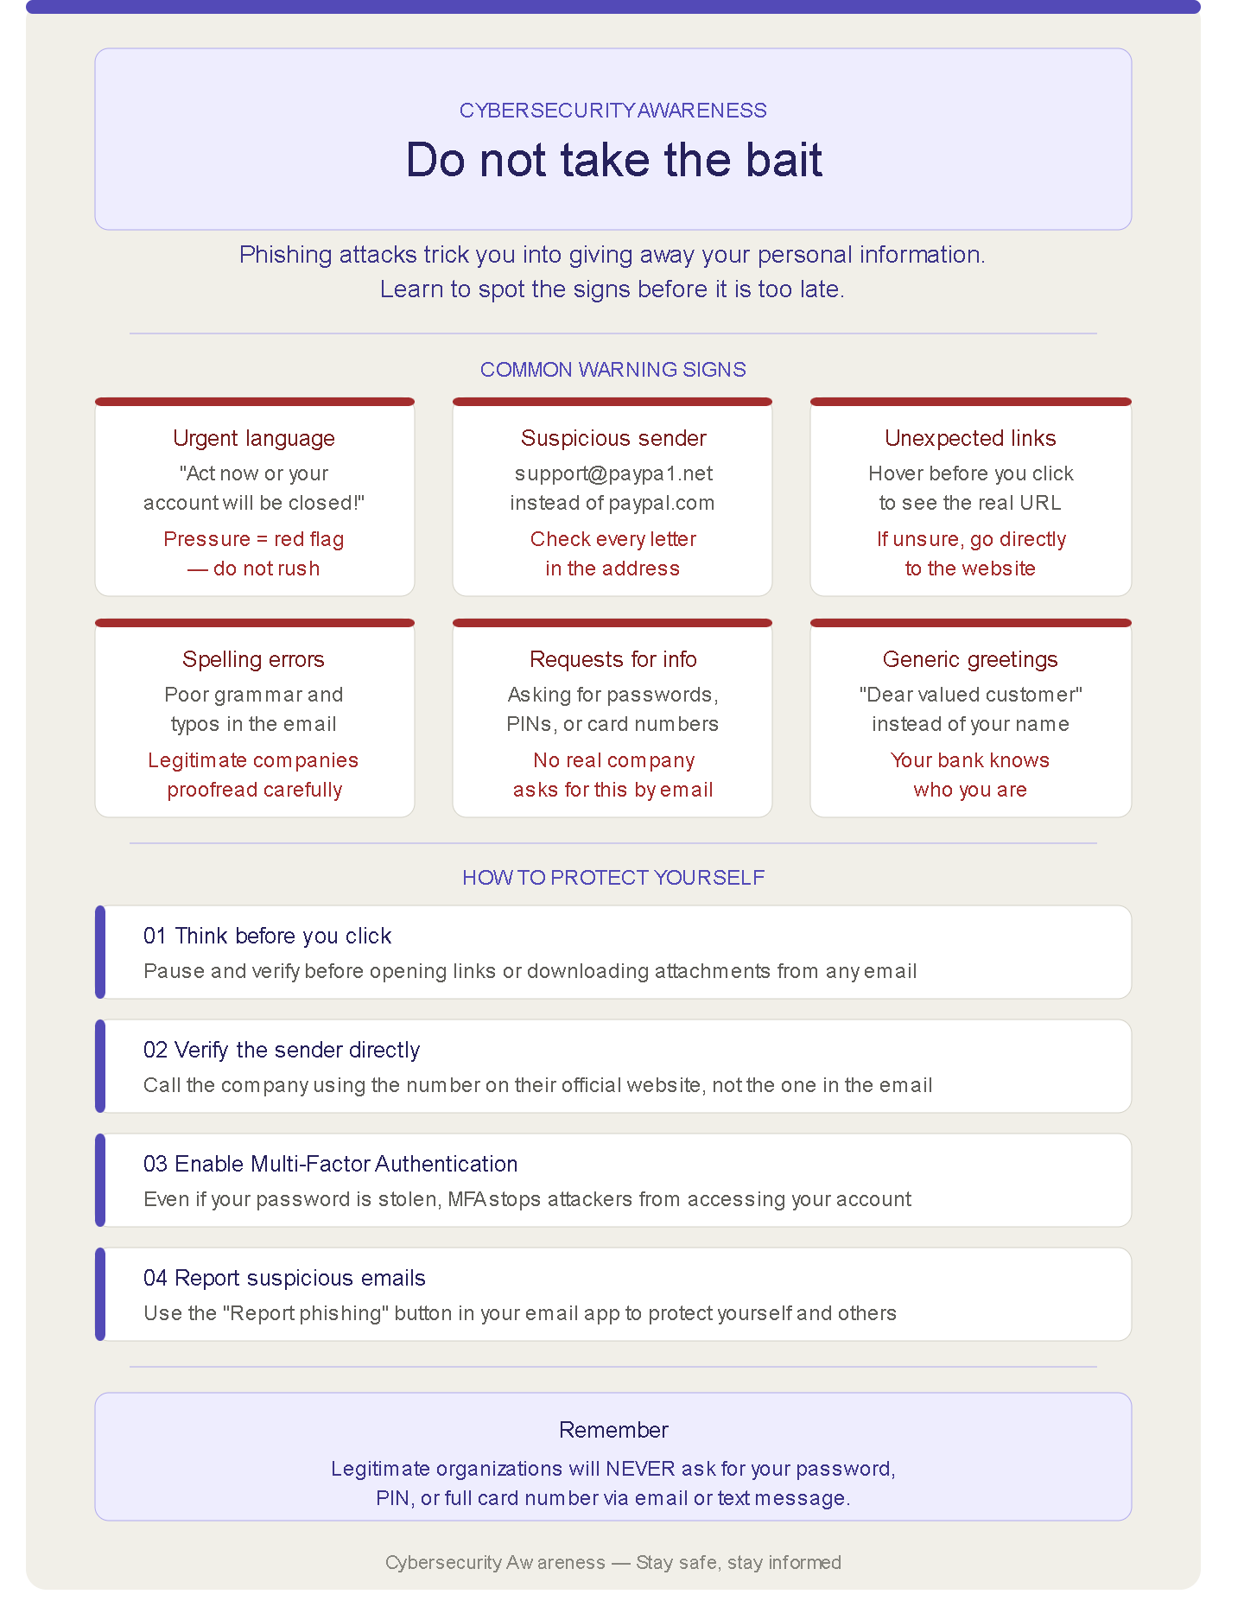

Part F: Security Reflection
After completing this cybersecurity module, I have developed a much deeper understanding of how vulnerable everyday digital habits can make a person to online threats. What started as a technical assignment quickly became a genuine eye-opener about how much we take our online security for granted.
1.What cybersecurity risks did you identify in your own digital habits?
One of the most significant risks I identified was the habit of reusing passwords across multiple accounts. When the same password is used for Google, Instagram, and other platforms, a single data breach anywhere can expose everything at once. This is one of the most common and dangerous mistakes people make online without even realizing it.
I also found that having no Multi-Factor Authentication enabled on any account is a serious vulnerability. A password alone is no longer enough protection in today's threat landscape. Attackers use automated tools that can guess or crack simple passwords within seconds, and without MFA as a backup, there is nothing standing between them and full account access.
Another risk was the absence of recovery emails on accounts. Without a recovery option configured, regaining access to a compromised or locked account becomes extremely difficult, sometimes impossible.
2.What security improvements will you implement immediately?
The most impactful improvement would be enabling MFA on every account without delay. This one step alone dramatically reduces the risk of unauthorized access even when a password is compromised. Alongside this, every account should have a unique and complex password of at least 12 characters, managed through a trusted password manager such as Bitwarden or Google Password Manager so nothing gets forgotten.
Setting up recovery emails across all accounts is another immediate priority, ensuring there is always a safe way to regain access if something goes wrong. Finally, developing the habit of pausing before clicking any link in an email — and always verifying the sender — is a small behavioral change that goes a long way in preventing phishing attacks.
3.Why is cybersecurity important in today’s world?
Cybersecurity is one of the most critical issues of our time. Nearly every aspect of modern life now exists online — banking, healthcare, education, communication, and personal identity. This digital dependence creates enormous opportunity for cybercriminals, who are becoming more sophisticated by the day.
The consequences of poor cybersecurity are not just inconvenient — they can be devastating. Identity theft can take years to recover from. Ransomware attacks have shut down hospitals, disrupting patient care. Data breaches at large companies have exposed the personal information of billions of people worldwide.
What this assignment made clear is that cybersecurity is not something that only concerns governments or large corporations. Every individual who owns a smartphone, uses email, or logs into any website online is a potential target. The good news is that most attacks can be prevented with basic but consistent security habits. Awareness is the first and most powerful line of defence, and that is exactly what this module has helped build.

