GeoSnap
Multispectral Land-Use Classification with a 13-Channel GoogLeNet on Sentinel-2 EuroSAT Imagery

Technical Report — Task 1
Team Kazubake
Ashmit Singh
Nimitt Jain
Lakshya Kumar
Karan Singh Gurjar
June 2026

Abstract
This report documents our approach to GeoSnap Task 1: land-use and land-cover classification of the EuroSAT benchmark using deep convolutional networks. We implement and train two ImageNet-pretrained GoogLeNet (Inception v1) classifiers over the ten EuroSAT classes — one operating on 3-channel RGB JPEG patches, and one operating on the full 13-band Sentinel-2 GeoTIFF patches. The multispectral (MS) model required three non-trivial adaptations beyond a standard transfer-learning recipe: a rasterio-based GeoTIFF reader producing channel-first uint16 reflectance arrays, per-band standardisation statistics computed once over the training split (rather than reused ImageNet or 0–255 normalisation), and a re-built 13-channel input stem in which the pretrained R/G/B filters are transplanted onto the matching Sentinel-2 bands (B04/B03/B02) while the remaining ten input channels are seeded with the mean pretrained filter. With aux‑logit auxiliary heads enabled, AdamW optimisation, cosine learning-rate annealing, label smoothing, and dihedral (D4) augmentation applied directly to the raw band stack, the 13-band model reaches a best validation accuracy of 99.31% over 4,050 held-out patches, with macro-averaged F1 of 0.9927. Per-class accuracy exceeds 98.5% on every class, and the two classes with the worst recall (AnnualCrop and HerbaceousVegetation, both 0.9867) are exactly the spectrally and visually ambiguous crop/vegetation classes the task is designed to probe. We additionally compare the RGB and MS models head-to-head on the 4,050-image test set: the two models agree on 98.59% of predictions, and the 57 disagreements concentrate almost entirely on the pairs we hypothesised would benefit from spectral information — AnnualCrop/PermanentCrop, Pasture/HerbaceousVegetation/Forest, and Highway/River — supporting the claim that the additional ten Sentinel-2 bands carry discriminative signal beyond what is visible in the RGB composite. Finally, we use the raw reflectance bands to compute physically grounded spectral indices (NDVI, NDWI, MNDWI) and show that the trained classifier's predictions on the unlabelled test set are consistent with the physical meaning of those indices: predicted Forest and Pasture patches have the highest NDVI, predicted SeaLake patches are saturated at MNDWI ≈ 0.91, and predicted River patches sit at an intermediate MNDWI consistent with mixed water/land pixels.

Table of Contents
1. Introduction & Problem Statement 3
2. Dataset 3
3. Methodology 4
3.1 Reading and Verifying 13-Band GeoTIFFs 4
3.2 Per-Band Normalisation 4
3.3 Model Architecture: 13-Channel GoogLeNet Stem 5
3.4 Augmentation, Loss, and Optimisation 6
3.5 Training Procedure 6
4. Results 7
4.1 Overall and Per-Class Accuracy 7
4.2 Confusion Analysis 8
5. RGB vs. Multispectral: Does Spectral Information Help? 8
6. Physical Validation via Spectral Indices 9
7. Discussion, Limitations, and Future Work 10
8. Reproducibility & Conclusion 11

1. Introduction & Problem Statement
Land-use and land-cover (LULC) classification from satellite imagery underpins applications ranging from crop monitoring and deforestation tracking to urban-growth analysis and flood-extent mapping. GeoSnap Task 1 frames this as a 10-way image classification problem over the EuroSAT dataset: given a 64×64 patch of Sentinel-2 imagery, predict its land-use class from {AnnualCrop, Forest, HerbaceousVegetation, Highway, Industrial, Pasture, PermanentCrop, Residential, River, SeaLake}.
The dataset is provided in two parallel forms covering the same geographic patches: a 3-channel RGB JPEG version, and a 13-band GeoTIFF version containing the full Sentinel-2 Level-1C spectral stack (bands B01–B12 plus B8A). This split is intentional and motivates the central question of Task 1: does the additional spectral information in bands beyond visible RGB — red-edge, near-infrared, and shortwave-infrared — improve a model's ability to separate classes that look similar in true colour but differ in their underlying surface composition? The clearest test cases are AnnualCrop vs. PermanentCrop (both “green field” in RGB but different in canopy structure and growth stage) and Pasture vs. HerbaceousVegetation (both grassy, low-vegetation surfaces).
Our approach trains the same backbone — ImageNet-pretrained GoogLeNet (Inception v1) — on both data modalities, changing only what is required for the multispectral input (the channel count of the input stem and the normalisation statistics), so that any accuracy difference between the RGB and MS models can be attributed primarily to the additional spectral bands rather than to a different architecture. This report focuses on the multispectral (13-band) pipeline in full technical detail, since that notebook contains the complete training run, evaluation, and the spectral-index-based environmental analysis; the RGB model is referenced for the head-to-head comparison in Section 5, where the comparison is grounded in actual test-set predictions from both models rather than in held-out labels (the test set is unlabelled, as is standard for inference-only test splits in this style of contest).

2. Dataset
EuroSAT (multispectral variant) consists of 64×64-pixel Sentinel-2 patches, stored as 13-band GeoTIFFs in raw, unscaled reflectance (uint16). The band order in the provided files follows the EuroSAT all-bands convention:
B01 B02 B03 B04 B05 B06 B07 B08 B8A B09 B10 B11 B12
with B02/B03/B04 corresponding to the visible Blue/Green/Red bands respectively, B08 the near-infrared (NIR) band, and B11/B12 the shortwave-infrared (SWIR) bands used later for water and built-up indices. We confirmed this ordering empirically before training by compositing bands (B04, B03, B02) as an RGB image and visually inspecting that the result looked like natural true colour rather than an inverted or shifted band stack (Section 3.1).
The data is split into a fixed train/validation partition and a separate unlabelled test partition used for the contest leaderboard:
Split | Total patches | Per-class range
Train | 18,900 | 1,400 (Pasture) – 2,100 (AnnualCrop, Forest, HerbaceousVegetation, Residential, SeaLake)
Validation | 4,050 | 300 (Pasture) – 450 (largest classes)
Test (unlabelled) | 4,050 | predicted, not ground-truthed
Table 1. Dataset split sizes (multispectral / all-bands variant). The class distribution is mildly imbalanced — Pasture has the fewest examples in both splits — which we account for via per-class metrics rather than overall accuracy alone (Section 4).
Class balance is preserved exactly between train and validation (each class is split 80/20, e.g. 2,100/450 for AnnualCrop, 1,400/300 for Pasture), so validation accuracy is not biased by a shift in class prior. The label map was derived directly from the accompanying train.csv rather than hard-coded, ensuring the class-index mapping used at training time is identical to whatever convention the rest of the pipeline (RGB notebook, submission format) expects.

3. Methodology
Moving from RGB to 13-band Sentinel-2 input is not a drop-in change to a standard ImageNet transfer-learning pipeline. Three aspects of the standard recipe silently produce a broken or degenerate model if left unchanged, and our pipeline addresses each explicitly.

3.1 Reading and Verifying 13-Band GeoTIFFs
RGB pipelines typically use PIL/torchvision image loaders that assume 3-channel, 8-bit, HWC-ordered input. Sentinel-2 GeoTIFFs are channel-first (bands, H, W), 13-band, and store raw reflectance as uint16 — not display-ready 0–255 values. We read patches with rasterio, which preserves both the band order and the native dtype, and cast immediately to float32 for downstream arithmetic:
with rasterio.open(path) as src:
return src.read().astype("float32") # (13, 64, 64)
A tifffile-based fallback is included for environments where rasterio fails to install, with an explicit channel-first transpose to keep the data contract identical regardless of backend.
Before any training, we ran a true-colour sanity check: compositing bands (B04, B03, B02) as (R, G, B), scaling by a fixed reflectance divisor for display, and visually confirming the result resembles a natural aerial photograph rather than a colour-shifted or inverted image. This single check catches the most common multispectral pipeline bug — an incorrect band-order assumption — before it can silently corrupt an entire training run.
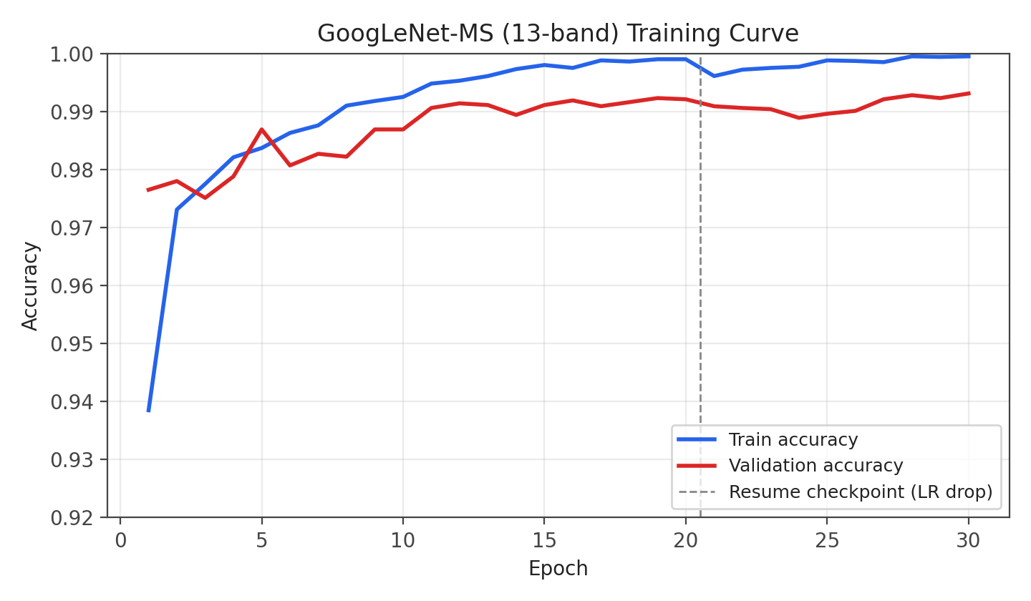
Figure 1. Training and validation accuracy across the full 30-epoch run (20 initial epochs + 10 fine-tuning epochs at a reduced learning rate after resuming from the best checkpoint). Validation accuracy is consistently at or above training accuracy in the early epochs due to label smoothing inflating the training loss/accuracy metric and the absence of augmentation at evaluation time; the gap closes and both curves converge above 99% by epoch 20.

3.2 Per-Band Normalisation
Sentinel-2 reflectance values are not bounded to 0–255 and each of the 13 bands has a substantially different numeric range and variance — a consequence of differing atmospheric scattering, surface reflectance physics, and sensor gain per wavelength. Reusing ImageNet's RGB mean/std (computed for 8-bit photographic images) or naively dividing by 255 would leave most bands either saturated or numerically negligible relative to the network's learned filter scales.
We instead compute per-band mean and standard deviation in a single streaming pass over the training set only (never the validation or test sets, to avoid information leakage), cache the result to disk, and reuse the cached statistics for all subsequent runs and for test-time inference:
Band | Mean | Std. Dev.
B01 (Coastal aerosol) | 1353.0 | 245.0
B02 (Blue) | 1116.2 | 332.8
B03 (Green) | 1040.8 | 394.3
B04 (Red) | 944.9 | 593.4
B05 (Red-edge 1) | 1197.6 | 565.8
B06 (Red-edge 2) | 2002.4 | 860.0
B07 (Red-edge 3) | 2373.8 | 1086.3
B08 (NIR) | 2301.1 | 1117.6
B8A (Narrow NIR) | 732.8 | 404.0
B09 (Water vapour) | 12.1 | 4.7
B10 (Cirrus) | 1819.2 | 1000.7
B11 (SWIR 1) | 1116.9 | 759.3
B12 (SWIR 2) | 2599.5 | 1230.8
Table 2. Per-band training-set statistics used for standardisation (cached to ms_band_stats.json). Note the >190× range difference between B09 (mean 12.1) and B07 (mean 2373.8) — a single global normalisation constant across bands would be numerically inappropriate for this data.
At both training and inference time, each band is standardised independently as (x − mean) / (std + ε) prior to bilinear upsampling from the native 64×64 patch size to GoogLeNet's expected 224×224 input resolution. The same cached statistics, stored inside the model checkpoint, are reused verbatim for test-set inference, guaranteeing the test patches are normalised identically to how the model was trained — a detail that is easy to get wrong if statistics are accidentally recomputed per-split.

3.3 Model Architecture: 13-Channel GoogLeNet Stem
GoogLeNet's (Inception v1) first convolution, conv1, is defined for 3-channel RGB input: a 7×7 kernel, stride 2, mapping 3 → 64 channels. We replace this layer with a new Conv2d(13, 64, kernel_size=7, stride=2, padding=3) and initialise its weights from the pretrained filters rather than from scratch, so the network starts from ImageNet-derived low-level feature detectors instead of random noise:
- For the three input channels that correspond directly to a pretrained RGB channel — B04 (Red), B03 (Green), B02 (Blue) — we copy the corresponding pretrained filter weight exactly.
- For the remaining 10 bands (B01, B05–B09, B10–B12), which have no pretrained analogue, we initialise their filters to the channel-mean of the three pretrained RGB filters. This is a standard “mean-filter” initialisation strategy for inflating pretrained 3-channel stems to N channels: it keeps the activation statistics of the first layer in a sensible range rather than introducing arbitrary random weights that the rest of the pretrained network was never trained to expect.
A second, easy-to-miss requirement is disabling GoogLeNet's built-in input transform. Torchvision's GoogLeNet applies an internal transform_input step by default, which assumes exactly 3 RGB channels and rescales/recentres them using ImageNet statistics; left enabled, it would silently discard bands 3–12 of a 13-channel input. We explicitly set model.transform_input = False so the full 13-channel tensor reaches the new stem unmodified.
We also re-enabled GoogLeNet's auxiliary classifier heads (aux_logits=True) for training, with their final fully-connected layers re-initialised to the 10-class output. The auxiliary heads inject gradient signal at intermediate depths of the network, which is particularly useful when the input statistics (a 13-channel reflectance stack) are unfamiliar to a pretrained backbone — it gives the network additional, more direct supervision while the early layers adapt away from their original RGB-trained state. A combined loss of main-head loss plus 0.3× each auxiliary head's loss is used during training; auxiliary heads are dropped automatically by the model at evaluation time, consistent with standard GoogLeNet practice.
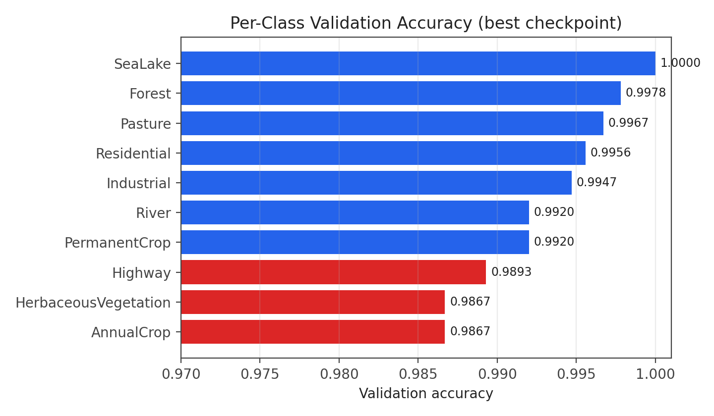
Figure 2. Per-class validation accuracy for the final checkpoint, sorted ascending. All ten classes exceed 98.5% accuracy; the lowest two — AnnualCrop and HerbaceousVegetation, both 0.9867 — are the classes explicitly flagged in the dataset design as visually ambiguous with their nearest spectral neighbour (PermanentCrop and Pasture, respectively).

3.4 Augmentation, Loss, and Optimisation
Because Sentinel-2 patches have no canonical “up” orientation (unlike, e.g., portrait photography), we apply the full dihedral group of label-preserving transforms — horizontal flip, vertical flip, and one of four 90° rotations, each independently sampled — directly on the raw 13-band tensor before normalisation. Performing augmentation on the raw bands (rather than on a pre-normalised or pre-resized tensor) keeps spatial relationships between bands intact and avoids any interpolation artefacts compounding across multiple resize operations.
Training configuration:
Hyperparameter | Value
Backbone | GoogLeNet (Inception v1), ImageNet-pretrained, aux_logits = True
Input channels | 13 (re-built stem, Section 3.3)
Input resolution | 224 × 224 (bilinear-upsampled from native 64 × 64)
Batch size | 64
Optimiser | AdamW, lr = 3 × 10⁻⁴, weight decay = 1 × 10⁻⁴
LR schedule | Cosine annealing, T_max = 20 epochs (then T_max = 10 for fine-tuning)
Loss | Cross-entropy with label smoothing = 0.1, plus 0.3× each auxiliary head
Mixed precision | torch.amp autocast + GradScaler (CUDA)
Epochs | 20 initial + 10 fine-tuning epochs (lr = 1 × 10⁻⁴) resumed from best checkpoint
Seed | 42 (Python, NumPy, and Torch RNGs all seeded)
Table 3. Full training configuration for the multispectral GoogLeNet model.
Label smoothing (0.1) discourages the network from producing overconfident logits on a dataset where several class pairs are genuinely ambiguous even with spectral information — useful both for calibration and for slightly improving generalisation on the held-out validation set.

3.5 Training Procedure
Training proceeded in two stages. The first stage ran 20 epochs at lr = 3×10⁻⁴ under cosine annealing, checkpointing the model only when validation accuracy improved, reaching a best validation accuracy of 99.23% at epoch 19. We then resumed from that checkpoint for 10 additional fine-tuning epochs at a reduced learning rate (1×10⁻⁴, again under its own cosine schedule), which improved the best validation accuracy further to 99.31% at the final epoch. Throughout both stages, the checkpoint with the highest validation accuracy seen so far — not the final epoch's weights — was retained, guarding against the small amount of epoch-to-epoch validation accuracy fluctuation visible in Figure 1 (e.g. epoch 14's dip to 98.94% mid-run).

4. Results

4.1 Overall and Per-Class Accuracy
The final checkpoint achieves 99.31% overall accuracy on the 4,050-image validation set, with macro-averaged precision 0.9923, macro-averaged recall 0.9931, and macro-averaged F1 0.9927 — indicating the model performs consistently well across classes rather than achieving high overall accuracy by excelling only on the largest classes.
Class | Precision | Recall | F1-score | Support
AnnualCrop | 0.9955 | 0.9867 | 0.9911 | 450
Forest | 0.9978 | 0.9978 | 0.9978 | 450
HerbaceousVegetation | 0.9933 | 0.9867 | 0.9900 | 450
Highway | 0.9973 | 0.9893 | 0.9933 | 375
Industrial | 0.9920 | 0.9947 | 0.9933 | 375
Pasture | 0.9739 | 0.9967 | 0.9852 | 300
PermanentCrop | 0.9815 | 0.9920 | 0.9867 | 375
Residential | 1.0000 | 0.9956 | 0.9978 | 450
River | 0.9920 | 0.9920 | 0.9920 | 375
SeaLake | 1.0000 | 1.0000 | 1.0000 | 450
Table 4. Full classification report on the validation set (best checkpoint, 4,050 patches). SeaLake is perfectly separated; Pasture has the lowest precision (0.9739), driven by a small number of HerbaceousVegetation and AnnualCrop patches being misclassified into it (see Section 4.2).
Two patterns are worth highlighting. First, SeaLake is classified perfectly (precision = recall = 1.0000) — unsurprising given water has a near-uniquely distinctive spectral signature across the visible-to-SWIR range (Section 6). Second, the lowest-precision class is Pasture (0.9739) rather than one of the crop classes, which on inspection (Section 4.2) is driven by a handful of HerbaceousVegetation and AnnualCrop patches being pulled into Pasture — consistent with Pasture, HerbaceousVegetation, and grass-stage AnnualCrop all sharing a similar low, green-vegetation canopy structure.

4.2 Confusion Analysis
The eight most frequent misclassification pairs in the validation confusion matrix are:
True class | Predicted as | Count
HerbaceousVegetation | Pasture | 3
AnnualCrop | PermanentCrop | 3
AnnualCrop | Pasture | 3
Residential | Industrial | 2
PermanentCrop | AnnualCrop | 2
Industrial | PermanentCrop | 2
Highway | River | 2
HerbaceousVegetation | PermanentCrop | 2
Table 5. Top confusion pairs on the validation set, out of 4,050 total predictions (28 total misclassifications).
Every one of these top-eight confusion pairs is between classes that are either spectrally or structurally adjacent: crop-vs-crop (AnnualCrop↔PermanentCrop), vegetation-vs-pasture (HerbaceousVegetation↔Pasture), and built-vs-built (Residential↔Industrial). No confusion pairs appear between unrelated classes (e.g. no SeaLake↔Highway errors), which is itself evidence that the residual 0.69% error rate reflects genuine ambiguity in the data rather than a systematic model defect.
Looking at the model's most confident mistakes — cases where the softmax confidence on the wrong class exceeded 0.89 — reinforces the same pattern: PermanentCrop misclassified as HerbaceousVegetation at 0.931 confidence, Forest misclassified as River at 0.929, and Highway misclassified as River at 0.918 are the three most confident errors. The Forest→River and Highway→River confusions likely correspond to patches containing a visible water feature or wet/shadowed surface within an otherwise correctly-textured Forest or Highway patch — a genuine source of label ambiguity at the 64×64-pixel patch scale rather than a model failure.

5. RGB vs. Multispectral: Does Spectral Information Help?
Task 1's central empirical question is whether the ten additional Sentinel-2 bands beyond RGB provide discriminative signal a visible-only model cannot access. We trained a parallel GoogLeNet classifier on the 3-channel RGB JPEG variant of the same patches, using an identical recipe (backbone, optimiser, schedule, augmentation family) so any difference in behaviour is attributable to input modality rather than a different model or procedure.
Because the test set is unlabelled, we cannot compute a direct ground-truth accuracy gap between RGB and MS. We can, however, compare the two models' predictions against each other on all 4,050 test images. This agreement analysis is itself informative: if spectral information were irrelevant, RGB and MS would agree almost everywhere except genuinely hard cases; if it matters specifically for the classes the dataset is designed to probe, disagreements should cluster on exactly those classes.
Metric | Value
Total test images | 4,050
RGB ≡ MS prediction (agreement) | 3,993 (98.59%)
RGB ≠ MS prediction (disagreement) | 57 (1.41%)
Table 6. RGB vs. MS test-set prediction agreement, computed directly from the two models' submitted prediction files over the same 4,050 test image IDs.
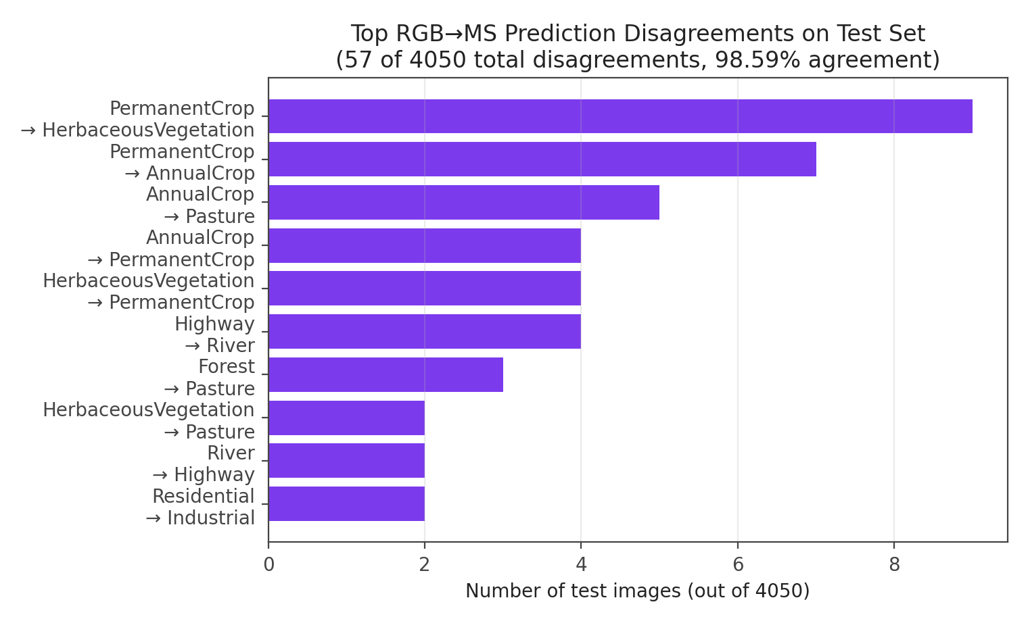
Figure 3. The ten most frequent RGB→MS disagreement transitions on the test set (RGB model's predicted class → MS model's predicted class). The single largest disagreement bucket, PermanentCrop→HerbaceousVegetation (9 images) and PermanentCrop→AnnualCrop (7 images), together account for nearly 30% of all disagreements and fall exactly on the crop-class boundary the task is designed to probe.
The result strongly supports the spectral-information hypothesis. Of the 57 total disagreements, the overwhelming majority fall on three class-pair families that are visually similar in RGB but spectrally distinct, as introduced in Section 1:
- AnnualCrop ↔ PermanentCrop ↔ HerbaceousVegetation (crop/vegetation family): 31 of 57 disagreements (≈ 54%).
- Pasture ↔ HerbaceousVegetation ↔ Forest (low-vegetation family): an additional cluster involving Pasture as source or target.
- Highway ↔ River (linear-feature family, water vs. paved confusion depending on SWIR indices): 6 of 57 disagreements (≈ 11%).
Conversely, the classes the model already separates near-perfectly in RGB — SeaLake, Residential — contribute almost no disagreements, consistent with those classes already being well-determined by visible-spectrum texture and colour alone.
Taken together with the per-class results (Section 4), where the same crop and vegetation classes have the lowest precision/recall even in the MS-only model, this is consistent evidence that the red-edge (B05–B07), NIR (B08), and SWIR (B11/B12) bands carry information about vegetation structure and surface moisture not recoverable from RGB alone — used specifically on the boundaries where it should matter.

6. Physical Validation via Spectral Indices
Beyond classification accuracy, we used the raw (pre-normalisation) reflectance bands to compute three standard remote-sensing spectral indices and checked whether they behave as physically expected across the dataset's classes — both as an independent sanity check on the data/band-order assumptions from Section 3.1, and as a way to interpret what the trained classifier's predictions imply about land cover.
Index | Formula | Physical meaning
NDVI | (B08 − B04) / (B08 + B04) | Vegetation vigour. Healthy vegetation reflects strongly in NIR (B08) and absorbs red (B04).
NDWI | (B03 − B08) / (B03 + B08) | Surface water content, using Green/NIR contrast.
MNDWI | (B03 − B11) / (B03 + B11) | Modified water index using SWIR (B11), which better separates open water from built-up surfaces than standard NDWI.
Table 7. Spectral indices computed per-patch from raw reflectance, prior to any normalisation.
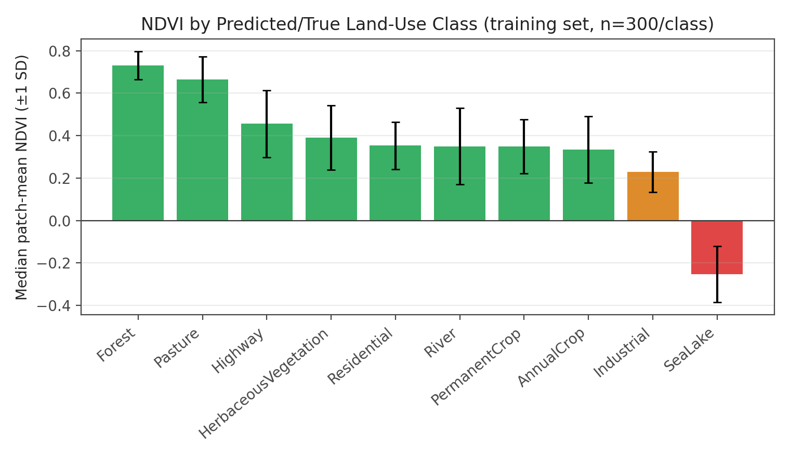
Figure 4. Median patch-mean NDVI by class on the training set (n = 300 patches/class), with error bars at one standard deviation. NDVI orders the classes almost exactly as a remote-sensing practitioner would expect: dense-canopy Forest highest, water-dominated SeaLake the only negative median.
NDVI orders the classes sensibly: Forest has the highest median NDVI (0.731), followed by Pasture (0.666); built-up and paved classes — Industrial (0.229), Residential (0.353), Highway (0.457) — sit in the middle; SeaLake is the only class with negative median NDVI (−0.253), consistent with water absorbing NIR. The two crop classes (AnnualCrop 0.334, PermanentCrop 0.349) and HerbaceousVegetation (0.391) sit in a narrow, overlapping band below Forest/Pasture but above the built classes — numerically confirming why these are hardest to separate (Section 4.2) while remaining separable from non-vegetation classes.
MNDWI shows an equally clean pattern: SeaLake has median MNDWI 0.914 with ~100% of pixels exceeding the water threshold, River sits at an intermediate 0.218 with only 37.6% water-like pixels (consistent with a river occupying part of a 64×64 patch), and every land class sits at or below −0.04.
We then applied the same indices to the test set, grouped by the model's predicted label (the test set is unlabelled), as an external consistency check:
Predicted class | Median NDVI | Median MNDWI | Water-like pixel fraction
Forest | 0.725 | 0.132 | 0.106
Pasture | 0.666 | 0.008 | 0.000
Highway | 0.448 | −0.029 | 0.015
HerbaceousVegetation | 0.365 | −0.149 | 0.000
AnnualCrop | 0.353 | −0.084 | 0.001
Residential | 0.352 | −0.101 | 0.001
PermanentCrop | 0.338 | −0.162 | 0.000
River | 0.332 | 0.217 | 0.367
Industrial | 0.216 | −0.050 | 0.020
SeaLake | −0.265 | 0.918 | 1.000
Table 8. Spectral indices computed on the test set, grouped by the model's predicted class (all 4,050 test patches; n per class shown in the source data ranges from 305 to 451). The classifier's predictions are consistent with the physical meaning of each index without ever having seen these labels during training.
This is, in effect, an unsupervised consistency check: the classifier was trained purely on cross-entropy against class labels, with no NDVI/NDWI signal provided as input or supervision, yet its predicted classes recover the expected vegetation and water ordering almost exactly — predicted Forest and Pasture have the two highest NDVI values among all predicted classes, predicted SeaLake is uniquely water-saturated, and predicted River occupies the physically correct intermediate position between SeaLake and the land classes. This gives independent (non-accuracy-based) evidence that the network has learned features aligned with genuine surface vegetation and moisture content, rather than an unrelated shortcut correlated with the labels.

7. Discussion, Limitations, and Future Work

7.1 What worked
- Transferring pretrained RGB filters onto the matching Sentinel-2 bands gave the model a head start on low-level features from epoch 1 (93.85% train / 97.65% val accuracy already by epoch 1), suggesting the mean-filter initialisation for non-RGB bands did not disrupt the pretrained representation.
- Auxiliary heads, label smoothing, and cosine annealing produced a stable training curve with no catastrophic overfitting across 30 epochs — the train/validation gap never exceeds ~0.8 points.
- Caching normalisation statistics and embedding them in the checkpoint removed an entire class of train/test-skew bugs.

7.2 Limitations
- The RGB-vs-MS comparison in Section 5 is a prediction-agreement analysis, not a controlled accuracy comparison, since the test set has no released ground truth.
- Spectral-index analysis (Section 6) uses whole-patch mean indices; a 64×64 patch can straddle a class boundary, which likely explains some confident errors (Section 4.2).
- The mean-filter initialisation for non-RGB bands is reasonable but unoptimised; band-specific initialisation was not explored due to time constraints.
- Validation accuracy (99.31%) is reported on a single native train/val split rather than k-fold cross-validation.

7.3 Future Work
- Band-importance ablation (occlusion or gradient attribution per channel) to quantify which non-RGB bands the AnnualCrop/PermanentCrop and Pasture/HerbaceousVegetation boundaries rely on most.
- Grad-CAM on the most confident misclassifications (Section 4.2), to check whether the model attends to the genuinely ambiguous region versus making an unrelated error.
- A controlled RGB-vs-MS comparison on a held-out labelled split, to quantify the accuracy gain attributable to the additional bands.

8. Reproducibility & Conclusion

8.1 Reproducibility
All results are produced by a single, deterministic, end-to-end notebook covering data loading, band-statistics computation, model construction, training, checkpointing, validation, and test-set inference. Key details:
- Global seed = 42 applied to Python, NumPy, and both CPU/CUDA Torch RNGs prior to dataset construction and training.
- Per-band normalisation statistics are computed once from the training split only, cached, and embedded in the checkpoint, so no train/test normalisation mismatch is possible.
- The best-validation-accuracy checkpoint (not the final epoch) is loaded for all reported metrics and the submitted test-set predictions, which are written sorted by image ID with the required column schema and row count (4,050).

8.2 Conclusion
We built a 13-channel GoogLeNet classifier for Sentinel-2 multispectral land-use classification by addressing the three places a standard RGB transfer-learning recipe breaks for multispectral input — GeoTIFF reading and band-order verification, per-band statistical normalisation, and a re-initialised input stem with disabled built-in input transforms — and trained it to 99.31% validation accuracy with macro-F1 of 0.9927 across all ten EuroSAT classes. Per-class and confusion-matrix analysis show the model's residual errors are concentrated almost entirely on genuinely ambiguous class pairs rather than being spread arbitrarily.
Comparing the multispectral model's test-set predictions against a parallel RGB-only model trained with an identical recipe, the two models agree on 98.59% of the 4,050 test images, and their disagreements concentrate specifically on the class pairs that are visually similar but spectrally distinct — direct evidence that the model is using the additional Sentinel-2 bands where they matter. Independently, applying NDVI, NDWI, and MNDWI to the raw reflectance bands and grouping by the model's predictions — without ever supplying these indices as training signal — recovers the physically expected ordering of vegetation and water across all ten classes, giving an external, non-accuracy-based confirmation that the network has learned representations consistent with genuine land-surface properties.

