**JSON VS XML**

| **Feature** | **JSON** | **XML** |
| --- | --- | --- |
| Syntax | Uses key-value pairs and arrays | Uses tags to define elements and attributes |
| Readability | Generally more concise and easier to read | Can be verbose, especially for large datasets |
| Data Types | Supports fewer data types (strings, numbers, Booleans , arrays, objects) | Supports a wider range of data types (text, numbers, dates, custom data structures) |
| Parsing | Faster and easier to parse due to simpler syntax | Can be more resource-intensive to parse, especially for large documents |
| Usage | Widely used in web services, APIs, modern web applications | Historically used in various domains such as web services, configuration files, document markup |
| Schema | No built-in schema, but schemas can be defined using JSON Schema | Supports XML Schema Definition (XSD) for formal schema definitions |

**AUTHORIZATION VS AUTHENTICATION**

| **Feature** | **Authentication** | **Authorization** |
| --- | --- | --- |
| Definition | Verifies the identity of a user or entity accessing a system or resource | Determines what actions and resources a user or entity is allowed to access |
| Purpose | Ensures that the user is who they claim to be | Controls access to specific resources or functionalities |
| Process | Verifies credentials (e.g., username/password, token) | Checks permissions against the user's identity or attributes |
| Example | Logging into a website with a username and password | Accessing a file after being granted permission by an admin |
| Scope | Typically focuses on user identity and authentication methods | Concerned with permissions, roles, and access control rules |
| Granularity | Usually binary (authenticated or not authenticated) | Can be granular, specifying different levels of access for different resources or actions |
| Dependency | Precedes authorization; users must authenticate before being authorized | Relies on authentication to determine what resources or actions are available to a user |
| Outcome | Provides access to the system or application | Grants or denies access to specific resources or functionalities |
| Example Technology | Username/password authentication, biometric authentication | Role-based access control (RBAC), access control lists (ACLs) |

**DEPARTMENT.XML**

<?xml version="1.0" encoding="UTF-8"?>

<department>

<department>

<deptid>1</deptid>

<deptname>IT</deptname>

</department>

<department>

<deptid>2</deptid>

<deptname>CSE</deptname>

</department>

<department>

<deptid>3</deptid>

<deptname>ECE</deptname>

</department>

</department>

**YEAR.XML**

<?xml version="1.0" encoding="UTF-8"?>

<year>

<year>

<id>1</id>

<name>firstyear</name>

</year>

<year>

<id>2</id>

<name>secondyear</name>

</year>

<year>

<id>3</id>

<name>thirdyear</name>

</year>

<year>

<id>4</id>

<name>fourthyear</name>

</year>

</year>

**STUDENT.XML**

<?xml version="1.0" encoding="UTF-8"?>

<student>

<student>

<id>1</id>

<name>Preethika</name>

<dept>IT</dept>

</student>

<student>

<id>2</id>

<name>Prathyusha</name>

<dept>CSE</dept>

</student>

<student>

<id>3</id>

<name>Vennela</name>

<dept>ECE</dept>

</student>

</student>

**DEPARTMENT.JSON**

{

"departments": [

{

"id": 1,

"name": "Computer Science",

"location": "Building A"

},

{

"id": 2,

"name": "Electrical Engineering",

"location": "Building B"

}

]

}

**Year JSON:**

{

"years": [

{

"id": 1,

"name": "Freshman"

},

{

"id": 2,

"name": "Sophomore"

}

]

}

**STUDENT.JSON**

{

"students": [

{

"id": 1,

"name": "John Doe",

"department_id": 1,

"year_id": 3

},

{

"id": 2,

"name": "Jane Smith",

"department_id": 2,

"year_id": 2

}

]

}

**3)CREATE A FILE WITH DEPARTMENT AS ROOT, YEAR AS SUBROOT AND STUDENT AS AN ELEMENT.**

<?xml version="1.0" encoding="UTF-8"?>

<department>

<year>

<id>1</id>

<name>firstyear</name>

<student>

<student>

<id>1</id>

<name>Preethika</name>

<dept>IT</dept>

</student>

<student>

<id>2</id>

<name>Vennela</name>

<dept>ECE</dept>

</student>

</student>

</year>

<year>

<id>2</id>

<name>secondyear</name>

<student>

<student>

<id>1</id>

<name>Preethika</name>

<dept>IT</dept>

</student>

<student>

<id>2</id>

<name>Vennela</name>

<dept>ECE</dept>

</student>

</student>

</year>

<year>

<id>3</id>

<name>thirdyear</name>

<student>

<student>

<id>1</id>

<name>Preethika</name>

<dept>IT</dept>

</student>

<student>

<id>2</id>

<name>Vennela</name>

<dept>ECE</dept>

</student>

</student>

</year>

<year>

<id>4</id>

<name>fourthyear</name>

<student>

<student>

<id>1</id>

<name>Preethika</name>

<dept>IT</dept>

</student>

<student>

<id>2</id>

<name>Vennela</name>

<dept>ECE</dept>

</student>

</student>

</year>

<department>

**LOGIN.HTML**

<html>

<head>

<title> LOGIN</title>

</head>

<body>

<body style="background-color:B2D3C2">

<form>

<h3><b><center> LOGIN </center> </b></h3>

<table border="0" align="center">

<tr>

<td>Username : </td>

<td><input type ="text"></td>

</tr>

<tr>

<td>Password: </td>

<td><input type ="password"></td>

</tr>

<tr>

<td><input type="button" value="submit"></td>

</tr>

</form>

</body>

</html>

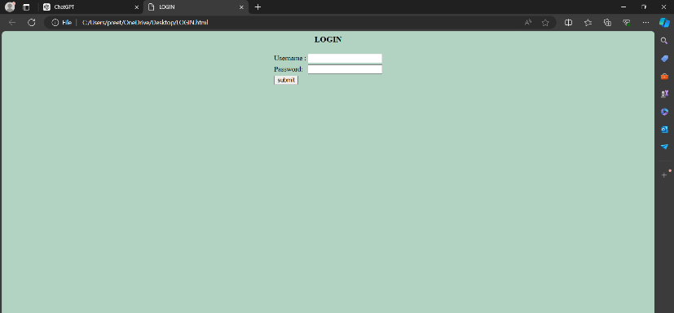

**REGISTRATION.HTML**

<html>

<head>

<title> Registration </title>

</head>

<body>

<body style="background-color:B2D3C2">

<form>

<h3><b><center> REGISTRATION FORM </center> </b></h3>

<table border="0" align="center">

<tr>

<td>First Name : </td>

<td><input type ="text"></td>

</tr>

<tr>

<td>Last Name : </td>

<td><input type ="text"></td>

</tr>

<tr>

<td>Phone number: </td>

<td><input type ="text"></td>

</tr>

<tr>

<td>Gender : </td>

<td><input type ="radio" name="g">Female

<input type ="radio" name="g">Male

<input type ="radio" name="g">Other</td>

</tr>

<tr>

<td>

<ul>List of the subjects:</td>

<td><li>Java</li>

<li>C</li>

<li>c++</li></td>

</ul>

</tr>

<tr>

<td>Email: </td>

<td><input type ="text"></td>

</tr>

<tr>

<td>branch: </td>

<td><select name="branch">

<option>--SELECT--</option>

<option>CSE</option>

<option>EEE</option>

<option>ECE</option>

</td>

</tr>

<tr>

<td>Address: </td>

<td> <textarea rows="5" cols="5"> </textarea> </td>

</tr>

<tr>

<td>DOB: </td>

<td><input type ="date"></td>

</tr>

<tr>

<td>HOBBIES</td>

<td><input type="checkbox" name="rcb">playing cricket</input>

<input type="checkbox" name="rcb">reading books</input></td>

</tr>

<tr>

<td>Landmark: </td>

<td><input type="text" name="input" placeholder="(optional)"></td>

</tr>

</form>

</body>

</html>

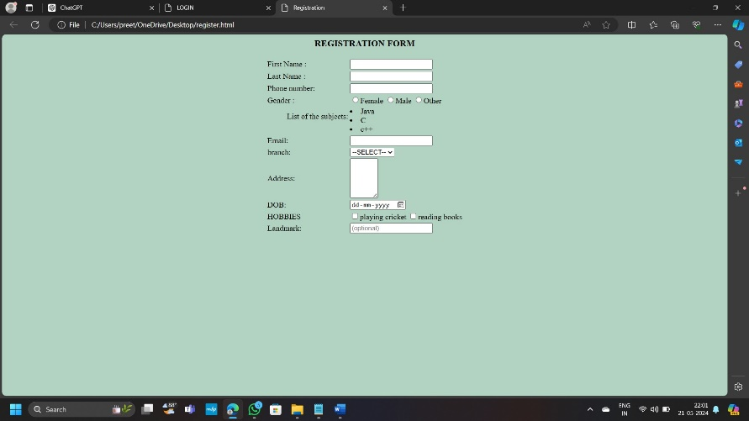

**VIDEO.HTML**

<html>

<head>

</head>

<body><center>

VIDEO<br>

<br>

<video width="400" controls>

<source src="C:/Users/srivy/Downloads/radhe.mp4" type="video/mp4">

</center>

</video>

</body>

</html>

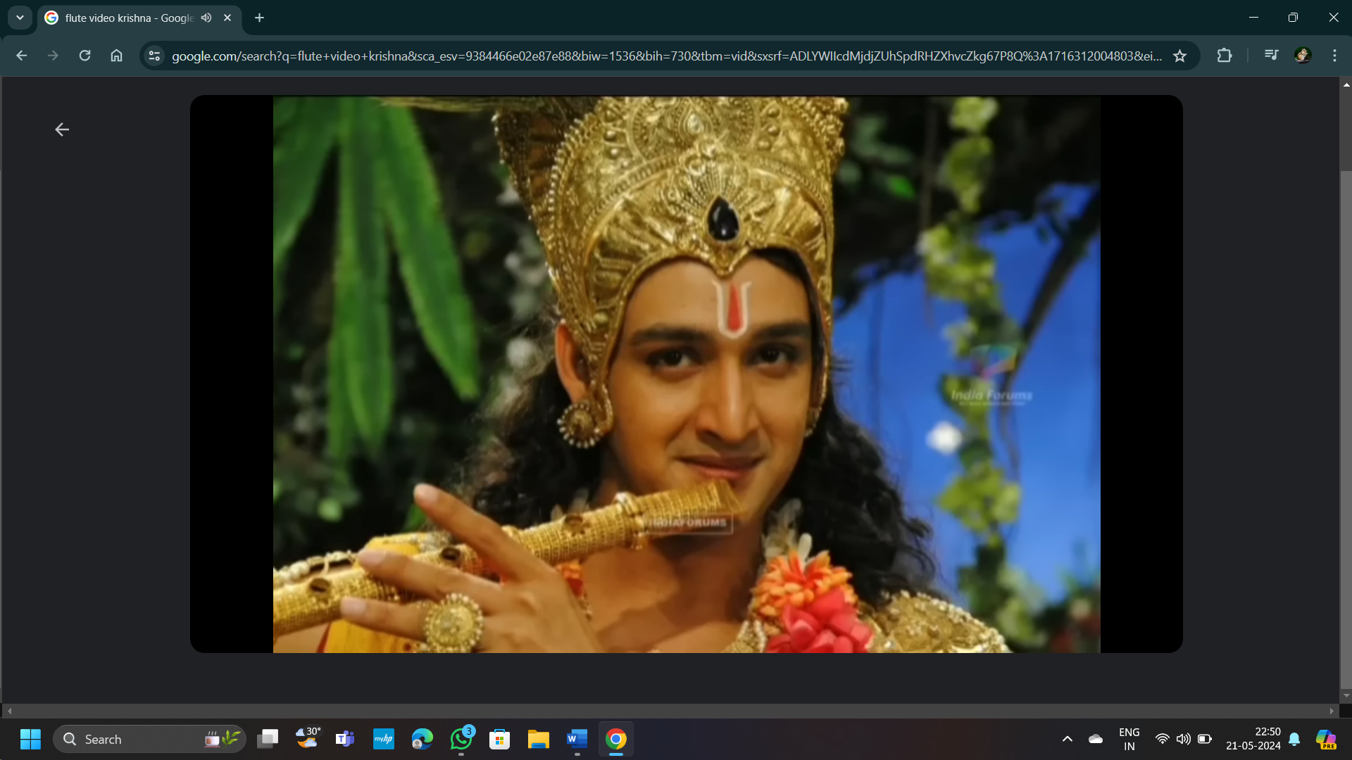

**AUDIO.HTML**

<html>

<body><center>

AUDIO<br>

<br>

<audio controls>

<source src="C:/Users/srivy/Downloads/aud.mp3" type="audio/mpeg"></center>

</audio>

</body>

</html>

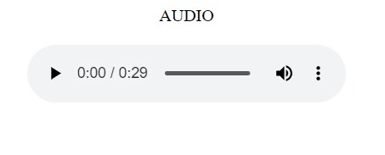

**MAP.HTML**

<html>

<body align="center">

<iframe src="https://www.google.com/maps/embed?pb=!1m18!1m12!1m3!1d3807.1930794820496!2d78.65009197455531!3d17.40251930237024!2m3!1f0!2f0!3f0!3m2!1i1024!2i768!4f13.1!3m3!1m2!1s0x3bcb90cedb836e63%3A0xae409c5cd6f1ce0c!2sNalla%20Narasimha%20Reddy%20Education%20Society%E2%80%99s%20Group%20of%20Institutions!5e0!3m2!1sen!2sin!4v1716309882498!5m2!1sen!2sin" width="600" height="450" style="border:0;" allowfullscreen="" loading="lazy" referrerpolicy="no-referrer-when-downgrade"></iframe>

</body>

</html

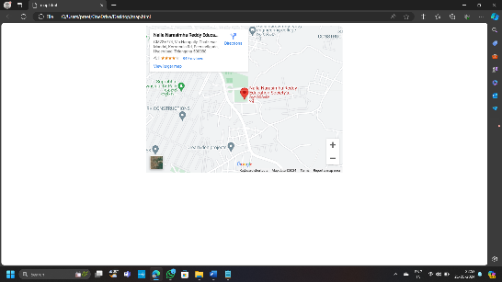

**UPLOADFILE.HTML**

<html>

<head>

<title>File Upload</title>

</head>

<body>

<input type="file" name="fileToUpload" id="fileToUpload">

<input type="submit" value="Upload File" name="submit">

</body>

</html>

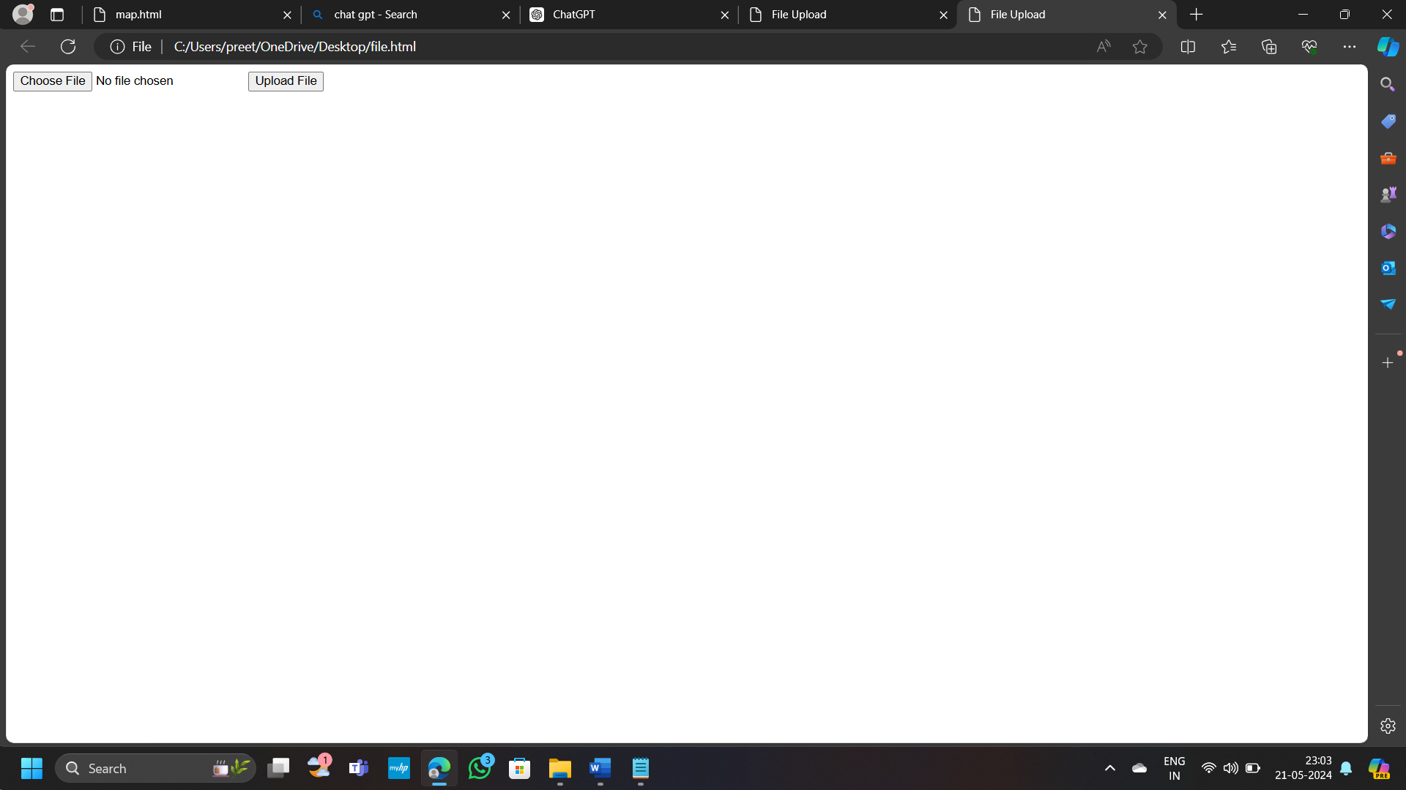

List all Users,Update user and Delete user(Popup for confirmation eg:Are you sure do you want to delete)t