**Topics: Descriptive Statistics and Probability**

1. Look at the data given below. Plot the data, find the outliers and find out $μ, σ, σ^{2}$

|  |  |
| --- | --- |
| **Name of company** | **Measure X** |
| Allied Signal | 24.23% |
| Bankers Trust | 25.53% |
| General Mills | 25.41% |
| ITT Industries | 24.14% |
| J.P.Morgan & Co. | 29.62% |
| Lehman Brothers | 28.25% |
| Marriott | 25.81% |
| MCI | 24.39% |
| Merrill Lynch | 40.26% |
| Microsoft | 32.95% |
| Morgan Stanley | 91.36% |
| Sun Microsystems | 25.99% |
| Travelers | 39.42% |
| US Airways | 26.71% |
| Warner-Lambert | 35.00% |

Solution: 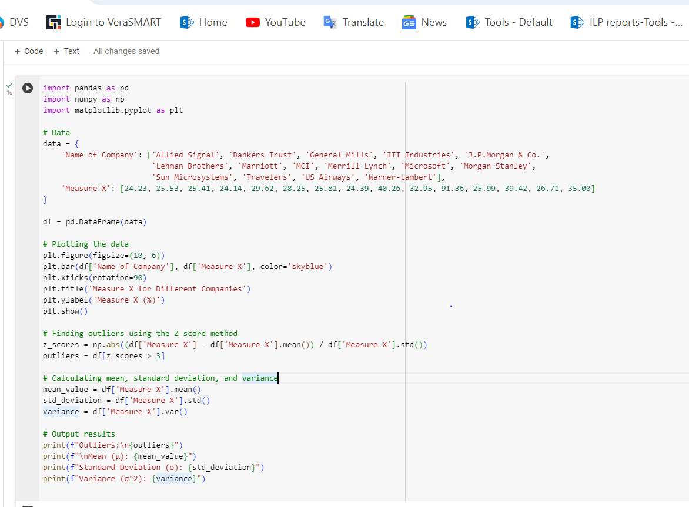

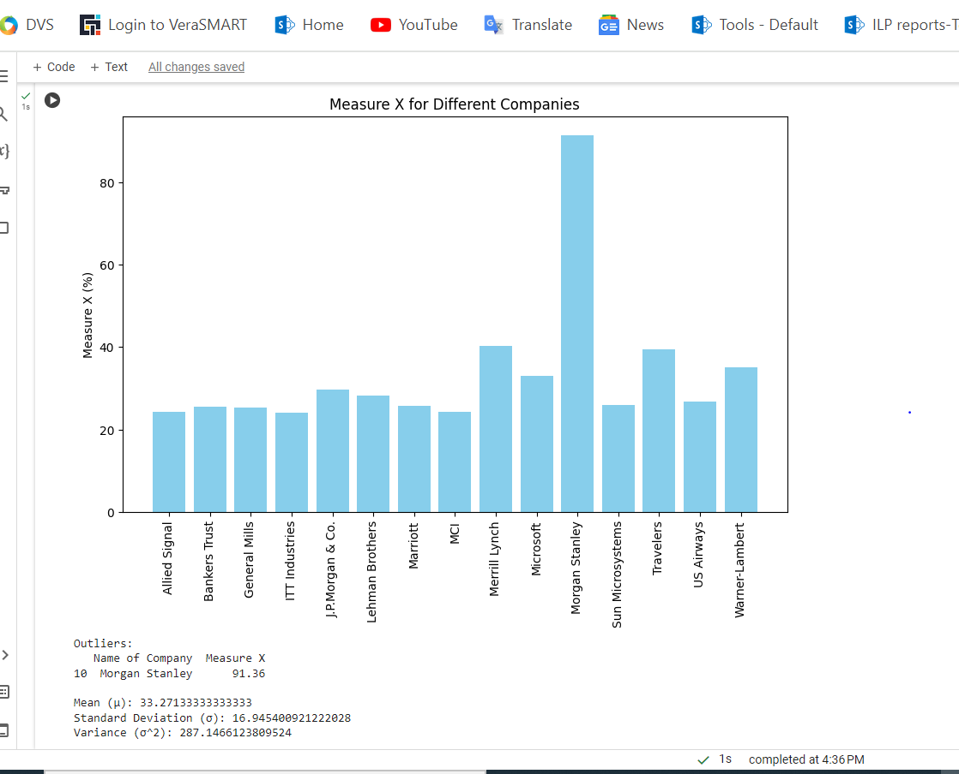



Answer the following three questions based on the box-plot above.

1. What is inter-quartile range of this dataset? (please approximate the numbers) In one line, explain what this value implies.
2. What can we say about the skewness of this dataset?
3. If it was found that the data point with the value 25 is actually 2.5, how would the new box-plot be affected?

Solution:

(i) In above diagram, 25 is outlier. Median is 7, 1st quartile is 5, 2nd quartile is 12, and IQR is 12-5=7

Here IQR tells us the range of the middle half of the data

(ii) we can say that the data is positively skewed

1. If it was found that the data value 25 is 2.5 then, there have been no outliers in the boxplot. Also, it would change the values of mean and median too. Also, boxplot would move to right slightly.



Answer the following three questions based on the histogram above.

1. Where would the mode of this dataset lie?
2. Comment on the skewness of the dataset.
3. Suppose that the above histogram and the box-plot in question 2 are plotted for the same dataset. Explain how these graphs complement each other in providing information about any dataset.

Solution: (i) Mode refers to the most frequent value in the data, so as per above boxplot it would be between 5 to 8

(ii) It is positively skewed

(iii) By comparing both the charts, the data would be positively skewed. Also, would help us in finding mean, mode values.

1. AT&T was running commercials in 1990 aimed at luring back customers who had switched to one of the other long-distance phone service providers. One such commercial shows a businessman trying to reach Phoenix and mistakenly getting Fiji, where a half-naked native on a beach responds incomprehensibly in Polynesian. When asked about this advertisement, AT&T admitted that the portrayed incident did not actually take place but added that this was an enactment of something that “could happen.” Suppose that one in 200 long-distance telephone calls is misdirected. What is the probability that at least one in five attempted telephone calls reaches the wrong number? (Assume independence of attempts.)

Solution: Probability of call getting misdirected = (1/200)

Hence probability of call not getting misdirected =1-(1/200)=199/200

Number of phone calls attempted=5

Hence probability that at least one in 5 attempted calls reaches the wrong number is:

=1-(199/200)^5

=0.025

1. Returns on a certain business venture, to the nearest $1,000, are known to follow the following probability distribution

|  |  |
| --- | --- |
| x | P(x) |
| -2,000 | 0.1 |
| -1,000 | 0.1 |
| 0 | 0.2 |
| 1000 | 0.2 |
| 2000 | 0.3 |
| 3000 | 0.1 |

1. What is the most likely monetary outcome of the business venture?
2. Is the venture likely to be successful? Explain
3. What is the long-term average earning of business ventures of this kind? Explain
4. What is the good measure of the risk involved in a venture of this kind? Compute this measure

Solution: (i) 2000

(ii) Yes, as the total earning of the venture is positive in value i.e. 800 and highest probability of earning is 2000

(iii) Total Income = 800

|  |  |  |
| --- | --- | --- |
| x | P(x) | Income (x*P(X)) |
| -2,000 | 0.1 | -200 |
| -1,000 | 0.1 | -100 |
| 0 | 0.2 | 0 |
| 1000 | 0.2 | 200 |
| 2000 | 0.3 | 600 |
| 3000 | 0.1 | 300 |

1. In the context of probability distributions for financial outcomes, a common measure of risk is the standard deviation. The standard deviation provides a measure of how spread out the possible values are from the mean.

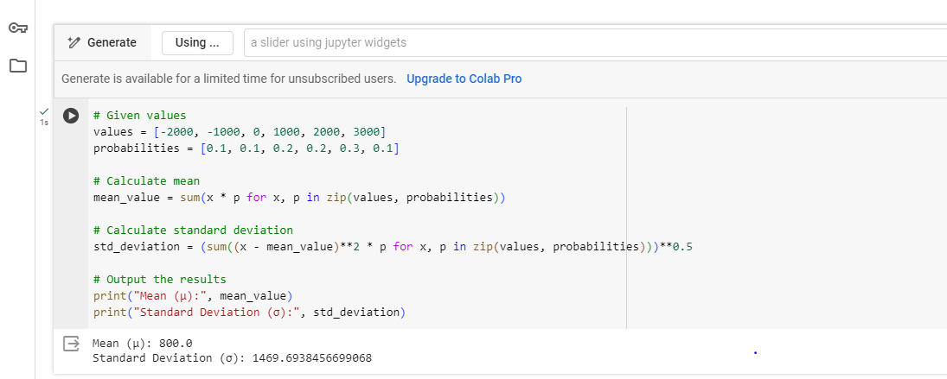

The standard deviation provides a measure of the risk involved in the business venture. A higher standard deviation indicates greater variability and, consequently, greater risk.