**antibiotic**,

chemical substance produced by a living organism, generally a microorganism, that is [detrimental](https://www.merriam-webster.com/dictionary/detrimental) to other microorganisms. Antibiotics commonly are produced by [soil](https://www.britannica.com/science/soil) microorganisms and probably represent a means by which organisms in a complex [environment](https://www.merriam-webster.com/dictionary/environment), such as soil, control the growth of competing microorganisms. Microorganisms that produce antibiotics useful in preventing or treating disease include the [bacteria](https://www.britannica.com/science/bacteria) and the [fungi](https://www.britannica.com/science/fungus).

Antibiotics came into worldwide prominence with the introduction of [penicillin](https://www.britannica.com/science/penicillin) in 1941. Since then they have revolutionized the [treatment](https://www.britannica.com/science/therapeutics) of bacterial infections in humans and other animals. They are, however, ineffective against [viruses](https://www.britannica.com/science/virus).

Antibiotic resistance

A problem that has plagued antibiotic [therapy](https://www.britannica.com/science/therapeutics) from the earliest days is the resistance that [bacteria](https://www.britannica.com/science/bacteria) can develop to the [drugs](https://www.britannica.com/science/drug-chemical-agent). An antibiotic may kill virtually all the bacteria causing a disease in a patient, but a few bacteria that are genetically less [vulnerable](https://www.merriam-webster.com/dictionary/vulnerable) to the effects of the [drug](https://www.britannica.com/science/drug-chemical-agent) may survive. These go on to reproduce or to transfer their resistance to others of their species through processes of [gene](https://www.britannica.com/science/gene) exchange. With their more vulnerable competitors wiped out or reduced in numbers by antibiotics, these resistant strains proliferate. The end result is bacterial infections in humans that are untreatable by one or even several of the antibiotics customarily effective in such cases. The [indiscriminate](https://www.merriam-webster.com/dictionary/indiscriminate) and inexact use of antibiotics encourages the spread of such bacterial resistance. (See [antibiotic resistance](https://www.britannica.com/science/antibiotic-resistance).)

Researchers are continually working to discover new antibiotics as a means of overcoming antibiotic resistance. Some potentially effective [compounds](https://www.merriam-webster.com/dictionary/compounds) that have been discovered include certain bacterial toxins and antimicrobial peptides. Novel treatment strategies, such as combining synergistic antibiotics to boost the killing of bacteria, are also under investigation. It may be possible to introduce compounds into bacterial populations that effectively resensitize the bacteria to existing antibiotic drugs.

**Scope of the problem**

Antibiotic resistance is rising to dangerously high levels in all parts of the world. New resistance mechanisms are emerging and spreading globally, threatening our ability to treat common infectious diseases. A growing list of infections – such as pneumonia, tuberculosis, blood poisoning, gonorrhoea, and foodborne diseases – are becoming harder, and sometimes impossible, to treat as antibiotics become less effective.

Where antibiotics can be bought for human or animal use without a prescription, the emergence and spread of resistance is made worse. Similarly, in countries without standard treatment guidelines, antibiotics are often over-prescribed by health workers and veterinarians and over-used by the public.

Without urgent action, we are heading for a post-antibiotic era, in which common infections and minor injuries can once again kill.

**Prevention and control**

Antibiotic resistance is accelerated by the misuse and overuse of antibiotics, as well as poor infection prevention and control. Steps can be taken at all levels of society to reduce the impact and limit the spread of resistance.

**Individuals**

To prevent and control the spread of antibiotic resistance, individuals can:

* Only use antibiotics when prescribed by a certified health professional.
* Never demand antibiotics if your health worker says you don’t need them.
* Always follow your health worker’s advice when using antibiotics.
* Never share or use leftover antibiotics.
* Prevent infections by regularly washing hands, preparing food hygienically, avoiding close contact with sick people, practising safer sex, and keeping vaccinations up to date.
* Prepare food hygienically, following the WHO Five Keys to Safer Food (keep clean, separate raw and cooked, cook thoroughly, keep food at safe temperatures, use safe water and raw materials) and choose foods that have been produced without the use of antibiotics for growth promotion or disease prevention in healthy animals.

**Policy makers**

To prevent and control the spread of antibiotic resistance, policy makers can:

* Ensure a robust national action plan to tackle antibiotic resistance is in place.
* Improve surveillance of antibiotic-resistant infections.
* Strengthen policies, programmes, and implementation of infection prevention and control measures.
* Regulate and promote the appropriate use and disposal of quality medicines.
* Make information available on the impact of antibiotic resistance.

**Health professionals**

To prevent and control the spread of antibiotic resistance, health professionals can:

* Prevent infections by ensuring your hands, instruments, and environment are clean.
* Only prescribe and dispense antibiotics when they are needed, according to current guidelines.
* Report antibiotic-resistant infections to surveillance teams.
* Talk to your patients about how to take antibiotics correctly, antibiotic resistance and the dangers of misuse.
* Talk to your patients about preventing infections (for example, vaccination, hand washing, safer sex, and covering nose and mouth when sneezing).

**Healthcare industry**

To prevent and control the spread of antibiotic resistance, the health industry can:

* Invest in research and development of new antibiotics, vaccines, diagnostics and other tools.

**Agriculture sector**

To prevent and control the spread of antibiotic resistance, the agriculture sector can:

* Only give antibiotics to animals under veterinary supervision.
* Not use antibiotics for growth promotion or to prevent diseases in healthy animals.
* Vaccinate animals to reduce the need for antibiotics and use alternatives to antibiotics when available.
* Promote and apply good practices at all steps of production and processing of foods from animal and plant sources.
* Improve biosecurity on farms and prevent infections through improved hygiene and animal welfare.

**Recent developments**

While there are some new antibiotics in development, none of them are expected to be effective against the most dangerous forms of antibiotic-resistant bacteria.

Given the ease and frequency with which people now travel, antibiotic resistance is a global problem, requiring efforts from all nations and many sectors.

**Impact**

When infections can no longer be treated by first-line antibiotics, more expensive medicines must be used. A longer duration of illness and treatment, often in hospitals, increases health care costs as well as the economic burden on families and societies.

Antibiotic resistance is putting the achievements of modern medicine at risk. Organ transplantations, chemotherapy and surgeries such as caesarean sections become much more dangerous without effective antibiotics for the prevention and treatment of infections.

**WHO response**

Tackling antibiotic resistance is a high priority for WHO. A global action plan on antimicrobial resistance, including antibiotic resistance, was endorsed at the World Health Assembly in May 2015. The global action plan aims to ensure prevention and treatment of infectious diseases with safe and effective medicines.

The “Global action plan on antimicrobial resistance” has 5 strategic objectives:

* To improve awareness and understanding of antimicrobial resistance.
* To strengthen surveillance and research.
* To reduce the incidence of infection.
* To optimize the use of antimicrobial medicines.
* To ensure sustainable investment in countering antimicrobial resistance.

A political declaration endorsed by Heads of State at the United Nations General Assembly in New York in September 2016 signalled the world’s commitment to taking a broad, coordinated approach to address the root causes of antimicrobial resistance across multiple sectors, especially human health, animal health and agriculture. WHO is supporting Member States to develop national action plans on antimicrobial resistance, based on the global action plan.

ANTIBIOTIC RESISTANCE

Massive use of antibiotics the past 80 years, both appropriate and inappropriate has lead to: ANTIBIOTIC RESISTANCE Photo: Drug resistance by Iqbal Osman (from flickr). 6 Increased occurrence and spread of bacteria that are resistant to antibiotics

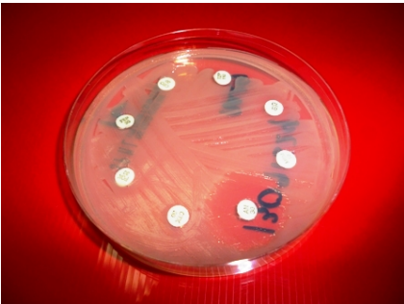

ANTIBIOTIC RESISTANCE = The ability of bacteria to protect themselves against the effects of an antibiotic ANTIBIOTIC RESISTANCE

• Bacteria are experts at surviving in changing environments

• In large bacterial populations there are often a few resistant bacteria

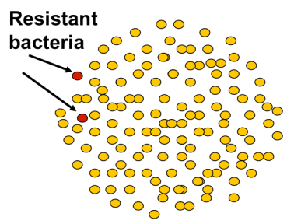

• Antibiotics select for resistant bacteria

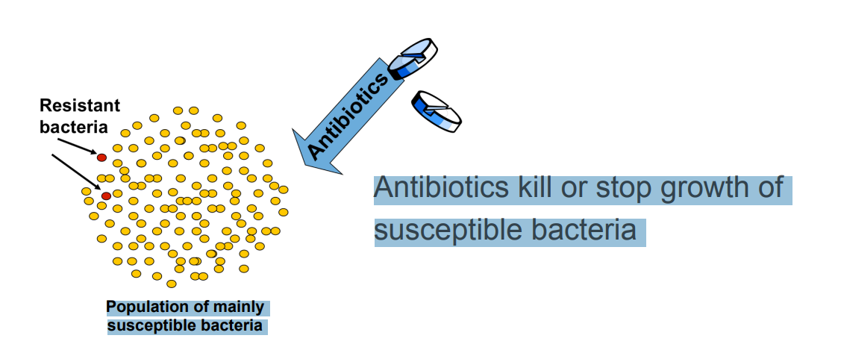

• Antibiotics select for resistant bacteria

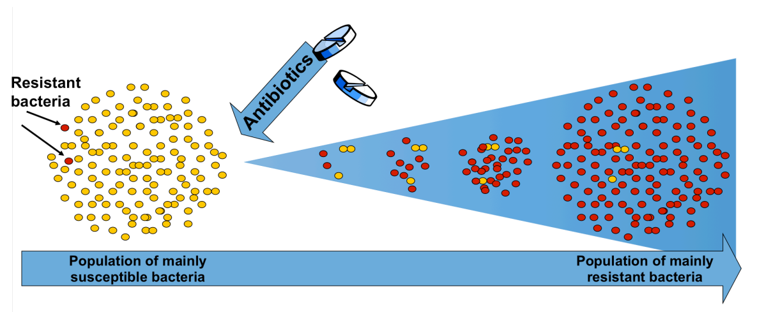

Is antibiotic resistance a problem?

• Antibiotic resistance leads to treatment failures

• Antibiotic resistance threatens our ability to perform modern medical procedures

• Antibiotic resistance imposes a major economic burden on society

• Antibiotic resistant bacteria already cause many deaths around the world

Antibiotic resistant bacteria each year cause:

• More than 38,000 deaths in Thailanda

• More than 23,000 deaths in the USAb

• 25,000 deaths in the European Unionc

… but the consequences of antibiotic resistance are most severe for the poor. For example:

• In South Asia (India, Pakistan, Afghanistan, Nepal, Bangladesh) one newborn child dies every 5 minutes from blood stream infections (sepsis) because the antibiotics given are not effective due to bacterial resistancea

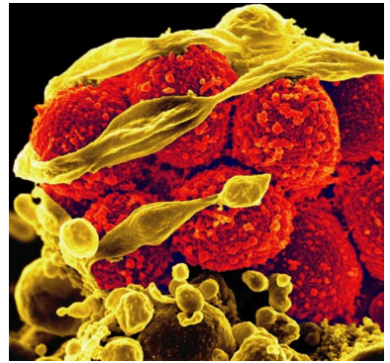

• Antibiotic resistance is a global issue!

– Exists on all continents

– Affects both low- and high income countries

– Affects both strong and weak health systems

How did we end up here?

USE & INAPPROPRIATE USE OF ANTIBIOTICS

• Use in human and animal medicine

• Use to increase growth of farm animals

• Use for routine prophylaxis in farm animals

SPREAD OF RESISTANT BACTERIA

• Poor hygiene and sanitation

• Food and water

• Travel

LACK OF NEW ANTIBIOTICS

• No new drugs for typhoid fever, gonorrhea, blood stream infections or postoperative infections

• Some bacteria already resistant to all available antibiotics

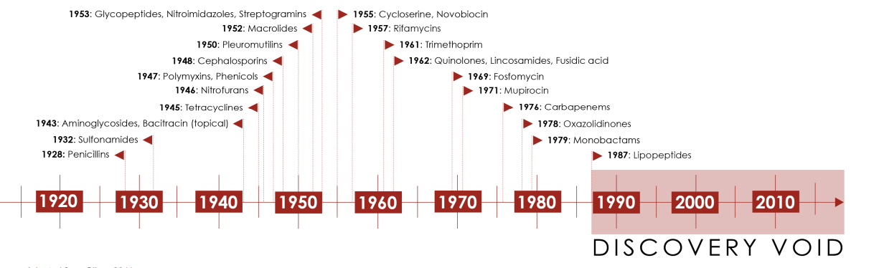

WHAT CAN YOU DO?

• Use antibiotics only when you need it – Not for a common cold or the flu

• Ask your doctor for advise – Don’t pressure – Don’t self medicate

• Wash your hands, especially…. – Before and after handling and preparing food – After visiting the bathroom

• Teach others about antibiotic resistance