Power BI Screenshot after the installation: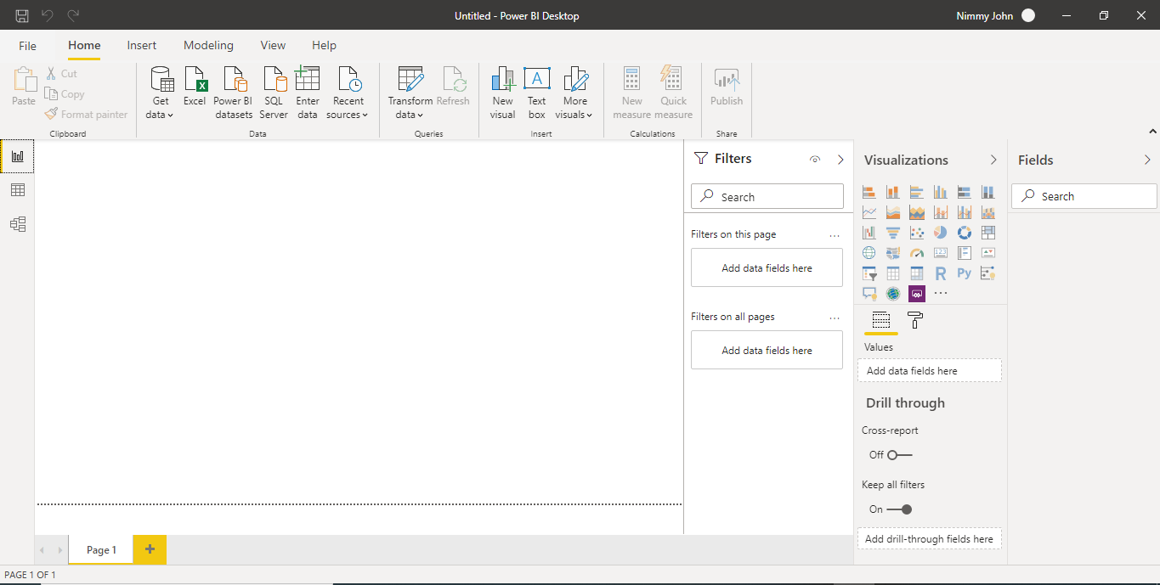

1. Report View: Section where reports are displayed. We can create different kinds of charts – Bar chart, Pie chart, Histogram, tabular form, etc.

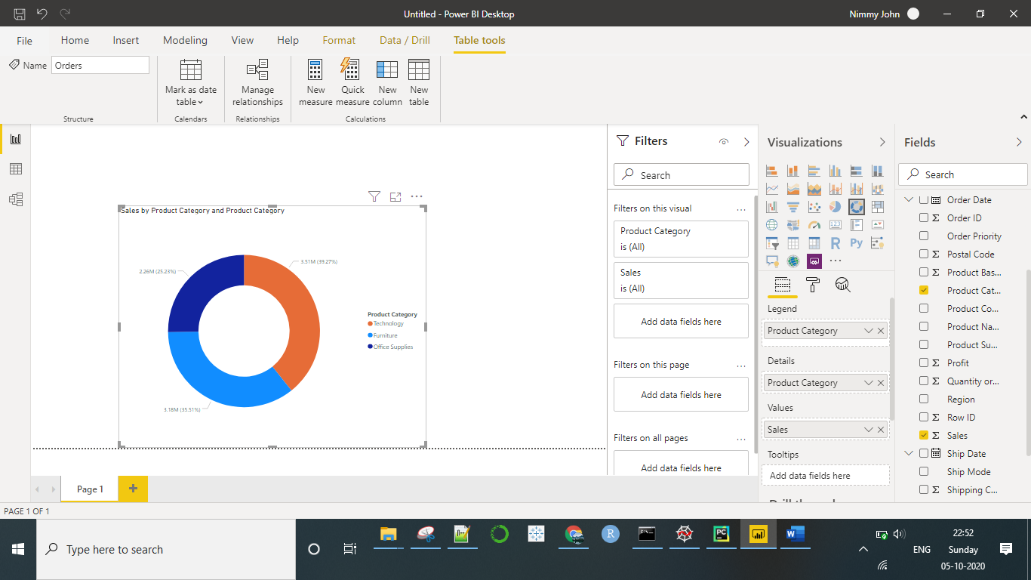

1. Data View: Section where we can see data in tabular format.

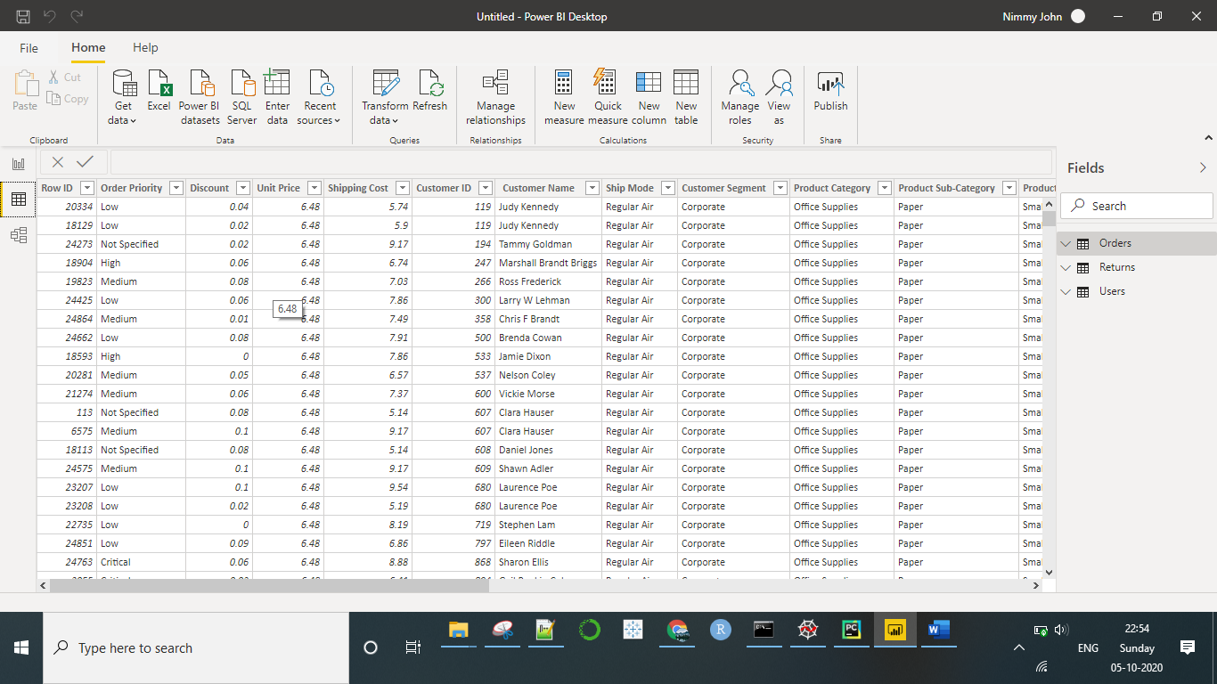

1. Model View: Model View is the section where we can showcase one/many – one/many relationship between different tables. Helpful to understand complex relationship in tables.

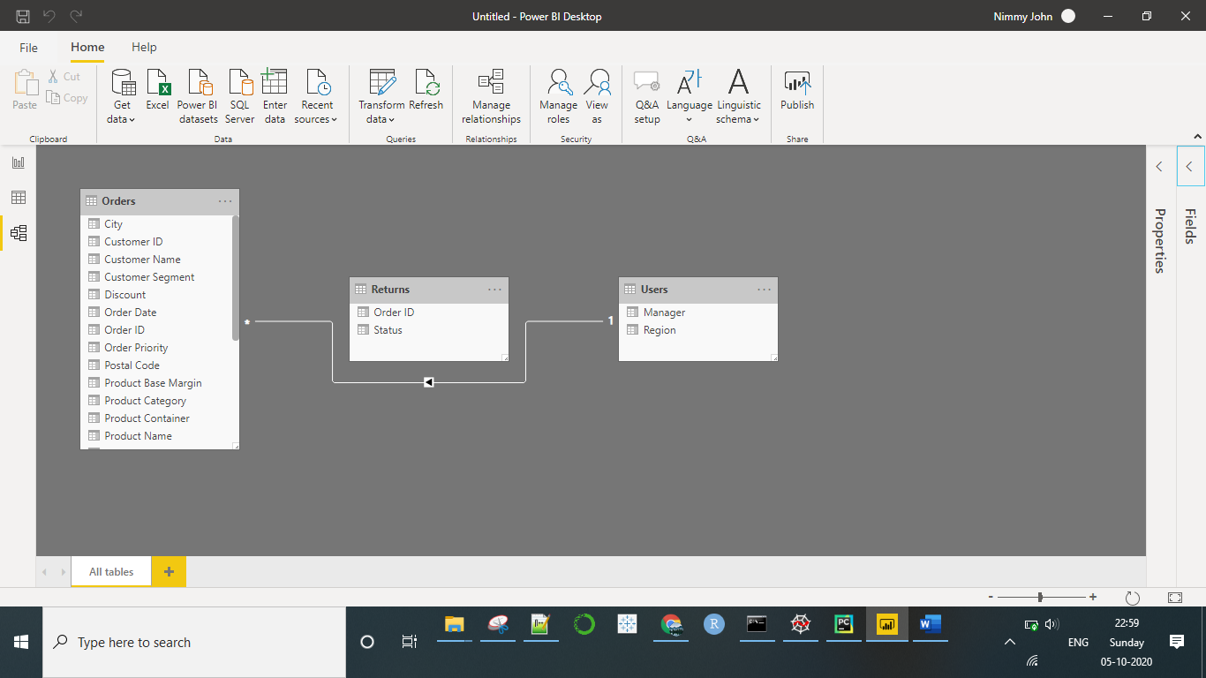

1. Power Query Editor View: The Power Query Editor view appears when we need to transform data that we have imported. We can change data type for the columns, edit the column headers, remove rows with null values, etc.

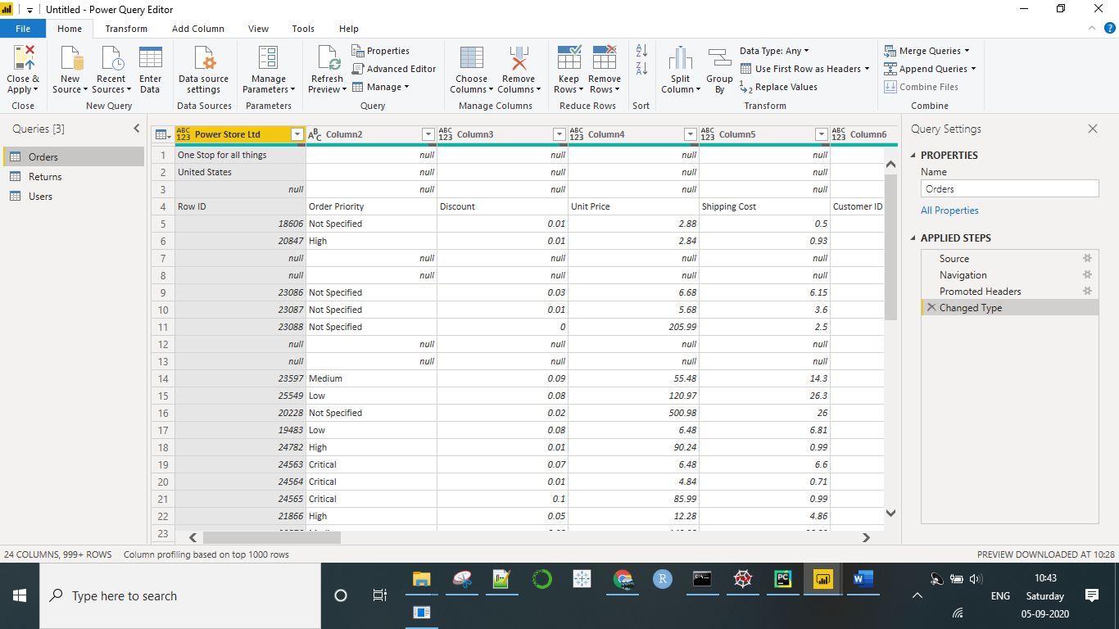

**Prepare a document with details of the following along with their price − Power BI Desktop − Power BI Pro − Power BI Premium**

**Power BI Desktop:** Power BI Desktop version is a free application which helps you to read transform, and visualize data.

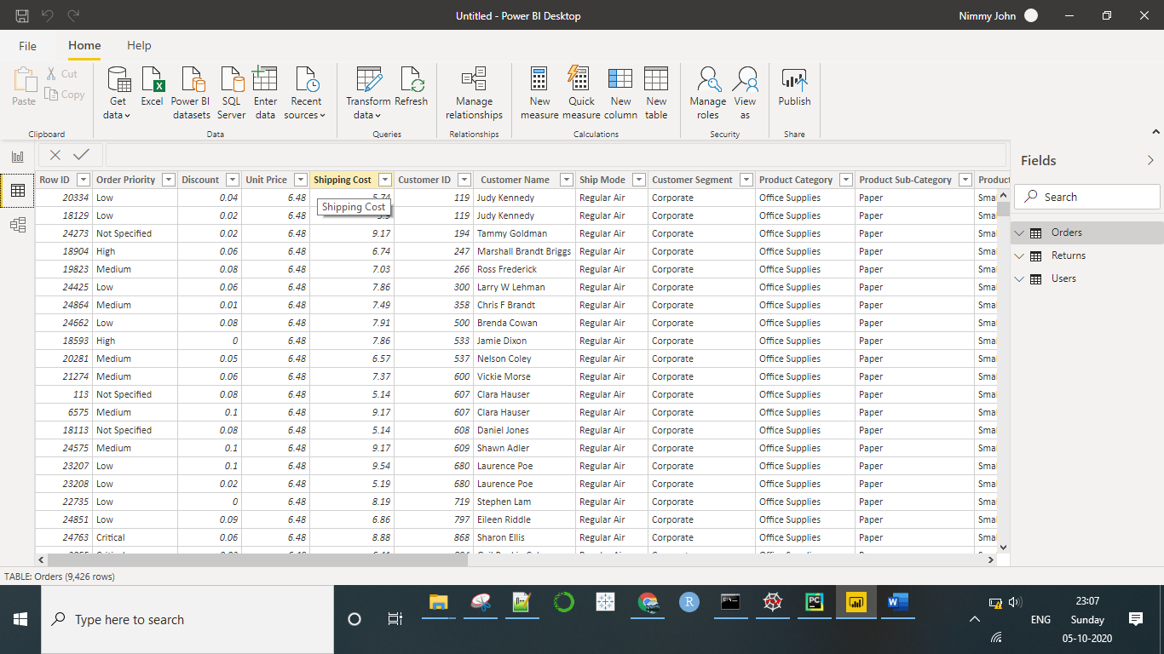

**Power BI Pro:** The software is a paid version of Power BI Desktop. Monthly charges for the software might go up to $ 9.99 or 660 in Indian Rupees per month. The software which includes Office 365 application is licensed per person. It has setup in cloud and has shared compute processing environment. The software allots maximum storage of 10 GB per user and individual dataset can have maximum size of only 1 GB.

Data security and encryption for this version is enabled. Content creation and publishing/sharing is monitored. Microsoft provides additional support to the users with immediate response related to queries asked.

**Power BI Premium:** This software is also a paid version. Monthly charges might go up to $ 4995 or 3,30,190 in Indian Rupees. The software is not licensed to individual user, rather used by companies. It has all the features of Power BI Pro version. The compute processing environment is not shared, rather is dedicated. Reports are published through Power BI Report Server. Power BI content can be deployed to many regions. It has additional AI-powered data modelling feature using AutoML, Cognitive Services, and Azure Machine Learning. This version of software allots maximum storage of 100 TB and individual dataset can have maximum size of 10 GB. Power BI Premium also supports fixed layout documents optimized for printing and archiving