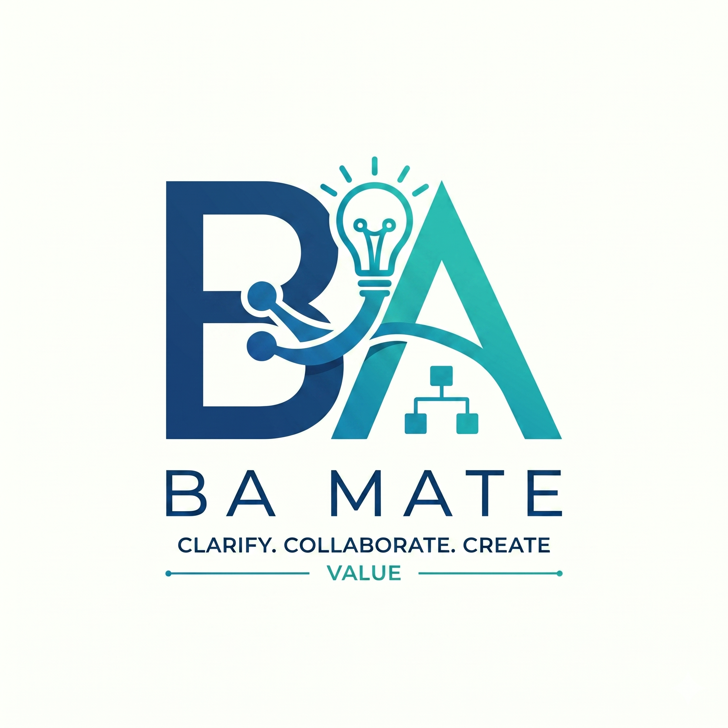

BA Mate Testing and Feedback
Guide 3 of 3 · Optional public beta testing · v1.0.5 research beta
Use this pack to try a fictional case and report what happened. The forms are separate from ordinary BA work. Complete the parts that apply; you do not need to answer every question.

1 Choose a small test
Install and select BA Mate using Guide 1. Choose one task below. Record the actual tool, model, outcome and help you needed. A copied folder or a plausible answer alone does not prove the skill loaded.
Task | Fictional input or action | What to check
Missing decision | A studio wants unpaid seats released “quickly”; no deadline is supplied. | Asks for the deadline and starting event; does not invent numbers or answers.
Contradictory proposal | Supply a rule retaining paid seats, then a draft that releases every seat. | Finds the contradiction even with a valid citation; blocks affected approval.
Changed baseline | Retain a fictional 36 hour baseline, then request 48 hours. | Preserves the old contents and prepares affected drafts for revalidation.
Resume and export | Save a draft, resume from its records and export it. | Uses available history, labels draft status and discloses open items or failures.

Guide 2 supplies the full pottery example. Record unavailable capabilities as unavailable. After a repair, repeat the failed task and affected journey; retain both results.

Complete the relevant pages
Record the test details and result. Ratings, written comments and reviewer notes are optional. Type into the answer areas in Word, or print and write on the lines. Keep completed copies privately until you have checked what is safe to share.

Check the current limits
No host is fully qualified across all workflows; practitioner pilot findings remain pending. Read the compatibility record for the 24 October 2026 successes, failures and unverified corrections.
Compatibility record · Qualification procedures

2 Test details
Use one run code for all pages relating to this task. Record only what you know. “Unknown”, “not exposed” and “not measured” are valid answers; missing measurements are not zero.

Your test setup
Run code and test date
Use a random code, not a participant name.
Type here
Fictional case and task
Name the case or version and describe what you tried to do.
Type here

AI tool and version
Give the app, IDE or CLI and its version. This is the host.
Type here
Provider and actual model label
Use the visible model name and revision if exposed; otherwise write unknown.
Type here
Skill and framework versions
Expected: package 1.0.5 beta; framework F4-draft.1; schema 1. Confirm or correct; add commit if known.
Type here
Available tools and skill activation
Note file access, Python or extraction tools, how you selected BA Mate and any observed SKILL.md read.
Type here

Optional session details
Timing and usage if measured
Start, end, breaks, correction effort and exposed usage. Leave unmeasured values missing.
Type here
Previous BA Mate experience
First use or previous experience; omit identifying details.
Type here

3 Test result
Run code: use the same code as on the test-details page. Describe the output you observed, including limitations and help you supplied. Do not convert an unfinished or unavailable test into a pass.
Overall outcome
☐ Completed ☐ Partial ☐ Failed ☐ Timed out ☐ Unavailable
What did you expect to happen
State the behaviour you were checking.
Type here

What actually happened
Describe the useful result, missing behaviour or failure. Identify affected mode or artifact revisions if known.
Type here

What assistance or correction was needed
Include human help, repeated attempts, errors, invented rules or numbers, and time spent correcting them if measured.
Type here

How could someone reproduce it
Give a short fictional prompt, necessary inputs and the relevant output. Omit private paths and identifying content.
Type here

Retest result if one was performed
What changed, which task and affected journey you repeated, and the new outcome. Retain the earlier run code.
Type here

You can submit one useful observation without completing the optional ratings or reviewer assessment. The written-feedback page explains how to return a sanitised report through GitHub.

4 Optional experience ratings
These questions describe your experience, not objective accuracy or a validated usability score. Mark one box per item. You may leave an item unanswered, choose NA or choose Skip. If your editor does not support the controls, type your chosen number beside the question.
Run code
Use the same random code as your test result.
Type here

Agreement scale
1 Strongly disagree · 2 Disagree · 3 Neither · 4 Agree · 5 Strongly agree
NA = Not applicable. Skip = Prefer not to answer.
F1 I could understand what to do next.
☐ 1 ☐ 2 ☐ 3 ☐ 4 ☐ 5 ☐ NA ☐ Skip
F2 I could identify which statements still needed confirmation.
☐ 1 ☐ 2 ☐ 3 ☐ 4 ☐ 5 ☐ NA ☐ Skip
F3 I could review and correct the artifact effectively.
☐ 1 ☐ 2 ☐ 3 ☐ 4 ☐ 5 ☐ NA ☐ Skip
F4 The effort required was reasonable for this task.
☐ 1 ☐ 2 ☐ 3 ☐ 4 ☐ 5 ☐ NA ☐ Skip
F5 I would find this approach useful for similar requirements work.
☐ 1 ☐ 2 ☐ 3 ☐ 4 ☐ 5 ☐ NA ☐ Skip

Confidence in the artifact
How confident are you that the artifact reflects the available information? Use 1 Not at all confident to 5 Very confident, or NA / Skip. This confidence scale is separate from the agreement scale above.
Confidence rating
☐ 1 ☐ 2 ☐ 3 ☐ 4 ☐ 5 ☐ NA ☐ Skip
Use the next page for explanations, examples and suggestions. Feedback does not grant permission to share project artifacts or process them in a cloud service.

5 Written feedback and return instructions
Your comments help explain the ratings. Give a small fictional example where useful. Leave any question blank if you prefer. Do not include client, company or personal details.
Run code
Use the same random code if these comments relate to a recorded test.
Type here
What most helped your work
Which step, question, explanation or output was useful, and why?
Type here

What most obstructed or confused you
Describe the point where you got stuck, needed help or distrusted the output.
Type here

What should we improve first
Suggest one change that would make BA Mate easier or more useful for your BA work.
Type here

Return a sanitised report
Open the GitHub issue chooser below. Select installation failure, workflow defect, unsupported AI commitment or suggestion. Paste the relevant test details and comments. A short, reproducible observation is enough; the whole completed document is not required.
Open a BA Mate feedback issue
Before posting, remove identifying details, private file paths, content hashes, secrets, private artifacts and screenshots containing unrelated project content. Public feedback is voluntary. Consented study records use their actual consent and return process and must not be posted publicly. No telemetry is included.

6 Optional separate reviewer notes
Assess the actual BA artifacts against the fictional evidence. Identify whether this is self-review or an independent review. This assessment does not approve the artifacts.
Run code and artifact revisions
Identify the actual material reviewed; use a permitted role or pseudonym, not personal contact details.
Type here
Review type and method
State review type, assistance and rubric or scale. If none applies, give qualitative findings.
Type here

Findings against the supplied evidence
Replace each prompt with a finding and evidence or revision references. Use not assessed where needed; a blank is not a pass. Keep longer findings in a local note.
Dimension | Finding and evidence
Clarity | Is the meaning understandable and unambiguous?
Completeness | What necessary information or scenarios are missing?
Consistency | What conflicts within or between artifacts?
Testability | Are outcomes and criteria observable?
Relevance | Does the content address the agreed scope and need?
Transparency | Are assumptions, uncertainty and AI proposals visible?
Stakeholder coverage | Whose needs or authority are missing?
Traceability | Do revision links support the claimed meaning?
Ethical risks | What confidentiality, fairness or other risks arise?

Unsupported commitments and critical findings
Identify actual revisions and passages; note invented rules, false approval or data loss if observed.
Type here

For coverage, trace or risk measures, record units, numerators and denominators; unmeasured values stay missing. Preserve original ratings and later adjudication separately. No automatic scoring is implemented. Ratings do not approve artifacts; skills testing remains separate from the application A/B/C study.

