APNK Mini POS Software Requirements Specification
Working draft for business analyst and stakeholder review
This document describes the scope, known functional requirements, process flow and outstanding decisions for the single-station APNK Mini POS. It is a review draft: unresolved decisions and proposed acceptance checks are not stakeholder approvals.
Document detail | Value
Source | Business Requirements Document (BRD), version 1.0, four pages
Status | Working draft; stakeholder decisions and technical review pending
Scope | Small supermarket and convenience store point of sale
Prepared | 29 October 2026
Source reference | SRC-01; original BRD requirement identifiers retained below

1 Purpose and scope
The POS supports checkout, payment, inventory deduction, receipts and end-of-day reporting for a small retail operation. The BRD describes requirements for an end-to-end testing phase. This specification translates the stated scope into reviewable requirements and identifies details that must be confirmed before implementation or acceptance.

1.1 In scope
- Cashier and Store Manager authentication and role restrictions.
- Barcode or SKU lookup, cart adjustments, item-level and cart-level discounts, and automatic calculation of totals.
- Cash, card and split payments; cash tender and change calculation.
- Stock deduction after successful sales and low-stock flagging.
- Digital receipt, print command and Store Manager end-of-day Z-Report.

1.2 Boundaries and open scope
The BRD assigns returns, transaction history and register open/close to Cashiers, and inventory updates and voids to Store Managers. Their detailed rules are not specified. Card-terminal integration, offline operation, tax and discount policy, error recovery and receipt simulation versus actual printer operation require confirmation. No unmentioned feature is excluded merely because it is not detailed here.

2 Users and permissions
Role | Capabilities stated in the BRD
Cashier | Checkouts, returns, daily transaction history, and opening or closing the register.
Store Manager | All Cashier capabilities plus stock add/update, EOD reports and transaction voids.

The BRD does not identify individual people or establish how permissions are administered. Administrative functions such as inventory restock and EOD reports are restricted to the Store Manager.

3 Functional requirements
The identifiers below retain the BRD identifiers. Each review and test note is a proposed check; it does not fill in an unspecified rule. Requirements should be split further when acceptance criteria and ownership are confirmed.
REQ-AUTH-01 The system shall allow users to log in using a unique username and PIN or password.
Review and test: Check successful login using an agreed test account. Account provisioning, credential rules and failed-login handling remain open. Source: BRD section 4.1.
REQ-AUTH-02 The system shall restrict administrative features, including inventory restock and EOD reports, to the Store Manager role.
Review and test: Check access for both roles using agreed role definitions. Source: BRD section 4.1.
REQ-POS-01 The system shall support scanning a product barcode with a connected scanner or entering a barcode or SKU manually.
Review and test: Verify both entry methods with agreed product data. Unknown-item behaviour is open. Source: BRD section 4.2.
REQ-POS-02 When an item is scanned, the system shall display its name, unit price, quantity and total line price.
Review and test: Check displayed values against the selected product and quantity. Source: BRD section 4.2.
REQ-POS-03 The Cashier shall be able to adjust item quantities or remove an item from the cart before payment.
Review and test: Check that a quantity change or removal updates the cart. Allowed quantities and error handling remain open. Source: BRD section 4.2.
REQ-POS-04 The system shall calculate subtotal, applicable taxes, discounts and final total automatically.
Review and test: Compare calculations with stakeholder-approved examples. Tax, discount, rounding and stacking rules are open. Source: BRD section 4.2.
REQ-POS-05 The system shall support cash, credit or debit card, and split payment using part cash and part card.
Review and test: Exercise the payment types with an agreed test setup. Allocation, integration, decline and partial-failure rules are open. Source: BRD section 4.2.
REQ-POS-06 For cash payments, the system shall request cash tendered and accurately calculate the change to return.
Review and test: Test exact and excess tender using agreed values. Insufficient-tender handling is open. Source: BRD section 4.2.
REQ-INV-01 After a successful transaction, the system shall immediately deduct purchased quantities from the active inventory database.
Review and test: Compare stock before and after an agreed successful transaction. Failure recovery and concurrency rules are open. Source: BRD section 4.3.
REQ-INV-02 The system should flag low-stock items when inventory falls below a predefined threshold.
Review and test: Confirm the threshold and unit before specifying boundary tests. The BRD gives fewer than five units as an example, not a confirmed value. Source: BRD section 4.3.
REQ-REP-01 Upon payment completion, the system shall generate a digital receipt and trigger a print command.
Review and test: Verify the receipt and print command in the agreed environment. The BRD also refers to printable or digital format simulation; intended printer behaviour needs confirmation. Source: BRD section 4.4 and scope.
REQ-REP-02 The system shall allow the Store Manager to generate an end-of-day Z-Report containing total sales, taxes collected, payment-method breakdowns and cash-drawer balance.
Review and test: Compare each report component with agreed transactions. Day boundaries, reconciliation and calculation rules remain open. Source: BRD section 4.4.
BRD-SCOPE-01 The checkout scope includes applying discounts at item level and cart level. The allowed discount types, authorisation, order of calculation, and combinations remain open. Source: BRD section 2.
Review and test: Exercise both discount levels with agreed rules and examples; check the recalculated totals. Source: BRD section 2.

3.1 Role capabilities requiring elaboration
Cashier returns, daily transaction history and register open/close, and Store Manager stock updates and voids, are stated as permissions. The BRD does not define their detailed functional behaviour, limits or acceptance criteria. These capabilities require stakeholder clarification before they can be specified fully.

4 Process view
Figure 1 depicts only the high-level successful checkout path described in the BRD. The relative timing and failure handling of downstream operations require confirmation. The diagram is a review aid, not an approved design.
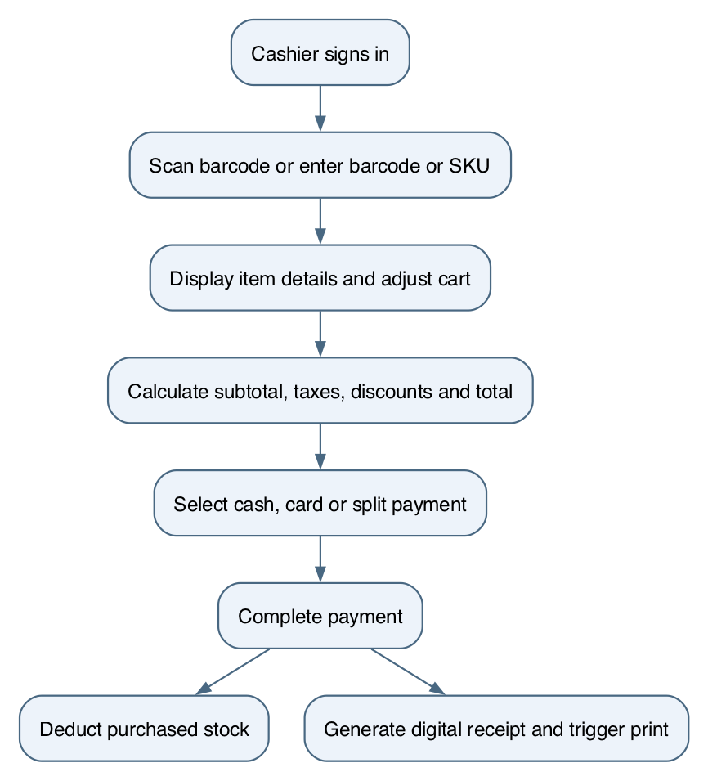
Figure 1 High-level successful checkout

5 Interfaces and data
The BRD identifies a connected barcode scanner, manual barcode or SKU entry, an active inventory database, digital receipts and a receipt-printer command. It names cash, card and split payment, but does not specify the terminal, gateway, protocols, card networks or offline behaviour. Data entities, storage schema, interfaces and integration contracts require technical and business review.

6 Quality attributes and constraints
The BRD identifies a lightweight, single-station system. It does not supply measurable performance, availability, recovery, backup, accessibility, security, audit-retention or deployment targets. These are open decisions; no numerical targets are asserted in this draft.

7 Open decisions
ID | Decision requiring confirmation
OD-01 | Low-stock threshold, unit of measure and whether it varies by product.
OD-02 | Card networks, terminal or gateway integration and offline behaviour.
OD-03 | Payment decline, insufficient cash, partial split payment and recovery when inventory or receipt operations fail.
OD-04 | Returns and voids: permissions, timing, refund method, authorisation and stock effects.
OD-05 | Tax, discount, rounding and discount-combination rules.
OD-06 | Register opening and closing, cash reconciliation and report day boundary.
OD-07 | Stock adjustment validation, transaction-history scope and filters.
OD-08 | Account administration, credential rules, lockout and expected security controls.
OD-09 | Receipt content, print environment, reprint and printer failure handling.
OD-10 | Measurable quality attributes, deployment environment and acceptance authority.

8 Proposed end to end acceptance scenarios
The following candidate scenarios reflect the BRD checklist and its stated scope and requirements. They are not test results. Expected outcomes for open business rules and a representative dataset must be agreed before execution.
- Cash checkout: sign in as Cashier, scan three items, pay with exact or excess cash, and verify change, receipt and stock deduction. Related: REQ-AUTH-01, REQ-POS-01, REQ-POS-06, REQ-INV-01, REQ-REP-01.
- Split payment: add items and complete a part-cash, part-card transaction using the agreed test integration. Related: REQ-POS-05; decisions OD-02 and OD-03.
- Cart modification: add an item, change quantity, remove an item, apply a percentage discount and verify the recalculated total against agreed rules. Related: REQ-POS-03–04 and BRD-SCOPE-01; decision OD-05.
- Manager reporting: check low-stock alerts, complete a sale and generate the Z-Report; compare the report with agreed transaction and drawer records. Related: REQ-AUTH-02, REQ-INV-02, REQ-REP-02; decisions OD-01 and OD-06.
- Manual lookup and line details: enter a known barcode and a known SKU; check the selected product and displayed details. Related: REQ-POS-01–02. The BRD specifies line details for scanned items; confirm the expected display for manual entry and the behaviour for unknown items.
- Role restriction: attempt restock and EOD reporting as Cashier and as Store Manager; verify access follows the role restriction. Related: REQ-AUTH-02. Account setup and other administrative permissions need agreement.
- Discount levels: apply an item-level discount and a cart-level discount in separate cases, then compare totals with agreed examples. Related: BRD-SCOPE-01 and REQ-POS-04; decision OD-05.
- Card payment: complete a card-only sale in the agreed test environment. Related: REQ-POS-05; terminal integration and failure handling remain open under OD-02 and OD-03.

9 Review and traceability
The table below maps the documented BRD requirements to this draft. It indicates that a topic is included, not that it is complete, verified, implemented or approved. Each open decision must be assigned an owner and resolved or explicitly deferred through the project governance process.
BRD IDs | SRS coverage
REQ-AUTH-01–02 | Authentication and administrative access
REQ-POS-01–06 | Product entry, cart, totals and payment
REQ-INV-01–02 | Stock deduction and low-stock flagging
REQ-REP-01–02 | Receipts, printing and EOD reporting
BRD role permissions | Returns, register, history, stock updates and voids require detailed rules
BRD scope section 2 | BRD-SCOPE-01: item-level and cart-level discounts; rules remain open

Reviewers should confirm the business decisions, refine each requirement into individually testable statements, review the process diagram and approve the resulting baseline through the agreed human process.

