Prior-art retrieval report
Machine-generated drafting aid — not a prior-art search opinion
Search mode: Novelty Subject: US-11999030-B2 Date: 2026-07-19

Search query / invention
Vacuum gripper
A vacuum gripper comprises a rigid base element and a loop-shaped vacuum seal element. The base element has first and second opposite sides. The seal element is attached at least indire

Method & corpus
Semantic + agentic search over a 107,795-publication vacuum-gripping corpus [US/EP/WO/DE; current to 2026-04-21] (2,728,288 embedded passages). Retrieval: 8-channel adaptive cascade (dense + BM25 + CPC + citation/family + query-by-example + cross-lingual) with weighted reciprocal-rank fusion and a cross-encoder reranker. Prior-art dating by a jurisdiction-neutral novelty/inventive-step engine.
1/12 elements disclosed · 2 references cited · 6 apparently novel

Scope and measured reliability — read before relying on this document
What this document is. This is the output of a BOUNDED TECHNICAL-FIELD search tool, not a clearance search and not a professional prior-art search opinion. It searched one indexed field, to a fixed date, with measured recall well below completeness. Every conclusion below is a machine-generated drafting aid that must be checked against the cited documents before it is relied on.
Corpus. 107,795 publications, limited to 8 CPC classes covering vacuum gripping, lifting and handling. US, EP, WO, DE only — no JP, CN, KR, GB, FR or other national collections, and no non-patent literature.
Current to. 2026-04-21. Nothing published after this date was searched. For a novelty or validity question this is a live gap, and it widens every day until the next ingest.
Measured recall. 19% @100. On a 11-query internal benchmark, 19% of known-relevant families appeared in the top 100 results — roughly four in five known-relevant families were NOT surfaced. Basis: 11-query internal benchmark with human-marked relevant families; fraction of known-relevant families appearing in the top 100 results.
AI output accuracy — verify every cell. Rationales and claim charts in this document are machine-generated drafting aids, not findings. Rationales overclaimed in 8% of 40 audited cases. Of the 5 retrieval-map cells that passed verification and were then independently re-read, 2 (40%) were judged overclaims. Assume residual error and check each citation against the reference text.
Absence of results is not evidence of absence of prior art. A short result list means this corpus did not surface art — it does not mean none exists. Given the recall figure, the date ceiling, and the class and jurisdiction limits above, a negative result here cannot support a clearance, freedom-to-operate, or patentability opinion. Those require a professional search across full collections.
Indexed CPC classes: B66C1/02 — suction lifting devices; B66C1/0225 — handheld suction lifting devices; B25J15/0616 — robotic vacuum grippers; B65G47/91 — suction transfer devices; B65G49/061 — suction handling of fragile sheets; B25B11/005 — vacuum work holders; F16B47/00 — suction cups; B65G7/12 — carrying objects by hand
Not indexed: anything outside the CPC classes listed above; jurisdictions other than US, EP, WO, DE; non-patent literature, standards, product manuals and datasheets; and anything published after 2026-04-21.

Executive summary
Strongest references:
- US-11207792-B2 — Gripper, cutting apparatus and method for cutting a product (match 0.793; SECRET prior art (novelty only))
- US-3005652-A — Vacuum gripping device (match None; not dated)
Elements disclosed by the cited art: Seal element attached to second side, protruding away from first side
Apparently novel (not found in corpus): Air extraction means configured to continuously extract air from chamber, Air extraction means in fluid communication with chamber through base element, Base element second side with central area and peripheral support area, Bracing structure arranged within or outside the seal element, Seal element attachment surface mounted to peripheral support area, Seal element contact surface urged towards and grips object surface

Element × reference retrieval map
DRAFTING AID — VERIFY EVERY CELL
This grid is NOT a verified claim chart and must not be filed or relied on as one. Cells come from semantic retrieval; each cited passage is then checked by a separate model pass asked to refute it. A cell is marked 'verified' only if that check confirmed the passage teaches the element — and that check is itself imperfect. In an audit of this feature 58% of 12 cells asserting coverage were wrong before the verification pass existed. After it, an independent review re-read the 5 surviving confirmed cells against the verbatim cited passages and judged 2 of them (40%) to be overclaims. The verification pass had reported 0 of 5 rejected, but that is the verifier grading its own work. Sample sizes are small, and the verifier shares a model family with the auditing judge, so treat the independent figure as a lower bound on the error rate. Open each cited reference and read the passage before using any cell.
Invention element | US-9266686-B2 | DE-102005020840-B4 | US-2006042892-A1 | DE-102005020840-A1 | US-2018244032-A1 | EP-0095218-B1 | DE-202005007145-U1 | US-11078051-B2
Rigid base element with first and second opposite sides | unrelated  0.046  cl 6 | · | · | · | · | · | · | ·
Loop-shaped vacuum seal element | · | no passage  0.053 | · | · | · | · | no passage  0.042 | verified  0.05  cl 7
Seal element attached to second side, protruding away from first side | · | · | · | no passage  0.045 | · | · | no passage  0.04 | ·
Seal element with contact surface and encircling surface defining a chamber | · | · | verified  0.037  cl 45 | · | · | · | · | ·
Seal element elastically deformable at contact surface | · | · | · | · | · | verified  0.042  cl 4 | · | ·
Air extraction means mounted to first side | · | · | · | · | unrelated  0.038  ¶ p0020 | · | · | ·
Air extraction means in fluid communication with chamber through base element | · | · | · | · | · | · | · | ·
Air extraction means configured to continuously extract air from chamber | · | · | · | · | · | · | · | ·
Seal element contact surface urged towards and grips object surface | · | · | · | · | · | · | · | ·
Base element second side with central area and peripheral support area | · | · | · | · | · | · | · | ·
Seal element attachment surface mounted to peripheral support area | · | · | · | · | · | · | · | ·
Bracing structure arranged within or outside the seal element | · | · | · | · | · | · | · | ·
Legend: 3 verified — passage checked and it does teach the element · 2 unrelated — cited passage is about something else · 4 no passage — no specific passage exists to verify
Of 5 verifiable cells in this report, 60% survived verification. The rest did not — treat the grid as a list of passages to read, not as a finding.

Combination / inventive-step analysis
Primary reference: US-9266686-B2 — discloses: Rigid base element with first and second opposite sides
+ Secondary: DE-102005020840-B4 — supplies: Loop-shaped vacuum seal element
+ Secondary: US-2006042892-A1 — supplies: Seal element with contact surface and encircling surface defining a chamber
+ Secondary: DE-102005020840-A1 — supplies: Seal element attached to second side, protruding away from first side
+ Secondary: US-2018244032-A1 — supplies: Air extraction means mounted to first side
+ Secondary: EP-0095218-B1 — supplies: Seal element elastically deformable at contact surface
Not disclosed by any reference: Air extraction means configured to continuously extract air from chamber, Air extraction means in fluid communication with chamber through base element, Base element second side with central area and peripheral support area, Bracing structure arranged within or outside the seal element, Seal element attachment surface mounted to peripheral support area, Seal element contact surface urged towards and grips object surface

Cited references

1. US-11207792-B2 — Gripper, cutting apparatus and method for cutting a product
Assignee: WEBER MASCHB GMBH  Inventors: BAUMEISTER CHRISTIAN, JUNG-SASSMANNSHAUSEN FABIAN, KAHL PHILIP, KNAUF MICHAEL, KUHMICHEL CHRISTOPH  Priority / Filing / Published: 2017-02-07 / 2018-02-01 / 2021-12-28  Family: 61132018  CPC: B26D7/018, A47J43/18, B25J11/0045, B25J11/0055, B25J15/0616, B26D2007/011, B26D2210/02, B26D7/0633  Legal status: FEPP 2018-02-01; AS 2018-04-30; STPP 2018-06-06  Prior-art basis: SECRET prior art (novelty only) Match: 0.793  Reads on: Seal element attached to second side, protruding away from first side | 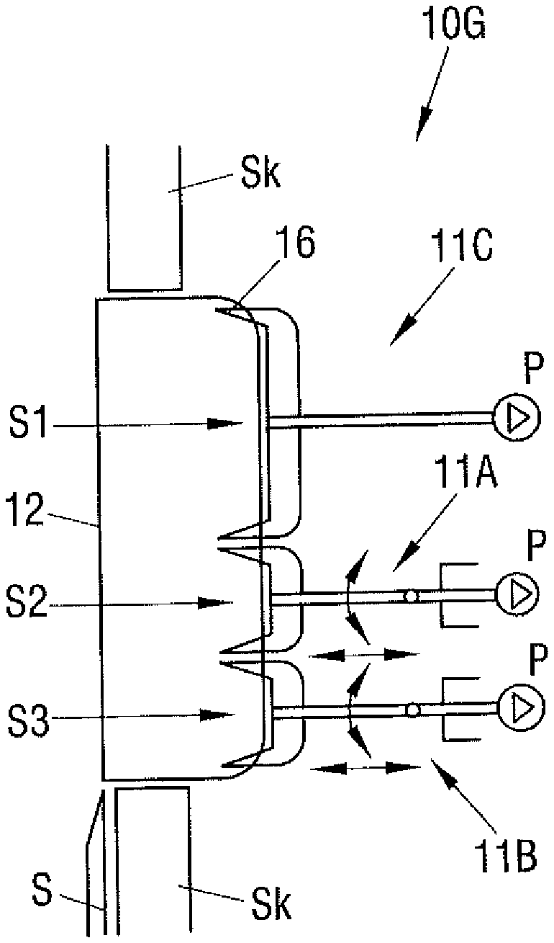  US-11207792-B2 · drawing
Why relevant: The reference appears relevant as it describes a "gripper for gripping a product" that includes a "suction device which has a contact surface" and a "sealing device" that bounds a "first suction section" and is in communication with a "pumping device generating a vacuum." This aligns with the concept of a vacuum gripper with a seal and air extraction means.
Relevant passage (paragraph ¶ p0011, similarity 0.793):
The selection of the suitable sealing device inter alia depends on the properties of the product to be gripped. Sealing devices of different designs can, if required, also be combined as desired in a gripper in order to take account of the respective present demands. An additional improvement in the sealing effect of the sealing devices can be achieved if they have suction openings in communication with the pumping device. They can then be reliably pressed toward the product surface by means of a vacuum. In accordance with a further embodiment, the first sealing device and/or the second sealing device is/are shaped such that a local compression of the product which can be brought into contact with the sealing device can be produced. The first sealing device and/or the second sealing device is/are in particular at least sectionally wedge-shaped. It is particularly efficient if two mutually oppositely disposed slopes are provided which diverge in a direction toward the product. On a gripping of the product, it is compressed by the V-shaped design of the space disposed between the slopes, which leads to the closing of possibly present pores in the product and to a good adhesion. In ot

2. US-3005652-A — Vacuum gripping device
Assignee: BEMIS BRO BAG CO  Inventors: HELM JACK D  Priority / Filing / Published: 1960-12-14 / 1960-12-14 / 1961-10-24  Family: 22127999  CPC: B66C1/0212, B66C1/0231  Legal status: filed 1960-12-14; priority 1960-12-14; granted 1961-10-24  Prior-art basis: not dated Match: None | 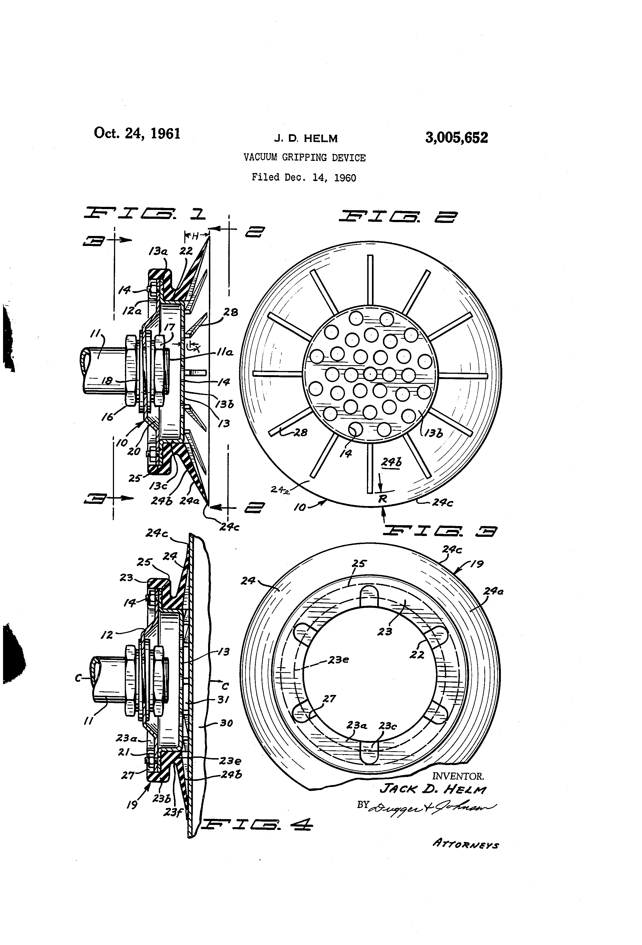  US-3005652-A · drawing
Relevant passage (whole , similarity 0.777):
Vacuum gripping device

Appendix — full ranked reference list
# | Publication | Title | Match | Basis | Channels
1 | US-10456928-B2 | Vacuum gripper unit comprising vacuum pump | 0.776 | SECRET prior art | citation, dense, qbe
2 | US-9266686-B2 | Vacuum gripper | 0.772 | PUBLIC prior art | citation, cpc, dense, qbe
3 | US-10195746-B2 | Grasping gripper | 0.79 | SECRET prior art | citation, dense, qbe
4 | US-7240935-B2 | Suction grip arm | 0.8 | PUBLIC prior art | citation, dense, qbe
5 | US-9815209-B2 | Casing with modular vacuum | 0.798 | PUBLIC prior art | citation, dense, qbe
6 | US-9803680-B2 | Releasable vacuum holding device | 0.782 | PUBLIC prior art | citation, crosslingual, dense, qbe
7 | US-8414045-B2 | Vacuum gripper | 0.789 | PUBLIC prior art | citation, dense, qbe
8 | US-8290624-B2 | Uniform lighting and gripper positioning system for robotic | 0.771 | PUBLIC prior art | citation, dense
9 | US-10562195-B2 | Gripper, in particular pneumatically operated gripper in the | 0.795 | SECRET prior art | citation, dense, qbe
10 | US-2007187965-A1 | Vacuum gripper | 0.808 | PUBLIC prior art | citation, cpc, crosslingual, dense, qbe
11 | US-11207792-B2 | Gripper, cutting apparatus and method for cutting a product | 0.793 | SECRET prior art | citation, crosslingual, dense, qbe
12 | US-2014161582-A1 | Gripping element for manipulators | 0.789 | PUBLIC prior art | dense
13 | US-2005134063-A1 | Gripping device for gripping and lifting an object | 0.798 | PUBLIC prior art | dense, qbe
14 | US-11078051-B2 | Seal for a vacuum material lifter | 0.763 | SECRET prior art | citation, cpc, crosslingual, dense, qbe
15 | US-6382692-B1 | Vacuum gripper | 0.794 | PUBLIC prior art | citation, cpc, dense, qbe
16 | US-8382174-B2 | System, method, and apparatus for suction gripping | 0.773 | PUBLIC prior art | citation, dense, qbe
17 | DE-202005007145-U1 | Vacuum operated gripping element, comprising several specifi | 0.821 | PUBLIC prior art | crosslingual, dense, qbe
18 | US-6171049-B1 | Method and device for receiving, orientating and assembling | 0.77 | PUBLIC prior art | dense, qbe
19 | US-3240525-A | Vacuum device for handling articles | 0.763 | PUBLIC prior art | citation, dense, qbe
20 | US-4708381-A | Holder fixed by vacuum for industrial use | 0.784 | PUBLIC prior art | citation, crosslingual, dense, qbe
21 | US-6279976-B1 | Wafer handling device having conforming perimeter seal | 0.777 | PUBLIC prior art | citation, dense
22 | DE-102005020840-A1 | Sauggreifer | 0.822 | PUBLIC prior art | citation, crosslingual, dense, qbe
23 | US-6419291-B1 | Adjustable flexible vacuum gripper and method of gripping | 0.799 | PUBLIC prior art | citation, dense, qbe
24 | US-3152828-A | Vacuum cup units for lifting pads | 0.742 | PUBLIC prior art | citation, cpc, dense, qbe
25 | US-8534633-B2 | Suction cup having replaceable sealing surfaces | 0.773 | PUBLIC prior art | citation, dense, qbe

