Prior-Art Search Report
Search mode: Novelty Subject: US-11999030-B2 Date: 2026-07-18

Search query / invention
Vacuum gripper
A vacuum gripper comprises a rigid base element and a loop-shaped vacuum seal element. The base element has first and second opposite sides. The seal element is attached at least indire

Method & corpus
Semantic + agentic search over a 107,795-publication vacuum-gripping corpus (US/EP/WO/DE, all dates; 1,819,616 embedded passages). Retrieval: 8-channel adaptive cascade (dense + BM25 + CPC + citation/family + query-by-example + cross-lingual) with weighted reciprocal-rank fusion and a cross-encoder reranker. Prior-art dating by a jurisdiction-neutral novelty/inventive-step engine.
1/12 elements disclosed · 5 references cited · 6 apparently novel

Executive summary
Strongest references:
- US-11207792-B2 — Gripper, cutting apparatus and method for cutting a product (match 0.793; SECRET prior art (novelty only))
- US-9457478-B2 — Area vacuum gripper (match 0.788; PUBLIC prior art)
- US-9803680-B2 — Releasable vacuum holding device (match 0.782; PUBLIC prior art)
Elements disclosed by the cited art: Seal element elastically deformable at contact surface
Apparently novel (not found in corpus): Air extraction means configured to continuously extract air from chamber, Air extraction means in fluid communication with chamber through base element, Air extraction means operable in a variable manner, Seal element attachment surface mounted to peripheral support area of base element, Seal element protrudes no greater than its thickness from peripheral support area, Variable operation by fluctuating operating power or reducing power to maintain grip

Element × Reference claim chart
Invention element | DE-102005020840-B4 | US-2018244032-A1 | US-10632596-B2 | EP-1748870-B1 | US-2006042892-A1 | US-6382692-B1 | DE-202005007145-U1 | US-11078051-B2
Rigid base element with first and second opposite sides | 0.038 | · | · | · | · | · | 0.038 | ·
Loop-shaped vacuum seal element | · | · | · | 0.056 | · | 0.046  ¶ p0009 | · | 0.055  cl 7
Seal element attached to second side, protruding away from first side | 0.045 | · | · | · | · | 0.037 | 0.04 | ·
Seal element with contact surface and encircling surface defining a chamber | · | · | 0.028  ¶ p0017 | · | 0.037  cl 45 | · | · | ·
Seal element elastically deformable at contact surface | · | · | 0.036  cl 5 | · | · | · | · | ·
Air extraction means mounted to first side | · | 0.038  ¶ p0020 | · | · | · | · | · | ·
Air extraction means in fluid communication with chamber through base element | · | · | · | · | · | · | · | ·
Air extraction means configured to continuously extract air from chamber | · | · | · | · | · | · | · | ·
Seal element attachment surface mounted to peripheral support area of base element | · | · | · | · | · | · | · | ·
Seal element protrudes no greater than its thickness from peripheral support area | · | · | · | · | · | · | · | ·
Air extraction means operable in a variable manner | · | · | · | · | · | · | · | ·
Variable operation by fluctuating operating power or reducing power to maintain grip | · | · | · | · | · | · | · | ·

Combination / inventive-step analysis
Primary reference: DE-102005020840-B4 — discloses: Rigid base element with first and second opposite sides, Seal element attached to second side, protruding away from first side
+ Secondary: US-2018244032-A1 — supplies: Air extraction means mounted to first side
+ Secondary: US-10632596-B2 — supplies: Seal element elastically deformable at contact surface
+ Secondary: EP-1748870-B1 — supplies: Loop-shaped vacuum seal element
+ Secondary: US-2006042892-A1 — supplies: Seal element with contact surface and encircling surface defining a chamber
Not disclosed by any reference: Air extraction means configured to continuously extract air from chamber, Air extraction means in fluid communication with chamber through base element, Air extraction means operable in a variable manner, Seal element attachment surface mounted to peripheral support area of base element, Seal element protrudes no greater than its thickness from peripheral support area, Variable operation by fluctuating operating power or reducing power to maintain grip

Cited references

1. US-3005652-A — Vacuum gripping device
Assignee: BEMIS BRO BAG CO  Inventors: HELM JACK D  Priority / Filing / Published: 1960-12-14 / 1960-12-14 / 1961-10-24  Family: 22127999  CPC: B66C1/0212, B66C1/0231  Legal status: filed 1960-12-14; priority 1960-12-14; granted 1961-10-24  Prior-art basis: PUBLIC prior art Match: 0.777 | 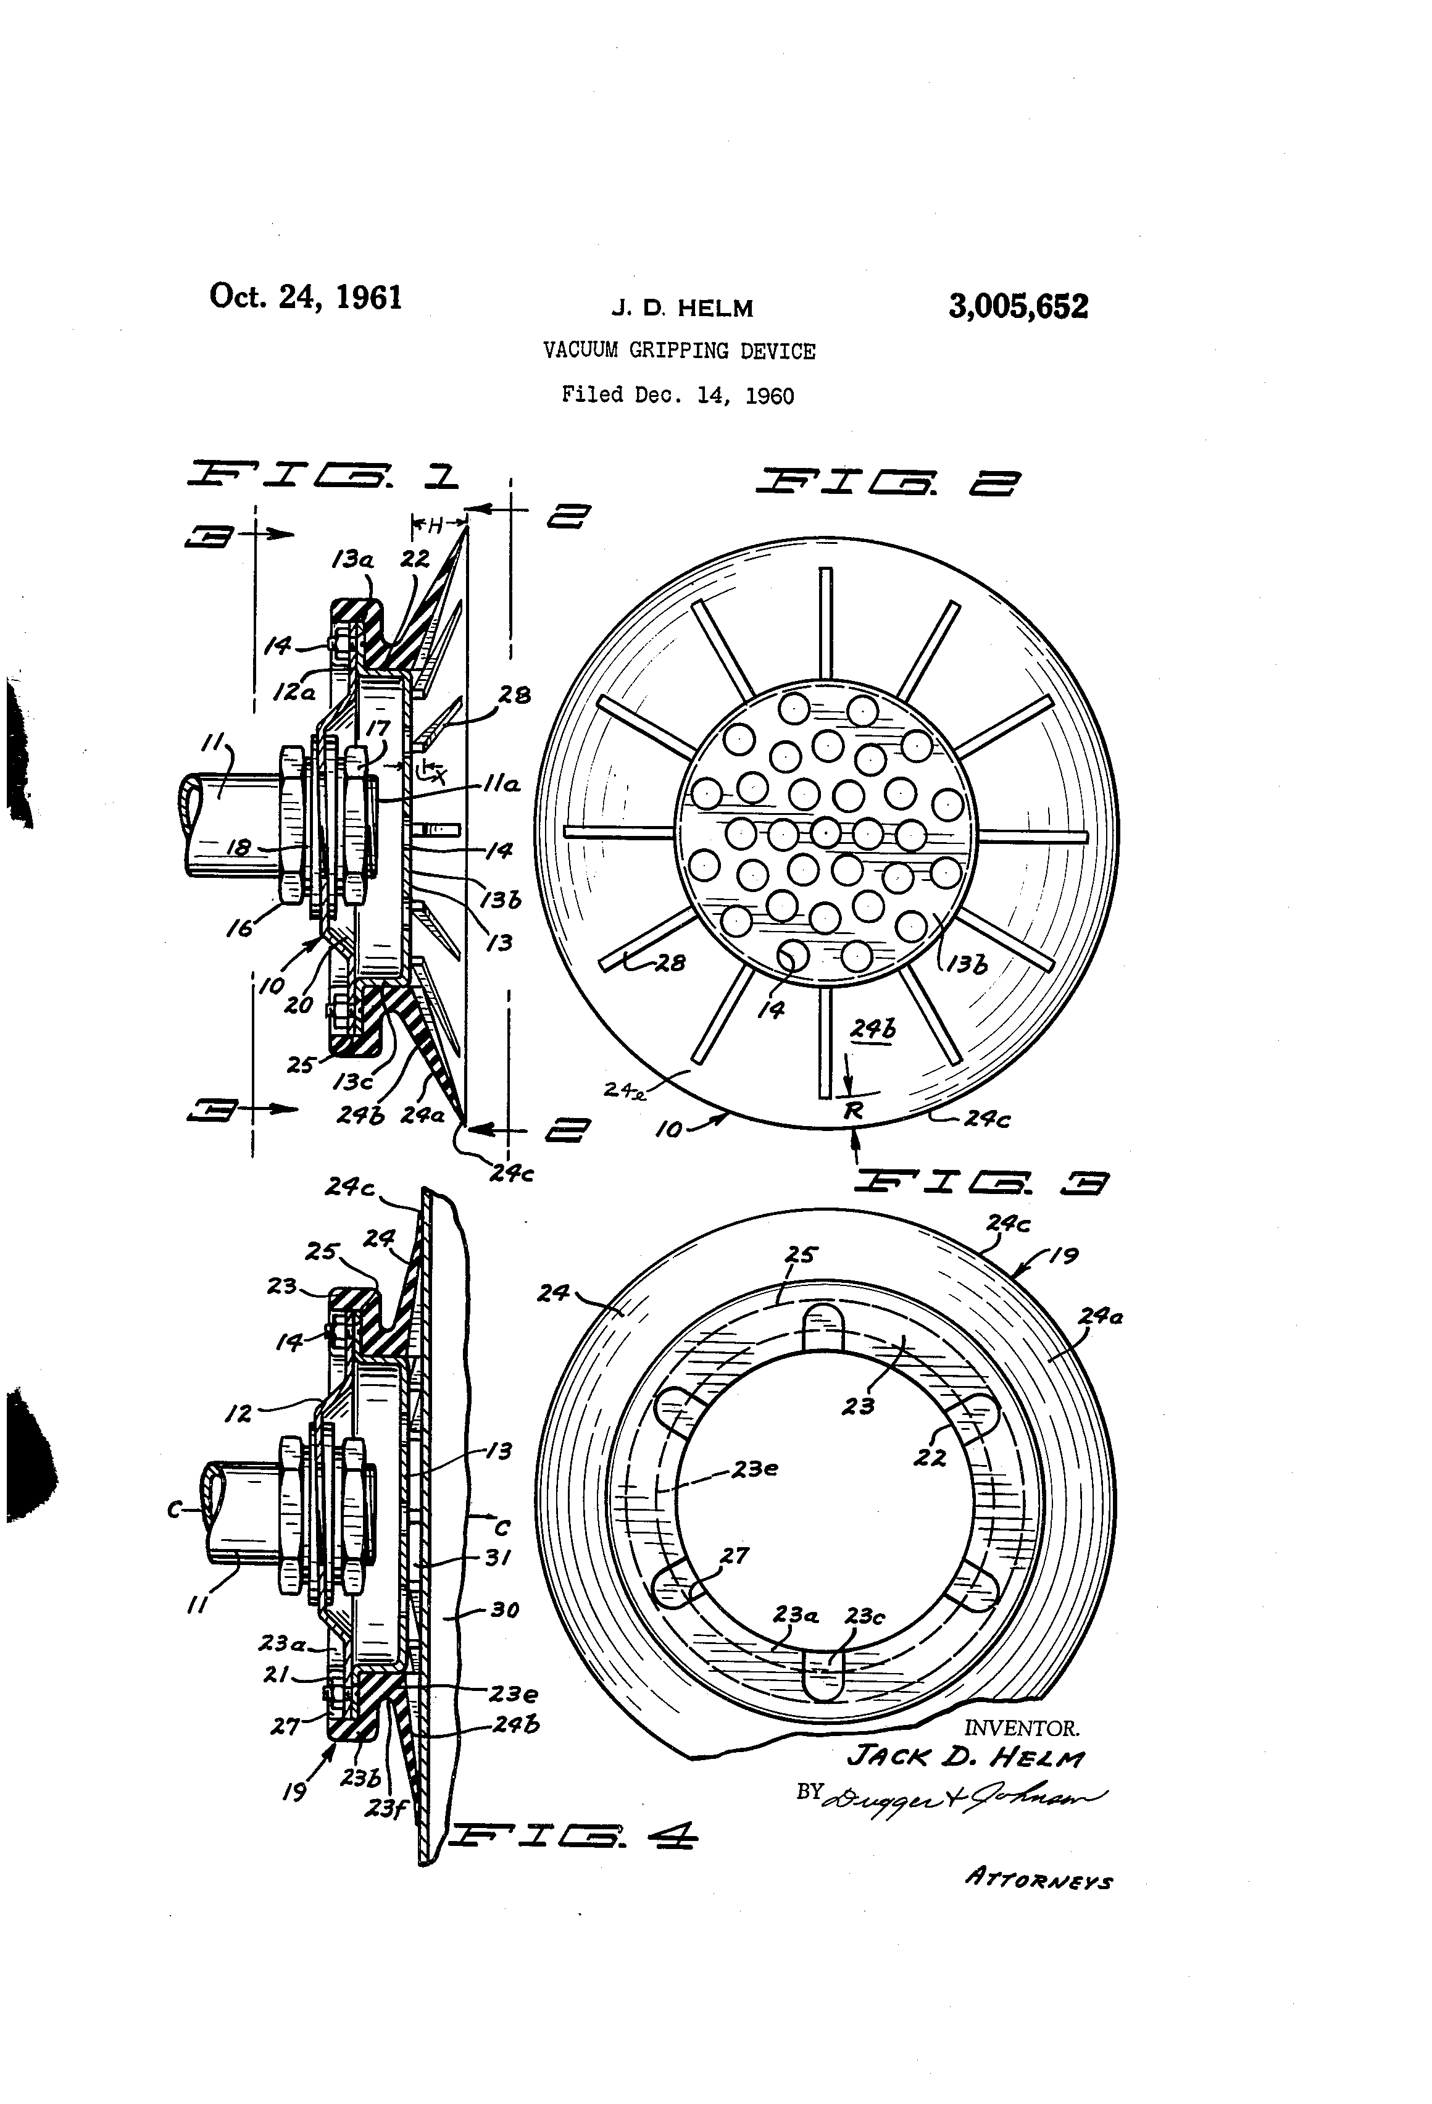  US-3005652-A · drawing
Why relevant: This reference is relevant as it describes a vacuum gripping device, which is the core of the invention. It specifically reads on the general concept of a vacuum gripper.
Relevant passage (whole , similarity 0.777):
Vacuum gripping device

2. US-11207792-B2 — Gripper, cutting apparatus and method for cutting a product
Assignee: WEBER MASCHB GMBH  Inventors: BAUMEISTER CHRISTIAN, JUNG-SASSMANNSHAUSEN FABIAN, KAHL PHILIP, KNAUF MICHAEL, KUHMICHEL CHRISTOPH  Priority / Filing / Published: 2017-02-07 / 2018-02-01 / 2021-12-28  Family: 61132018  CPC: B26D7/018, A47J43/18, B25J11/0045, B25J11/0055, B25J15/0616, B26D2007/011, B26D2210/02, B26D7/0633  Legal status: FEPP 2018-02-01; AS 2018-04-30; STPP 2018-06-06  Prior-art basis: SECRET prior art (novelty only) Match: 0.793 | 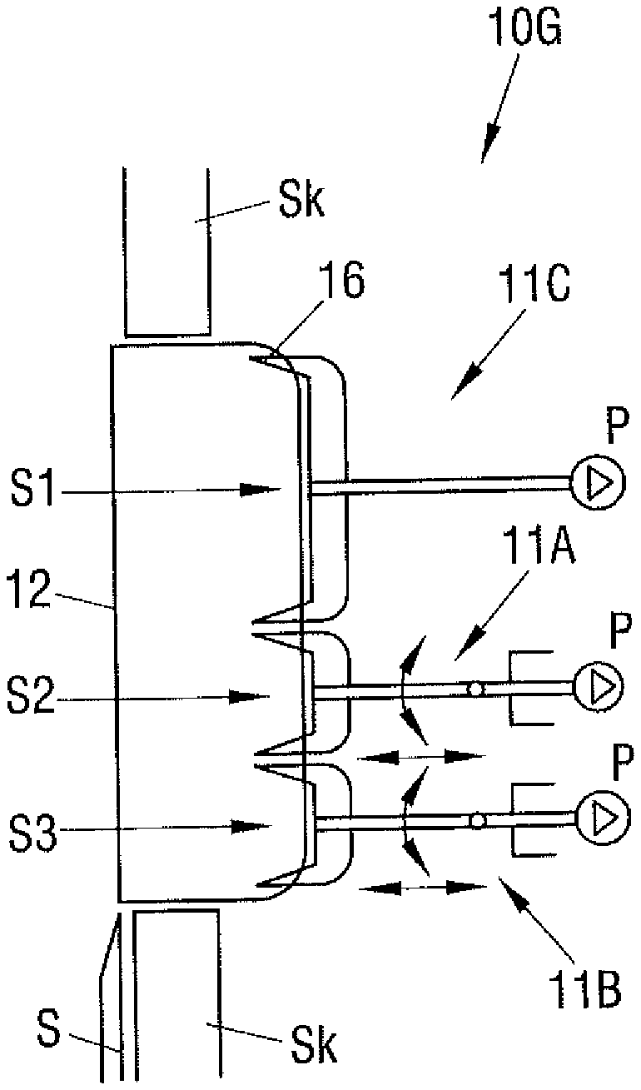  US-11207792-B2 · drawing
Why relevant: The reference describes a gripper with a suction device that has a contact surface and a sealing device bounding a suction section, which is in communication with a pumping device. This directly relates to the core components of the invention's vacuum gripper.
Relevant passage (paragraph ¶ p0011, similarity 0.793):
The selection of the suitable sealing device inter alia depends on the properties of the product to be gripped. Sealing devices of different designs can, if required, also be combined as desired in a gripper in order to take account of the respective present demands. An additional improvement in the sealing effect of the sealing devices can be achieved if they have suction openings in communication with the pumping device. They can then be reliably pressed toward the product surface by means of a vacuum. In accordance with a further embodiment, the first sealing device and/or the second sealing device is/are shaped such that a local compression of the product which can be brought into contact with the sealing device can be produced. The first sealing device and/or the second sealing device is/are in particular at least sectionally wedge-shaped. It is particularly efficient if two mutually oppositely disposed slopes are provided which diverge in a direction toward the product. On a gripping of the product, it is compressed by the V-shaped design of the space disposed between the slopes, which leads to the closing of possibly present pores in the product and to a good adhesion. In ot

3. US-9457478-B2 — Area vacuum gripper
Assignee: SCHMALZ J GMBH  Inventors: HARTER LEONHARD, STEYERL KEN  Priority / Filing / Published: 2013-01-25 / 2014-01-21 / 2016-10-04  Family: 50002714  CPC: B25J15/0616, B65G47/91, B25J15/0691, B25J19/00, B65G47/91, B65G47/917  Legal status: AS 2015-11-03; STCF 2016-09-14; MAFP 2020-03-13  Prior-art basis: PUBLIC prior art Match: 0.788 | 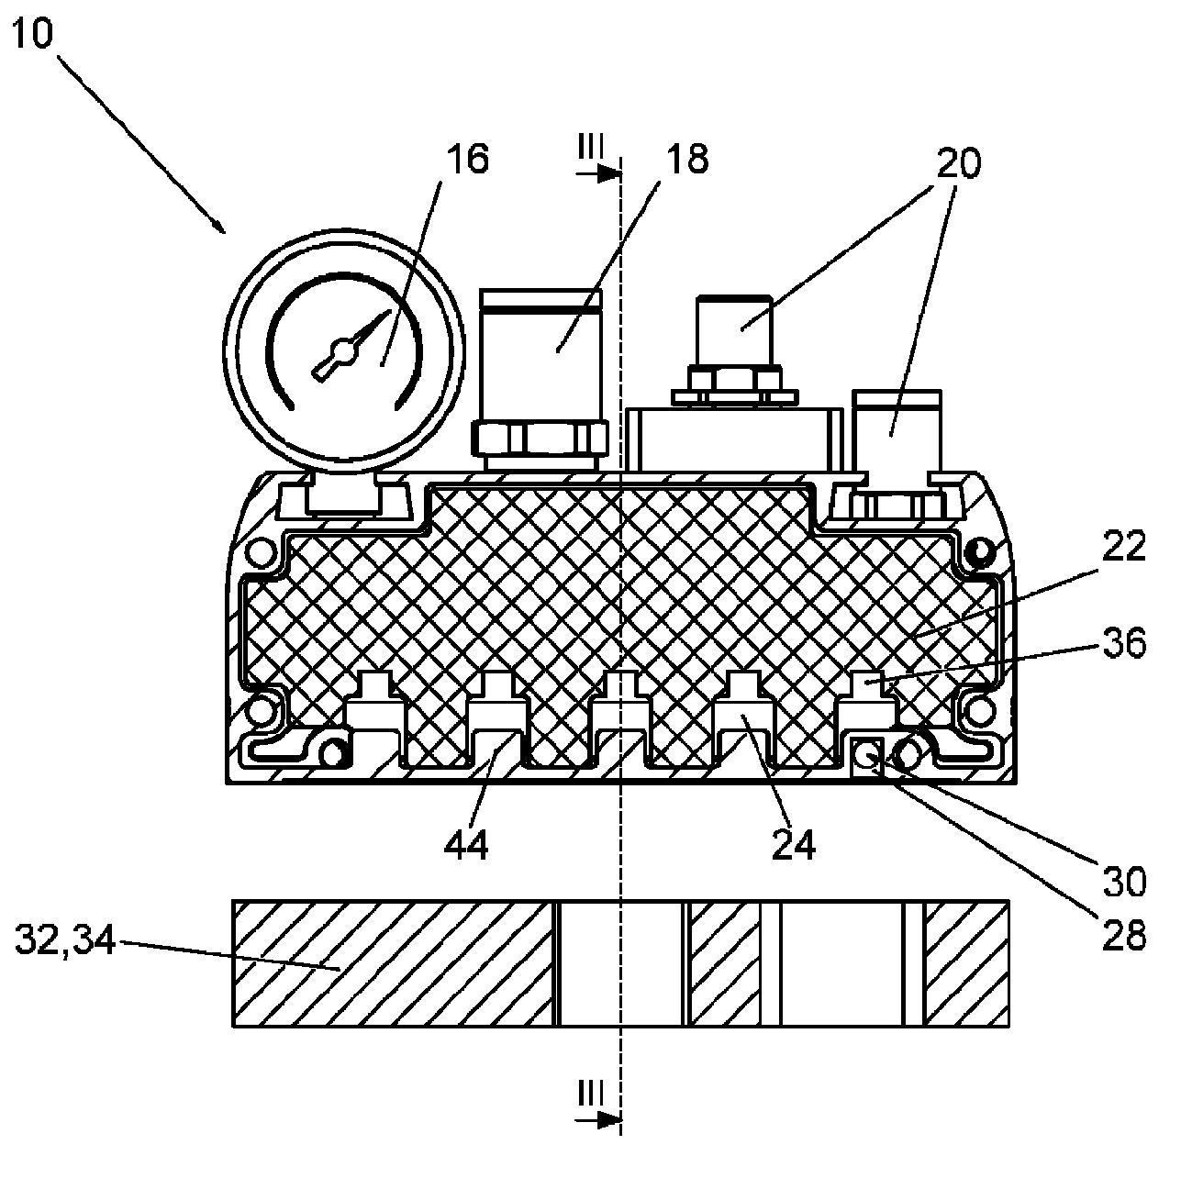  US-9457478-B2 · drawing
Why relevant: This reference describes a vacuum gripper with a housing, a negative pressure vacuum chamber, and suction openings, which aligns with the basic structure of the invention's gripper.
Relevant passage (whole , similarity 0.788):
Area vacuum gripper. A surface area vacuum gripper for sucking and handling workpieces, comprising a housing, in which a negative pressure vacuum chamber is provided that can be subjected to negative pressure and wherein the housing includes suction openings on the suction side, facing the workpiece. An insertion element is provided in the housing, which reduces the free inner space of the housing and includes vacuum channels fed by a vacuum generator. The insertion element can be equipped with a plurality of optional functions.

4. US-9803680-B2 — Releasable vacuum holding device
Assignee: PÖTTERS KATJA  Inventors: PÖTTERS GERT, SCHMIDT PATRICK  Priority / Filing / Published: 2013-02-04 / 2014-02-04 / 2017-10-31  Family: 50482890  CPC: F16B47/00, A47G1/17, F16M13/02  Legal status: STCF 2017-10-11; CC 2019-06-25; AS 2021-01-22  Prior-art basis: PUBLIC prior art Match: 0.782  Reads on: Seal element elastically deformable at contact surface | 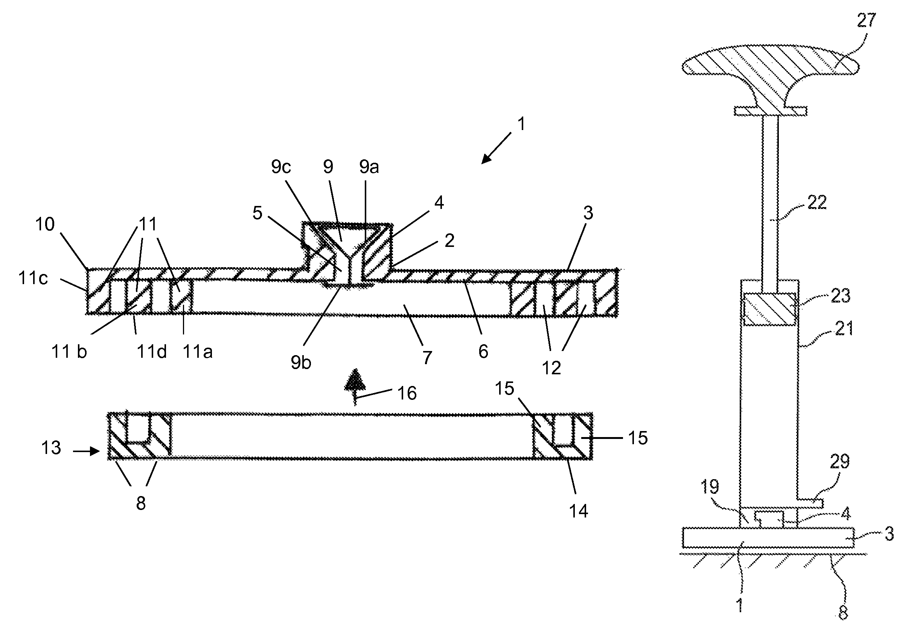  US-9803680-B2 · drawing
Why relevant: This reference describes a vacuum holding device with a vacuum chamber, an elastic seal, and a suction device to generate a vacuum, which directly reads on several elements of the invention.
Relevant passage (claim_own cl 1, similarity 0.782):
A vacuum holding device for attaching objects to an essentially gas-tight contact surface, comprising: a holding body that forms a vacuum chamber, wherein a vacuum is producible in the vacuum chamber following application to the contact surface, and the holding body comprises a press-on web with a web front edge encircling the vacuum chamber, wherein the web front edge is oriented towards the contact surface, at least one seal, that seals the vacuum chamber towards an exterior of the holding device in a gas-tight manner against the contact surface, at least one opening between the vacuum chamber and the exterior having at least one valve that ensures gas-tight opening and closing between the vacuum chamber and the exterior, wherein the holding body with the press-on web, during formation of the vacuum in the vacuum chamber, presses on the contact surface by means of the seal provided towards the contact surface, the seal comprises one or several U-profiles, wherein two limbs and a foot surface linking the limbs form an U-profile and the limbs at least partially bilaterally encompass the respective press-on web of the holding body and the foot surface spans the respective web front

5. US-6554241-B1 — Vacuum cup
Assignee: SMART ROBOTICS  Inventors: Nadav Leshem  Priority / Filing / Published: 2002-02-19 / 2002-02-19 / 2003-04-29  Family: 22131835  CPC: B62D57/024  Legal status: AS 2002-03-25; REMI 2006-11-15; LAPS 2007-04-29  Prior-art basis: PUBLIC prior art Match: 0.773 | 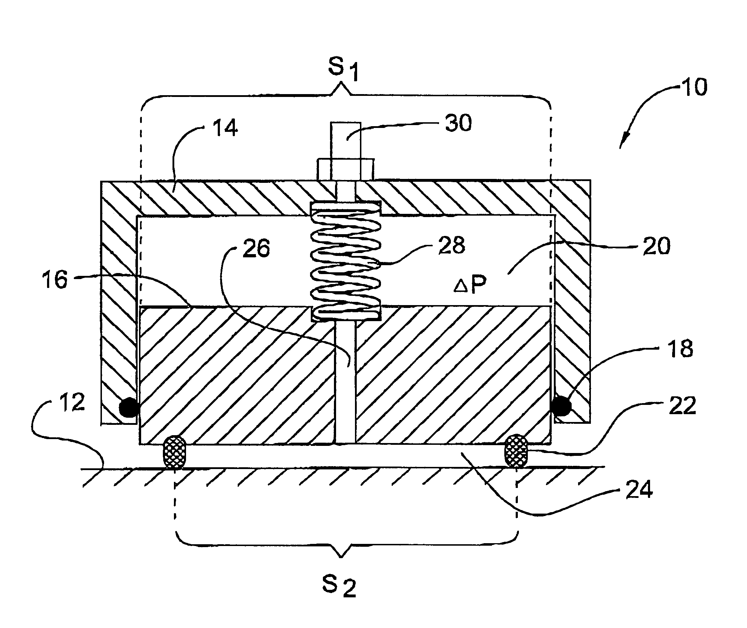  US-6554241-B1 · drawing
Why relevant: This reference describes a vacuum device with a body and a piston having a protruding sealing lip that contacts a surface to define a chamber, which is connected to a vacuum source. This directly relates to the core components and function of the invention's vacuum gripper.
Relevant passage (claim_own cl 14, similarity 0.773):
A vacuum device for attaching an object to a surface, comprising a body element fixable to said object; a piston element connected to said body element along a first sealing contour, thereby defining with said body element a first chamber, said piston element having a protruding sealing lip adapted to contact said surface along a second sealing contour, thereby defining with said surface a second chamber; said two chambers being connectable to a source of vacuum; said sealing lip being urged to said surface by a first sealing force due to the action of a vacuum created in said second chamber, said piston element being movable with respect to said body element by the action of a vacuum created in said first chamber and/or by an external force due to the contact of said sealing lip with said surface; wherein said vacuum device further comprises an elastic element connected to said piston element and said body element so as to deform when said piston element moves to reduce the volume of said first chamber, thereby creating a second sealing force urging said sealing lip towards said surface, which force is independent of said vacuum in said second chamber.

Appendix — full ranked reference list
# | Publication | Title | Match | Basis | Channels
1 | US-3005652-A | Vacuum gripping device | 0.777 | PUBLIC prior art | citation, crosslingual, dense, qbe
2 | US-8414045-B2 | Vacuum gripper | 0.789 | PUBLIC prior art | citation, dense, qbe
3 | US-7240935-B2 | Suction grip arm | 0.8 | PUBLIC prior art | citation, dense, qbe
4 | US-11207792-B2 | Gripper, cutting apparatus and method for cutting a product | 0.793 | SECRET prior art | citation, dense, qbe
5 | DE-102005020840-B4 | Sauggreifer | 0.822 | PUBLIC prior art | citation, crosslingual, dense, qbe
6 | US-9457478-B2 | Area vacuum gripper | 0.788 | PUBLIC prior art | citation, dense, qbe
7 | US-9803680-B2 | Releasable vacuum holding device | 0.782 | PUBLIC prior art | citation, crosslingual, dense, qbe
8 | US-3377096-A | Vacuum gripping pad | 0.77 | PUBLIC prior art | citation, dense, qbe
9 | US-2007187965-A1 | Vacuum gripper | 0.808 | PUBLIC prior art | citation, cpc, crosslingual, dense, qbe
10 | US-6554241-B1 | Vacuum cup | 0.773 | PUBLIC prior art | crosslingual, dense, qbe
11 | US-2014161582-A1 | Gripping element for manipulators | 0.789 | PUBLIC prior art | dense
12 | US-8290624-B2 | Uniform lighting and gripper positioning system for robotic | 0.771 | PUBLIC prior art | citation, dense, qbe
13 | US-2005134063-A1 | Gripping device for gripping and lifting an object | 0.798 | PUBLIC prior art | dense, qbe
14 | US-11078051-B2 | Seal for a vacuum material lifter | 0.763 | SECRET prior art | citation, crosslingual, dense, qbe
15 | US-6382692-B1 | Vacuum gripper | 0.794 | PUBLIC prior art | citation, cpc, dense, qbe
16 | US-8382174-B2 | System, method, and apparatus for suction gripping | 0.773 | PUBLIC prior art | citation, dense
17 | US-5611585-A | Vacuum lifting plate | 0.752 | PUBLIC prior art | citation, crosslingual, dense, qbe
18 | US-3152828-A | Vacuum cup units for lifting pads | 0.742 | PUBLIC prior art | citation, cpc, dense
19 | US-10562195-B2 | Gripper, in particular pneumatically operated gripper in the | 0.795 | SECRET prior art | citation, dense, qbe
20 | US-6171049-B1 | Method and device for receiving, orientating and assembling | 0.77 | PUBLIC prior art | dense, qbe
21 | US-3240525-A | Vacuum device for handling articles | 0.763 | PUBLIC prior art | citation, dense, qbe
22 | US-4708381-A | Holder fixed by vacuum for industrial use | 0.784 | PUBLIC prior art | citation, crosslingual, dense, qbe
23 | US-6279976-B1 | Wafer handling device having conforming perimeter seal | 0.777 | PUBLIC prior art | citation, dense, qbe
24 | DE-202005007145-U1 | Vacuum operated gripping element, comprising several specifi | 0.821 | PUBLIC prior art | crosslingual, dense, qbe
25 | US-6419291-B1 | Adjustable flexible vacuum gripper and method of gripping | 0.799 | PUBLIC prior art | citation, dense, qbe

