WADF105 – Network Security Fundamentals
Practical Laboratory 1: Two VM Network Commissioning and Connectivity Verification
Student: Nimo Khadar Ahmed
Date: 5 October 2026
Required VMs: icdfa-nslab-client-v1 and icdfa-nslab-firewall-v1
1. Introduction
This practical involved creating a small protected network using an Ubuntu Client and an OPNsense Firewall in VirtualBox. The main tasks were configuring the VirtualBox network adapters, verifying IP addressing and routing, testing connectivity, and observing ARP, ICMP and DNS traffic using Wireshark.
3. Part A – VirtualBox Configuration
The OPNsense firewall was configured with:
- Adapter 1: NAT
- Adapter 2: Internal Network – ICDFA-LAN
- Cable Connected enabled
- Unused adapters disabled
The Ubuntu Client was configured with:
- Adapter 1: Internal Network – ICDFA-LAN
- Cable Connected enabled
- Other adapters disabled
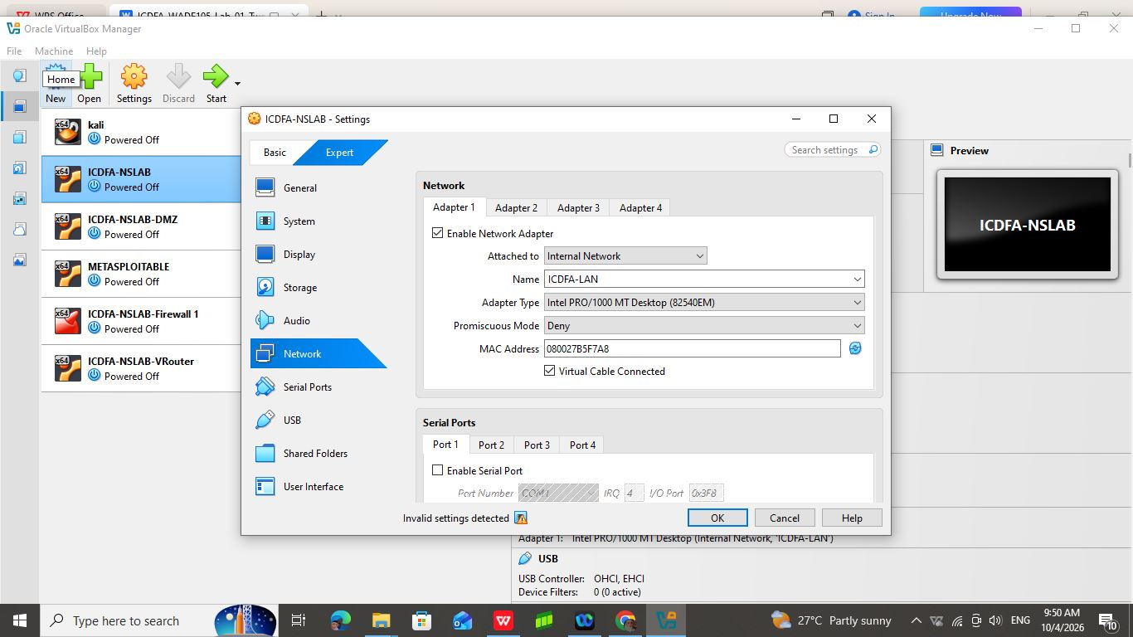
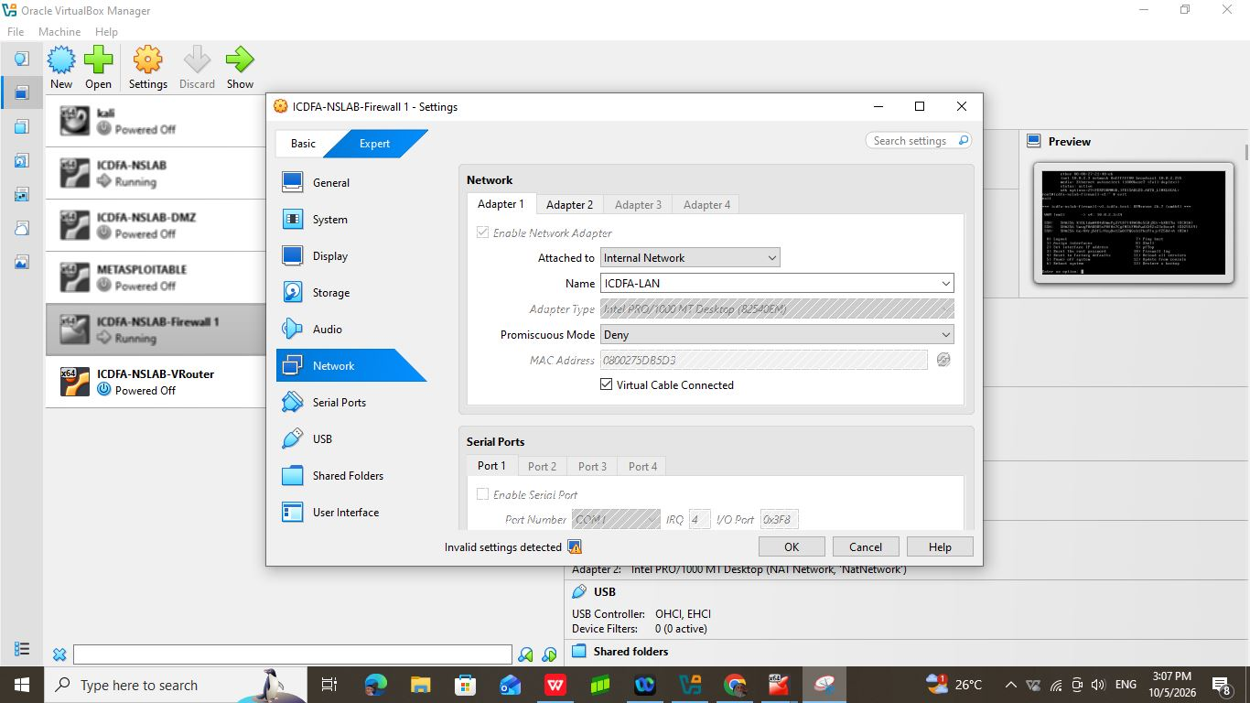

5. Part C – Ubuntu Addressing
The Ubuntu Client was started after OPNsense was ready. The following commands were used to check the network configuration:
ip -4 -br address
ip route
resolvectl status

6. Part D – Connectivity Tests
The following tests were required:
ping -c 4 10.10.10.1
ping -c 4 1.1.1.1
getent hosts opnsense.org
curl -I https://opnsense.org
Because the Ubuntu Client did not yet obtain a valid LAN address, the connectivity tests could not be fully completed.
The expected results are:
- 10.10.10.1 → verifies connectivity to the firewall
- 1.1.1.1 → verifies routing and outbound NAT
- opnsense.org → verifies DNS resolution
- curl → verifies web connectivity

8. Troubleshooting
The main problem encountered was that Ubuntu did not obtain the expected 10.10.10.x address.
Possible causes include:
- Incorrect VirtualBox Internal Network name
- DHCP not enabled on OPNsense LAN
- Network adapter not connected
- Ubuntu DHCP lease problem
The following commands can be used for troubleshooting:
sudo dhclient -v <interface>
or:
sudo systemctl restart NetworkManager
Both virtual machines should also be checked to ensure that their LAN adapters use exactly ICDFA-LAN.
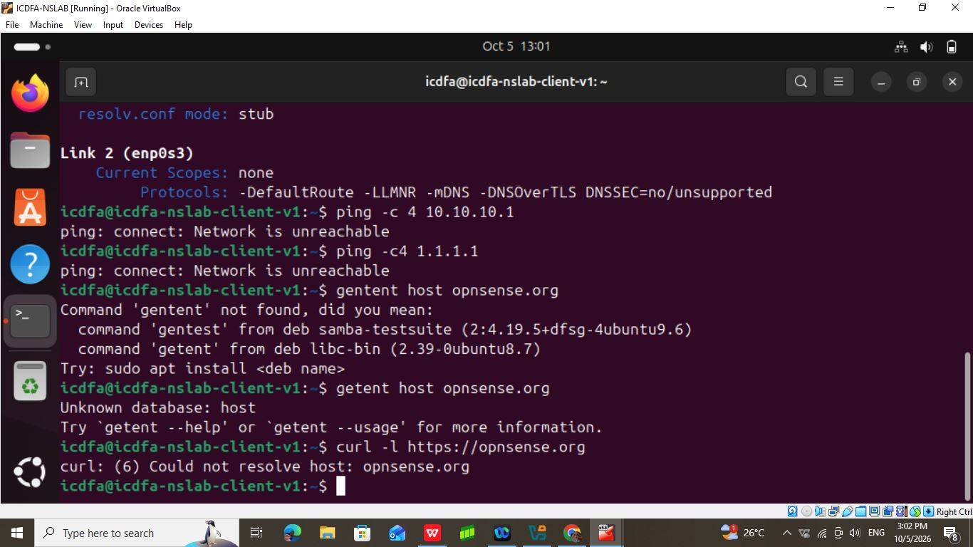
9. Completion Questions
29. Difference between WAN and LAN
The WAN interface connects OPNsense to the external network or internet. The LAN interface connects OPNsense to the protected internal network.
30. Why use the same VirtualBox network name?
Both adapters must use ICDFA-LAN so that Ubuntu and the OPNsense LAN interface are connected to the same virtual Ethernet network.
31. What does the default route provide?
The default route tells Ubuntu where to send traffic destined for networks that are not directly connected. In this laboratory the gateway is 10.10.10.1.
32. Which packet exchange provides the firewall MAC address?
The ARP request and ARP reply allow Ubuntu to learn the MAC address associated with 10.10.10.1.
33. Why does pinging 1.1.1.1 not prove DNS is working?
Because 1.1.1.1 is already an IP address. The ping does not require DNS. DNS must be tested separately using a domain name such as opnsense.org.
10. Conclusion
The laboratory demonstrated the basic design of a protected two-VM network using OPNsense and Ubuntu. OPNsense provides the WAN connection and acts as the LAN gateway at 10.10.10.1. Ubuntu should receive its LAN address through DHCP.
The VirtualBox network configuration was prepared successfully. However, the Ubuntu client encountered a network connectivity issue and did not obtain the expected LAN address. Therefore the remaining connectivity and Wireshark evidence must be completed after resolving the Ubuntu network problem.

