***ASP.NET CORE WEB API***

***Creating Asp.Net Core Web Api***

## ***Create new project search for Templates:***

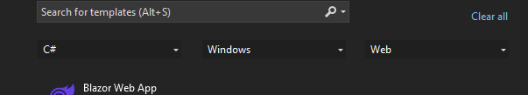

## ***Select Asp.Net Core web Api:***

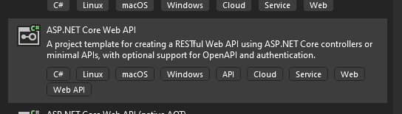

## ***Install Following Packages:***



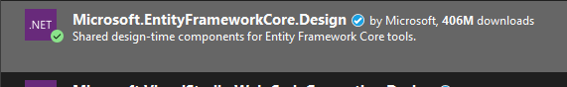



## ***Open sql server create table for student***

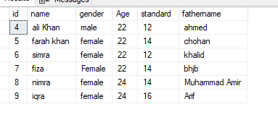

create table Student(

id int primary key identity,

name varchar(50),

gender varchar(50),

age int,

standard int,

fathername varchar(50)

)

## ***Run Scaffold-Dbcontext class in Nuget Pacakage Manager***

Scaffold-DbContext "server=DESKTOP-UJ2IMA0\SQLEXPRESS;database=webapidb;Trusted_connection=true" Microsoft.EntityFrameworkCore.SqlServer -OutputDir Models

## ***add connection string in appsetting.json***

"ConnectionStrings": {

"dbcs": "Server=DESKTOP-JB8EL87\\SQLEXPRESS;Database=multidata;Trusted_Connection=True;TrustServerCertificate=True"

},

## ***register connection string in program.cs***

var provider = builder.Services.BuildServiceProvider();

var config = provider.GetRequiredService<IConfiguration>();

builder.Services.AddDbContext<ApplicationContext>(item => item.UseSqlServer(config.GetConnectionString("dbcs")));

## ***Add api controller***

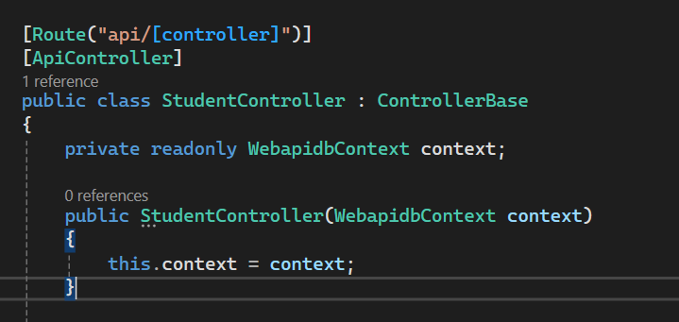

## ***To Fetch all student :***

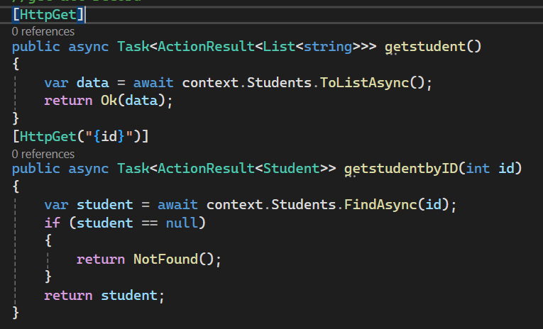

## ***To Fetch selected student :***



## ***To Add new student :***

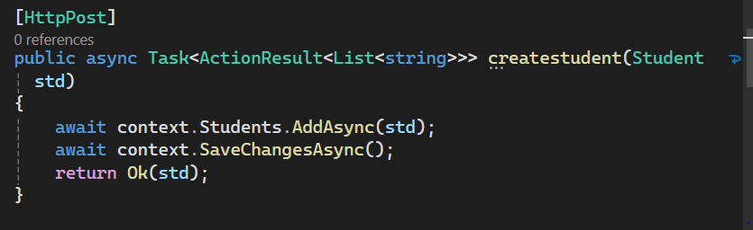

## ***To Update new student :***

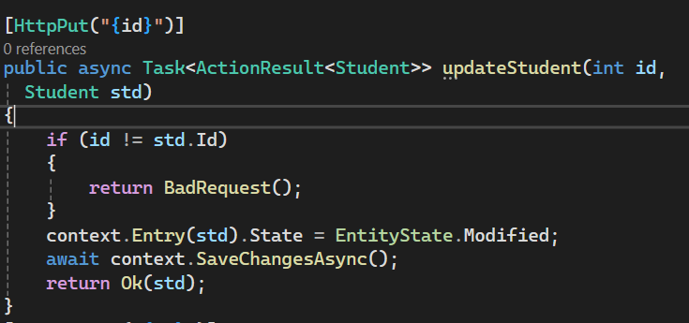

## ***To Delete student :***

