*CONSUMING WEB API IN ANGULAR*

**Create angular project**

***ng new project***

**Angular Material Design**

is a design language developed by Google in 2014.Create new angular project

**Install material UI**

***ng add @angular/material***

***proceed?*** Select yes

***typography ?*** yes

***animation?*** Enable animation

**Install tailwind CSS**

***Install :***

***npm install -D tailwindcss***

***configure tailwind css in angular :***

***npx tailwindcss init***

***In tailwind.configure.ts file :***

***content: ["./src/**/*.{html,js}"],***

***import namespaces in style.css***

***@tailwind base;***

***@tailwind components;***

***@tailwind utilities;***

**Add Toolbar(navbar)**

Add toolbar(nav) in app.html from angular material

**Create component for employee-list**

***ng g c components/employee-list***

**Now add routing in app.route.ts**

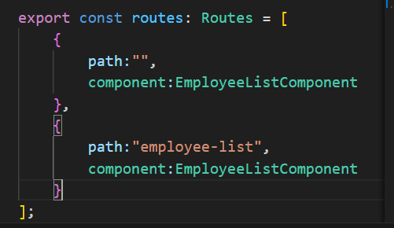

**Create folder interface in app and add file employee.ts**

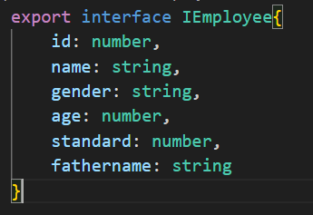

**Now goto employee-list.ts**

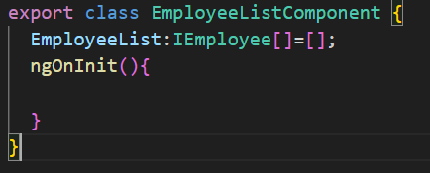

**Add service http**

***ng g s http***

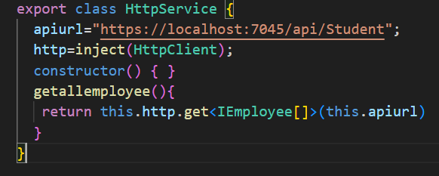

**Now inject service in employee-list.ts**

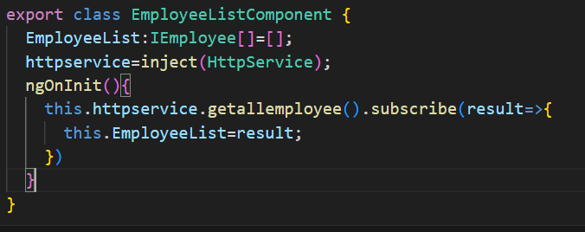

**Go to app config.ts**

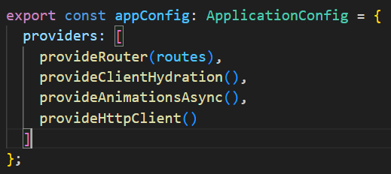

**To Solve port error go to .net web api and add UseCors() in program.cs**

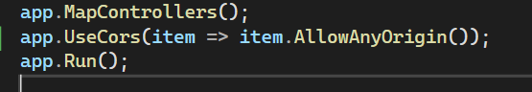

**Add table in employee-list.html from angular material**

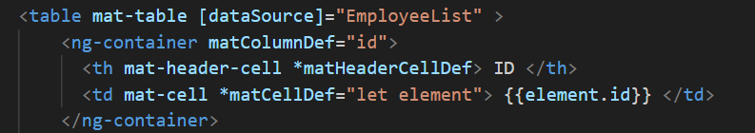

**import MatTableModule in employee-list.ts**



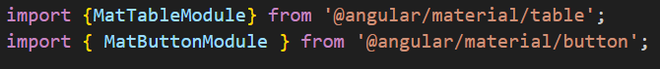

**Now add displayed columns in employee-list.ts**

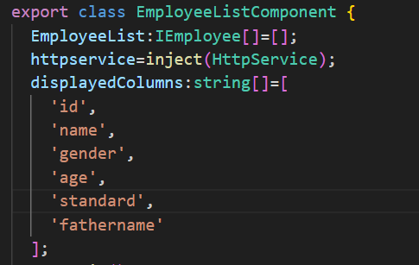

**Add following tailwind classes in employee-list.html**

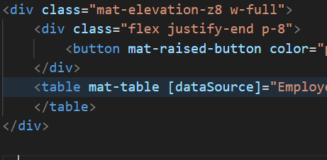

# ***For Create***

**Now create new component for student add**

***ng g c components/employee-form***

**Now add routing**

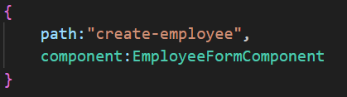

**Now add route on employee add button**

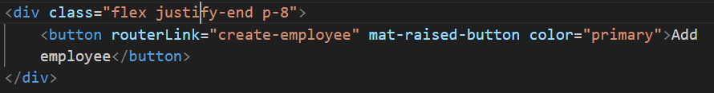

**Now add form in employee-form.html**

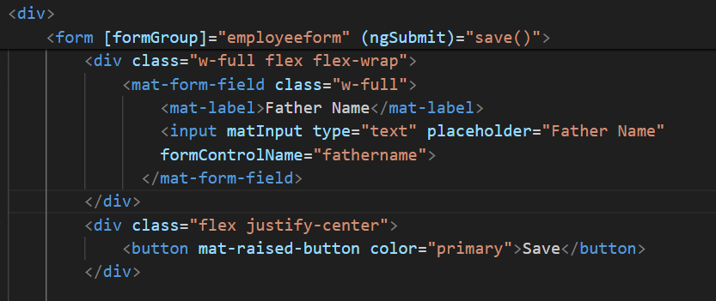

**Add form group in employee-form.ts**

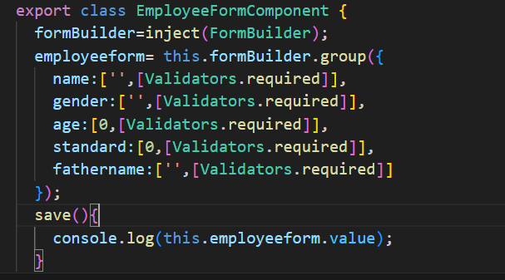

**Addstudent method in http services**

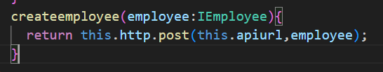

**Now sent request to web api to save data**

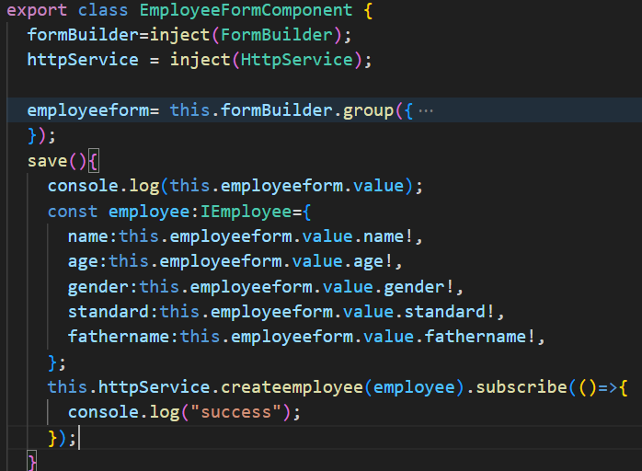

**Add Allowanymethod() & Allowanheader in .net web api program.cs file :**



**After employee added navigate to employee-list go to employee-form.ts :**

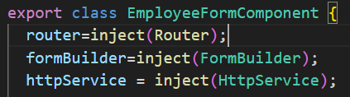

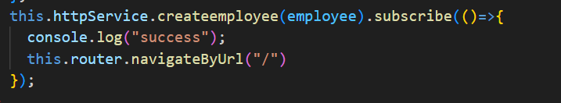

# ***For Update***

**Now working on edit student add edit buton in employee-form :**

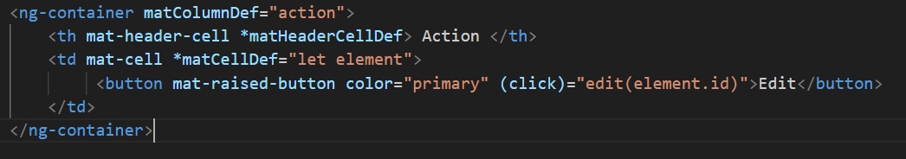

**Add edit method in employee-form.ts :**

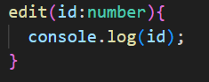

**Add action in displayedcolumns :**

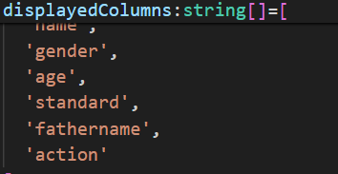

**To edit & create we are using same for**

**So Now, add route in app.route.ts**

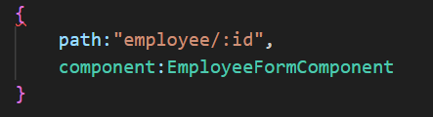

**Navigate to employee-form**



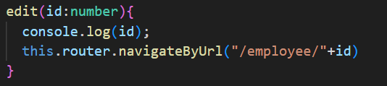



**Add ngoninit in employee-form.ts**

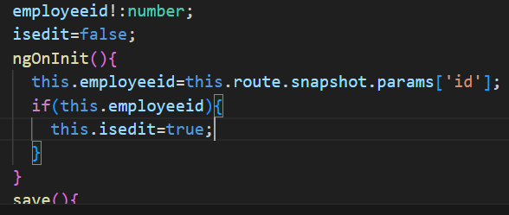

**Goto employee-list**

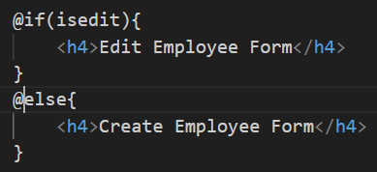

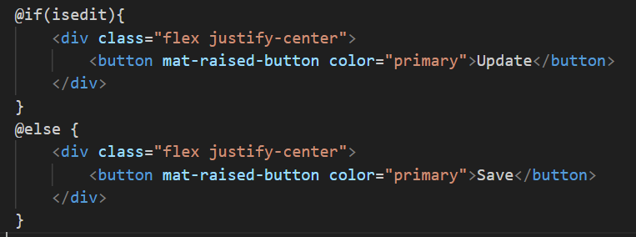

**Goto http service**

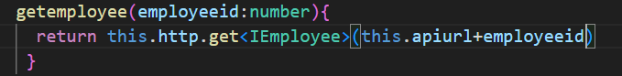

**Goto employee-form.ts**

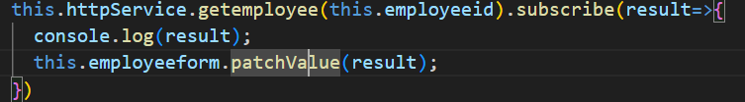

**Goto http service**

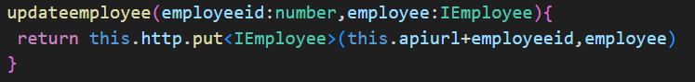

**Goto employee-form.ts and call put method**

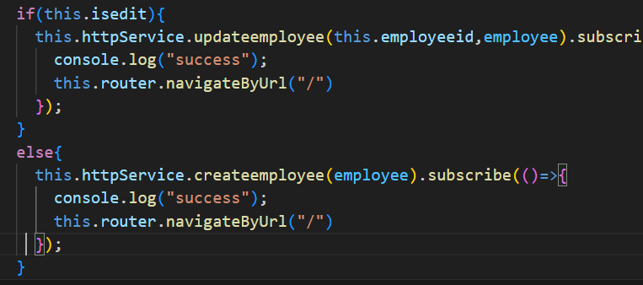

# ***FOR DELETE***

Add button in employee-list.html



Add delete method in employee-list.ts

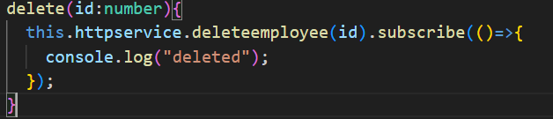

Add deleteemployee method in http service

