**Name:** Nimra Mursleen

**Reg no:** 2023-BSE-47

**Course:** Cloud Computing Lab

**Section:** V-B

**LAB 1**

**VMware Installation**

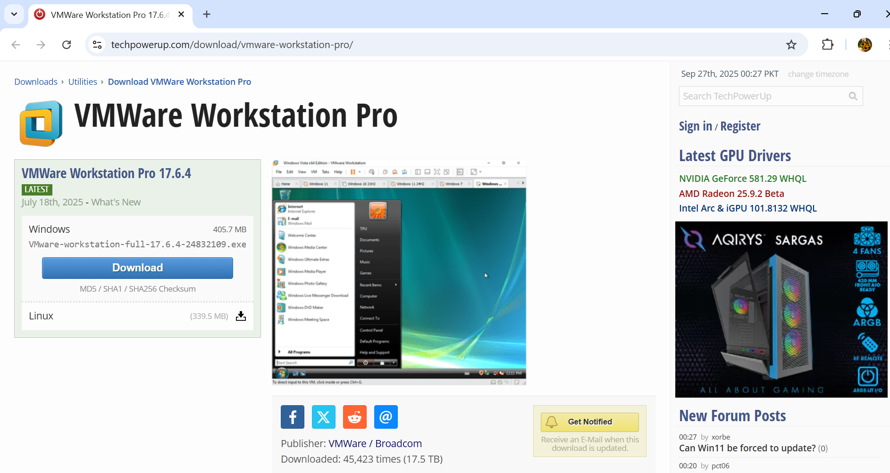

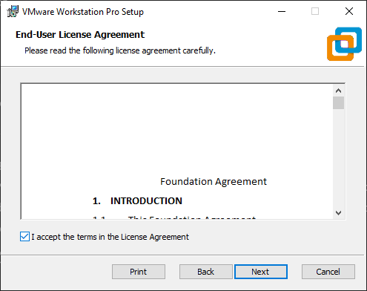

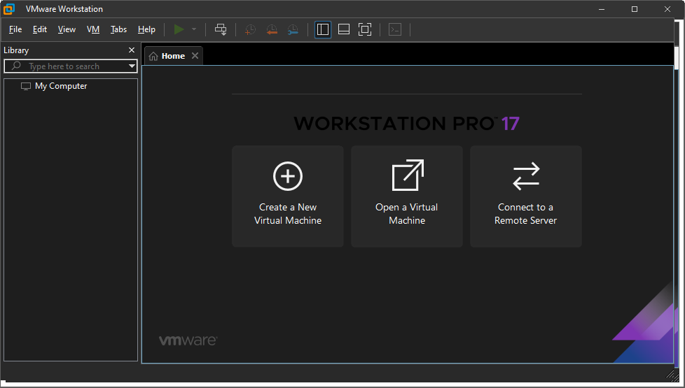

**Ubuntu Server Installation**

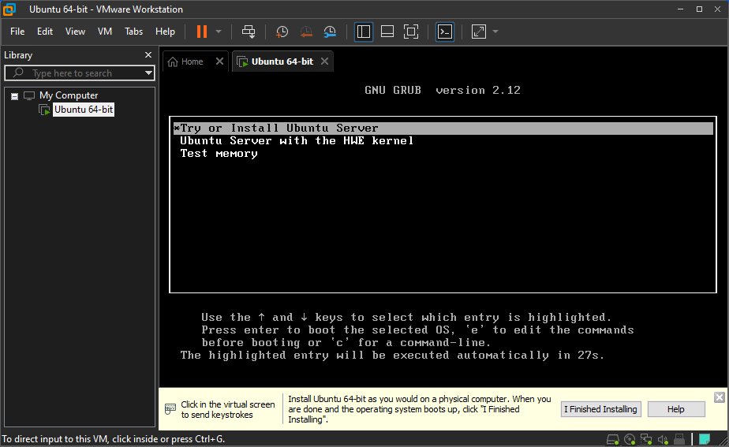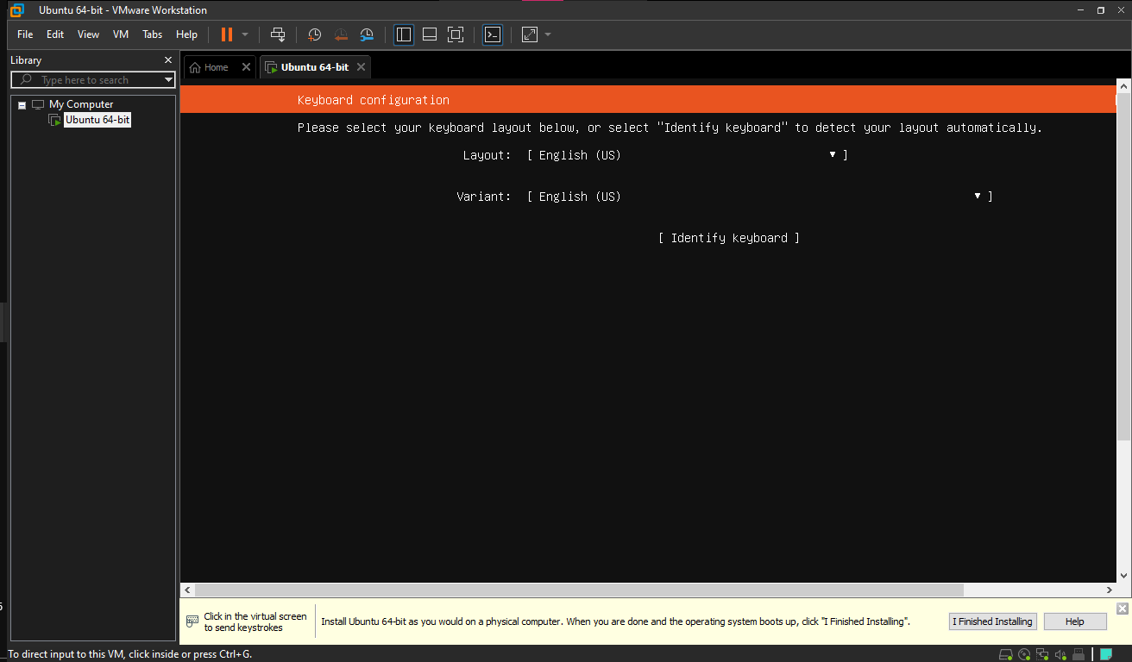

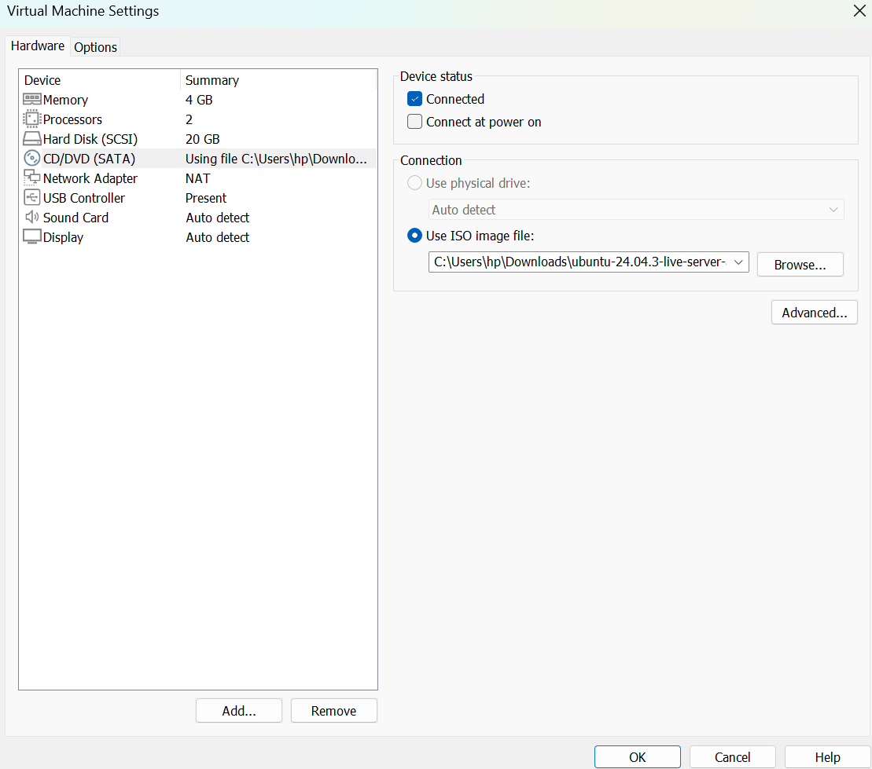

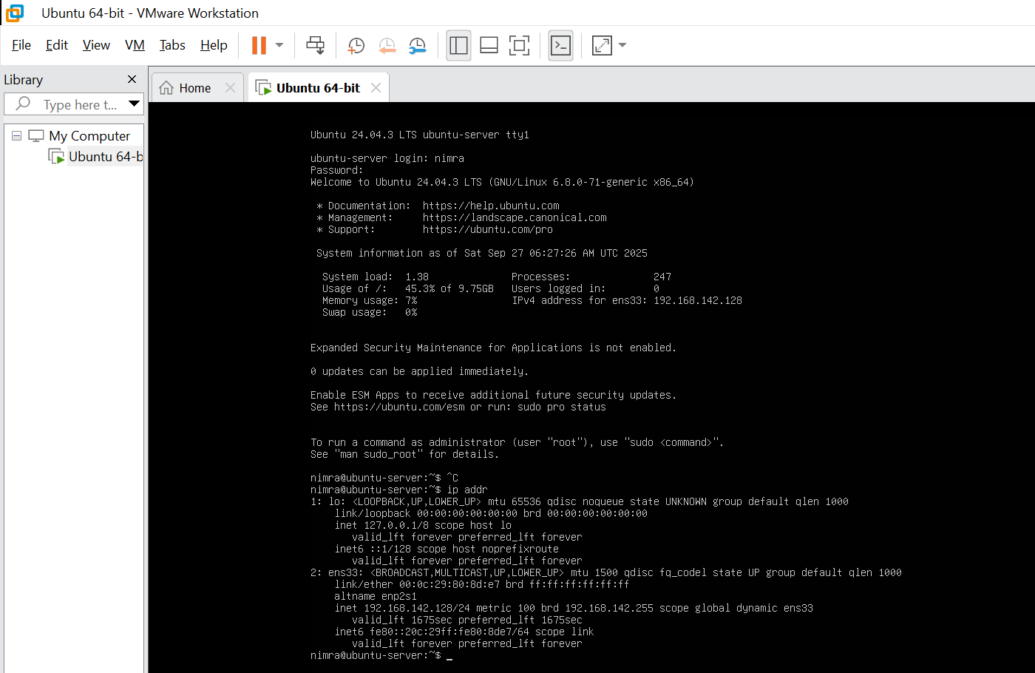

**Accessing Ubuntu Server from Windows**

