**Name:** Nimra Mursleen

**Reg no:** 2023-BSE-47

**Course:** Cloud Computing Lab

**Section:** V-B

**LAB 2**

**Install Git on your PC**

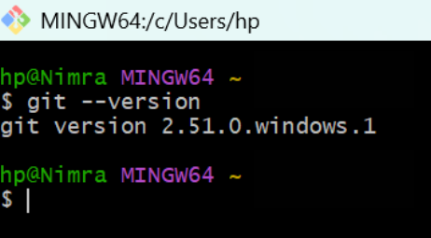

**Task 1: Create Private GitHub Repository**

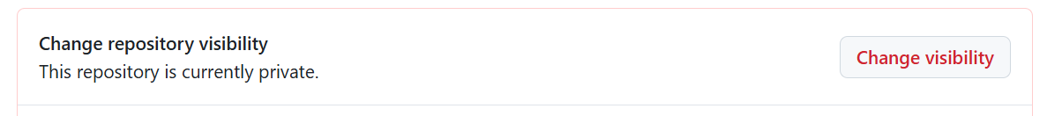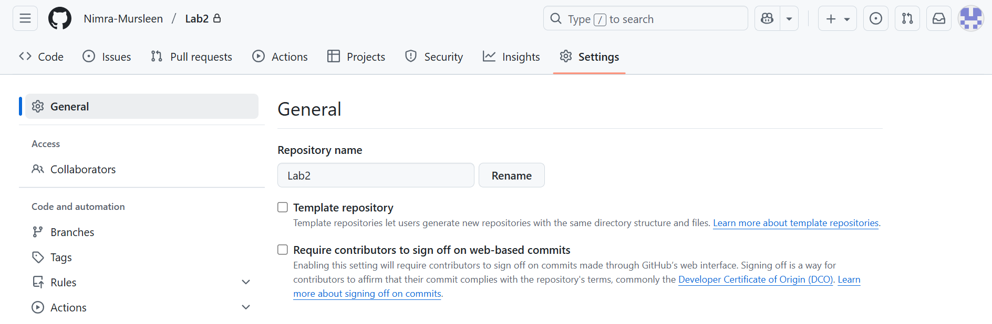

**Task 2: Connect Repository via SSH**

1. 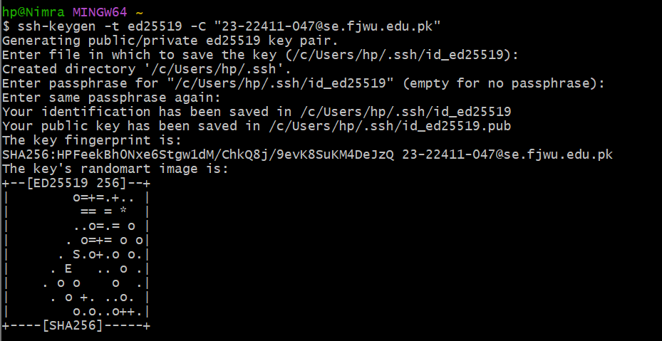**Generate a new SSH key**
2. 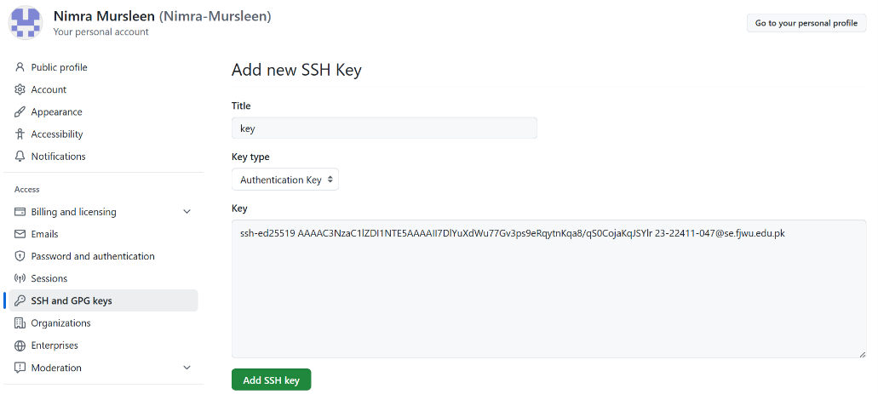**Add SSH public key to GitHub**
3. 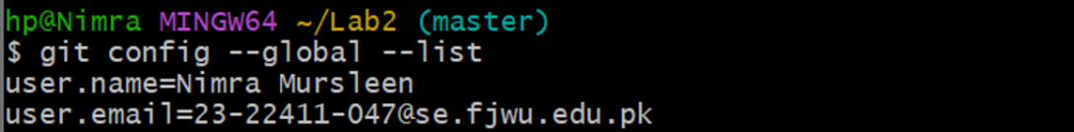**Clone your Lab2 repo using SSH.**

**Task 3: Configure Git Username and Email**

1. **Set up Git identity**

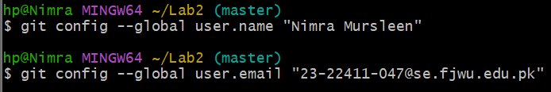

1. **Verify configuration**

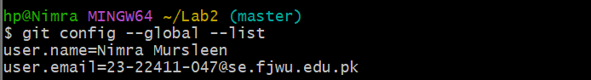

**Task 4: Explore the .git Folder**

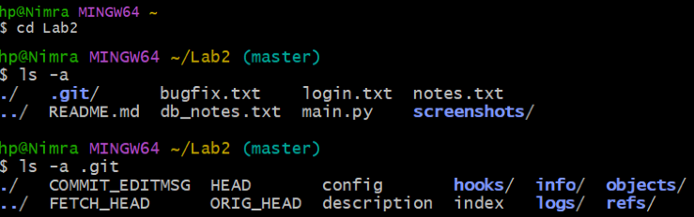

**Task 5: Local Repository Management**

1. **Delete the existing .git folder**



1. **Re-initialize the local git repository**

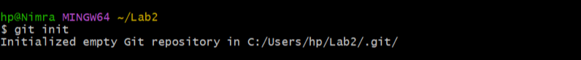

1. **Add a file named README.md and commit it**

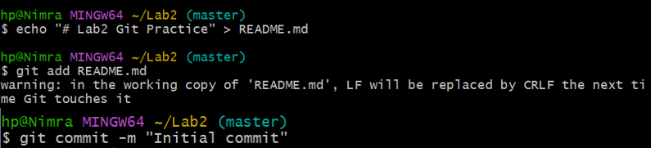

1. **Connect local repo to GitHub and push**

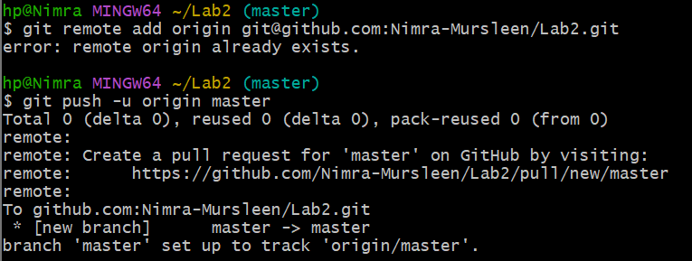

**Task 6: File Status & Staging**

1. **Create a new file notes.txt and write a note and Check status**

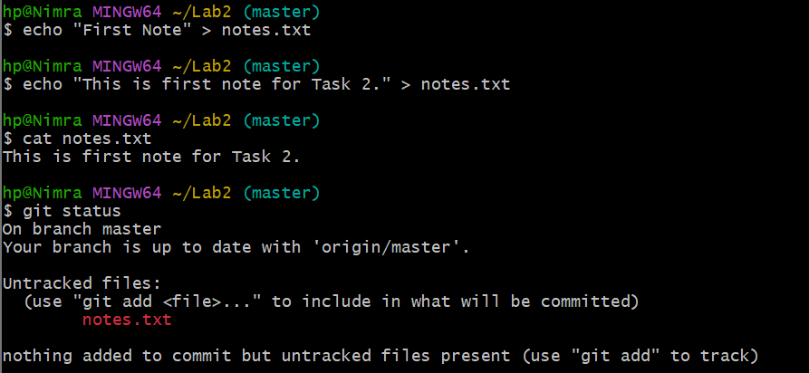

1. **Stage and commit**

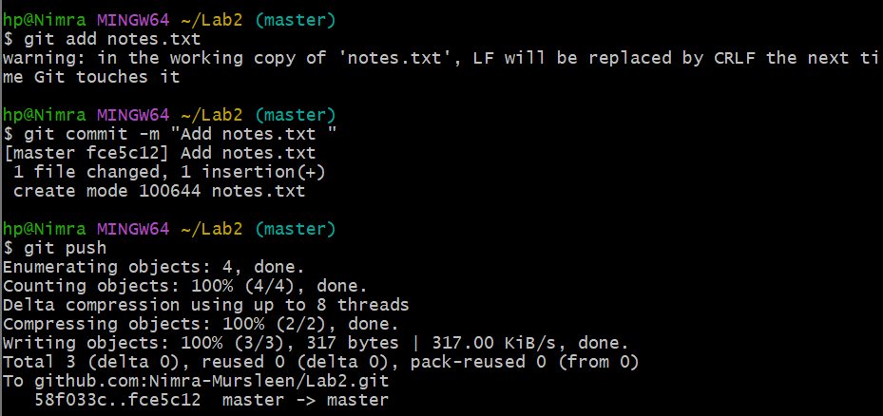

3. **Edit notes.txt and repeat status/commit steps**

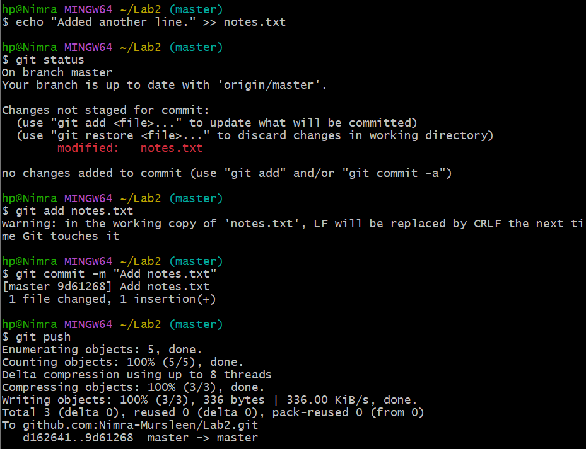

**Task 7: Branch Creation Using GitHub GUI**

1. **On GitHub, create a branch named bugfix/user-auth-error**

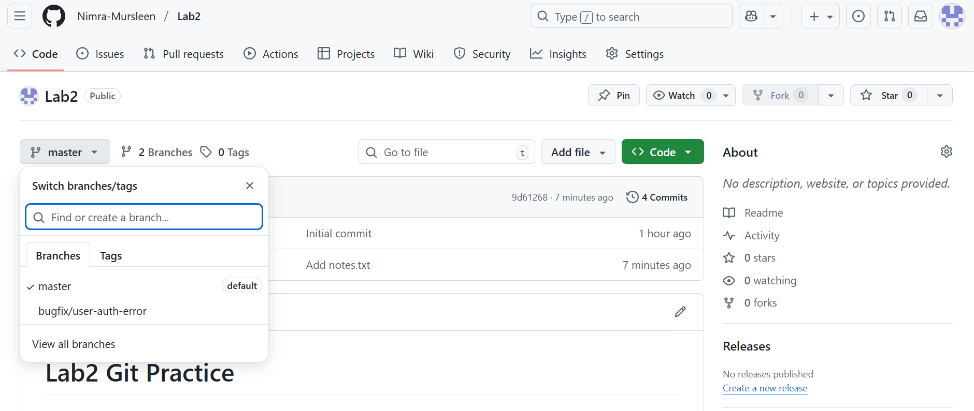

1. **Pull the branch to local repository to sync**

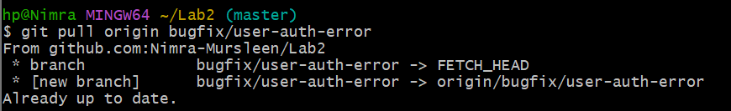

**Task 8: Branch Creation and Push Using Git Bash**

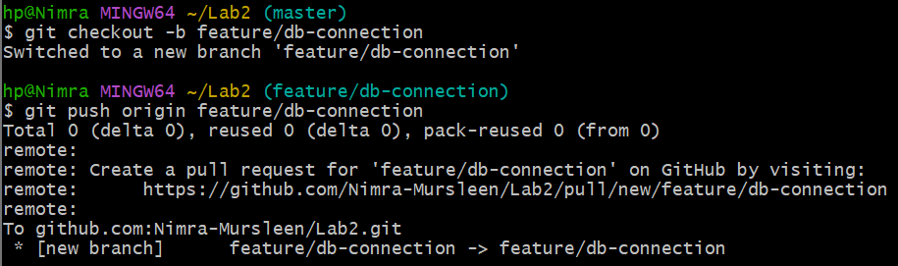

**Task 9: Branching &Merging**

1. **Create and switch to a branch feature-1**



1. **Modify main.py (add a function) and commit**

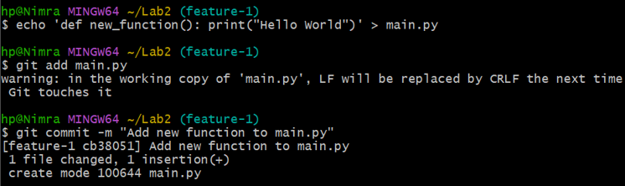

1. **Switch back to master and merge**

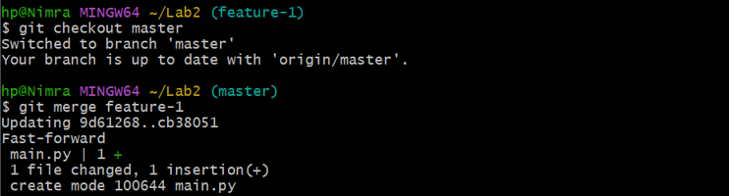

1. **Push all branches**

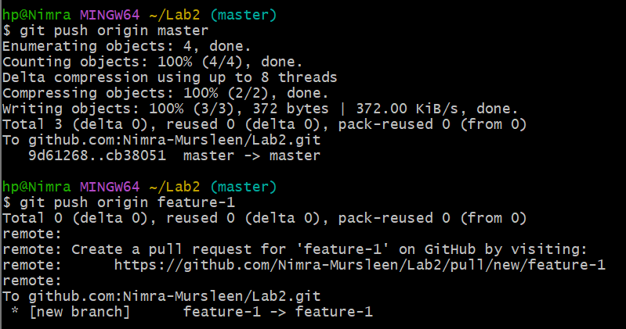

**Task 10: Pull Request and Branch Review (GitHub GUI)**

1. **Pull Request creation**

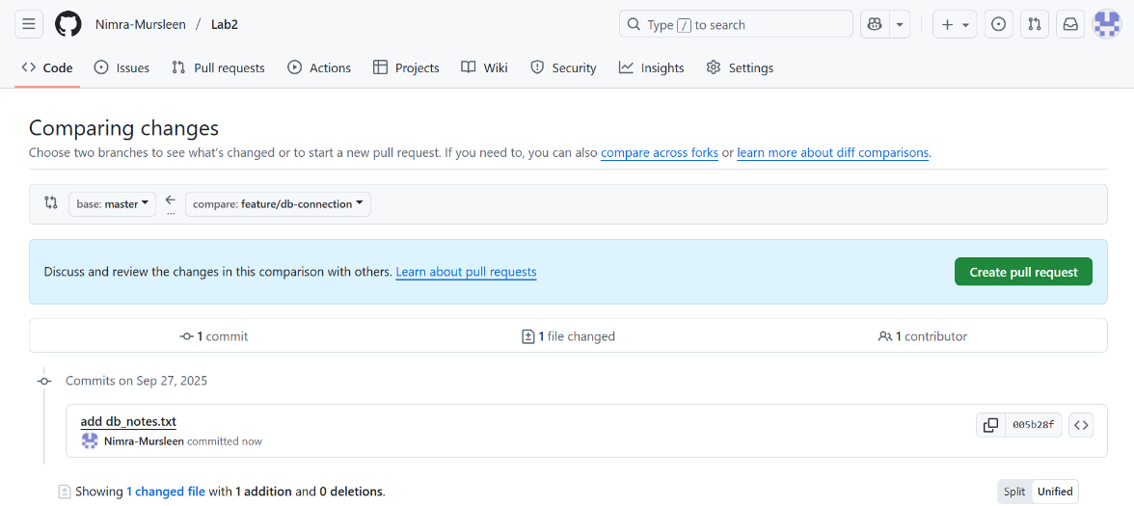

1. **Pull Request review and merge**

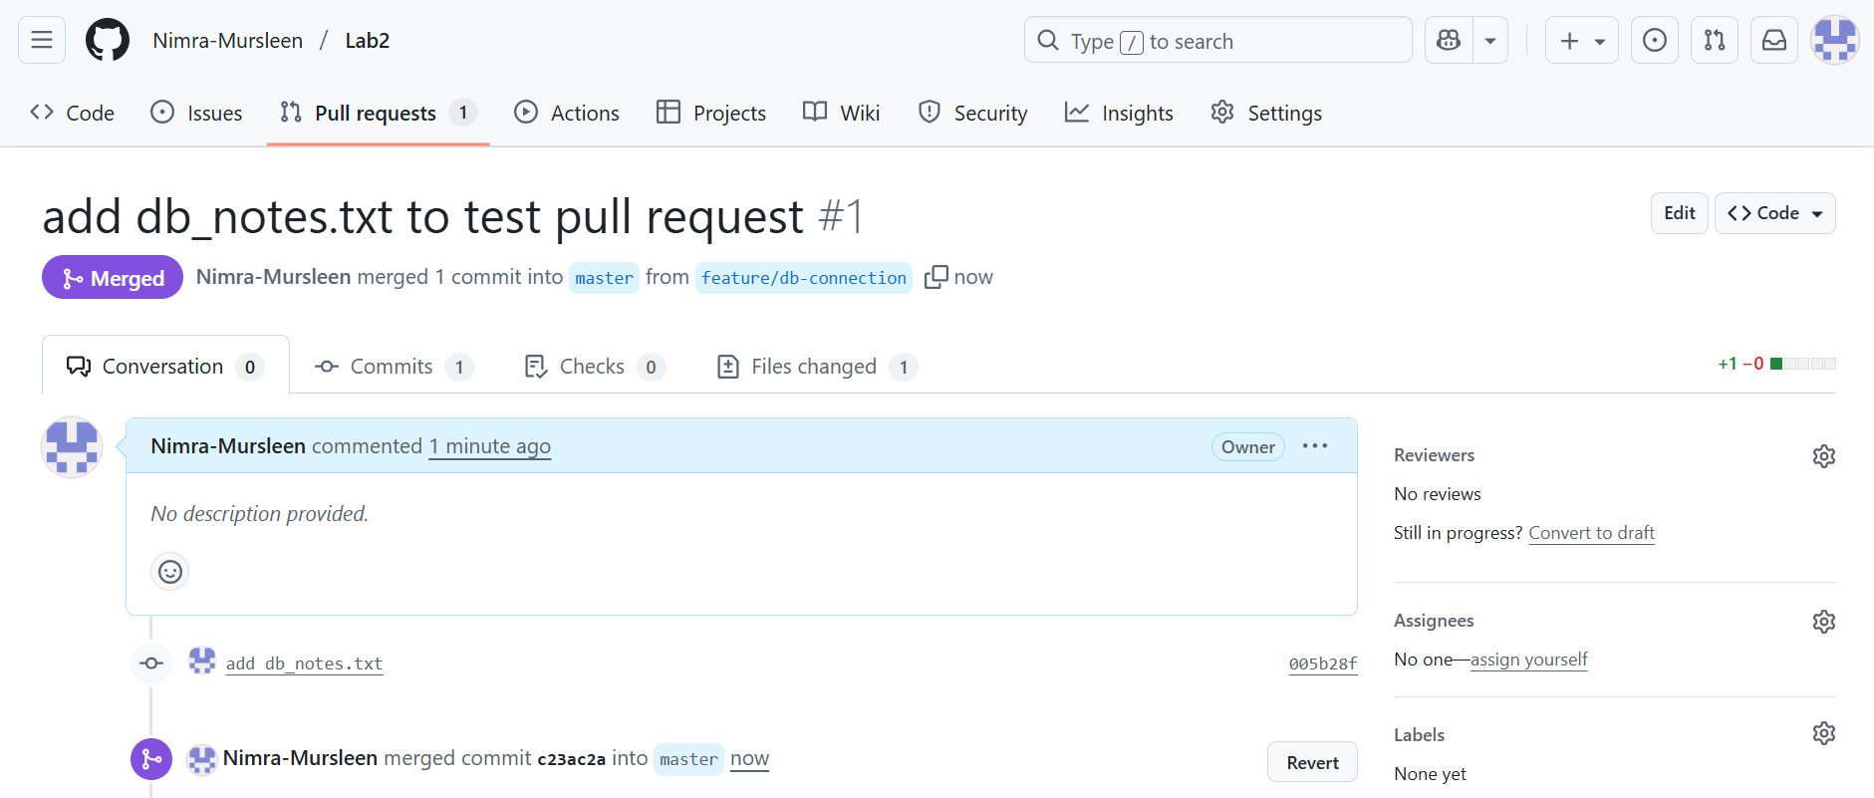

1. **branch deletion**

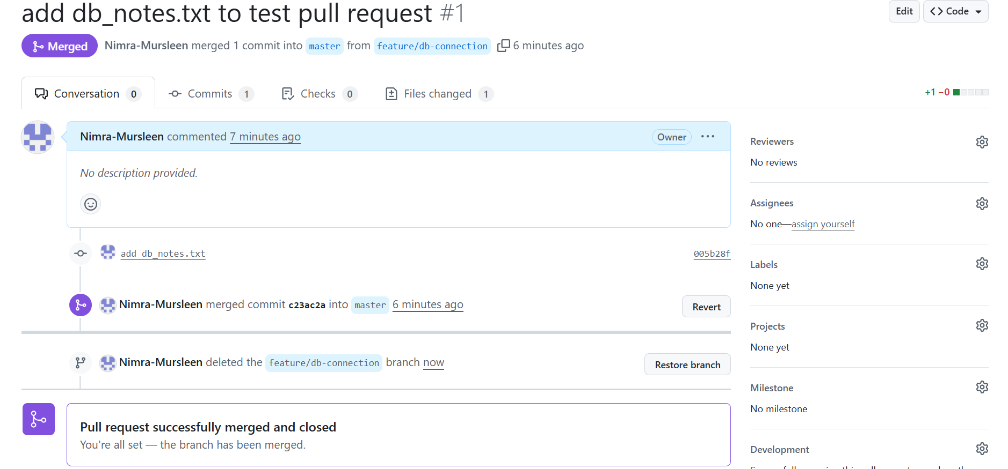

**Task 11: Detailed Branch Strategy (Develop/Staging)**

1. **Branch list**

**Create develop and staging branch:**

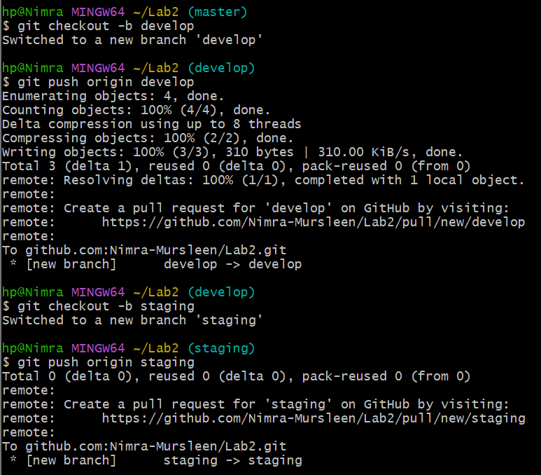

**Create feature/login and bugfix/error-msg branch in develop:**

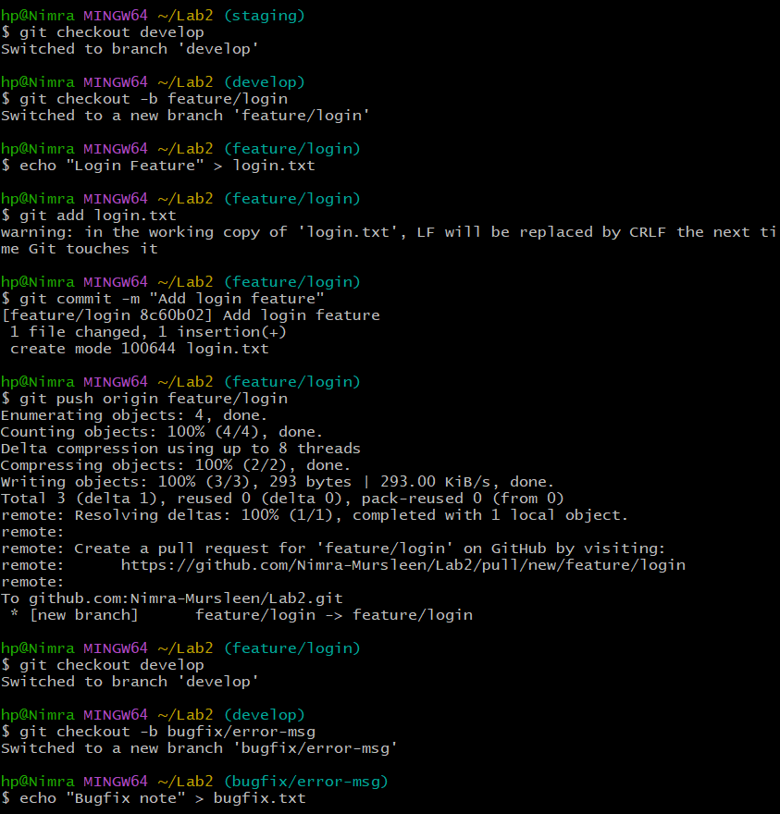

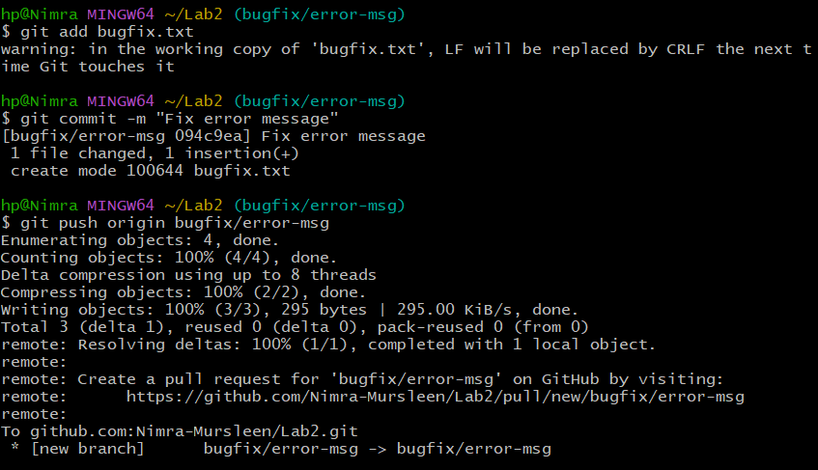

1. **Merges into develop and staging**

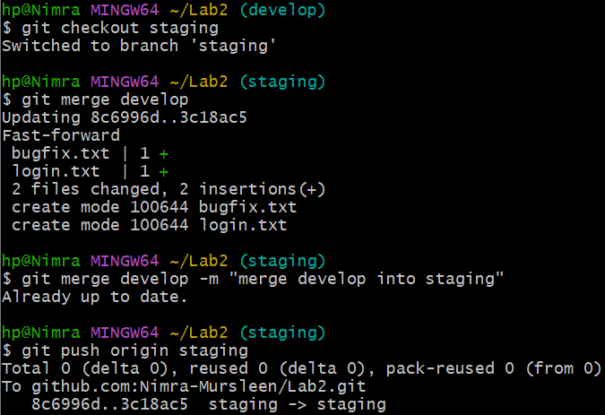

1. **Final merge into master**

