

**Software Engineering**

**Project Deliverable 2: Requirements Document**

**Date: November 21, 2020**

**Submitted to:**

Sir Zeeshan Rana

**Submitted by:**

Spriggan 5

**Group Members:**

Muhammad Fahad Arshad L17-4014

Nimra Abid L17-4088

Abubakar Nadeem L17-4172

Muhammad Muneeb L17-4333

Yasoob ul Hassan L17-4380

National University of Computer and Emerging Sciences

Department of Computer Sciences

**Table of Contents**

|  |
| --- |
| 1. Introduction to the Document  1.1 Purpose of the Product  1.2 Scope of the Product  1.3 Acronyms, Abbreviations, Definitions  1.4 References  1.5 Outline of the rest of the SRS  2. General Description of Product  2.1 Context of Product  2.2 Product Functions  2.3 User Classes and Characteristics  2.4 Constraints  2.5 Assumptions and Dependencies  3. Specific Requirements  3.1 External Interface Requirements  3.1.1 User Interfaces  3.1.2 Hardware Interfaces  3.1.3 Software Interfaces  3.1.4 Communications Interfaces  3.2 Functional Requirements  3.2.1 Requirement 1  3.2.2 Requirement 2  3.2.3 Requirement 3  3.2.4 Requirement 4  3.2.5 Requirement 5  3.2.6 Requirement 6  3.2.7 Requirement 7  3.2.8 Requirement 8  3.2.9 Requirement 9  3.2.10 Requirement 10  3.2.11 Requirement 11  3.3 Performance Requirements  3.4 Design Constraints  3.5 Other Quality Requirements  3.6 Other Requirements  4. Appendices  4.1 Appendix 1: Use Cases  4.2.1 Use Cases for Jailor  4.2.2 Use Cases for Jail Officer  4.2.3 Use Cases for Court Officer  4.2.4 Use Case Diagram  4.2 Appendix 2: ClassDiagram |

**1. General Description of Product**

**1.1 Purpose of the Product**

The purpose of this application is to provide a management system for prisoners. This product provides convenience to the jail management as well as the prisoners. Due to the immutability of the data and real time information, it will be easier for the authorities to keep track of the prisoners and the proceedings. Furthermore, it will also provide a user-friendly interface for the jail staff to deal with.

**1.2 Scope of the Product**

The goal of this project is to provide a simple web-application that will perform CRUD operations along with some other functionalities. However, this project will not include the real-time information exchange among several users. The benefits of the product will include the ease-of-use for the police department and the court. Moreover, it will also help maintain the crime history of the region/country.

**1.3 Acronyms, Abbreviations, Definitions**

CRUD: Create, Read, Update, Delete

SRS: Software Requirements Specification Document

**1.4 References**

[1] IEEE Recommended Practice for Software Requirements Specification (IEEE-STD-830- 1998). Available at http://ieeexplore.ieee.org

[2] Standard Glossary of Software Engineering Terminology (IEEE Std 610.12-1990 IEEE). Available at http://ieeexplore.ieee.org

**1.5 Outline of the rest of the SRS**

**2. General Description of Product**

**2.1 Context of Product**

A product's context is the circumstances or environment in which an object is used and which contributes to its significance. The satisfaction of a customer with a product depends upon the context of its use. As the environment in a prison is really stressful as there is overcrowding, violence, poor lighting, dull buildings, noise and unpleasant prison conditions therefore, our system should not be too demanding and dull. We can help lift up the tension of the user a little by making our layout brighter, colorful and which invites harmony. Moreover, our system should ensure safety. We can use a safety plan in case of an emergency by a time out function which will logout on its own after some time of inactivity. Our system should not be much input demanding as it will overburden the user.

**2.2 Product Functions**

The major functions which our system will let the user perform are:

1. The Jailor can add/delete Jail Officers in the system.
2. The Jail Officer can add the details of each incoming prisoner (name, CNIC, address, phone, criminal history, release date etc.)
3. Jail Officer can request the transfer of a prisoner.
4. Court Officer can approve the transfer of the prisoner.
5. Court Officer can file the complaints of Prisoners.
6. Jail Officer can request the Reduction in sentence-duration.
7. Court Officer can approve the Reduction in sentence.
8. Jailor can oversee the capacity and assign the prisoners jobs for good behavior.
9. Jailor can keep a check on the limited meeting hours for each prisoner per week.
10. Jailor can keep a record of the execution details of a prisoner.

**2.3 User Classes and Characteristics**

There will be three main group of users who will be using our system:

1. **Jailor:** In a prison or jail, a jailor or correctional officer enforces the laws and regulations and preserves order.
2. **Jail Officer:** Prison jail officers in jails or prisons ensure the safety and security of inmates. They protect the facility and are the first to respond to any issues that arise. Jail Officers are the subordinates of the Jailor.
3. **Court Officer:** A court officer is a person who keeps a record of the court processes. By following court orders and serving legal orders, he enforces court decisions.

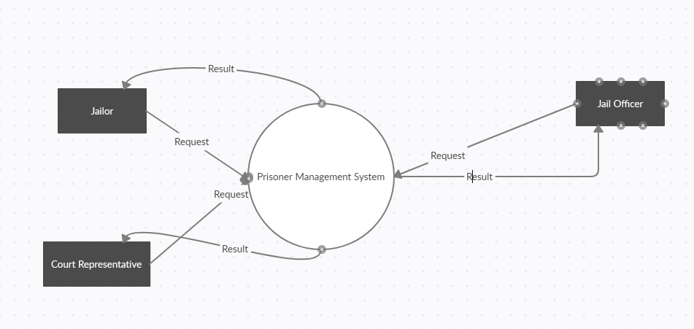

Figure: DFD Level 0

**2.4 Constraints**

The main constraints which need to be catered for this project are the time required for the completion of the project, the scope of the project which will determine the expected outcomes of the project, the customer satisfaction level, the database management and monitoring, the safety measures and the risk analysis of the project.

The following table represents the hardware and systems currently available:

|  |  |
| --- | --- |
| Item | Specifications |
| Operating System | Windows 10 ver. 1903 |
| Processors | Intel(R) Core(TM) 2.40GHz |
| RAM Capacity | 8.00 GB |
| Hard Drive | 440GB |

Table: Hardware Limitations

**2.5 Assumptions and Dependencies**

Some assumptions which we have taken into consideration are that

there exists a hierarchy in the prison and every user has its set of tasks assigned to them. Moreover, another assumption is that the users are literate and have the knowledge of using the software. Furthermore, all users are at least familiar with the functionality standard among Windows programs.

**3. Specific Requirements**

**3.1 External Interface Requirements**

**3.1.1 User Interfaces**

The user interface needs to be user friendly and provide ease of use to the users. Moreover, it will follow the UI/UX design conventions and rules. It will include confirmation messages and error messages that will appear as the users wants to perform some actions. The diagram below illustrates the relationship between the interfaces.

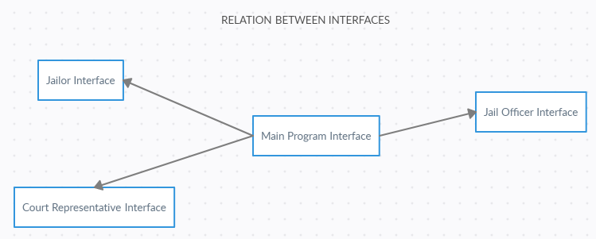

**3.1.2 Hardware Interfaces**

This product is completely a software-based implementation and does not provide interaction between the underlying hardware. However, the user will need to have I/O devices and the application will be capable of handling Input from the Keyboard and the Mouse.

**3.1.3 Software Interfaces**

This project will use ReactJS as a front-end framework and NodeJS as server-side language. Moreover, the data will be stored in a SQL database.

**3.1.4 Communications Interfaces**

This product will follow the standard communication protocol i.e. HTTP. Moreover, security protocols can be followed upon the request of the client.

**3.2 Functional Requirements**

**3.2.1 Requirement 1**

The Prisoner Management System should have three types of Users (Jailor, Jail Officer, and Court Representative).

**3.2.2 Requirement 2**

Jailor can add/delete Jail Officers in the System.

**3.2.3 Requirement 3**

Jail Officer will add the details of each incoming prisoner (name, CNIC, address, phone, criminal history, release date etc.).

**3.2.4 Requirement 4**

Jail Officer can request the transfer of a prisoner.

**3.2.5 Requirement 5**

Court Officer will approve the transfer.

**3.2.6 Requirement 6**

Court Officer will file the complaints of Prisoners.

**3.2.7 Requirement 7**

Jail Officer can request the Reduction in sentence-duration.

**3.2.8 Requirement 8**

Court Officer will approve the Reduction in sentence.

**3.2.9 Requirement 9**

Jailor will oversee the capacity and assign the prisoners jobs for good behavior.

**3.2.10 Requirement 10**

There will be limited meeting hours for each prisoner per week.

**3.2.11 Requirement 11**

The Prisoner to be executed should have his execution date and the executor’s name should be mentioned in the record.

**3.3 Performance Requirements**

The applications need to perform all the required operations. Moreover, the application also requires to retain the state and the data provided in the previous sessions.

**3.4 Design Constraints**

The system required to develop the application should have the frameworks installed and working. Moreover, the database software like SQL Server should also be available to retain the data. The system should also have an operating system and enough memory to execute and store the application.

**4. Appendices**

**4.1 Appendix 1: UseCases**

**4.1.1 Use cases for Jailor**

|  |  |
| --- | --- |
| **UseCase** | **Description** |
| Add Jail Officer | The Jailor can add Jail Officers in the system. |
| Delete Jail Officer | The Jailor can delete Jail Officers in the system. |
| Approve Prisoner Transfer | Jailor can approve the request to transfer the prisoner. |
| Assign Prisoner Job | Jailor can oversee the capacity and assign the prisoners jobs for good behavior. |
| Add Execution Details | Jailor can keep a record of the execution details of a prisoner. |
| Check Meeting Hours | Jailor can keep a check on the limited meeting hours for each prisoner per week. |

**4.1.2 Use Cases for Jail Officer**

|  |  |
| --- | --- |
| **UseCase** | **Description** |
| Add Prisoner Details | The Jail Officer can add the details of each incoming prisoner (name, CNIC, address, phone, criminal history, release date etc.). |
| Request Transfer of Prisoner | The Jail Officer can request the transfer of the prisoner. |
| Request Reduction in Sentence | Jail Officer can request the reduction in sentence of a prisoner. |
| Permit Prisoner Meeting | Jail Officer can permit the prisoner to have a meeting. |
| Reject Prisoner Meeting | Jail Officer can reject the prisoner to have a meeting. |

**4.1.3 Use Cases for Court Officer**

|  |  |
| --- | --- |
| **UseCase** | **Description** |
| Finalize Approval of transfer | The Court Officer can finalize the approval of transfer of a prisoner. |
| File Complaint | TheCourt Officer can file the complaints of prisoners. |
| Approve Reduction in Sentence | Court Officer can approve the reduction in Sentence of a prisoner. |

**4.1.4 Use Case Diagram**

Figure: Use Case Diagram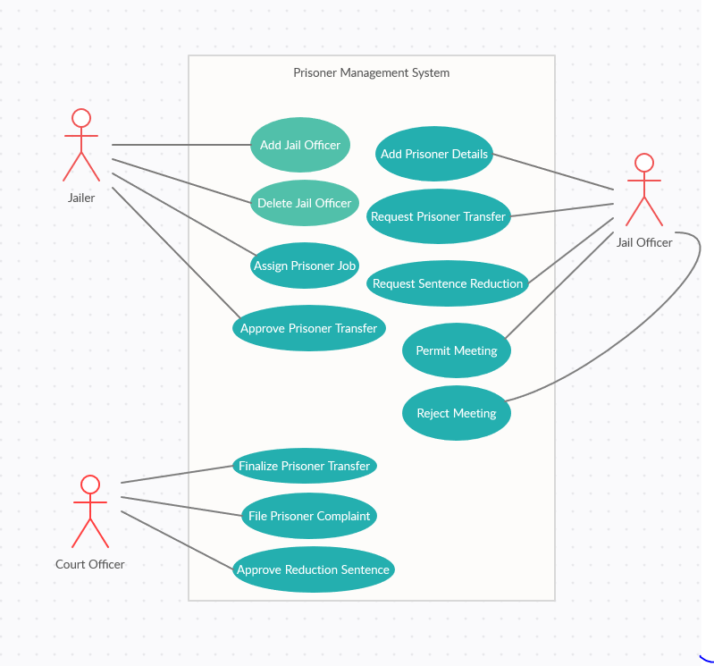

**4.2 Appendix 2: Class Diagram**

