**YoungDevInterns_Sql_Tasks**

**Task 02**

Basic SELECT Queries

* Retrieve employees' names and positions.
* List departments with locations.

**SQL Queries**

**1. Retrieve Employees' Names and Positions**

SELECT EmpName, Position FROM Employees;

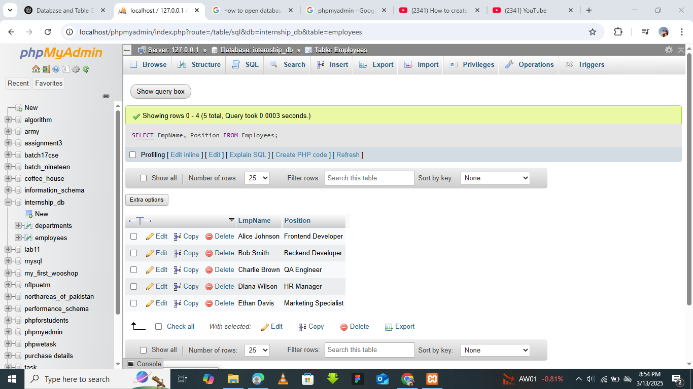

**2. List Departments with Locations**

Since the Departments table does not have a location field, let's first **add a Location column** and then insert sample locations.

**Modify the Departments table to include a Location column:**

ALTER TABLE Departments ADD Location VARCHAR(100);

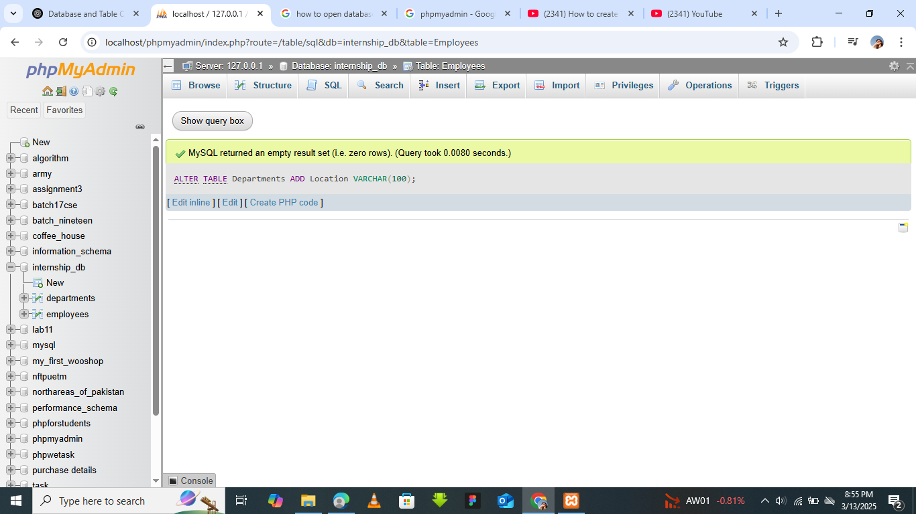

**Update department locations:**

UPDATE Departments

SET Location = 'New York' WHERE DeptID = 1;

UPDATE Departments

SET Location = 'San Francisco' WHERE DeptID = 2;

UPDATE Departments

SET Location = 'Los Angeles' WHERE DeptID = 3;

UPDATE Departments

SET Location = 'Chicago' WHERE DeptID = 4;

UPDATE Departments

SET Location = 'Boston' WHERE DeptID = 5;

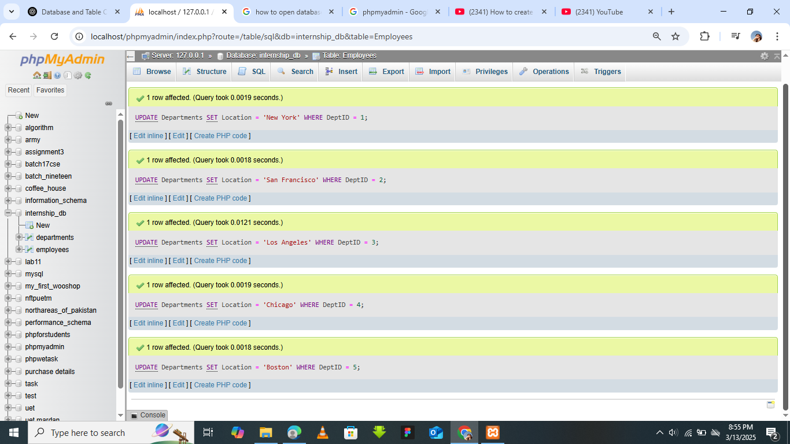

**Query to list departments with their locations:**

SELECT DeptName, Location FROM Departments;

