**YoungDevInterns_Sql_Tasks**

**Task 03**

**Filtering & Sorting**

* Query employees earning > $50,000.
* Sort employees by name, list departments in specific cities

**SQL Queries**

**1. Query Employees Earning More Than $50,000**

SELECT EmpName, Position, Salary

FROM Employees

WHERE Salary > 50000;

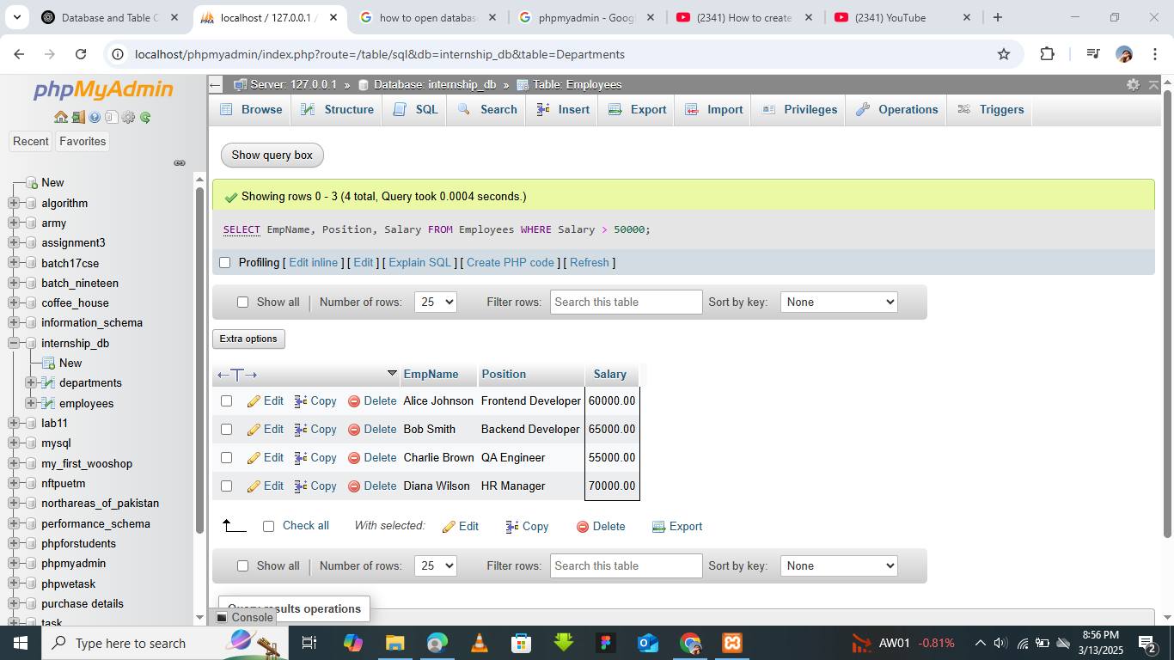

**2. Sort Employees by Name**

SELECT EmpName, Position, Salary, DeptID

FROM Employees

ORDER BY EmpName ASC;

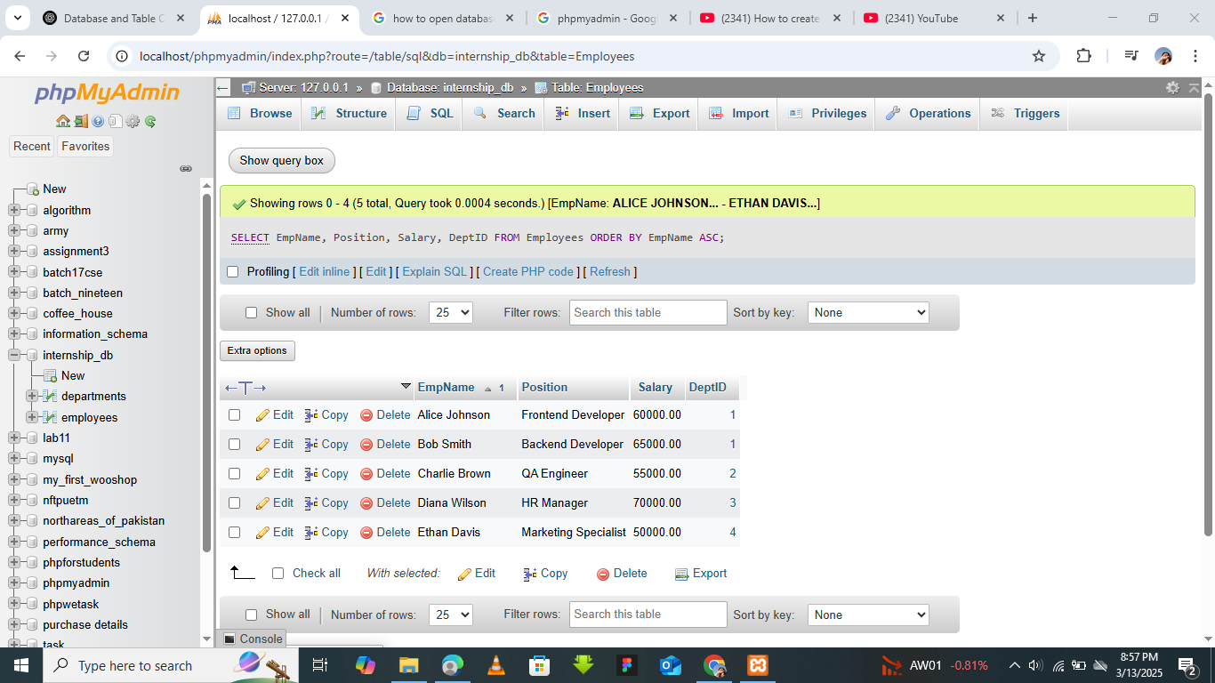

**3. List Departments in Specific Cities**

SELECT DeptName, Location

FROM Departments

WHERE Location IN ('New York', 'San Francisco');

