Questions 1:

a). Find out the Linux kernel version of your system using the command on the terminal. You are required to paste the screenshot in the answer.

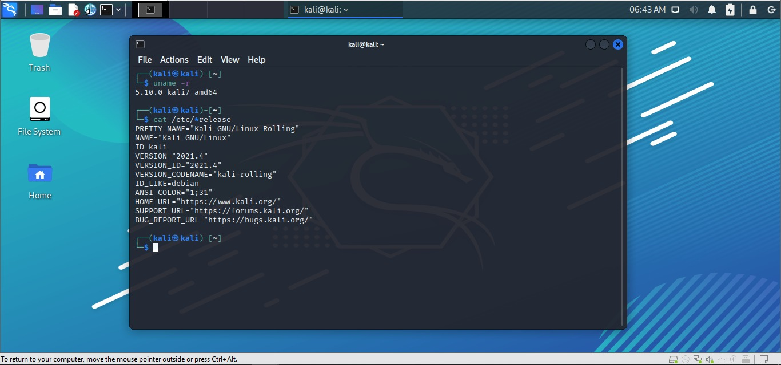

b). Find out the distribution name and version of your operating system using the command on the terminal. You are required to paste the screenshot in the answer.

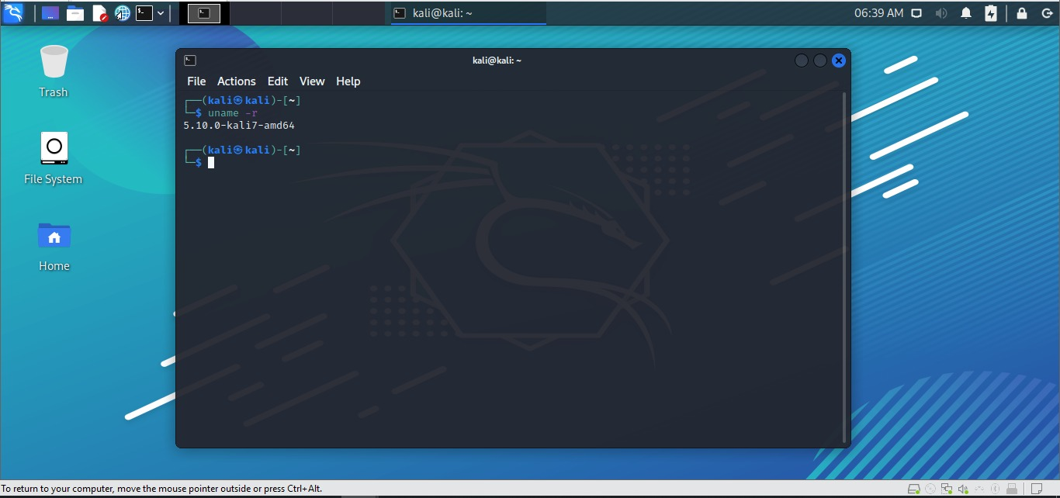

Question 2:

a) Write a C program (named: mywrite.c) which will open a new text file (myFile.txt) in the write mode. Using the c standard library API, your program should take the following information from the user in the terminal window:

Name, Age (type integer), Height (in Feet, type float).

Next, it should write the above information to the myFile.txt.

**mywrite.c**

1. #include <stdio.h>
2. void main()
3. {
4. char Name[50];
5. int Age;
6. float Height;
7. FILE* fp = fopen( "myFile.txt", "w" );
8. if (fp == NULL)
9. { printf("Not Found .\n");
10. Return 0;
11. }
12. printf("Enter Name:");
13. scanf("%s", &Name);
14. printf("Enter Age:");
15. scanf("%d", &Age);
16. printf("Enter Height:");
17. scanf("%f", &Height);
18. fprintf(fp,"%s,%d,%.2f\n", Name, Age, Height);
19. fclose(fp) ;
20. }

Output:

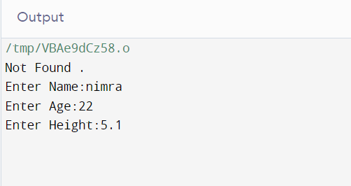

**myFile.txt**

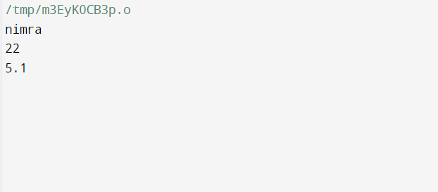

b) Write another C program (myread.c) which will open an already existing file (myFile.txt obtained from the above program) in read mode. Using the c standard library API, your program will read the information in the myFile.txt and print it to the terminal window.

**myread.c**

1. #include <stdio.h>
2. void main()
3. {
4. FILE* fp = fopen( "myFile.txt", "r" );
5. if( fp == NULL )
6. {
7. printf("Not Found.\n");
8. return 0;
9. }
10. char ch;
11. printf("Name,Age,Height \n");
12. do
13. {
14. ch = fgetc(fp);
15. printf("%c", ch);
16. }
17. while (ch != EOF);
18. fclose( fp );
19. }

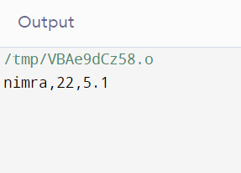

Questions 3:

What does POSIX stand for? Write a short description on POSIX.

POSIX stands for Portable Operating System Interface. It is a bunch of connection point principles determined by the Institute of Electrical and Electronics Engineers (IEEE) computer society and in light of UNIX. It gives the definition of the application programming connection points, the related utility points of interaction, and order line shells for the similarity of various applications and programming with multiple working frameworks and variations of UNIX. POSIX is a developing group of computer principles that comprises of a wide range of working framework parts going from the C programming language and points of interaction in view of the shell to the organization of computer frameworks.

Questions 4:

Various Operating systems use various structures such as Monolithic, Layered or Microkernel. Give at least five examples of operating systems for each of the structure.

The operating system can be executed with the assistance of different designs. The design of the operating system relies heavily on how the different normal parts of the operating system are interconnected and merged into the portion. On this we have following structures of the operating system:

1. Simple Structure: MS-DOS
2. Monolithic Structure: Unix, Linux, Open VMS, XTS-400, z/TPF, BSD, SunOS, AIX, and MULTICS
3. Layered Approach Structure: CP/M and DOS
4. Micro-kernel Structure: QNX, Symbian, L4L.inux, Singularity, K42, Mac OS X, Integrity, PikeOS, HURD, Minix, and Coyotos.
5. Client-Server Model: DNS (Domain Name Systems), web browsers and web servers, and FTP (file transfer protocol) clients.