**R**

Dataset:

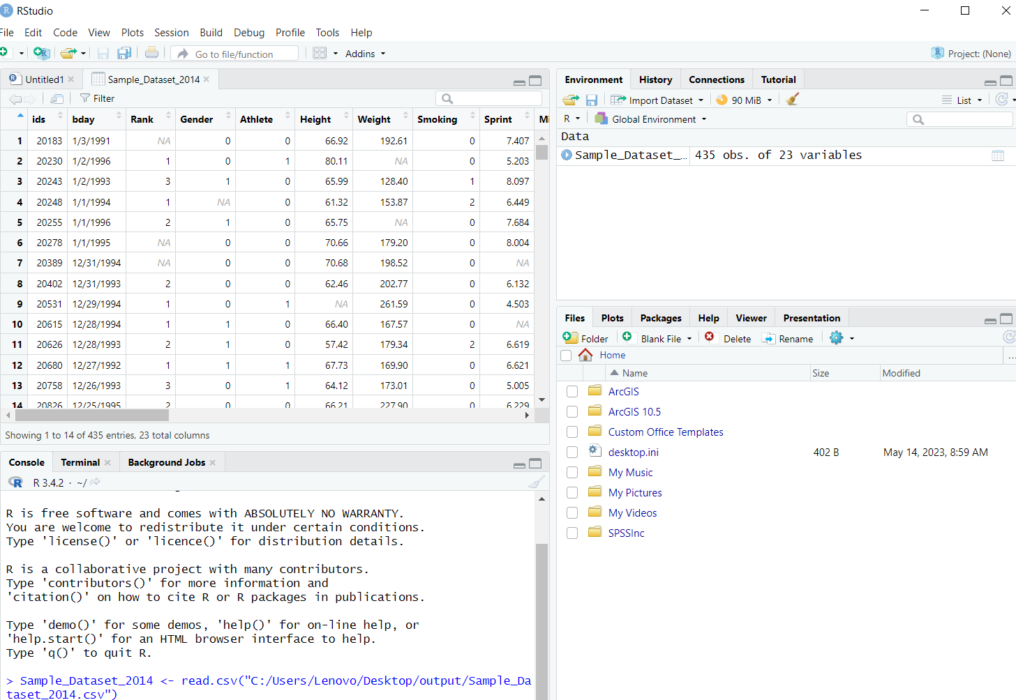

* **One Sample T-Test**

**Code:**

#One Sample T-Test

Sample_Dataset_2014 <- read.csv("C:/Users/Lenovo/Desktop/output/Sample_Dataset_2014.csv")

C:/Users/Lenovo/Desktop/output/Sample_Dataset_2014.csv

str(Sample_Dataset_2014)

names(Sample_Dataset_2014)

t.test(Sample_Dataset_2014$Height, conf.level = 0.95)

t.test(Sample_Dataset_2014$Height, alternative = "greater", conf.level = 0.95)

**result:**

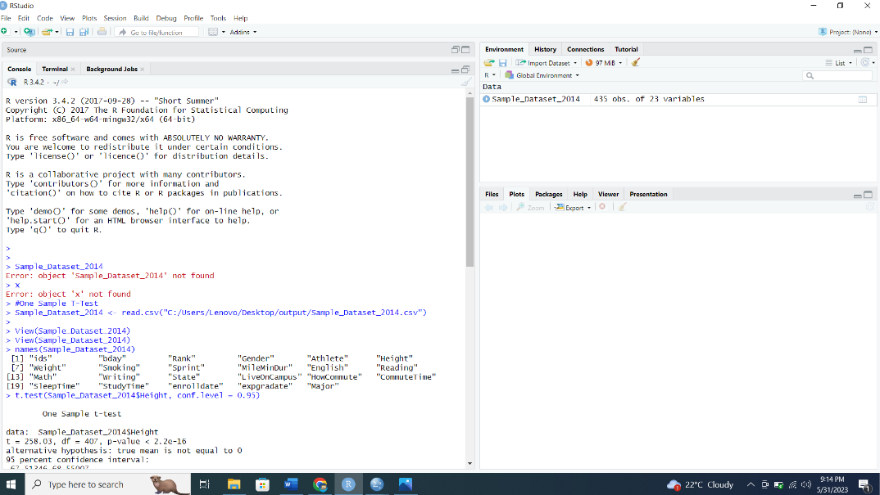

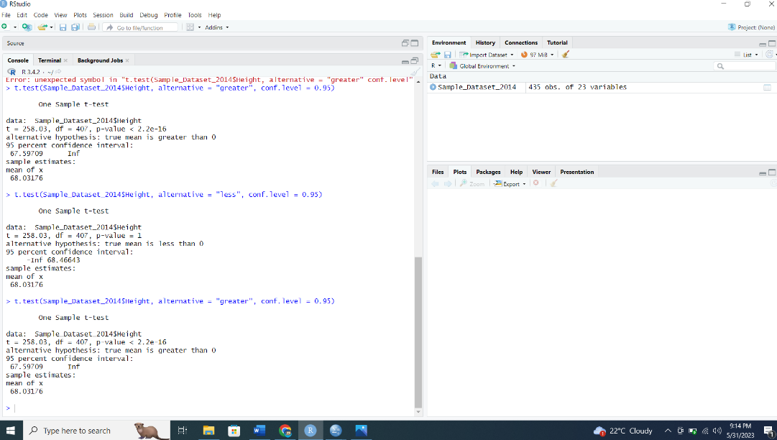

* **Paired Sample T-Test**

**Code:**

#Paired Sample T-Test

Sample_Dataset_2014 <- read.csv("C:/Users/Lenovo/Desktop/output/Sample_Dataset_2014.csv")

attach (Sample_Dataset_2014)

t.test(Sample_Dataset_2014$English, Sample_Dataset_2014$ Math, paired=T, alternative='two.sided', conf.level = 0.95)

**result:**

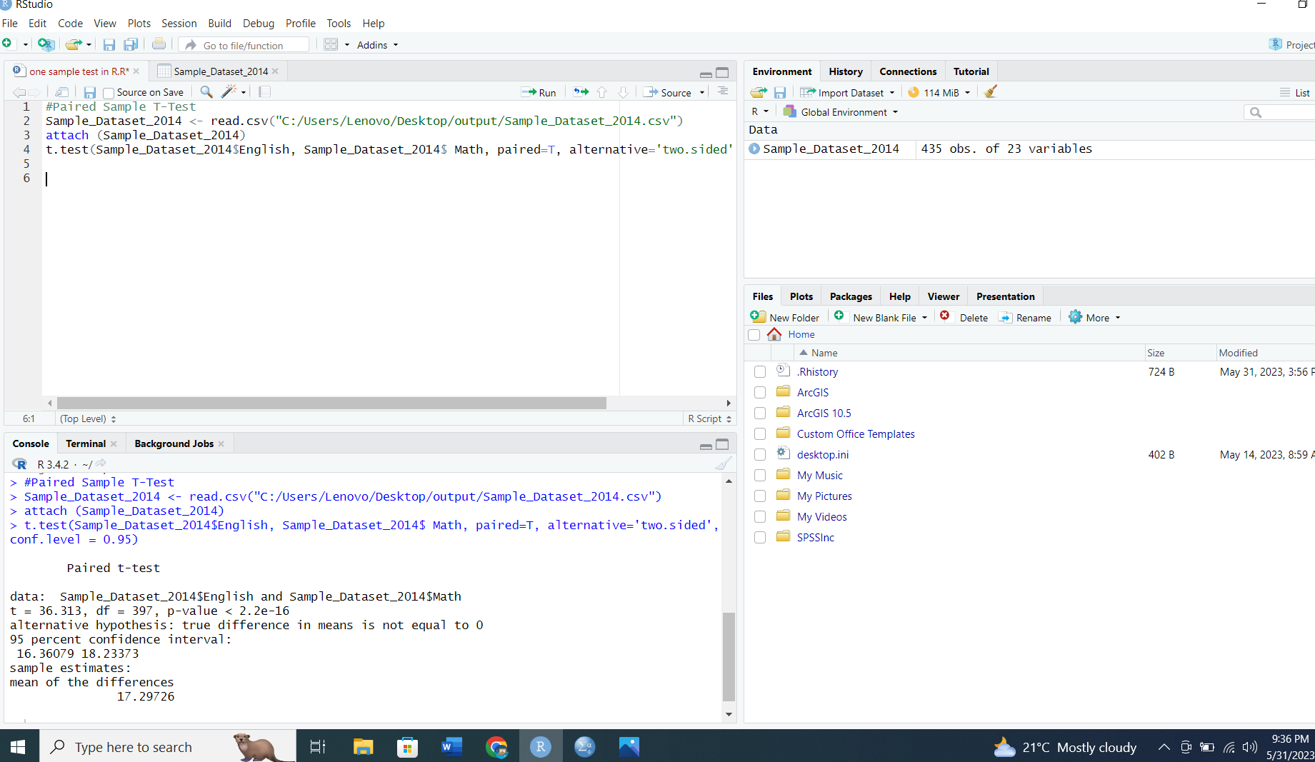

* **Independent Sample T-Test**

**Code:**

#Data for Independent Sample T-Test

Sample_Dataset_2014 <- read.csv("C:/Users/Lenovo/Desktop/output/Sample_Dataset_2014.csv")

attach (Sample_Dataset_2014)

View(Sample_Dataset_2014)

#homogeneity of variance

bartlett.test(list(Sample_Dataset_2014$Athlete, Sample_Dataset_2014$MileMinDur))

#Independent Sample T-Test

t.test(Sample_Dataset_2014$Athlete, Sample_Dataset_2014$MileMinDur, dataset=Sample_Dataset_2014, alternative = "two.sided", conf.level = 0.95, var.equal = T)

**Result:**

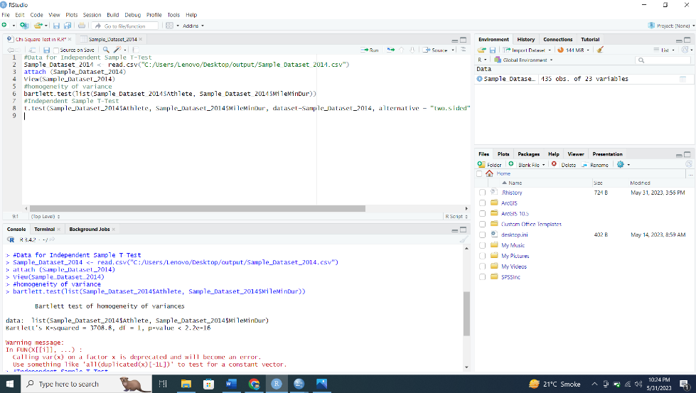

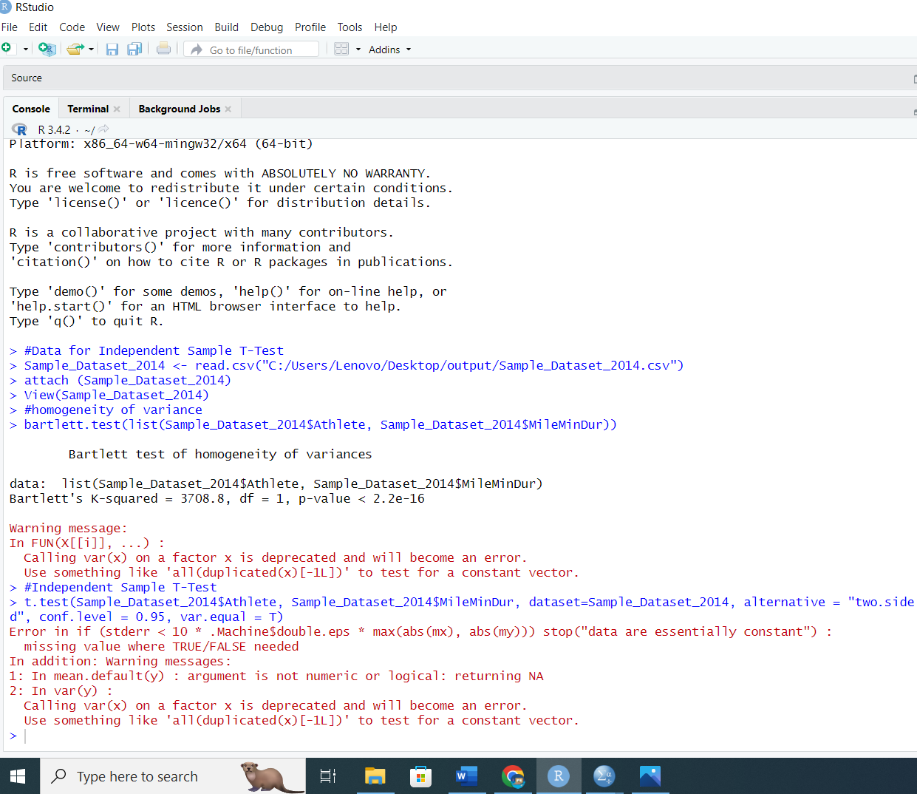

* **ANOVA**

**Code:**

#ANOVA

Sample_Dataset_2014 <-read.csv("C:/Users/Lenovo/Desktop/output/Sample_Dataset_2014.csv")

attach (Sample_Dataset_2014)

View(Sample_Dataset_2014)

aov (Smoking ~ Sprint)

summary(aov(Smoking ~ Sprint))

TukeyHSD(aov(Smoking ~ as.factor(Sprint)))

**Results:**

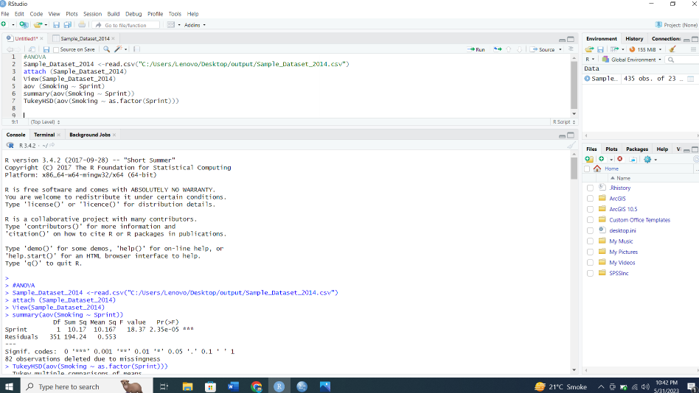

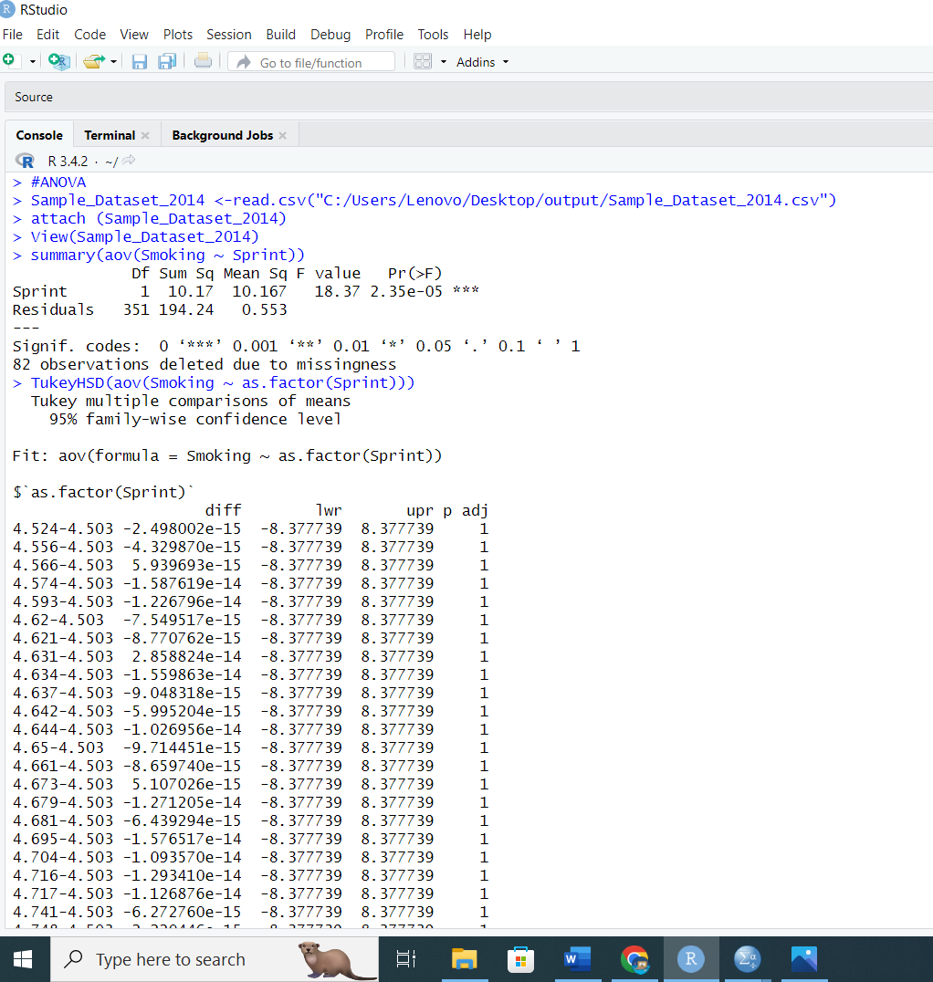

* **Pearson Correlation**

**Code:**

#Pearson Correlation

Sample_Dataset_2014 <-read.csv("C:/Users/Lenovo/Desktop/output/Sample_Dataset_2014.csv")

attach (Sample_Dataset_2014)

View(Sample_Dataset_2014)

cor.test(Sample_Dataset_2014$Height, Sample_Dataset_2014$Weight)

cor.test(Sample_Dataset_2014$Height, Sample_Dataset_2014$Weight, conf.level = 0.95)

cor.test(Sample_Dataset_2014$Height, Sample_Dataset_2014$Weight, alternative = "greater")

**Results:**

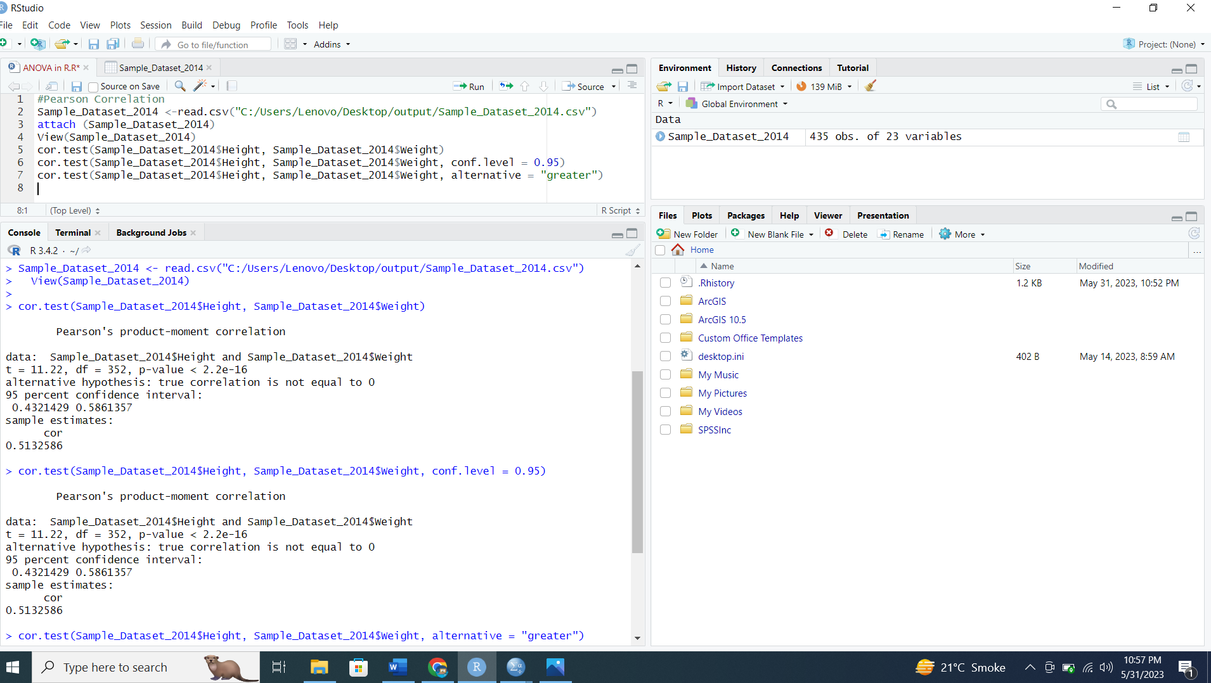

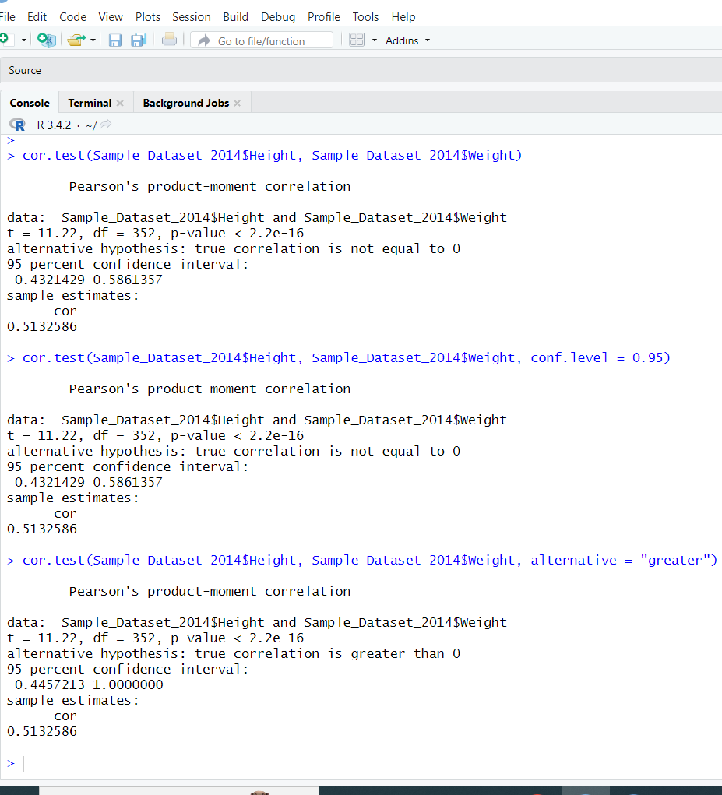

* **Chi-Square Test**

**Code:**

#Chi-Square Test

Sample_Dataset_2014 <-read.csv("C:/Users/Lenovo/Desktop/output/Sample_Dataset_2014.csv")

attach (Sample_Dataset_2014)

View(Sample_Dataset_2014)

#contingency table

table(Sample_Dataset_2014$Smoking, Sample_Dataset_2014$Gender)

#chi square test of independence

result <- chisq.test(Sample_Dataset_2014$Smoking, Sample_Dataset_2014$Gender)

result

**Results:**

