**SPSS**

Dataset:

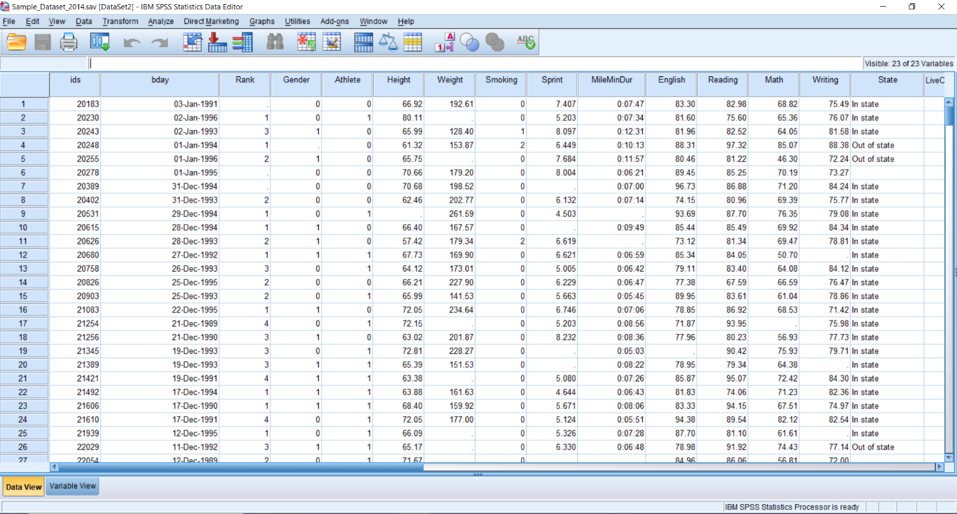

* **One Sample T-Test**

In this I choose height as a variable and graph in histogram. In result it shows minimum, maximum, mean and standard deviation of height of the people.

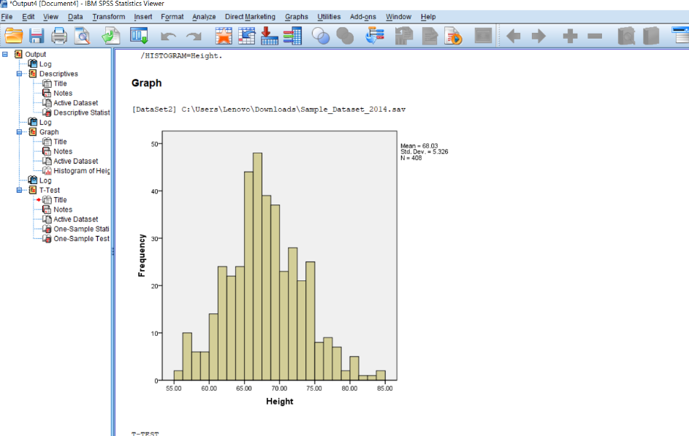

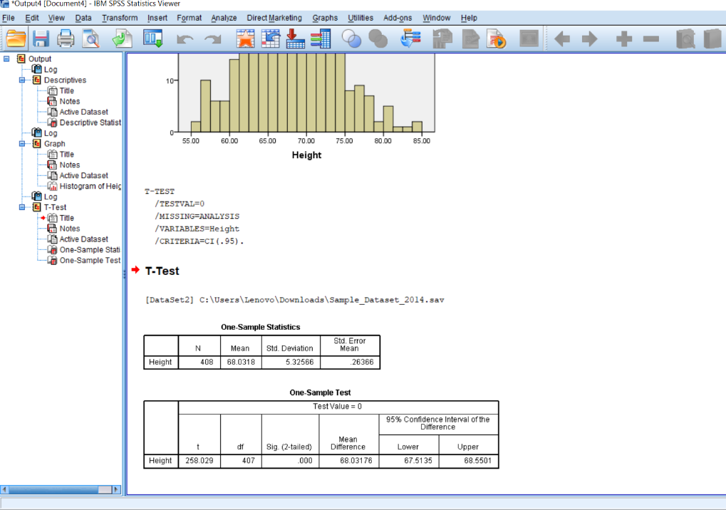

* **Paired Sample T-Test**

In this I compare English and math with each other.in result it shows paired samples statistic, correlation and case processing summary in the form of boxplot. It also shows mean, difference and p-value two tailed in Paired Sample T-Test.

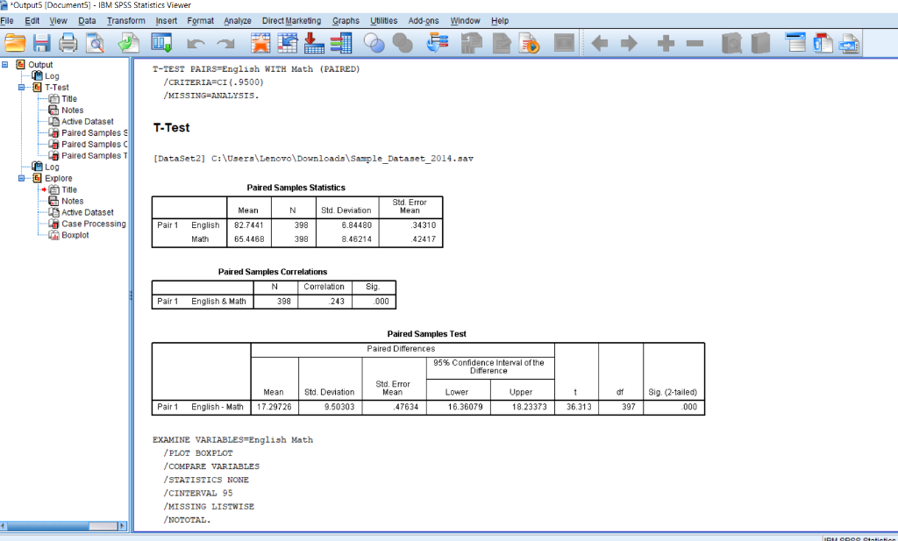

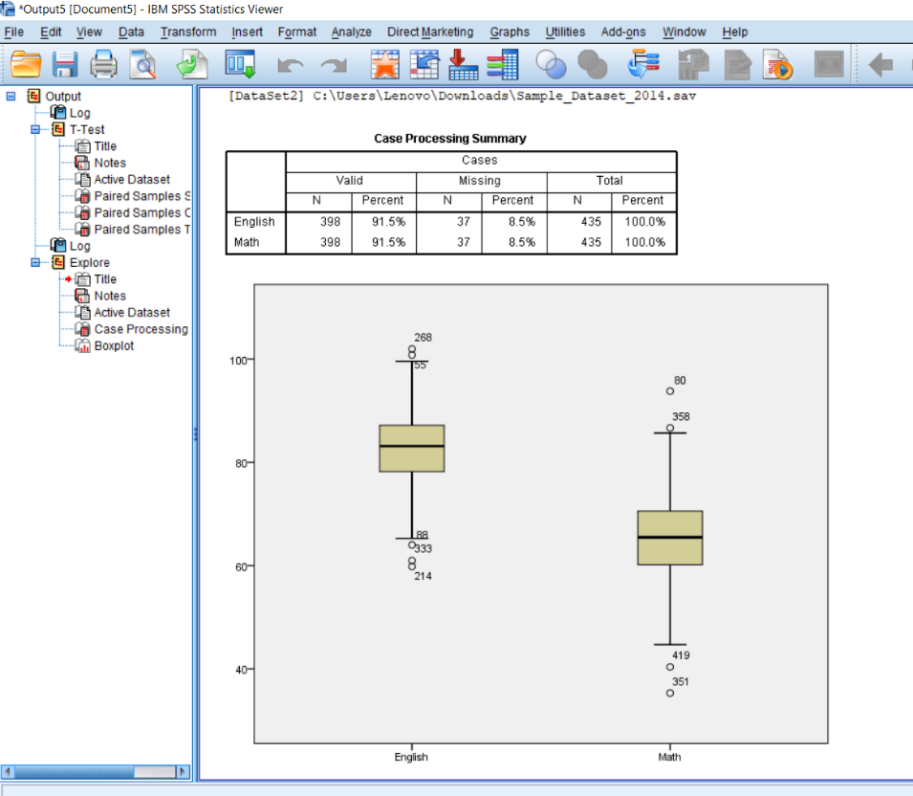

* **Independent Sample T-Test**

In the result of an Independent Sample T-Test I find out test statistic (t-value), the degrees of freedom, the p-value, and descriptive statistics (means, standard deviations, sample sizes) for Athlete and MileMinDur. The graph shows stem and leaf plot.

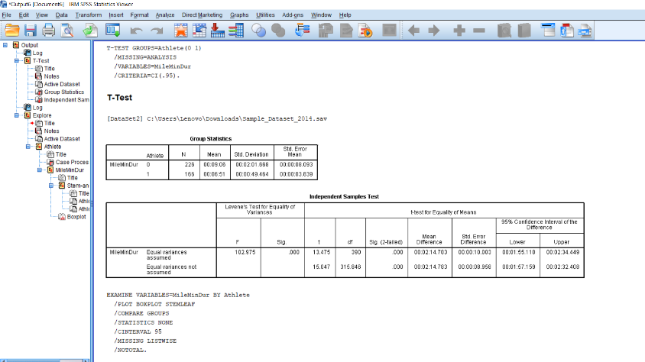

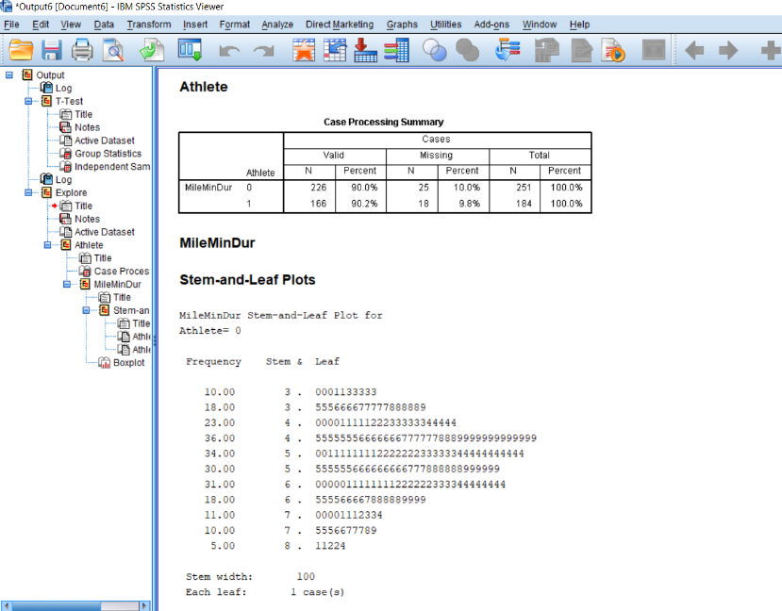

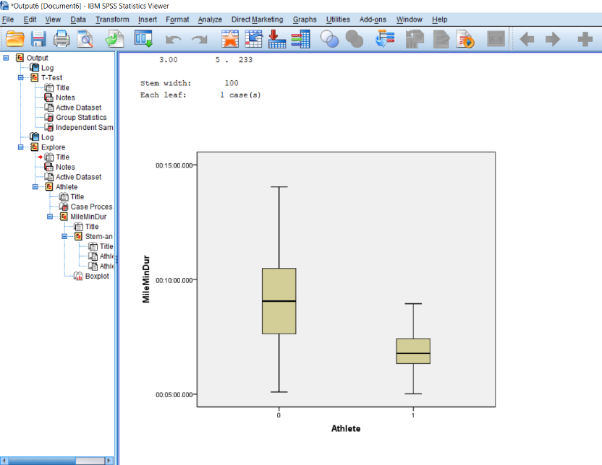

* **ANOVA**

It shows differences between the means of sprint and smoking, the F-value, degrees of freedom for both the numerator and denominator, and the p-value. The graph shows the mean plots of smoking.

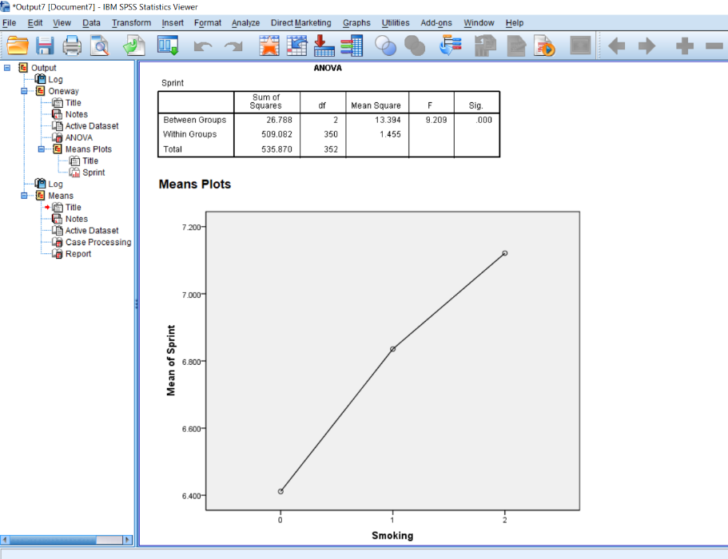

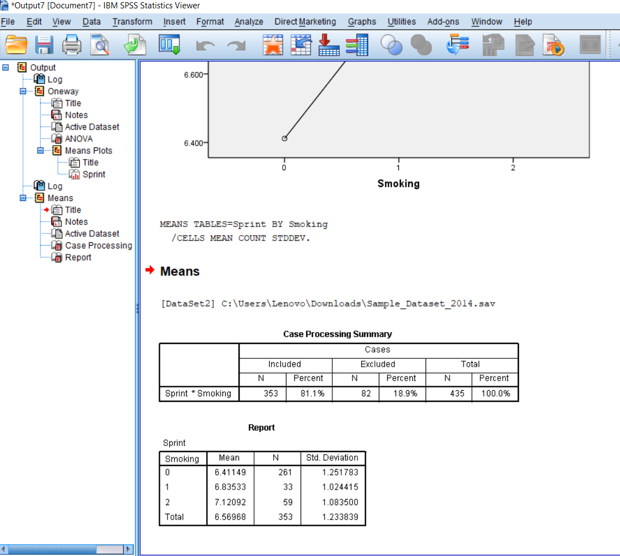

* **Pearson Correlation**

In this I find the correlation coefficient r-value, the degrees of freedom, and the p-value. Result provides information about the strength and direction of the linear relationship between height and weight in scatter plot.

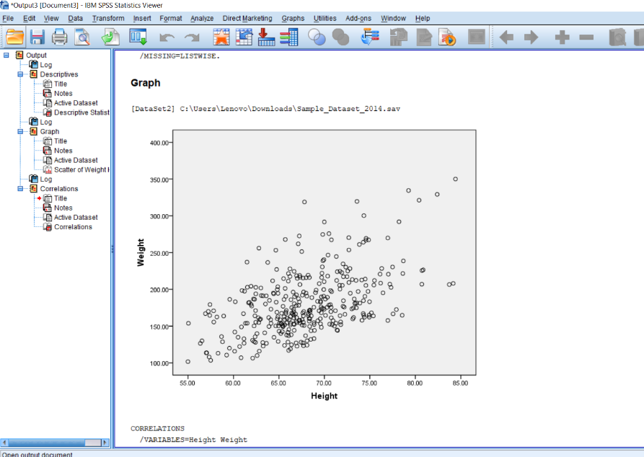

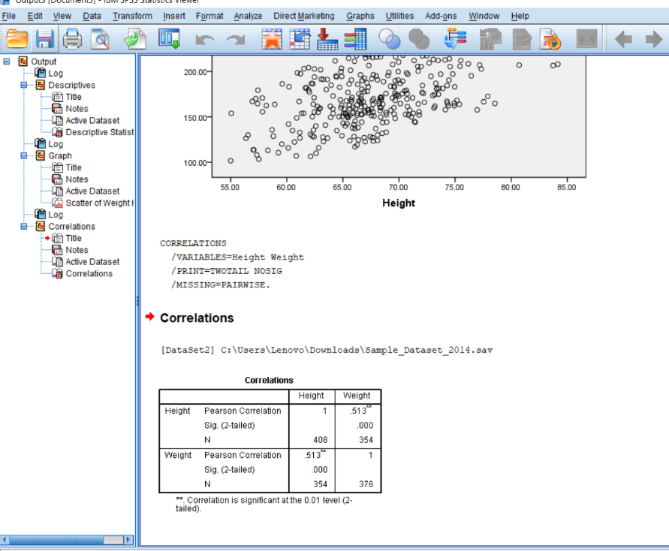

* **Chi-Square Test**

In Chi-Square value, degrees of freedom, and the p-value. Result helps determine between smoking and gender.

