**NAME:** NIMRA ASIF

**ID:** F2023065108

**SUBJECT:** Software Engineering

**SECTION:** W6

**Documentation**

**Daily Paws:** Pet Care Reminder and Journal

**Project Overview:**

Daily Paws is a pet care management app designed to help pet owners streamline routine tasks, monitor their pets' health, and engage with a like-minded community. It provides personalized care reminders, a journaling feature to capture memories, and tools to track health metrics. The app also incorporates gamification and social features to foster user engagement and promote responsible pet care.

1. **Problem:**

Pet owners struggle with consistent care routines and reliable information. Daily Paws solves this with reminders, health tracking, and a community platform to support responsible pet ownership.

1. **Objectives:**

* Remind users of key pet care tasks like feeding, grooming, exercise, and vet visits through customizable notifications.
* Provide a journal to capture special moments with pets, allowing users to log memories with text, photos, and videos.
* Encourage responsible pet care through reminders, checklists, and educational content.
* Enable users to connect with a community of pet owners for advice, experiences, and inspiration.
* Provide personalized care tips based on pet-specific data and health trends.

1. **Goals:**

* Ensure regular pet care for better pet health and well-being.
* Encourage users to capture pet moments for memorable experiences.
* Achieve consistent user engagement through personalized reminders and community interactions.
* Increase awareness of responsible pet ownership and provide educational resources.
* Measure success through KPIs such as Daily Active Users (DAUs), retention rate, and user satisfaction scores.

1. **Scope:**

* Basic care task tracking (feeding, grooming, vet visits).
* Pet profile and journal entries with photo storage.
* Reminders for recurring tasks.
* Customizable reminders for unique care tasks based on the type of pet.
* Community forums or groups for breed-specific advice and support.
* Future updates may include specialized content and custom recommendations based on pet type and age.

1. **Stakeholders:**

* **Users:** Pet owners who want to keep up with care routines.
* **Veterinarians:** Could offer sponsorship or advice.
* **Pet Food or Product Brands**: Potential partnerships for promotions, content, or sponsorship.
* **Animal Welfare Organizations**: Provide resources and support for responsible pet ownership.
* **Developers:** Responsible for building and updating the app.

1. **Customers:**

The target audience includes pet owners who seek assistance in managing pet care routines, tracking health metrics, and engaging in community-driven pet-related discussions. Customers include individuals with various types of pets, such as cats, dogs, and exotic animals, who value organized care and personalized recommendations.

1. **Tools and Techniques:**

* **Front-End:** Flutter for cross-platform development to support iOS and Android; build an intuitive, pet-themed user interface.
* **Backend**: Firebase for real-time data sync, cloud storage for photo and video journaling, and user account management.
* **Data Analytics and Machine Learning:** Collect and analyze pet care data to provide personalized health insights and proactive care tips.
* **AI Integration:** Implement image recognition to identify pet species/breeds, or detect mood in photos, enhancing the journaling and community aspects.
* **Security and Privacy**: Ensure robust security measures and data privacy compliance to protect user and pet information.
* **Notifications:** In-app notifications for pet care reminders.

1. **Deployment:**

* Mobile App Stores for maximum accessibility.
* Launch a beta version for initial feedback and testing within a community of pet owners and vets.
* In-app feedback to refine and improve pet care recommendations.
* Include a lightweight web version for desktop users in future updates.

**Requirements Analysis**

**Functional Requirements:**

**1. Login:**

* Users who already have an account can log in by providing their credentials (email/password, phone number, or third-party authentication).
* After successful login, they are directed to the **Home Dashboard**.

**2. Signup:**

* If the user is new and doesn’t have an account, they can sign up by providing necessary details (email, phone number, or third-party authentication).
* After successful signup, the user is directed to the **Home Dashboard**.

**3. Home Dashboard:**

* This is the main screen users see after logging in or signing up.
* The dashboard offers easy access to all the core features:
  + Pet profiles.
  + Care reminders.
  + Notifications and alerts.

**4. User Account Management:**

* Users can manage their account details, preferences, and settings.
* This can be done directly from the **Home Dashboard**.

**5. Pet Profile Creation:**

* The user creates profiles for their pets by providing details like:
  + Name
  + Breed
  + Age
  + Health conditions
* This is done from the **Home Dashboard** or through a dedicated pet profile section.

**6. Customizable Care Reminders:**

* Users can set personalized care reminders for:
  + Feeding
  + Grooming
  + Vet visits
  + Exercise
* These reminders will be displayed in the **Home Dashboard** and users will receive notifications.

**7. Notifications and Alerts:**

* The app will send notifications to remind users of pending or overdue tasks.
* Alerts for upcoming milestones (e.g., vet visits, vaccinations) will also appear.

**8. Health Metrics Tracking:**

* Users can input and track their pet's health metrics like:
  + Weight
  + Vaccination history
  + Vet visits
* This data is stored and updated in the **Home Dashboard** for easy access.

**9. AI-Driven Recommendations:**

* Based on the pet’s health and profile, the app will provide personalized recommendations on:
  + Nutrition
  + Exercise
  + Care tips
* These recommendations will be shown in the **Home Dashboard**.

**10. Educational Content:**

* Users can access articles, videos, and resources on responsible pet ownership.
* These can be found in the **Educational Content** section of the app.

**11. Journal Entries:**

* Users can log memories and experiences with their pets, such as:
  + Text
  + Photos
  + Videos
* These can be added to the pet's journal, accessible via the **Home Dashboard**.

**12. Community Engagement:**

* Users can join forums and pet groups to share experiences, seek advice, and connect with other pet owners.
* The community features can be accessed directly from the **Home Dashboard**.

**13. Third-Party Integration:**

* The app can integrate with third-party services such as:
  + Veterinarians
  + Pet food or product brands
* Users can access content or services from these partners through the app.

**14. Secure Data Storage:**

* All user and pet data is securely stored in the cloud and complies with privacy laws like GDPR and CCPA.
* This ensures that all data is protected and kept confidential.

**Non-Functional Requirements:**

1. **Fast**

* Quick responses (**<2 seconds**) and real-time sync (**<5 seconds**).

1. **User-Friendly**

* Easy-to-use, pet-themed interface.
* Accessible for everyone (readable fonts, screen readers).

1. **Reliable**

* Always available (**99.9% uptime**).
* Daily data backups.

1. **Secure**

* Strong encryption (**AES-256**).
* Privacy laws compliance (**GDPR, CCPA**).

1. **Scalable**

* Handles millions of users and grows easily.

1. **Easy to Fix**

* Clean, modular code for quick updates.

1. **Compatible**

* Works on **iOS** and **Android** with Flutter.

1. **Maintainable**

* Code is easy to maintain and update without extensive rework.

1. **Efficient**

* Optimal use of system resources, including memory and processing power.

1. **International**

* Supports multiple languages and time zones for a global audience.

**List of Actors:**

1. **Pet Owners (Primary Users):** Manage pet profiles, receive reminders, and use journaling features.
2. **Veterinarians:** May provide content or interact with users in forums.
3. **Community Members:** Participate in forums, share advice, and engage with the pet care community.
4. **System Administrator:** Manages app operations, data security, and user issues.
5. **Third-Party Partners:** Brands or organizations providing sponsored content or services.

**List of Use Cases:**

1. **Login:**

* Access account using email/password, phone number, or third-party authentication (Google/Facebook).
* Recover forgotten password through email or SMS verification.

1. **Signup:**

* Create a new account using email, phone number, or third-party authentication (Google/Facebook).
* Set up account details such as name, email, and password for the first time.

1. **Dashboard:**

* **View Information:** Display user details, pet summaries, and key updates (reminders, tasks).
* **Navigation:** Provide easy access to features like Pet Profiles, Notifications, and Journal.
* **Widgets:** Show interactive elements like health stats and upcoming tasks.

1. **User Account Management**:

* Update account details such as name, email, and password.

1. **Pet Profile Creation**:

* Add a new pet profile with details such as name, breed, and age.
* Update existing pet profiles.

1. **Customizable Care Reminders**:

* Set reminders for feeding, grooming, exercise, and vet visits.
* Customize reminder schedules.

1. **Notifications and Alerts**:

* Receive reminders for scheduled tasks.
* Get alerts for upcoming vaccinations or overdue care tasks.

1. **Health Metrics Tracking**:

* Record and monitor health data such as weight, vaccinations, and medical history.
* Generate health reports for a pet.

1. **AI-Driven Recommendations**:

* Receive care suggestions based on the pet’s age, breed, and health history.

1. **Educational Content**:

* Access articles, videos, or tips on pet care.
* Bookmark favorite resources for later use.

1. **Journal Entries**:

* Log memories with text, photos, and videos.
* View and edit previous entries.

1. **Community Engagement**:

* Participate in forums or groups for advice and discussions.
* Post questions or share tips with other users.

1. **Third-Party Integration**:

* Link profiles to veterinarian services for medical advice or appointments.
* Access offers from pet product brands.

1. **Secure Data Storage**:

* Ensure compliance with data security standards for storing pet and user information.

**System Use Case Diagrams and Tables:**

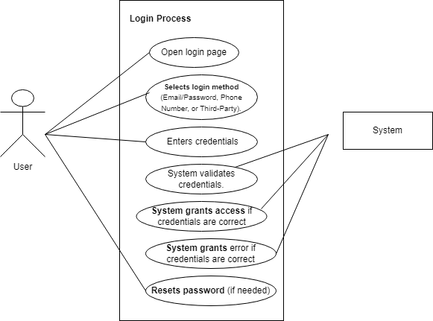

**Use Case Table for Login Process**

|  |  |
| --- | --- |
| **Field** | **Details** |
| **Use Case Name** | Login |
| **Created By** | Nimra Asif |
| **Date Created** | 12-06-24 |
| **Last Updated By** | 17-06-24 |
| **Last Revision Date** | 24-06-24 |
| **Actors** | **Primary**: User, **Secondary**: System |
| **Description** | This use case describes the login process where a user accesses their account by providing valid credentials or resetting the password if needed. |
| **Trigger** | The user accesses the login page. |
| **Preconditions** | - The user must have a valid account. - The login page must be accessible. |
| **Post conditions** | - User is granted access to their account if credentials are valid. - Error message is displayed if credentials are invalid. |
| **Normal Flow** | 1. The user opens the login page. 2. The user selects the login method (Email/Password, Phone, or Third-party). 3. The user enters credentials. 4. The system validates the credentials. 5. If the credentials are valid, the system grants access to the account. |
| **Alternative Flows** | **Forgot Password Flow**: 1. The user selects "Forgot Password". 2. The user follows the password reset process. 3. After resetting the password, the user retries logging in. |
| **Exceptions** | - **Invalid Credentials**: The system displays an error and prompts the user to re-enter valid credentials. - **Network Issues**: The system displays a message indicating login cannot proceed due to connectivity problems. |
| **Includes** | Password Reset Process |
| **Frequency of Use** | Frequent, as users typically log in daily or multiple times. |
| **Special Requirements** | - Secure communication (e.g., HTTPS). - Support for multi-factor authentication (MFA). |
| **Assumptions** | - The user knows their credentials. - The system is functioning correctly. |
| **Notes and Issues** | - Consideration for accessibility (e.g., screen readers). - Handle brute-force login attempts with lockout policies. |
| **Use Case ID** | UC-1 |

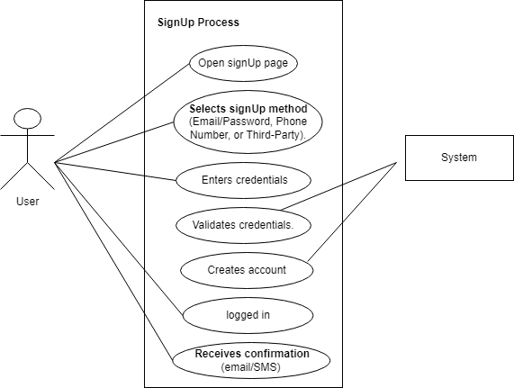

**Use Case Table for Sign-Up Process**

|  |  |
| --- | --- |
| **Field** | **Details** |
| **Use Case Name** | Sign-Up |
| **Created By** | Nimra Asif |
| **Date Created** | 24-07-24 |
| **Last Updated By** | 25-07-24 |
| **Last Revision Date** | 27-07-24 |
| **Actors** | **Primary**: User, **Secondary**: System |
| **Description** | This use case describes the process of creating a new account, where the user provides credentials, selects a sign-up method, and receives confirmation upon successful account creation. |
| **Trigger** | The user accesses the sign-up page. |
| **Preconditions** | - The user must not already have an account. - The sign-up page must be accessible. |
| **Post conditions** | - A new user account is created successfully. - The user is logged into the system and receives a confirmation (email/SMS). |
| **Normal Flow** | 1. The user opens the sign-up page. 2. The user selects the sign-up method (Email/Password, Phone, or Third-party). 3. The user enters credentials. 4. The system validates the credentials. 5. If credentials are valid, the system creates an account. 6. The user is logged into the system. 7. The system sends a confirmation (email/SMS) to the user. |
| **Alternative Flows** | **Invalid Credentials Flow**: 1. The system displays an error message if credentials are invalid. 2. The user retries with correct credentials. |
| **Exceptions** | - **Duplicate Account**: The system displays an error if the email/phone number is already registered. - **Invalid Data**: The system prompts the user to provide correct details. |
| **Includes** | Email/SMS Confirmation Process |
| **Frequency of Use** | Occasional, typically once per user. |
| **Special Requirements** | - Secure communication (e.g., HTTPS). - Captcha validation to prevent spam. |
| **Assumptions** | - The user provides accurate and verifiable information. - The system is functioning correctly. |
| **Notes and Issues** | - Consideration for multi-language support in the sign-up page. - Ensure accessibility for all users (e.g., screen readers). |
| **Use Case ID** | UC-2 |

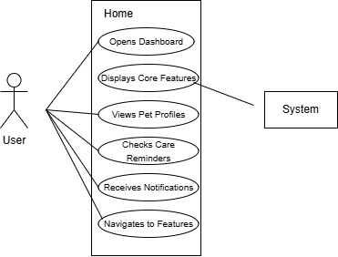

**Use Case Table for Home (Dashboard)**

|  |  |
| --- | --- |
| **Field** | **Details** |
| **Use Case Name** | Home |
| **Created By** | Nimra Asif |
| **Date Created** | 28-07-24 |
| **Last Updated By** | 29-07-24 |
| **Last Revision Date** | 30-07-24 |
| **Actors** | Primary: User, Secondary: System |
| **Description** | This use case describes how a user interacts with the home module to access core features such as the dashboard, pet profiles, care reminders, and notifications. |
| **Trigger** | The user navigates to the Home screen of the application. |
| **Preconditions** | - The user is logged into the application. - The home screen and its features must be functional. |
| **Postconditions** | - The user successfully interacts with the displayed features and navigates within the application. |
| **Normal Flow** | 1. The user opens the Home screen. 2. The system displays the dashboard and core features. 3. The user interacts with features such as pet profiles, care reminders, and notifications. |
| **Alternative Flows** | - Feature Inaccessibility: If a feature fails to load, the system displays an error message and offers retry options. - Notification Error: The user is informed if notifications are unavailable. |
| **Exceptions** | - App Crash: The application shuts down unexpectedly. - Network Unavailability: Features dependent on internet access fail to function. |
| **Includes** | - Displays reminders and notifications in real-time. - Navigation links to key features. |
| **Frequency of Use** | Regular, as it is the central hub for accessing app features. |
| **Special Requirements** | - Ensure a smooth user interface with quick loading times. - Provide offline access for certain features (e.g., reminders). |
| **Assumptions** | - The user has necessary permissions to view and interact with all features. - The system functions as expected. |
| **Notes and Issues** | - Consider adding customization options for the dashboard layout. - Ensure all features are accessible across devices. |
| **Use Case ID** | UC-2 |

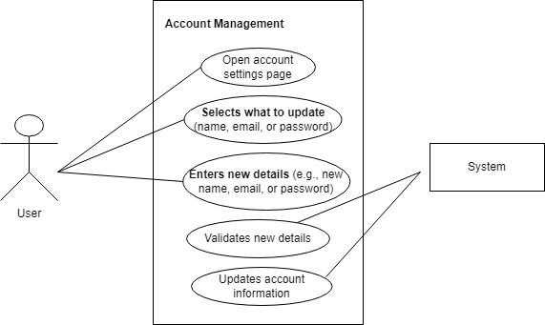

**Use Case Table for Account Management Process**

|  |  |
| --- | --- |
| **Field** | **Details** |
| **Use Case Name** | Account Management |
| **Created By** | Nimra Asif |
| **Date Created** | 01-08-24 |
| **Last Updated By** | 08-08-24 |
| **Last Revision Date** | 10-08-24 |
| **Actors** | **Primary**: User, **Secondary**: System |
| **Description** | This use case describes the process of managing account information, allowing users to update details like name, email, or password. |
| **Trigger** | The user accesses the account settings page. |
| **Preconditions** | - The user must be logged into their account. - The account settings page must be accessible. |
| **Post conditions** | - The account information is updated successfully in the system. |
| **Normal Flow** | 1. The user opens the account settings page. 2. The user selects what information to update (e.g., name, email, or password). 3. The user enters new details. 4. The system validates the new details. 5. If validation is successful, the system updates the account information. |
| **Alternative Flows** | **Validation Failure Flow**: 1. The system displays an error message if the entered details are invalid (e.g., incorrect email format, weak password). 2. The user retries with correct details. |
| **Exceptions** | - **Server Error**: The system fails to update details due to technical issues. - **Authentication Timeout**: The user session expires, requiring re-login. |
| **Includes** | Notification to the user upon successful update (e.g., email confirmation). |
| **Frequency of Use** | Periodic, as needed by the user. |
| **Special Requirements** | - Secure validation and storage of sensitive information (e.g., passwords). - Compatibility with multi-factor authentication (if enabled). |
| **Assumptions** | - The user has permission to update the account details. - The system provides real-time feedback on input validation. |
| **Notes and Issues** | - Ensure system logs changes for audit purposes. - Consider user experience for accessibility (e.g., clear error messages). |
| **Use Case ID** | UC-3 |

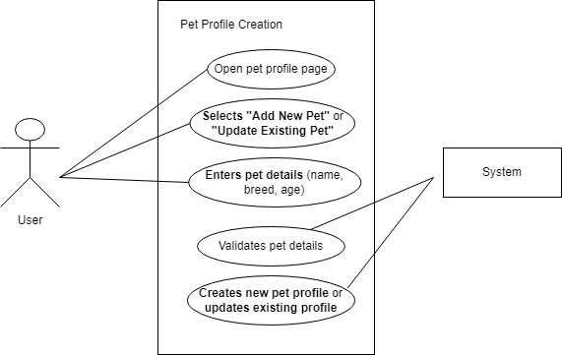

**Use Case Table for Pet Profile Creation Process**

|  |  |
| --- | --- |
| **Field** | **Details** |
| **Use Case Name** | Pet Profile Creation |
| **Created By** | Nimra Asif |
| **Date Created** | 08-08-24 |
| **Last Updated By** | 12-08-24 |
| **Last Revision Date** | 17-08-24 |
| **Actors** | **Primary**: User, **Secondary**: System |
| **Description** | This use case describes the process of creating or updating a pet profile by providing details such as name, breed, and age. |
| **Trigger** | The user accesses the pet profile page. |
| **Preconditions** | - The user must be logged into their account. - The pet profile page must be accessible. |
| **Post conditions** | - A new pet profile is created, or an existing pet profile is successfully updated. |
| **Normal Flow** | 1. The user opens the pet profile page. 2. The user selects either "Add New Pet" or "Update Existing Pet." 3. The user enters pet details such as name, breed, and age. 4. The system validates the entered details. 5. If validation is successful, the system creates a new pet profile or updates the existing profile. |
| **Alternative Flows** | **Validation Failure Flow**: 1. The system displays an error message if the entered details are invalid (e.g., missing fields, invalid age). 2. The user retries with correct details. |
| **Exceptions** | - **Server Error**: The system fails to save details due to technical issues. - **Authentication Timeout**: The user session expires, requiring re-login. |
| **Includes** | Notification to the user upon successful profile creation or update. |
| **Frequency of Use** | Periodic, whenever the user wants to add or update a pet profile. |
| **Special Requirements** | - Ensure user-friendly validation feedback (e.g., clear error messages). - Provide default values or suggestions for common pet breeds. |
| **Assumptions** | - The user has the necessary permissions to create or update pet profiles. - The system stores all pet profiles securely. |
| **Notes and Issues** | - Consider handling edge cases like duplicate profiles. - Provide a preview of the pet profile before saving. |
| **Use Case ID** | UC-4 |

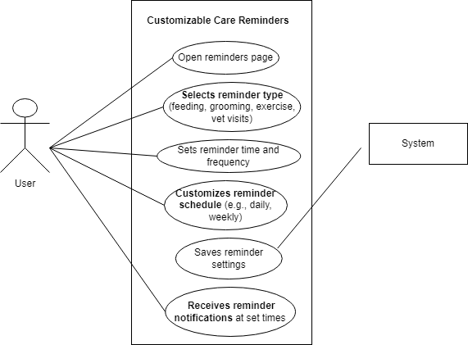

**Use Case Table for Customizable Care Reminders Process**

|  |  |
| --- | --- |
| **Field** | **Details** |
| **Use Case Name** | Customizable Care Reminders |
| **Created By** | Nimra Asif |
| **Date Created** | 14-08-24 |
| **Last Updated By** | 16-08-24 |
| **Last Revision Date** | 20-08-24 |
| **Actors** | **Primary**: User, **Secondary**: System |
| **Description** | This use case describes the process by which a user sets up customized reminders for pet care activities such as feeding, grooming, exercise, or vet visits. |
| **Trigger** | The user accesses the reminders page. |
| **Preconditions** | - The user must be logged into their account. - The reminders page must be accessible. |
| **Post conditions** | - Reminder settings are successfully saved. - Notifications are sent at the scheduled times. |
| **Normal Flow** | 1. The user opens the reminders page. 2. The user selects the type of reminder (e.g., feeding, grooming, exercise, vet visits). 3. The user sets the reminder time and frequency. 4. The user customizes the reminder schedule (e.g., daily, weekly). 5. The user saves the reminder settings. 6. The system sends reminder notifications at the specified times. |
| **Alternative Flows** | **Editing or Canceling Reminders**: 1. The user edits or deletes previously set reminders. 2. The system updates or cancels the reminder schedule. |
| **Exceptions** | - **Validation Failure**: The system displays an error if required fields (e.g., time or type) are missing. - **Notification Delivery Failure**: The system is unable to send notifications due to a server error or connectivity issues. |
| **Includes** | Notification functionality to ensure users receives reminders. |
| **Frequency of Use** | Regular, based on the frequency of reminders set by the user (e.g., daily, weekly). |
| **Special Requirements** | - Notifications should be timely and reliable. - Allow flexibility to modify or cancel reminders. |
| **Assumptions** | - The user has a clear understanding of the reminder requirements. - The system supports push notifications or email delivery. |
| **Notes and Issues** | - Ensure reminders are customizable for multiple pets if applicable. - Test notification delivery to prevent delays. |
| **Use Case ID** | UC-5 |

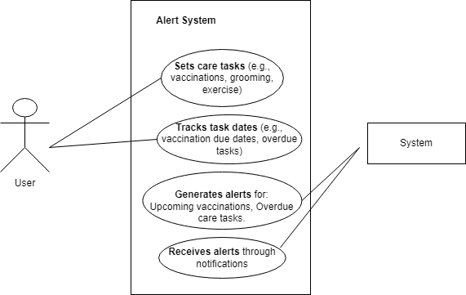

**Use Case Table for Alert System**

|  |  |
| --- | --- |
| **Field** | **Details** |
| **Use Case Name** | Alert System for Care Tasks |
| **Created By** | Nimra Asif |
| **Date Created** | 22-08-24 |
| **Last Updated By** | 25-08-24 |
| **Last Revision Date** | 28-08-24 |
| **Actors** | **Primary**: User, **Secondary**: System |
| **Description** | This use case describes the process by which the system generates alerts to remind users of care tasks such as vaccinations, grooming, exercise, and other pet-related activities. |
| **Trigger** | A task's due date or time for a reminder approaches or the user manually sets a care task. |
| **Preconditions** | - The user must have set care tasks in the system. - The system must have access to the user’s task data. |
| **Post conditions** | - Alerts are successfully generated for upcoming or overdue tasks. - Notifications are sent to the user. |
| **Normal Flow** | 1. The user sets care tasks (e.g., vaccinations, grooming, and exercise). 2. The system tracks the due dates for the care tasks. 3. The system generates alerts for upcoming or overdue tasks. 4. The system sends notifications to the user. |
| **Alternative Flows** | **Editing Alerts**: 1. The user modifies or deletes a previously set care task. 2. The system updates the alert schedule accordingly. |
| **Exceptions** | - **Invalid Task Information**: The system displays an error if required details (e.g., task name, due date) are incomplete. - **Notification Delivery Failure**: Alerts fail due to connectivity or server issues. |
| **Includes** | Notification functionality to ensure users receives reminders. |
| **Frequency of Use** | Regular, depending on the user’s task schedule (e.g., daily, weekly, monthly). |
| **Special Requirements** | - Alerts must be accurate and sent on time. - Allow users to choose notification preferences (e.g., email, SMS, or in-app). |
| **Assumptions** | - Users provide accurate task details and due dates. - The system can reliably send alerts and notifications. |
| **Notes and Issues** | - Ensure system scalability to handle alerts for multiple users simultaneously. - Address notification delivery failures promptly to avoid missed alerts. |
| **Use Case ID** | UC-6 |

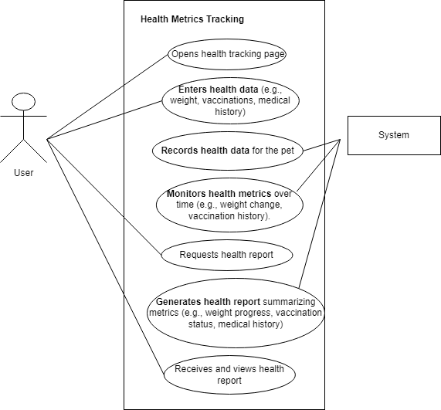

**Use Case Table for Health Metrics Tracking**

|  |  |
| --- | --- |
| **Field** | **Details** |
| **Use Case Name** | Health Metrics Tracking |
| **Created By** | Nimra Asif |
| **Date Created** | 03-09-24 |
| **Last Updated By** | 06-09-24 |
| **Last Revision Date** | 09-09-24 |
| **Actors** | **Primary**: User, **Secondary**: System |
| **Description** | This use case describes the process of tracking a pet’s health metrics, including recording data such as weight, vaccinations, and medical history, and generating health reports. |
| **Trigger** | The user accesses the health tracking page. |
| **Preconditions** | - The user must be logged into their account. - The health tracking page must be accessible. |
| **Post conditions** | - Health data is successfully recorded. - A health report summarizing the metrics is generated and made available to the user. |
| **Normal Flow** | 1. The user opens the health tracking page. 2. The user enters health data (e.g., weight, vaccinations, medical history). 3. The system records the health data for the pet. 4. The system monitors health metrics over time (e.g., weight changes, vaccination history). 5. The user requests a health report. 6. The system generates a health report summarizing metrics (e.g., weight progress, vaccination status, medical history). 7. The user receives and views the health report. |
| **Alternative Flows** | - **Editing Health Data**: 1. The user updates previously recorded health data. 2. The system updates the monitored metrics accordingly. |
| **Exceptions** | - **Invalid Data Entry**: The system displays an error if required fields (e.g., weight or vaccination date) are missing. - **Report Generation Failure**: The system fails to generate a health report due to a technical issue. |
| **Includes** | - Data input functionality for health metrics. - Report generation functionality for summarizing health metrics. |
| **Frequency of Use** | Regular, based on the frequency of health data entry or report requests by the user. |
| **Special Requirements** | - The system should support tracking for multiple pets. - Health reports should be visually clear and easy to understand. |
| **Assumptions** | - Users provide accurate and timely health data. - The system can store and retrieve health data reliably. |
| **Notes and Issues** | - Ensure data privacy and security for user and pet information. - Test report accuracy and ensure no missing metrics. |
| **Use Case ID** | UC-7 |

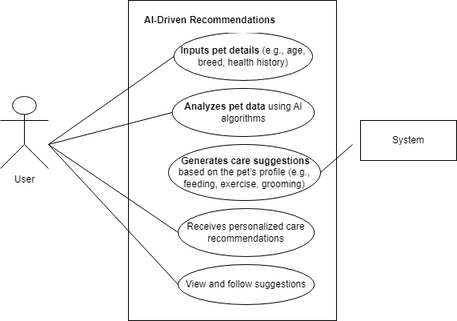

**Use Case Table for AI-Driven Recommendations**

|  |  |
| --- | --- |
| **Field** | **Details** |
| **Use Case Name** | AI-Driven Recommendations |
| **Created By** | Nimra Asif |
| **Date Created** | 14-09-24 |
| **Last Updated By** | 16-09-24 |
| **Last Revision Date** | 18-09-24 |
| **Actors** | **Primary**: User, **Secondary**: System |
| **Description** | This use case describes how the system uses AI algorithms to analyze pet data and generate personalized care recommendations, such as feeding schedules, exercise plans, and grooming tips. |
| **Trigger** | The user inputs pet details into the system. |
| **Preconditions** | - The user must be logged into their account. - Accurate pet details (e.g., age, breed, health history) must be provided. |
| **Post conditions** | - Personalized care recommendations are generated and made available to the user. - The user views and follows the care suggestions. |
| **Normal Flow** | 1. The user inputs pet details (e.g., age, breed, health history). 2. The system analyzes the pet data using AI algorithms. 3. The system generates care suggestions based on the pet's profile (e.g., feeding, exercise, grooming). 4. The user receives the personalized care recommendations. 5. The user views and follows the suggestions. |
| **Alternative Flows** | - **Updating Pet Data**: 1. The user updates the pet’s details. 2. The system reanalyzes the updated data and adjusts the recommendations accordingly. |
| **Exceptions** | - **Incomplete Data**: The system displays an error if essential pet details are missing. - **Analysis Failure**: AI algorithms fail to analyze the data due to a technical issue. |
| **Includes** | AI algorithm functionality to analyze pet data and generate recommendations. |
| **Frequency of Use** | Occasional, typically when the user updates pet details or requires new recommendations. |
| **Special Requirements** | - Recommendations must be accurate, relevant, and easy to understand. - Support for diverse pet types (e.g., dogs, cats). |
| **Assumptions** | - Users provide complete and accurate pet data. - The system is capable of handling diverse data inputs and generating actionable recommendations. |
| **Notes and Issues** | - Ensure AI algorithms are regularly updated for accuracy. - Test recommendations to verify reliability and usefulness for users. |
| **Use Case ID** | UC-8 |

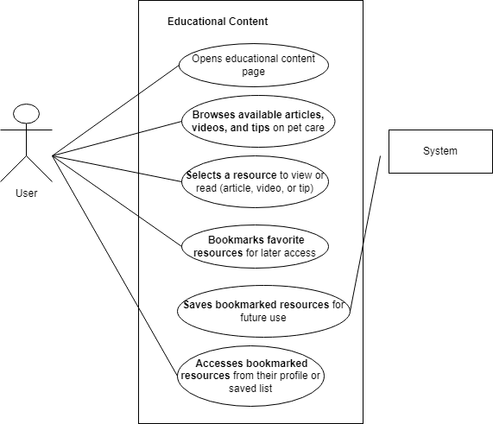

**Use Case Table for Educational Content**

|  |  |
| --- | --- |
| **Field** | **Details** |
| **Use Case Name** | Educational Content |
| **Created By** | Nimra Asif |
| **Date Created** | 20-09-24 |
| **Last Updated By** | 24-09-24 |
| **Last Revision Date** | 26-09-24 |
| **Actors** | **Primary:** User, **Secondary:** System |
| **Description** | This use case describes how a user interacts with the system to explore, bookmark, and access educational resources on pet care. |
| **Trigger** | The user opens the educational content page. |
| **Preconditions** | - The user must be logged into their account. |
|  | - Educational resources must be available in the system. |
| **Post conditions** | - The user browses, bookmarks, and accesses educational resources. |
|  | - Bookmarked resources are saved for future use. |
| **Normal Flow** | 1. The user opens the educational content page. |
|  | 2. The user browses available articles, videos, and tips on pet care. |
|  | 3. The user selects a resource to view or read (article, video, or tip). |
|  | 4. The user bookmarks favorite resources for later access. |
|  | 5. The system saves the bookmarked resources for future use. |
|  | 6. The user accesses bookmarked resources from their profile or saved list. |
| **Alternative Flows** | - **No Resources Available:** The system displays a message if no resources are found. |
|  | - **Updating Saved List:** 1. The user updates their saved list. |
|  | 2. The system reflects changes in the bookmarked resources. |
| **Exceptions** | - **No Internet:** The system shows an error if the user is offline. |
|  | - **System Error:** Failure in saving bookmarks due to technical issues. |
| **Includes** | Bookmarking functionality to save and retrieve resources. |
| **Frequency of Use** | Regular, depending on the user’s interest in pet care content. |
| **Special Requirements** | - The content must be well-organized and categorized. |
|  | - The system must provide a user-friendly interface. |
| **Assumptions** | - The user is interested in educational content. |
|  | - The system has a library of relevant and engaging resources. |
| **Notes and Issues** | - Ensure the system allows seamless bookmarking and retrieval. |
|  | - Regularly update content to maintain relevance and engagement. |
| **Use Case ID** | UC-9 |

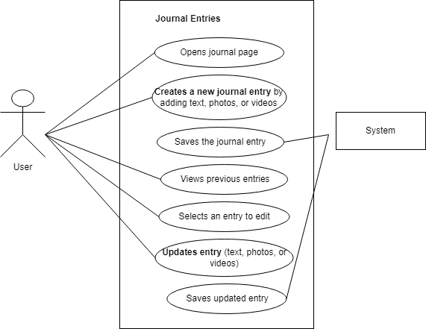

**Use Case Table for Journal Entries**

|  |  |
| --- | --- |
| **Field** | **Details** |
| **Use Case Name** | Journal Entries |
| **Created By** | Nimra Asif |
| **Date Created** | 28-09-24 |
| **Last Updated By** | 30-09-24 |
| **Last Revision Date** | 02-10-24 |
| **Actors** | **Primary:** User, **Secondary:** System |
| **Description** | This use case describes how a user interacts with the system to create, save, view, edit, and update journal entries with text, photos, or videos. |
| **Trigger** | The user opens the journal page. |
| **Preconditions** | The user must be logged into their account. |
|  | The journal feature must be available in the system. |
| **Post conditions** | The user successfully creates, saves, views, or updates journal entries. |
| **Normal Flow** | 1. The user opens the journal page. |
|  | 2. The user creates a new journal entry by adding text, photos, or videos. |
|  | 3. The user saves the journal entry. |
|  | 4. The user views previous journal entries. |
|  | 5. The user selects an entry to edit. |
|  | 6. The user updates the selected entry (text, photos, or videos). |
|  | 7. The user saves the updated entry. |
| **Alternative Flows** | - **No Entries Found:** The system displays a message if no previous entries exist. |
|  | - **Entry Not Saved:** The system alerts the user if saving the entry fails. |
| **Exceptions** | - **No Internet:** The system shows an error if offline and unable to save. |
|  | - **System Error:** The system fails to load or update entries due to technical issues. |
| **Includes** | Functionality for creating, saving, viewing, and editing journal entries. |
| **Frequency of Use** | Regular, depending on the user's need to document activities or memories. |
| **Special Requirements** | The interface must support text, photo, and video uploads seamlessly. |
| **Assumptions** | The user regularly updates their journal. |
|  | The system stores entries securely. |
| **Notes and Issues** | Ensure the system supports multimedia uploads. |
|  | Regular backups should be enabled to prevent data loss. |
| **Use Case ID** | UC-10 |

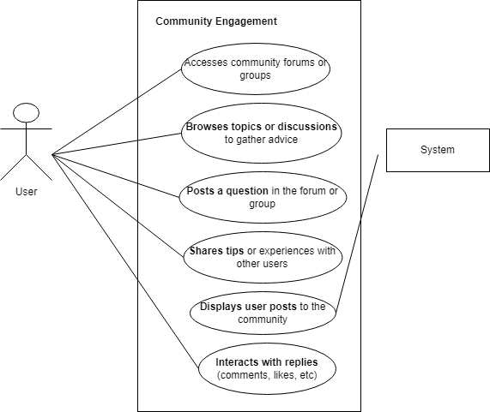

**Use Case Table for Community Engagement**

|  |  |
| --- | --- |
| **Field** | **Details** |
| **Use Case Name** | Community Engagement |
| **Created By** | Nimra Asif |
| **Date Created** | 05-10-24 |
| **Last Updated By** | 07-10-24 |
| **Last Revision Date** | 10-10-24 |
| **Actors** | **Primary:** User, **Secondary:** System |
| **Description** | This use case describes how a user interacts with community forums or groups to ask questions, share experiences, and engage with other users. |
| **Trigger** | The user accesses the community forum or group. |
| **Preconditions** | The user must be logged into their account. |
|  | The community feature must be available in the system. |
| **Post conditions** | The user successfully engages with the community by posting, sharing, or interacting with replies. |
| **Normal Flow** | 1. The user accesses community forums or groups. |
|  | 2. The user browses topics or discussions to gather advice. |
|  | 3. The user posts a question in the forum or group. |
|  | 4. The user shares tips or experiences with other users. |
|  | 5. The system displays user posts to the community. |
|  | 6. The user interacts with replies (e.g., comments, likes). |
| **Alternative Flows** | - **No Posts Available:** The system displays a message if no topics or posts are found. |
|  | - **Restricted Post:** The system notifies the user if their post violates community guidelines. |
| **Exceptions** | - **System Error:** The forum fails to load due to a technical issue. |
|  | - **Post Submission Failure:** The system alerts the user if their post fails to upload. |
| **Includes** | Functionality for posting, browsing, and interacting within forums. |
| **Frequency of Use** | Frequent, depending on the user’s level of engagement with the community. |
| **Special Requirements** | The interface must be user-friendly and support interactive features. |
| **Assumptions** | Users actively participate in community discussions. |
|  | The system maintains a supportive and moderated environment. |
| **Notes and Issues** | Ensure proper moderation to prevent misuse of the community feature. |
|  | Enable features like filtering, sorting, and notifications for better user experience. |
| **Use Case ID** | UC-11 |

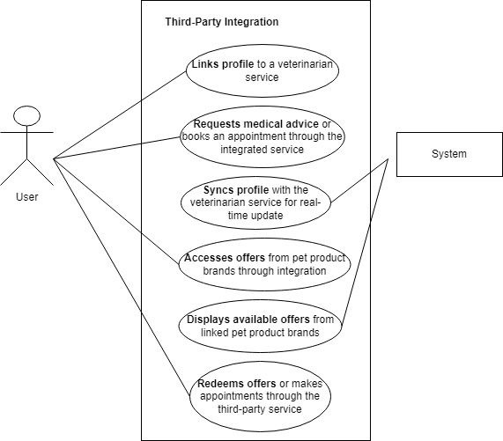

**Use Case Table for Third-Party Integration**

|  |  |
| --- | --- |
| **Field** | **Details** |
| **Use Case Name** | Third-Party Integration |
| **Created By** | Nimra Asif |
| **Date Created** | 15-10-24 |
| **Last Updated By** | 18-10-24 |
| **Last Revision Date** | 20-10-24 |
| **Actors** | **Primary:** User, **Secondary:** System |
| **Description** | This use case describes how a user interacts with third-party services, such as veterinarian services and pet product brands, through the system. |
| **Trigger** | The user links their profile to a third-party service or accesses integrated features. |
| **Preconditions** | The user must have an active account linked to third-party services. |
|  | The system must support integrations with third-party services. |
| **Post conditions** | The user successfully interacts with third-party services, accessing updates, offers, or appointments. |
| **Normal Flow** | 1. The user links their profile to a veterinarian service through the system. |
|  | 2. The user requests medical advice or books an appointment through the integrated service. |
|  | 3. The user’s profile syncs with the veterinarian service for real-time updates. |
|  | 4. The user accesses offers from pet product brands through the integration. |
|  | 5. The system displays available offers from linked pet product brands. |
|  | 6. The user redeems offers or makes appointments through the third-party service. |
| **Alternative Flows** | - **No Integration Available:** The system informs the user if no third-party services are linked. |
|  | - **Invalid Request:** The system notifies the user if the request fails due to missing or invalid information. |
| **Exceptions** | - **System Error:** The integration fails due to technical issues. |
|  | - **Sync Failure:** Profile synchronization with the third-party service is unsuccessful. |
| **Includes** | Functionality for linking profiles, accessing offers, and syncing data with third-party services. |
| **Frequency of Use** | Moderate to frequent, depending on user interaction with integrated services. |
| **Special Requirements** | The system must ensure secure data transfer between the user and third-party services. |
|  | Maintain compatibility with multiple third-party providers. |
| **Assumptions** | Users actively utilize third-party integrations for enhanced functionality. |
|  | The system supports secure and seamless integration mechanisms. |
| **Notes and Issues** | Ensure real-time updates and synchronization with third-party services. |
|  | Provide clear notifications for errors or unsuccessful interactions. |
| **Use Case ID** | UC-12 |

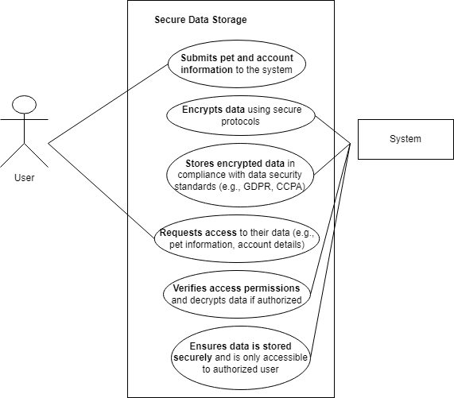

**Use Case Table for Secure Data Storage**

|  |  |
| --- | --- |
| **Field** | **Details** |
| **Use Case Name** | Secure Data Storage |
| **Created By** | Nimra Asif |
| **Date Created** | 25-10-24 |
| **Last Updated By** | 30-10-24 |
| **Last Revision Date** | 05-11-24 |
| **Actors** | **Primary:** User, **Secondary:** System |
| **Description** | This use case describes how a user securely stores and accesses their data within the system, ensuring compliance with data protection standards. |
| **Trigger** | The user submits information (e.g., pet and account details) to the system. |
| **Preconditions** | The user must be logged in and authorized to submit or access information. |
|  | The system must support secure data encryption and storage mechanisms. |
| **Post conditions** | The user’s data is securely stored and accessible only to authorized users. |
| **Normal Flow** | 1. The user submits pet and account information to the system. |
|  | 2. The system encrypts the submitted data using secure protocols. |
|  | 3. The system stores the encrypted data in compliance with data security standards (e.g., GDPR, CCPA). |
|  | 4. The user requests access to their data (e.g., pet information, account details). |
|  | 5. The system verifies the user’s access permissions. |
|  | 6. If authorized, the system decrypts the data and provides it to the user. |
|  | 7. The system ensures the data is stored securely and inaccessible to unauthorized users. |
| **Alternative Flows** | - **Unauthorized Access:** The system denies access if the user fails authentication. |
|  | - **Encryption Failure:** The system notifies the user if data encryption fails. |
| **Exceptions** | - **System Error:** A system failure prevents data submission or retrieval. |
|  | - **Compliance Issue:** The system raises a flag if storage does not meet compliance requirements. |
| **Includes** | Functionality for data encryption, secure storage, and access control. |
| **Frequency of Use** | Frequent, depending on user data updates and retrieval needs. |
| **Special Requirements** | The system must comply with data security standards (e.g., GDPR, CCPA). |
|  | Robust encryption protocols must be implemented. |
| **Assumptions** | Users provide accurate and valid data. |
|  | The system is equipped with necessary infrastructure for secure data handling. |
| **Notes and Issues** | Regular audits are needed to ensure data security compliance. |
|  | Provide clear notifications in case of access or encryption failures. |
| **Use Case ID** | UC-13 |
|  |  |

Daily Paws

Pet Care System

Pet Owners

Community Members

Veterinarians

Third Party Partners

**Extended use cases:**

<<extend>>

<<extend>>

<<extend>>

<<extend>>

<<extend>>

<<extend>>

User

<<extend>>

<<extend>>

<<extend>>

**Class Diagram:**

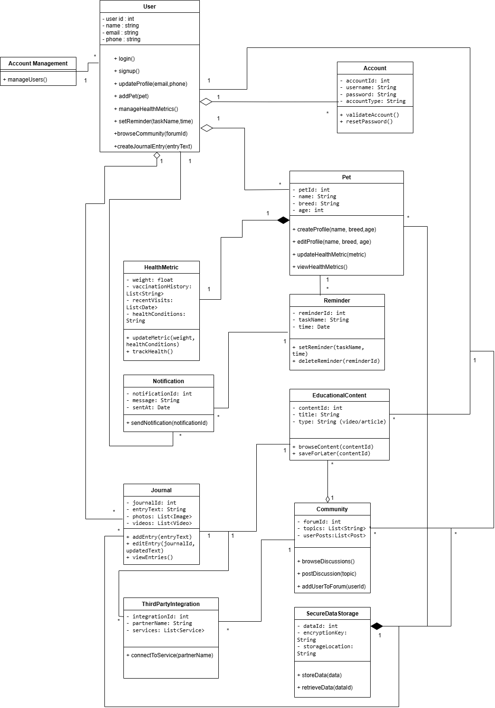

**Sequence Diagram:**

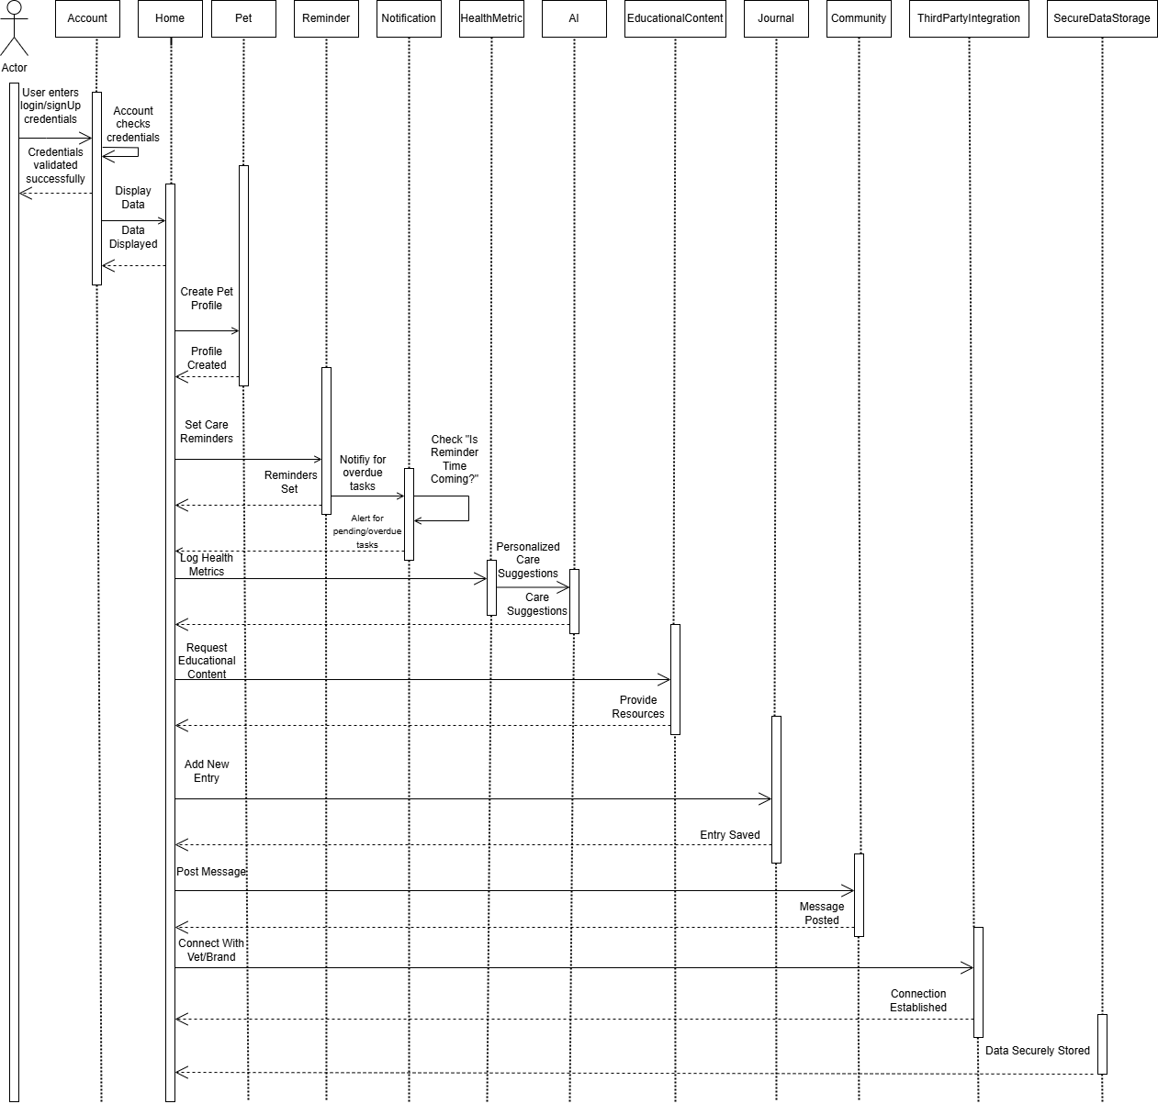

**Activity Diagram:**

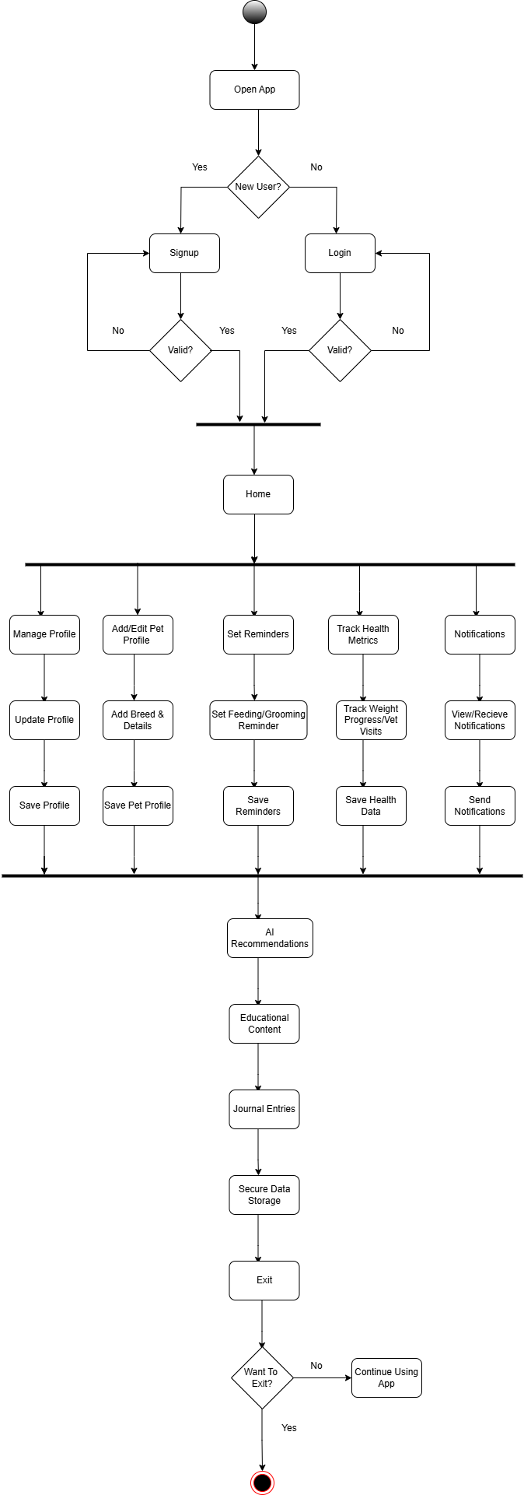

**Architecture Diagram:**

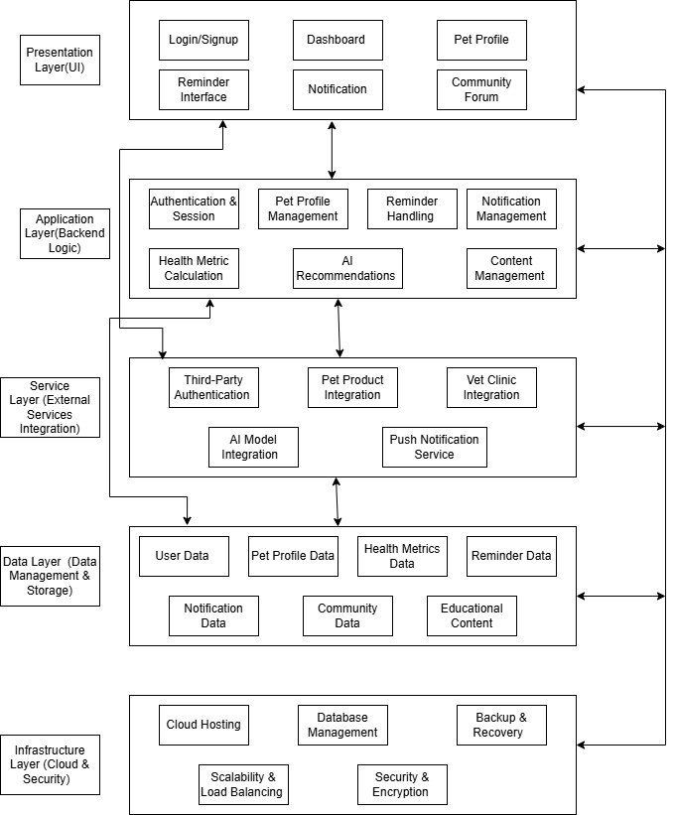

**DFD (Level – 0):**

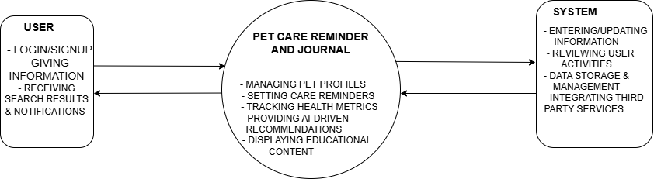

**DFD (Level – 1):**

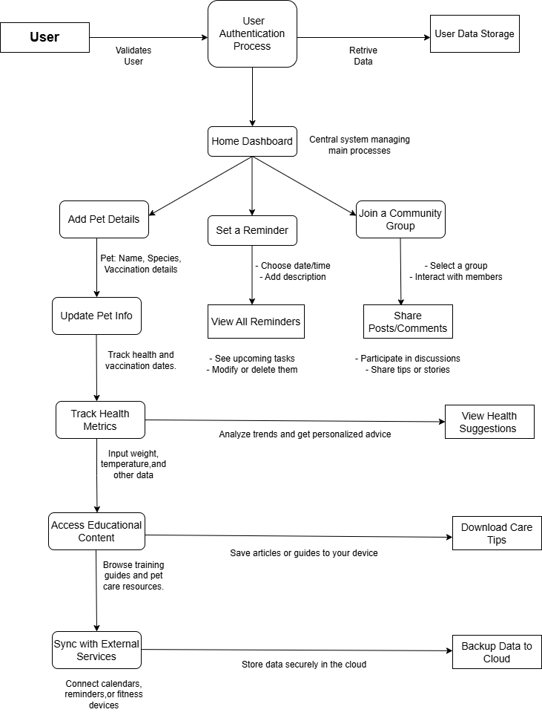

**Type of testing:**

**Functional Testing(Positive/Negative Test Case)**

|  |  |
| --- | --- |
| **Module Name** | **Login** |
| **Test Case ID** | login_01 |
|  |  |
| **Test Case Description** | To check the login functionality of the application. |
| **Prerequisites** | 1. Stable internet connection.  2. Mobile device with the app installed.  3. Valid user account for testing. |
| **Tester's Name** | Nimra |
| **Environmental Information** | 1. OS: Android/iOS  2. Device: Smartphone/Tablet. |
| **Test Scenario** | Checking that users can log in with correct credentials and are handled properly for incorrect credentials. |

|  |  |  |  |  |  |  |
| --- | --- | --- | --- | --- | --- | --- |
| **Test Case ID** | **Test Steps** | **Test Input** | **Expected Results** | **Actual Results** | **Status** | **Comments** |
| 1.1 | Enter valid username and password. | Username: valid_userPassword: valid_pass | User is redirected to the Home Dashboard. | User is redirected to the Home Dashboard. | Pass | No issues found. |
| 1.2 | Enter invalid username and valid password. | Username: invalid_userPassword: valid_pass | Error message: "Invalid credentials." | Error message: "Invalid credentials." | Fail | Invalid credentials rejected successfully. |
| 1.3 | Enter valid username and invalid password. | Username: valid_userPassword: invalid_pass | Error message: "Invalid credentials." | Error message: "Invalid credentials." | Fail | Invalid credentials rejected successfully. |
| 1.4 | Leave both fields blank. | Username: blankPassword: blank | Error message: "Fields cannot be empty." | Error message: "Fields cannot be empty." | Fail | Empty input handled properly. |
| 1.5 | Enter valid email but invalid format. | Username: user@example.Password: any_password | Error message: "Invalid email format." | Error message: "Invalid email format." | Fail | Invalid email format handled properly. |
| 1.6 | Attempt login without internet connection. | Username: valid_userPassword: valid_pass | Error message: "No internet connection." | Error message: "No internet connection." | Fail | Internet connection error displayed. |

|  |  |
| --- | --- |
| **Module Name** | **Signup** |
| **Test Case ID** | signup_02 |
|  |  |
| **Test Case Description** | To check the signup functionality of the mobile app. |
| **Prerequisites** | 1. Stable internet connection.2. Mobile device with the app installed.3. No existing account with the test credentials. |
| **Tester's Name** | Nimra |
| **Environmental Information** | 1. OS: Android/iOS2. Device: Smartphone/Tablet. |
| **Test Scenario** | Checking that users can sign up with valid details and are handled properly for invalid inputs. |

|  |  |  |  |  |  |  |
| --- | --- | --- | --- | --- | --- | --- |
| **Test Case ID** | **Test Steps** | **Test Input** | **Expected Results** | **Actual Results** | **Status** | **Comments** |
| **2.1** | Enter valid email, phone number, and password. | Email: [user@example.com](mailto:user@example.com)Phone: 1234567890Password: valid_pass | User is successfully registered and redirected to the Home Dashboard. | User is redirected to the Home Dashboard. | Pass | No issues found. |
| **2.2** | Enter an already registered email. | Email: [user@example.com](mailto:user@example.com)Phone: 1234567890Password: valid_pass | Error message: "Email is already registered." | Error message: "Email is already registered." | Pass | Duplicate email handled correctly. |
| **2.3** | Enter invalid email format. | Email: user@examplePhone: 1234567890Password: valid_pass | Error message: "Invalid email format." | No error displayed. | Fail | Email format validation failed. |
| **2.4** | Leave one or more fields blank and tap "Signup." | Email: blankPhone: blankPassword: blank | Error message: "All fields are required." | No error displayed. | Fail | Blank input not handled properly. |
| **2.5** | Enter phone number in an invalid format. | Email: [user@example.com](mailto:user@example.com)Phone: abc123Password: valid_pass | Error message: "Invalid phone number format." | No error displayed. | Fail | Phone number validation failed. |
| **2.6** | Enter a weak password (e.g., fewer than 6 characters). | Email: [user@example.com](mailto:user@example.com)Phone: 1234567890Password: weak | Error message: "Password must be at least 6 characters." | Error message: "Password must be at least 6 characters." | Pass | Password validation works correctly. |
| **2.7** | Attempt signup without an internet connection. | Email: [user@example.com](mailto:user@example.com)Phone: 1234567890Password: valid_pass | Error message: "No internet connection." | Error message: "No internet connection." | Pass | Connection error handled properly. |
| **2.8** | Use third-party authentication (e.g., Google/Facebook). | Google/Facebook credentials | User is successfully registered and redirected to the Home Dashboard. | User is redirected to the Home Dashboard. | Pass | Third-party signup works correctly. |
| **2.9** | Attempt signup using an outdated app version. | Email: [user@example.com](mailto:user@example.com)Phone: 1234567890Password: valid_pass | Error message: "Please update the app to continue." | No error displayed. | Fail | Outdated app error not handled. |

|  |  |
| --- | --- |
| **Module Name** | **Home Dashboard** |
| **Test Case ID** | home_03 |
|  |  |
| **Test Case Description** | To validate the functionality and accessibility of the Home Dashboard after logging in or signing up. |
| **Prerequisites** | 1. Stable internet connection.2. Valid user login or successful signup.3. Mobile device with the app installed. |
| **Tester's Name** | Nimra |
| **Environmental Information** | 1. OS: Android/iOS2. Device: Smartphone/Tablet. |
| **Test Scenario** | Verifying that the Home Dashboard displays the main features and functions correctly. |

|  |  |  |  |  |  |  |
| --- | --- | --- | --- | --- | --- | --- |
| **Test Case ID** | **Test Steps** | **Test Input** | **Expected Results** | **Actual Results** | **Status** | **Comments** |
| **3.1** | Navigate to the Home Dashboard after logging in. | Valid credentials provided | User is redirected to the Home Dashboard. | User is redirected to the Home Dashboard. | Pass | No issues found. |
| **3.2** | Verify that pet profiles are displayed on the dashboard. | Existing pet profiles added | Pet profiles are visible on the dashboard. | Pet profiles are visible on the dashboard. | Pass | Feature works as expected. |
| **3.3** | Verify that care reminders are displayed. | Care reminders added | All active care reminders are displayed. | Care reminders are not displayed. | Fail | Care reminders are missing from the dashboard. |
| **3.4** | Verify that notifications/alerts are displayed. | Notifications added | Notifications/alerts are visible on the dashboard. | Notifications are not visible. | Fail | Notifications display error. |
| **3.5** | Attempt to access the Home Dashboard without logging in. | No credentials provided | Error message: "Please log in to access the dashboard." | Error message displayed. | Pass | Authentication check works. |
| **3.6** | Verify that tapping a pet profile navigates to the pet details. | Tap on a pet profile | User is redirected to the pet details page. | User remains on the dashboard. | Fail | Navigation issue for pet profiles. |
| **3.7** | Verify that tapping a care reminder navigates to the reminder details. | Tap on a care reminder | User is redirected to the reminder details page. | User is redirected to the reminder details page. | Pass | Navigation works correctly. |
| **3.8** | Verify the response when the dashboard has no data (no pets, reminders, or notifications). | Empty dashboard | Display message: "No data available. Add a pet or care reminder to get started." | No message displayed. | Fail | Empty state not handled properly. |
| **3.9** | Verify that the dashboard refreshes data on pull-to-refresh. | Perform pull-to-refresh | Dashboard updates with the latest data. | Dashboard does not refresh. | Fail | Pull-to-refresh not working. |
| **3.10** | Verify dashboard responsiveness on different devices. | Open on different devices | Dashboard adapts to various screen sizes. | Dashboard layout breaks on smaller screens. | Fail | Dashboard not responsive. |

|  |  |
| --- | --- |
| **Module Name** | **User Account Management** |
| **Test Case ID** | user_04 |
|  |  |
| **Test Case Description** | To validate the functionality and accessibility of user account management features from the Home Dashboard. |
| **Prerequisites** | 1. Stable internet connection.2. Valid user login.3. Mobile device with the app installed. |
| **Tester’s Name** | Nimra |
| **Environmental Information** | 1. OS: Android/iOS2. Device: Smartphone/Tablet. |
| **Test Scenario** | Verifying that users can manage their account details, preferences, and settings from the Home Dashboard. |

|  |  |  |  |  |  |  |
| --- | --- | --- | --- | --- | --- | --- |
| **Test Case ID** | **Test Steps** | **Test Input** | **Expected Results** | **Actual Results** | **Status** | **Comments** |
| **4.1** | Navigate to user account settings from the Home Dashboard. | Tap on "Account Settings" | User is redirected to account settings page. | User is redirected to account settings page. | Pass | No issues found. |
| **4.2** | Verify that the user can update their personal details. | Update name, email, etc. | Changes are saved and reflected in the settings. | Changes are saved and reflected in the settings. | Pass | Feature works as expected. |
| **4.3** | Verify that the user can update their notification preferences. | Modify notification settings | New preferences are saved and reflected. | Notification preferences not saved. | Fail | Preferences not updated. |
| **4.4** | Verify that the user can change their password. | Provide old and new password | Password is updated successfully. | Password not updated. | Fail | Password change error. |
| **4.5** | Verify that the user can log out from the account settings. | Tap on "Log Out" | User is logged out and redirected to the login screen. | User is logged out and redirected to the login screen. | Pass | Logout functionality works correctly. |
| **4.6** | Verify that the user can delete their account. | Tap on "Delete Account" | User is prompted for confirmation, and the account is deleted. | Account deletion fails. | Fail | Account deletion error. |
| **4.7** | Verify that an error is displayed if the user tries to update account details with invalid data. | Enter invalid details | Error message displayed: "Invalid input." | No error message displayed. | Fail | Error handling not working. |
| **4.8** | Verify that the user can view their account details. | Navigate to "Account Info" | Account details are visible (name, email, etc.). | Account details displayed correctly. | Pass | Account details visible as expected. |
| **4.9** | Verify that the user can change their preferences for dark/light mode. | Toggle theme preference | Preference is updated and applied across the app. | Theme applied successfully. | Pass | Theme preference updated correctly. |
| **4.10** | Verify that account settings are responsive across devices. | Open on different devices | Account settings page adapts to different screen sizes. | Account settings responsive on all devices. | Pass | Settings page layout responsive on all screen sizes. |

|  |  |
| --- | --- |
| **Module Name** | **Pet Profile Creation** |
| **Test Case ID** | pet_05 |
|  |  |
| **Test Case Description** | To validate the functionality and accessibility of pet profile creation from the Home Dashboard or dedicated pet profile section. |
| **Prerequisites** | 1. Stable internet connection.2. Valid user login.3. Mobile device with the app installed. |
| **Tester’s Name** | Nimra |
| **Environmental Information** | 1. OS: Android/iOS2. Device: Smartphone/Tablet. |
| **Test Scenario** | Verifying that users can create profiles for their pets, including details like name, breed, age, and health conditions. |

|  |  |  |  |  |  |  |
| --- | --- | --- | --- | --- | --- | --- |
| **Test Case ID** | **Test Steps** | **Test Input** | **Expected Results** | **Actual Results** | **Status** | **Comments** |
| **5.1** | Navigate to pet profile creation from the Home Dashboard. | Tap on "Create Pet Profile" | User is redirected to pet profile creation page. | User is redirected to pet profile creation page. | Pass | Functionality works as expected. |
| **5.2** | Verify that the user can enter pet details. | Name, breed, age, health conditions | All details are entered correctly. | Details entered and saved successfully. | Pass | All details captured correctly. |
| **5.3** | Verify that the user can save the pet profile. | Complete pet details | Pet profile is saved and visible in the pet list. | Profile saved and visible. | Pass | Pet profile saved successfully. |
| **5.4** | Verify that the user can add multiple pets. | Add another pet | New pet profile is created and displayed in the list. | New pet profile not added. | Fail | Issue with saving multiple profiles. |
| **5.5** | Verify that the user can update an existing pet profile. | Edit pet details | Changes are saved and reflected in the pet profile. | Changes not saved. | Fail | Update functionality not working. |
| **5.6** | Verify that required fields are validated during profile creation. | Leave required fields empty | Error message displayed: "This field is required." | No error message displayed. | Fail | Validation error handling not working. |
| **5.7** | Verify that the pet profile is accessible after creation. | Tap on pet profile | User is redirected to the pet profile details page. | User is redirected correctly. | Pass | Navigation to pet profile works. |
| **5.8** | Verify that invalid data (e.g., incorrect breed or age) is rejected. | Enter invalid data | Error message displayed: "Invalid input." | Invalid data accepted. | Fail | No validation for incorrect data. |

|  |  |
| --- | --- |
| **Module Name** | **Customizable Care Reminders** |
| **Test Case ID** | care_06 |
|  |  |
| **Test Case Description** | To validate the functionality and accessibility of customizable care reminders for feeding, grooming, vet visits, and exercise. |
| **Prerequisites** | 1. Stable internet connection.2. Valid user login.3. Mobile device with the app installed. |
| **Tester’s Name** | Nimra |
| **Environmental Information** | 1. OS: Android/iOS2. Device: Smartphone/Tablet. |
| **Test Scenario** | Verifying that users can set and receive personalized care reminders, and these reminders are displayed in the Home Dashboard and via notifications. |

|  |  |  |  |  |  |  |
| --- | --- | --- | --- | --- | --- | --- |
| **Test Case ID** | **Test Steps** | **Test Input** | **Expected Results** | **Actual Results** | **Status** | **Comments** |
| **6.1** | Navigate to care reminder creation from the Home Dashboard. | Tap on "Add Care Reminder" | User is redirected to care reminder creation page. | User is redirected to reminder page. | Pass | Functionality works as expected. |
| **6.2** | Verify that the user can set reminders for feeding, grooming, vet visits, and exercise. | Set reminder for each category | Reminders are set and saved correctly for each category. | Reminders set successfully. | Pass | All categories saved properly. |
| **6.3** | Verify that reminders appear on the Home Dashboard. | View Home Dashboard | All active reminders are displayed. | Reminders displayed correctly. | Pass | Reminders shown as expected. |
| **6.4** | Verify that the user receives notifications for active reminders. | Receive reminder notifications | Notification appears for each active reminder. | No notification received. | Fail | Notifications not triggered. |
| **6.5** | Verify that the user can edit an existing care reminder. | Edit reminder details | Reminder is updated successfully. | Reminder not updated. | Fail | Edit functionality not working. |
| **6.6** | Verify that the user can delete a care reminder. | Delete a care reminder | Reminder is removed from the dashboard and notifications. | Reminder not deleted. | Fail | Deletion functionality not working. |
| **6.7** | Verify that the user can set reminders with custom time. | Set reminder with custom time | Reminder is set with the specified time. | Reminder set correctly. | Pass | Custom time for reminders works as expected. |
| **6.8** | Verify that the user can set recurring reminders. | Set recurring reminder | Reminder is set to repeat at the specified interval. | Recurring reminder not set. | Fail | Recurring reminders not functioning. |
| **6.9** | Verify that reminders can be paused or snoozed. | Pause/snooze reminder | Reminder is paused or snoozed successfully. | Reminder not paused or snoozed. | Fail | Snooze/pause feature not working. |
| **6.10** | Verify that reminders are responsive across devices. | Open on different devices | Reminders are displayed correctly on all screen sizes. | Reminders not displayed correctly on smaller screens. | Fail | Layout issues on smaller screens. |

|  |  |
| --- | --- |
| **Module Name** | **Notifications and Alerts** |
| **Test Case ID** | notify_07 |
|  |  |
| **Test Case Description** | To validate the functionality of notifications for pending/overdue tasks and alerts for upcoming milestones like vet visits and vaccinations. |
| **Prerequisites** | 1. Stable internet connection.2. Valid user login.3. Mobile device with the app installed. |
| **Tester’s Name** | Nimra |
| **Environmental Information** | 1. OS: Android/iOS2. Device: Smartphone/Tablet. |
| **Test Scenario** | Verifying that users receive notifications for tasks and alerts for upcoming milestones (like vet visits or vaccinations). |

|  |  |  |  |  |  |  |
| --- | --- | --- | --- | --- | --- | --- |
| **Test Case ID** | **Test Steps** | **Test Input** | **Expected Results** | **Actual Results** | **Status** | **Comments** |
| **7.1** | Verify that the user receives notifications for pending tasks. | Set pending tasks | Notification appears for each pending task. | Notification received for pending task. | Pass | Notifications triggered as expected. |
| **7.2** | Verify that the user receives notifications for overdue tasks. | Set overdue tasks | Notification appears for each overdue task. | Notification received for overdue task. | Pass | Overdue task notifications received correctly. |
| **7.3** | Verify that the user receives alerts for upcoming vet visits. | Set upcoming vet visit | Alert appears for the upcoming vet visit. | Alert received for vet visit. | Pass | Alert for vet visit works as expected. |
| **7.4** | Verify that the user receives alerts for upcoming vaccinations. | Set upcoming vaccination | Alert appears for the upcoming vaccination. | No alert received for vaccination. | Fail | Vaccination alert not triggered. |
| **7.5** | Verify that the user can dismiss notifications. | Dismiss a notification | Notification is removed from the notification center. | Notification not dismissed. | Fail | Dismissal functionality not working. |
| **7.6** | Verify that the user can view detailed information from a notification. | Tap on notification | User is redirected to the relevant page for more details. | User is not redirected. | Fail | Tap on notification not functioning. |
| **7.7** | Verify that the app can send multiple notifications for different tasks. | Set multiple tasks | All notifications are sent for each task. | Some notifications not received. | Fail | Multiple notifications not sent. |
| **7.8** | Verify that notifications are received even if the app is closed. | Close the app and set a task | Notification is received even when the app is not active. | Notification not received when app is closed. | Fail | Notifications not received in background. |
| **7.9** | Verify that alerts for upcoming milestones appear on the Home Dashboard. | Check Home Dashboard | Alerts for vet visits and vaccinations are displayed on the dashboard. | Alerts not displayed on dashboard. | Fail | Alerts missing on the dashboard. |
| **7.10** | Verify that notifications and alerts are responsive on different devices. | Open on different devices | Notifications and alerts are displayed correctly across devices. | Alerts not displayed correctly on smaller devices. | Fail | Display issue on smaller screens. |

|  |  |
| --- | --- |
| **Module Name** | **Health Metrics Tracking** |
| **Test Case ID** | health_08 |
| **Test Case Description** | To validate the input and tracking of pet health metrics like weight, vaccination history, and vet visits. |
| **Prerequisites** | 1. Stable internet connection. 2. Valid user login. 3. Mobile device with the app installed. |
| **Tester’s Name** | Nimra |
| **Environmental Information** | 1. OS: Android/iOS 2. Device: Smartphone/Tablet. |
| **Test Scenario** | Verifying that users can input and track their pet's health metrics in the Home Dashboard. |

|  |  |  |  |  |  |
| --- | --- | --- | --- | --- | --- |
| **Test Case ID** | **Test Steps** | **Expected Results** | **Actual Results** | **Status** | **Comments** |
| **8.1** | Input weight for the pet. | Weight is saved and displayed correctly. | Weight saved and displayed. | Pass | Works as expected. |
| **8.2** | Input vaccination history for the pet. | Vaccination history is saved and displayed. | Vaccination history saved correctly. | Pass | Works as expected. |
| **8.3** | Input vet visits for the pet. | Vet visit details are saved and displayed. | Vet visit details saved correctly. | Pass | Works as expected. |
| **8.4** | View health metrics in the Home Dashboard. | All metrics (weight, vaccinations, vet visits) are displayed correctly. | Health metrics displayed correctly. | Pass | All data is visible. |
| **8.5** | Edit weight of the pet. | Weight is updated correctly. | Weight not updated. | Fail | Edit functionality not working. |
| **8.6** | Edit vaccination history. | Vaccination history is updated correctly. | History not updated. | Fail | Edit functionality not working. |
| **8.7** | Edit vet visit details. | Vet visit details are updated correctly. | Vet visit not updated. | Fail | Edit functionality not working. |
| **8.8** | Delete health metrics (weight, vaccinations, vet visits). | Data is deleted and no longer displayed. | Data not deleted. | Fail | Deletion functionality not working. |
| **8.9** | Check for responsiveness of health metrics across devices. | Metrics display correctly on all devices. | Layout issue on smaller screens. | Fail | Layout breaks on small screens. |
| **8.10** | Verify health metrics data sync across devices. | Data syncs correctly across devices. | Data not synced. | Fail | Sync issue between devices. |

|  |  |
| --- | --- |
| **Module Name** | **AI-Driven Recommendations** |
| **Test Case ID** | ai_09 |
| **Test Case Description** | To validate personalized AI-driven recommendations for nutrition, exercise, and care tips based on the pet’s health and profile. |
| **Prerequisites** | 1. Stable internet connection.2. Valid user login.3. Mobile device with the app installed. |
| **Tester’s Name** | Nimra |
| **Environmental Information** | 1. OS: Android/iOS2. Device: Smartphone/Tablet. |
| **Test Scenario** | Verifying that users receive personalized recommendations in the Home Dashboard based on their pet’s profile and health. |

|  |  |  |  |  |  |
| --- | --- | --- | --- | --- | --- |
| **Test Case ID** | **Test Steps** | **Expected Results** | **Actual Results** | **Status** | **Comments** |
| **9.1** | View AI-driven recommendations for nutrition. | Personalized nutrition recommendations displayed. | Recommendations displayed correctly. | Pass | Works as expected. |
| **9.2** | View AI-driven recommendations for exercise. | Personalized exercise recommendations displayed. | Recommendations displayed correctly. | Pass | Works as expected. |
| **9.3** | View AI-driven care tips based on pet health. | Personalized care tips displayed. | Care tips displayed correctly. | Pass | Works as expected. |
| **9.4** | Verify the accuracy of recommendations based on pet profile. | Recommendations align with pet's health profile. | Recommendations partially match profile. | Fail | Recommendations not entirely accurate for all pets. |
| **9.5** | Test AI-driven recommendations for pets with special conditions. | Personalized recommendations for pets with special conditions displayed. | Recommendations not displayed for special conditions. | Fail | No recommendations for pets with specific conditions. |
| **9.6** | Ensure no recommendations are displayed for an incomplete profile. | No recommendations displayed. | Recommendations displayed despite incomplete profile. | Fail | Incomplete profile still shows recommendations. |

|  |  |
| --- | --- |
| **Module Name** | **Educational Content** |
| **Test Case ID** | edu_10 |
| **Test Case Description** | To validate the availability and accessibility of educational content on responsible pet ownership, such as articles, videos, and resources. |
| **Prerequisites** | 1. Stable internet connection.2. Valid user login.3. Mobile device with the app installed. |
| **Tester’s Name** | Nimra |
| **Environmental Information** | 1. OS: Android/iOS2. Device: Smartphone/Tablet. |
| **Test Scenario** | Verifying that users can access educational content (articles, videos, resources) on responsible pet ownership. |

|  |  |  |  |  |  |
| --- | --- | --- | --- | --- | --- |
| **Test Case ID** | **Test Steps** | **Expected Results** | **Actual Results** | **Status** | **Comments** |
| **10.1** | Navigate to the Educational Content section. | The Educational Content section opens correctly. | Section opens correctly. | Pass | Works as expected. |
| **10.2** | Access articles on responsible pet ownership. | Articles are displayed and readable. | Articles displayed correctly. | Pass | No issues found. |
| **10.3** | Watch videos on responsible pet ownership. | Videos load and play without errors. | Videos play without issues. | Pass | Works as expected. |
| **10.4** | Access additional resources like guides or checklists. | Resources are accessible and downloadable. | Resources accessible and downloadable. | Pass | Works as expected. |
| **10.5** | Search for specific educational content. | Search results show relevant content. | Search results do not return relevant content. | Fail | Search functionality not accurate. |
| **10.6** | Verify accessibility of content in offline mode. | Content is accessible offline (if supported). | Content not accessible offline. | Fail | Offline access not supported for all content. |
| **10.7** | Test content loading speed in the Educational Content section. | Content loads within an acceptable time frame. | Content takes too long to load. | Fail | Slow loading times. |

|  |  |
| --- | --- |
| **Module Name** | **Journal Entries** |
| **Test Case ID** | jou_11 |
| **Test Case Description** | To validate the functionality of adding journal entries, including text, photos, and videos, to the pet’s journal, accessible via the Home Dashboard. |
| **Prerequisites** | 1. Stable internet connection.2. Valid user login.3. Mobile device with the app installed. |
| **Tester’s Name** | Nimra |
| **Environmental Information** | 1. OS: Android/iOS2. Device: Smartphone/Tablet. |
| **Test Scenario** | Verifying that users can log memories and experiences with their pets through text, photos, and videos in the journal. |

|  |  |  |  |  |  |
| --- | --- | --- | --- | --- | --- |
| **Test Case ID** | **Test Steps** | **Expected Results** | **Actual Results** | **Status** | **Comments** |
| **11.1** | Add a text entry to the pet's journal. | Text entry is successfully added to the journal. | Text entry added successfully. | Pass | Works as expected. |
| **11.2** | Add a photo to the pet's journal. | Photo is successfully added to the journal. | Photo added correctly. | Pass | No issues found. |
| **11.3** | Add a video to the pet's journal. | Video is successfully added to the journal. | Video added correctly. | Pass | No issues found. |
| **11.4** | View the journal entry with text, photo, and video. | All entries (text, photo, video) are visible in the journal. | All entries displayed correctly. | Pass | Works as expected. |
| **11.5** | Edit an existing journal entry. | Journal entry is successfully edited. | Journal entry not edited. | Fail | Edit functionality not working. |
| **11.6** | Delete a journal entry. | Journal entry is successfully deleted. | Entry not deleted. | Fail | Deletion functionality fails. |
| **11.7** | Verify the display of journal entries on the Home Dashboard. | Journal entries appear on the Home Dashboard. | Journal entries do not appear. | Fail | Journal entries not showing. |

|  |  |
| --- | --- |
| **Module Name** | **Community Engagement** |
| **Test Case ID** | comu_12 |
| **Test Case Description** | To validate the functionality of joining forums and pet groups, sharing experiences, and connecting with other pet owners through the app. |
| **Prerequisites** | 1. Stable internet connection.2. Valid user login.3. Mobile device with the app installed. |
| **Tester Name** | Nimra |
| **Environmental Information** | 1. OS: Android/iOS2. Device: Smartphone/Tablet. |
| **Test Scenario** | Verifying that users can access and interact with forums and pet groups from the Home Dashboard. |

|  |  |  |  |  |  |
| --- | --- | --- | --- | --- | --- |
| **Test Case ID** | **Test Steps** | **Expected Results** | **Actual Results** | **Status** | **Comments** |
| **12.1** | Join a forum or pet group. | User successfully joins the forum or group. | User successfully joined the group. | Pass | Works as expected. |
| **12.2** | Post a message or share an experience in a forum or group. | Post or message is successfully shared. | Message posted successfully. | Pass | No issues found. |
| **12.3** | View posts from other users in the forum or group. | Posts from other users are displayed correctly. | Posts displayed correctly. | Pass | Works as expected. |
| **12.4** | Like or comment on a post in the forum or group. | User can like or comment on posts. | Likes and comments function correctly. | Pass | No issues found. |
| **12.5** | Search for a specific forum or pet group. | Search results show relevant forums/groups. | Search returns no results. | Fail | Search functionality not returning results. |
| **12.6** | Leave a forum or pet group. | User successfully leaves the group/forum. | User unable to leave the group. | Fail | Leaving the group fails. |
| **12.7** | Verify community features accessibility from the Home Dashboard. | Community section is easily accessible from the Home Dashboard. | Community section not visible on Dashboard. | Fail | Navigation issue from Home Dashboard. |

|  |  |
| --- | --- |
| **Module Name** | **Third-Party Integration** |
| **Test Case ID** | thp_13 |
| **Test Case Description** | To validate the functionality of integrating with third-party services such as veterinarians and pet product brands, and accessing their content or services through the app. |
| **Prerequisites** | 1. Stable internet connection.2. Valid user login.3. Mobile device with the app installed. |
| **Tester Name** | Nimra |
| **Environmental Information** | 1. OS: Android/iOS2. Device: Smartphone/Tablet. |
| **Test Scenario** | Verifying that users can access third-party content or services via integration with veterinarians, pet food or product brands. |

|  |  |  |  |  |  |
| --- | --- | --- | --- | --- | --- |
| **Test Case ID** | **Test Steps** | **Expected Results** | **Actual Results** | **Status** | **Comments** |
| **13.1** | Access third-party services for veterinarians. | User can access and interact with veterinary services. | Veterinary services available. | Pass | Works as expected. |
| **13.2** | Access third-party services for pet food/product brands. | User can view and interact with pet food/product brands' services. | Pet product services displayed. | Pass | No issues found. |
| **13.3** | Purchase pet products or services through third-party integration. | User can complete a purchase through the integrated third-party services. | Purchase completed successfully. | Pass | No issues with purchase flow. |
| **13.4** | Verify that third-party content is displayed correctly. | Third-party content (e.g., product info, veterinarian info) is displayed properly. | Content displayed as expected. | Pass | Works as expected. |
| **13.5** | Verify that third-party links open correctly within the app. | Links open directly in the app without errors. | Links do not open in-app. | Fail | Links opening outside the app or not working. |
| **13.6** | Test third-party integration for errors or slow loading. | Third-party services load quickly without errors. | Third-party services load slowly or show errors. | Fail | Slow loading times, occasional errors. |
| **13.7** | Verify accessibility of third-party features from the Home Dashboard. | Third-party services accessible from Dashboard. | Third-party services not accessible from Dashboard. | Fail | Navigation issue from Dashboard. |

|  |  |
| --- | --- |
| **Module Name** | **Secure Data Storage** |
| **Test Case ID** | sec_14 |
| **Test Case Description** | To validate the secure storage of all user and pet data in compliance with privacy laws such as GDPR and CCPA. |
| **Prerequisites** | 1. Stable internet connection.2. Valid user login.3. Mobile device with the app installed. |
| **Tester Name** | Nimra |
| **Environmental Information** | 1. OS: Android/iOS2. Device: Smartphone/Tablet. |
| **Test Scenario** | Verifying that user and pet data is securely stored in the cloud, ensuring data privacy and protection. |

|  |  |  |  |  |  |
| --- | --- | --- | --- | --- | --- |
| **Test Case ID** | **Test Steps** | **Expected Results** | **Actual Results** | **Status** | **Comments** |
| **14.1** | Verify that user data is securely stored. | User data is stored in compliance with security standards (e.g., encryption). | User data stored securely. | Pass | No issues found. |
| **14.2** | Verify that pet data is securely stored. | Pet data is stored with proper encryption and access control. | Pet data stored securely. | Pass | Data encryption works as expected. |
| **14.3** | Check compliance with privacy laws (e.g., GDPR, CCPA). | The app complies with relevant privacy laws for user and pet data storage. | Compliant with GDPR/CCPA. | Pass | No issues with compliance. |
| **14.4** | Test for data retrieval after a period of time. | User and pet data can be securely retrieved when needed. | Data retrieval works correctly. | Pass | Data retrieval as expected. |
| **14.5** | Test data encryption and decryption. | Data is encrypted during storage and decrypted only when accessed securely. | Data encryption/decryption failed. | Fail | Encryption/decryption issue. |
| **14.6** | Verify data access control. | Unauthorized access to user or pet data is denied. | Unauthorized access allowed. | Fail | Access control vulnerability found. |
| **14.7** | Verify that data is securely backed up. | Data backup processes adhere to security protocols. | Backup process failed or insecure. | Fail | Backup process not secure. |

**Prototypes:**

Welcome Screen Login Screen

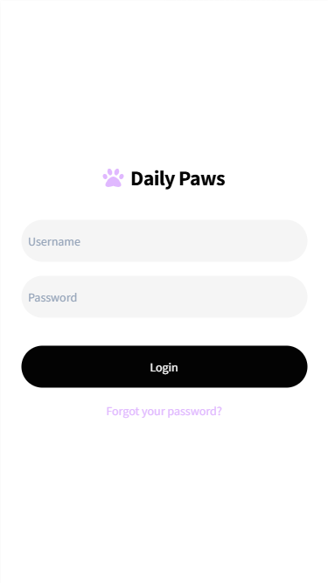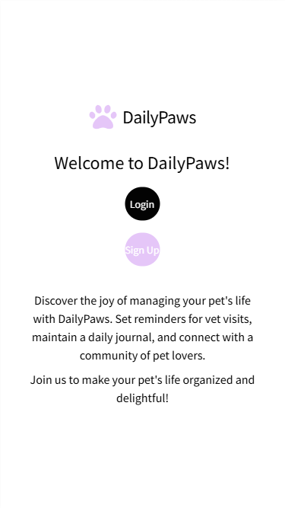

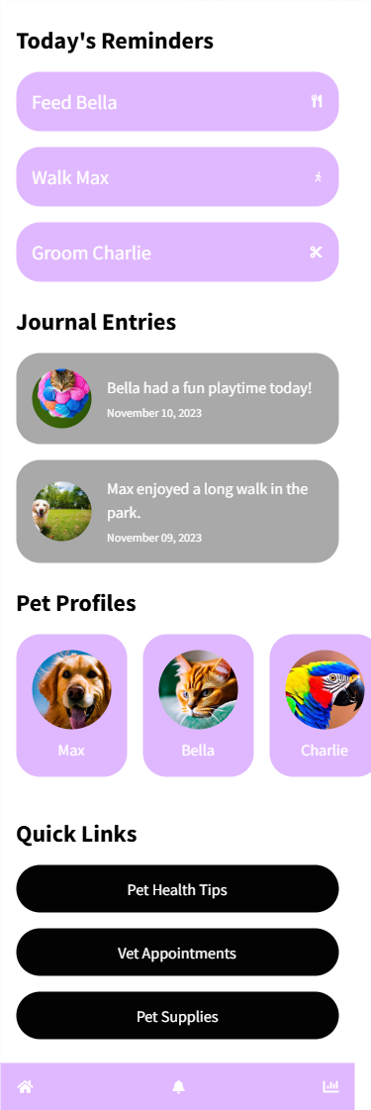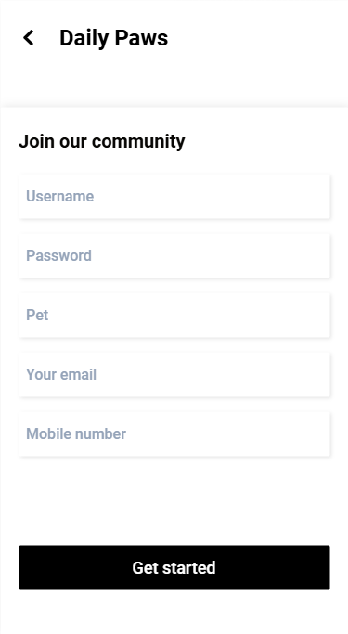Sign Up Screen Home (Dashboard) Screen

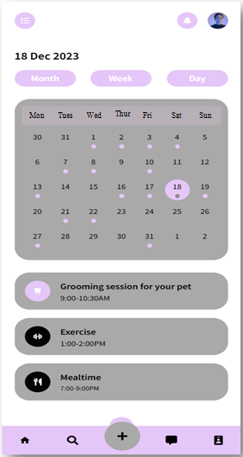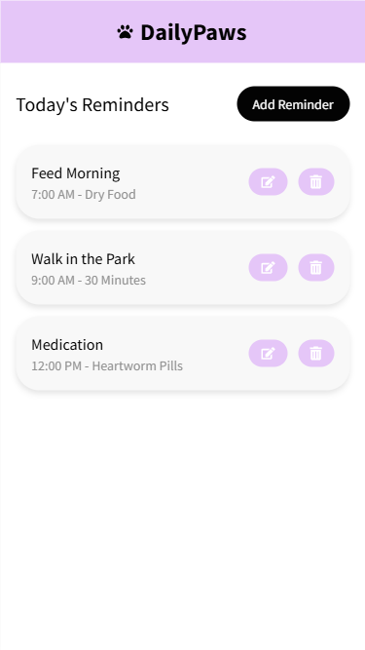 Reminder Screen Calendar Screen

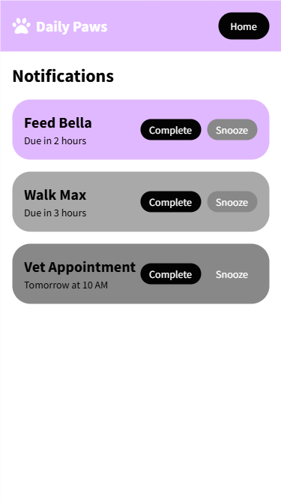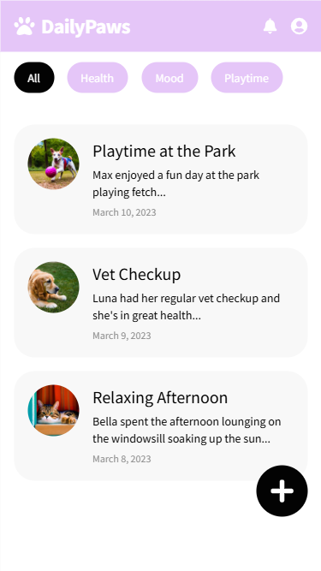 Journal Screen Notification Screen

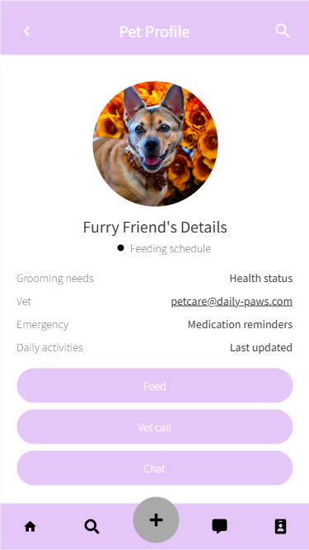Profile Screen

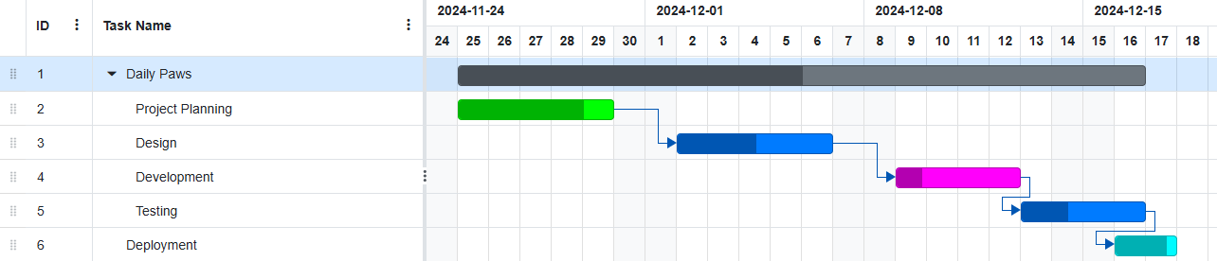**Gantt Chart:**