

Ministry Of Youth Affairs & Skills Development

Vocational Training Authority

**NVQ 5 IN ICT**

|  |  |  |  |  |  |  |  |  |  |  |  |  |  |  |  |  |  |  |  |
| --- | --- | --- | --- | --- | --- | --- | --- | --- | --- | --- | --- | --- | --- | --- | --- | --- | --- | --- | --- |
| **Group Name** | IT ELITE | | | | | | | | | | | | | | | | | | |
|  | | | | | | | | | | | | | | | | | | | |
| **Group Number** | 04 | | | | | | | | | | | | | | | | | | |
|  | | | | | | | | | | | | | | | | | | | |
| **Student Name-1** | M | . | D | . | P | . | S | U | P | I | P | I | K | A |  |  |  |  |  |
| **MIS No** | Q | P | / | 2 | 3 | / | I | C | T | 5 | D | / | 2 | / | 0 | 0 | 1 | 5 |  |
|  | | | | | | | | | | | | | | | | | | | |
| **Student Name-2** | W | . | S | . | K | A | U | S | H | A | L | Y | A |  |  |  |  |  |  |
| **MIS No** | Q | P | / | 2 | 3 | / | I | C | T | 5 | D | / | 2 | / | 0 | 0 | 2 | 2 |  |
|  | | | | | | | | | | | | | | | | | | | |
| **Student Name-3** | P | . | N | . | D | U | L | S | H | A | N |  |  |  |  |  |  |  |  |
| **MIS No** | Q | P | / | 2 | 3 | / | I | C | T | 5 | D | / | 2 | / | 0 | 0 | 3 | 0 |  |
|  | | | | | | | | | | | | | | | | | | | |
| **Student Name-4** | K | . | N | . | S | . | P | . | N | E | T | H | M | I | N | I |  |  |  |
| **MIS No** | Q | P | / | 2 | 3 | / | I | C | T | 5 | D | / | 2 | / | 0 | 0 | 1 | 7 |  |
|  | | | | | | | | | | | | | | | | | | | |
| **Student Name-5** | M | . | D | . | H | . | N | A | V | E | E | N | D | R | A |  |  |  |  |
| **MIS No** | Q | P | / | 2 | 3 | / | I | C | T | 5 | D | / | 2 | / | 0 | 0 | 1 | 4 |  |
|  | | | | | | | | | | | | | | | | | | | |
| **Center Name** | VTC HORANA | | | | | | | | | | | | | | | | | | |
|  | | | | | | | | | | | | | | | | | | | |
| **Supervisor**  **Name** | Mrs. N .C .Nawagamuwa | | | | | | | | | | | | | | | | | | |
| Miss. G. L. G. M. R. De. Silva | | | | | | | | | | | | | | | | | | |



**Group Project Information Sheet**

**Declaration**

I hereby declare that the project “Auto Lab” carried out at the project site has not been duplicated for submission to any other university for award of any degree. Apart from me, as far as I know, no one has applied to any other university.

The project is undertaken in partial fulfillment of the requirement for the award of the Ict level V diploma to be submitted as a final semester project as part of our curriculum.

Name of the Student

M. D. P. Supipika

W. S. Kaushalya

P. N. Dulshan

K. N. S. P. Nethmini

M. D. H. Naveendra

Signature of Student

……………………………..

……………………………..

……………………………..

……………………………..

……………………………..

Date:………………………

**Acknowledgment**

We would like to that everyone who has been a part of this journey to turn this project into a working model. We are grateful to

Ms. N. C. I. Nawagamuwa

and

Ms. G. L. M. R. De. Silva

For enhancing our development skills and providing all possible help while undertaking this project. Also, we would like to thank our classmates and other who directly or indirectly helped us to solve the problems encountered during the development of the project and to make our Project Auto Lab (Billing & Inventory Management System) more efficient and effective.

**Abstract**

This project outlines the Software Requirements Specification (SRS) for a billing and inventory management system. The system aims to automate and improve the efficient of billing processes and inventory management. Key features include user authentication, billing module for invoice generation, payment tracking and inventory module for product management and stock tracking. SRS defines user roles, interfaces, and functional requirements with an emphasis on performance and security. The proposed system is expected to provide a comprehensive solution for businesses, ensuring streamlined operations and insightful reporting capabilities.

**Introduction**

A Billing and stock management system is a software application that helps businesses manage their sales and inventory or stock levels efficiently. It allows companies to monitor product sales, monitor product movement, monitor stock levels, forecast demand, and automate various inventory-related tasks such as ordering, restocking, and reporting. This method helps the business to optimize their inventory control.

This system is designed to streamline warehouse information entry process for Janaka Motors service center to know spare parts sales information. Our system helps to seamlessly track spare parts sales, stock spare parts and track spare parts sales history.

Our spare parts sales and warehouse information entry system is specially designed to meet the requirements. It aims to provide a solution for efficient storage, maintenance, access and parts history of motorcycle spare parts data and seamless storage and sale of spare parts.

Selling spare parts as important modules of our system. Includes storing, updating, deleting spare parts and viewing spare parts sale history.

Selling spare parts as important modules of our system. Includes storing, updating, deleting spare parts and viewing spare parts sale history, Generate reports on sales, tends for informed decision making. And admin and users can be called as the main users of the system.

Each user has facilities to sell spare parts, store spare parts information, update, delete information and view spare parts sale information history

The system provides extensive scheduling capabilities. At Janaka motors service Center, the system to provide warehouse information in a proper manner.

We expect this system to effectively manage motorcycle spare parts, sell spare parts, update spare parts quantity, maintain and know about spare parts history through this system.

**Background of the company**

Janaka Motors Service Center is a popular motorcycle service center. The main branch here is also known as "Jana Motors Service Centre". This center belongs to Mr. Janaka Jayawardena. It was launched on 2019-12-05 and its main branch is Vaskaduwa. Kalamulla, Malaboda, Tudugala, Sirikadura, Baduraliya are its other branches. Currently, 25 employees are working here, including the owner. They have 4 dealerships under the brands Hero, Honda, Yamaha, TVS. The objective of Janaka Motors Service Center is to provide quality service to the customers at an efficient and affordable price.

**Motivation**

Currently using and over dated database system lacking on details processing and data base filtering management system.Doesn’t have a monitored logging system for inventory data base.Couldn’t identify supplies separately which remains low in quantity in supplies.Doesn’t have the ability to see the recent uses of the system. When the system works manually there are plenty of problems when the products are returning from the customers.

We are looking to create an inventory management system and billing system. The system hopes to manage and quickly analyze motorcycle spare parts information, monitor current levels of products, and alert when stocks are low and need to be recorded. Purchase is monitored for delivery of orders to ensure timely fulfillment.

Generate reports on sales, tends for informed decision making.

By effectively managing an ordered product, it is possible to identify a damaged product separately. A notification message will be displayed to the user when the stock is reduced to 20.

**Project Scope**

Biling and inventory Management System is the selling of spare parts and spare parts management in warehouse of Janaka Motors Service Center.

The Billing and inventory management system project scope encompasses the design, development and implementation of a software solution to efficiently handle billing and inventory tasks. This includes creating a user friendly interface for managing sales transaction, generating invoices, tracking inventory levels, and providing comprehensive reports. The system aims to streamline business operations, improve accuracy in financial transactions, and enhance overall inventory management processes for better business efficiency.

The scope of this project will be limited to the following:

* + **System**

Develop computer application ensuring compatibility between operating System and data base allows the emplace to easily enter data into the database The Solution allows the employee to easily other data into the database.

* **Billing Module**

Ability to create and manage customer profiles. Generate invoice for sales transactions. Support for various payment methods. Record and track sales history.

* + **User-Friendly Interface**

Design intuitive and wear-friendly interfaces. That simplify the ware have’s entry process for amplest Implement clear navigation, information tools and contextual help to assist users at every step of the warehouse process.

* + **Inventory Management and**

Track product details, including name, description, and unit price. Monitor stock levels in real time. Set up alerts for low stock or product expiration.

* + **Store directory**

Operate a Comprehensive warehouse direction that provides detailed information on wave house details it can get the details of the store Empower the manager to search and filter inform information about items in Stock, items to be reordered, items to be returned and items Sold during the month.

* **Reporting and Analytics**

Generate comprehensive reports on sales, revenue, and inventory levels. Analytical tools for insights into business performance.

* **Notification System**

Automated alerts for low inventory, successful transaction, and critical system events.

* **Data Backup and Recovery**

Regular automated backups to prevent data loss. Mechanism for data recovery in case of system failures.

* **Scalability**

Designed to accommodate business growth by supporting an increasing number of products, customers and transactions.

By incorporating these features, the Billing and inventory Management System aims to optimize business processes, enhance decision-making through data insights and provide a robust platform for effective financial and inventory management.

**Aim and Objectives**

**Aims**

* **Streamline Business Operations**

Develop a system that automates billing processes and inventory management to streamline day-to-day business operations.

* **Improve Efficiency**

Increase overall operational efficiency by reducing manual effort and automating repetitive tasks associated with billing and inventory management.

* **Optimize Inventory Management**

Optimize inventory levels by implementing a system that enables efficient tracking, minimizing holding costs, and preventing stockouts.

* **Enhance Customer Satisfaction**

Improve customer satisfaction by streamlining billing processes, reducing billing disputes and ensuring timely and accurate.

* **Enhance Accuracy**

Improve accuracy in financial transactions, billing calculations, and inventory tracking to minimize errors and discrepancies.

**Objectives**

* **Develop User-Friendly interface**

Create an intuitive and user-friendly interface for easy navigation, reducing billing disputes, and ensuring timely and accurate invoices.

* **Build inventory Management System**

Design and implement an inventory management system with features such as product tracking, stock level monitoring, purchase order management.

* **Generate Comprehensive Reports**

Develop reporting functionalities to generate comprehensive reports on sales, revenue, inventory levels and other relevant business metrics.

* **Incorporate Notification**

Implement a notification system to alert users about low inventory levels, successful transactions and other critical events.

* **Design for scalability**

Design the system to be scalable , accommodating business growth by supporting and increasing number of products, customers and transactions.

**Problem Statement**

The Billing and inventory management system problem statement addresses the challenges and inefficiencies in traditional manual billing and inventory processes, emphasizing the need for a streamlined and automated solution. Key points in the problem statement include

* **Manual Processes and Errors**

Businesses currently rely on manual methods for billing and inventory management, leading to errors, delays and inefficiencies.

* **Lack of real time Visibility**

Absence of a centralized system results in a lack of real-time visibility into stock levels, sales trends, and financial data, hampering decision-making.

* **Ineffective Record-keeping**

Difficulty in maintaining accurate and up-to-date records of sales transactions, customer details and inventory movements.

* **Inefficient Reporting**

Manual generation of reports is time-consuming and prone to errors, impeding the ability to derive meaningful insights for strategic planning.

* **Security Concerns**

Security risks associated with manual record-keeping and handling financial transactions without a robust authentication and authorization system.

* **Customer Experience**

Lack of a streamlined billing process may impact customer satisfaction, potentially leading to billing disputes and delays.

* **Supplier Relationship Management**

Challenges in managing purchase orders, supplier details and ensuring timely replenishment of inventory

The Billing and inventory Management System project aims to address these challenges by developing an integrated, automated solution that enhances accuracy, efficiency, and overall business productivity while ensuring compliance with industry standards and regulations.

**Expected Benefits**

The implementation of a billing and inventory management system is expected to yield several significant benefits for businesses. These include:

* **Increased Efficiency**

Automation of billing processes and inventory management leads to a reduction in manual effort, enabling faster and more efficient operations.

* **Error Reduction**

Automation minimizes the likelihood of human errors in billing calculations, inventory tracking and financial record-keeping, improving overall accuracy.

* **Real time Visibility**

Centralized tracking provides real-time visibility into inventory levels, sales trends and financial data, facilitating better decision making and strategic planning.

* **Improved Record-keeping**

The system ensures accurate and up-to-date records of sales transactions, customer information and inventory movements, enhancing data integrity.

* **Enhanced Scalability**

The system is designed to scale with business growth, accommodating an increasing number of products, customers and transactions without operational bottlenecks.

* **Effective Reporting**

Automated report generation provides quick access to comprehensive insights, aiding in informed decision-making and strategic analysis.

* **Customer Satisfaction**

Streamlined billing processes contribute to a better customer experience, reducing billing disputes and delays and fostering positive relationships.

* **Optimized Inventory Levels**

Real-time inventory tracking helps maintain optimal stock levels, preventing stockouts or overstock situations and minimizing holding costs.

* **Improved Supplier Relationships**

Efficient management of purchase orders and supplier details ensures timely replenishment of inventory, fostering positive relationships with suppliers.

* **Cost Savings**

Automation reduces labor costs associated with manual processes and efficient inventory management prevents unnecessary holding costs and stock outs.

* **Enhanced Decision-making**

Access to accurate and timely data empowers decision-makers with the information needed for strategic planning and business growth.

In summary, the billing and inventory management system is expected to bring operational efficiency, accuracy and improved decision-making, leading to overall business success and sustainability.

**CHAPTER 2**

**System Requirements**

1. **Requirements Gathering Methods**

A crucial stage in the development of our system, a motorcycle spare parts management system, is the actual assembly machine. Requirements include gathering, documenting, and analyzing requirements and expectations to define the features and functionality to be delivered. Certainly, developing a motorcycle spare parts management system is a complex task, and the assembly machine is a crucial stage in the process. To ensure the success of this phase, we have adopted a systematic approach to gathering, documenting and analyzing requirements.

1. Identifying contacts identifying all customers connected to the spare parts management system. This includes end users, administrators, suppliers and other relevant users. Our stakeholders are Institutional Providers, Institutional Seekers, and Suppliers.

* We conducted an interview with them. Interview Interviews with key stakeholders such as spare parts managers, inventory clerks, technicians and other staff involved in spare parts management. Ask open-ended questions to gather detailed information about their workflow, pain points, and specific requirements for the system.
* As well as surveys and questions from our associated experts to gather input from different perspectives and distribute surveys or questions to a wider audience. Both closed-ended and open-ended questions are used to collect quantitative and qualitative data about needs.

1. Monitoring current spare parts management processes in place to identify inefficiencies and areas for improvement. Identify manual tasks, barriers and common challenges faced by users. What are the challenges we face?

* Manual and paper based processes. The existing system heavily relies on manual and paper based processes, leading to time consuming and error prone procedures the reliance on physical paper work, data entry, and manual record – keeping not only increases administrative burdens but also increases the risk of data loss, duplication, and inaccuracies.
* Couldn’t take a proper count of inventory in the available stock. And the returned items.
* Couldn’t record inter branch transactions and exchange of items.

1. Analysis Reviewing inventory records, purchase orders and current systems to understand the current state of spare parts management. Identifying gaps and areas for improvement.

* Being able to see many faults in the current system.
* The current system is a website based system and therefore internet facility is essential. When internet facility is lost the system will crash.
* The current system should be updated.
* Since the current system is a web-based system, the user is unable to operate the system properly.

1. Use Case Analysis Identify and analyze common use cases within the parts management process. Documenting the steps, actors involved and expected results to derive functional requirements.

* This also includes the challenges seen above. That ” Monitoring current spare parts management processes in place to identify inefficiencies and areas for improvement. Identify manual tasks, barriers and common challenges faced by users. What are the challenges we face?”
* This also includes the seen above that(Manual and paper based processes. The existing system heavily relies on manual and paper based processes, leading to time consuming and error prone procedures the reliance on physical paper work, data entry, and manual record – keeping not only increases administrative burdens but also increases the risk of data loss, duplication, and inaccuracies. Couldn’t take a proper count of inventory in the available stock. And the returned items. Couldn’t record inter branch transactions and exchange of items.)

1. Benchmarking Research and analysis of similar parts management systems in the industry. Identify best practices, features and functionality that can be adapted to meet the specific needs of your organization.

* Finally, we studied Honda and Yamaha company's system. Through it, we studied how we should create our system's interface, system and databases.

1. **Functional and Non-functional Requirements**

Functional requirements describe what the system should do. They specify the features and functionalities that the system must provide to meet the needs of the users. Our system is to manage motorcycle spare parts. There are many functions to be performed in this system. As the first

1. A new window setup for entering user name and password that is easy for the operator to navigate as the first.

Like this the enables the user to easily log into the system.

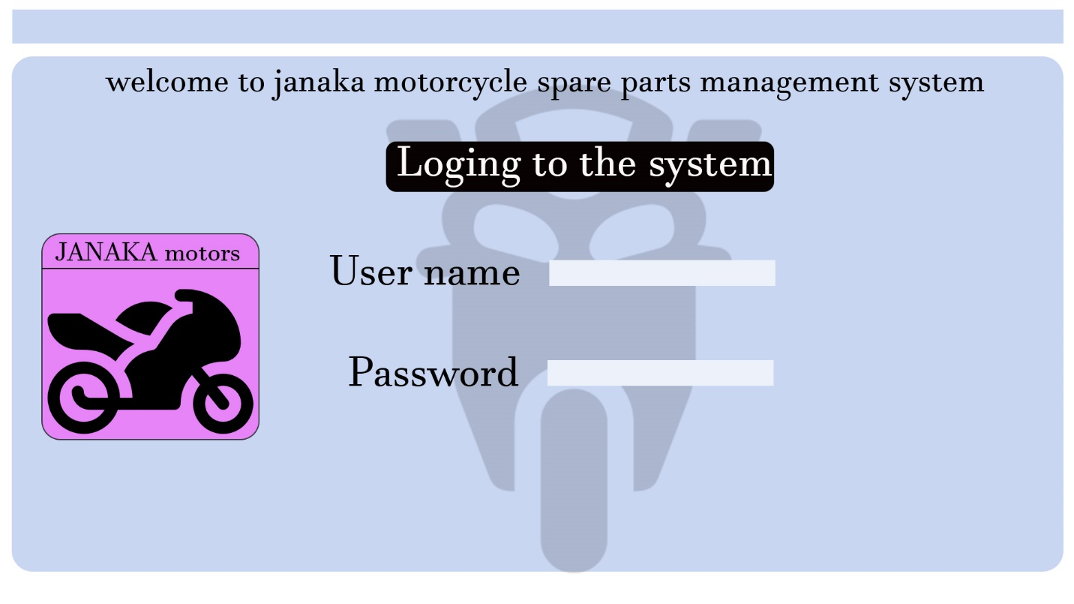

1. The user is able to navigate the system easily. The system is accessible to the user easily.

Like this.

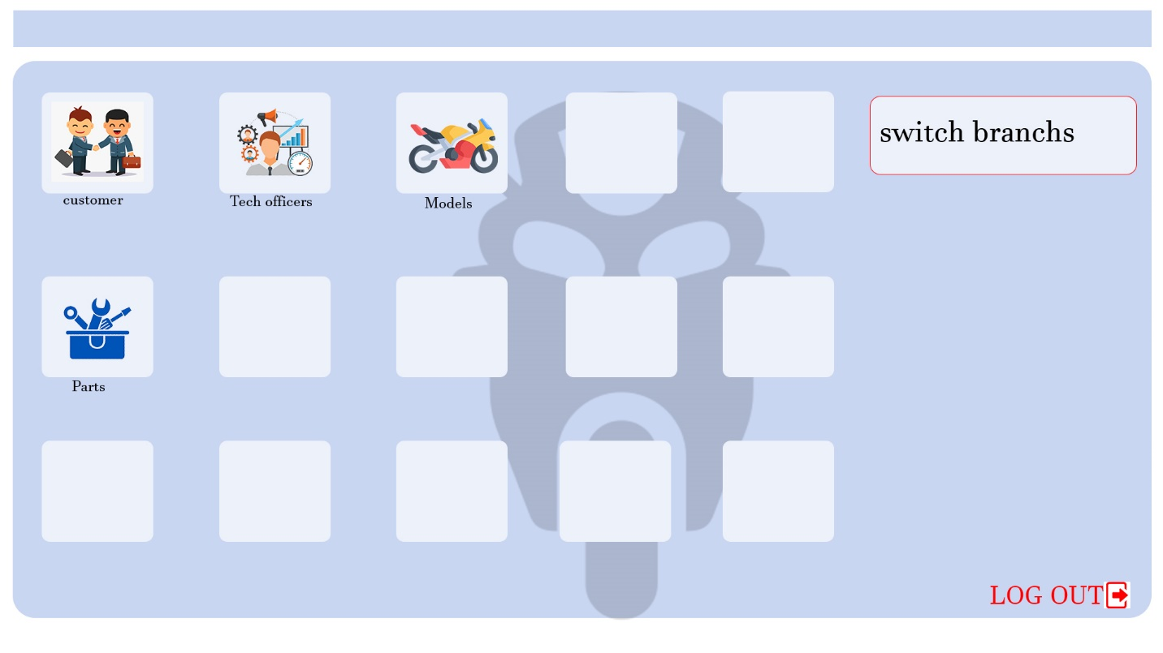

1. When the inventory is exhausted from the system, the system itself will issue a warning massage.

Like this.

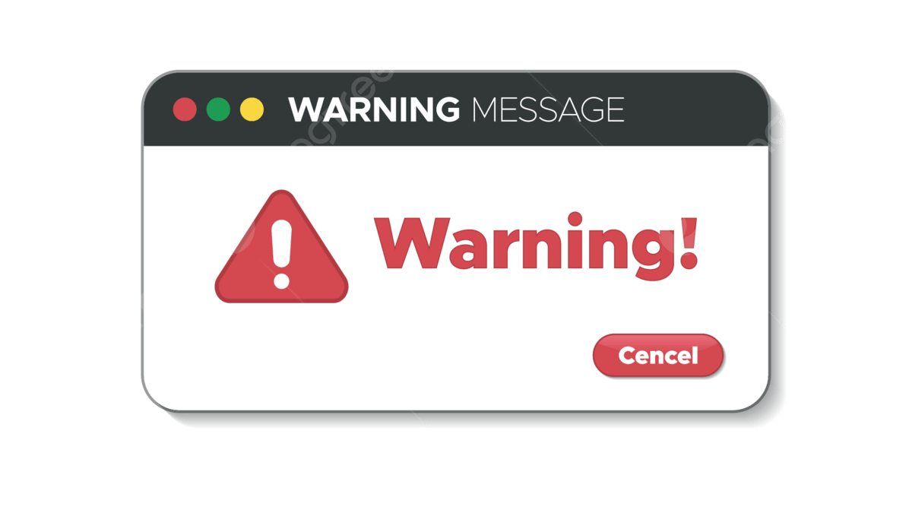

1. Entering data into the system, changing data and getting the right to delete data.

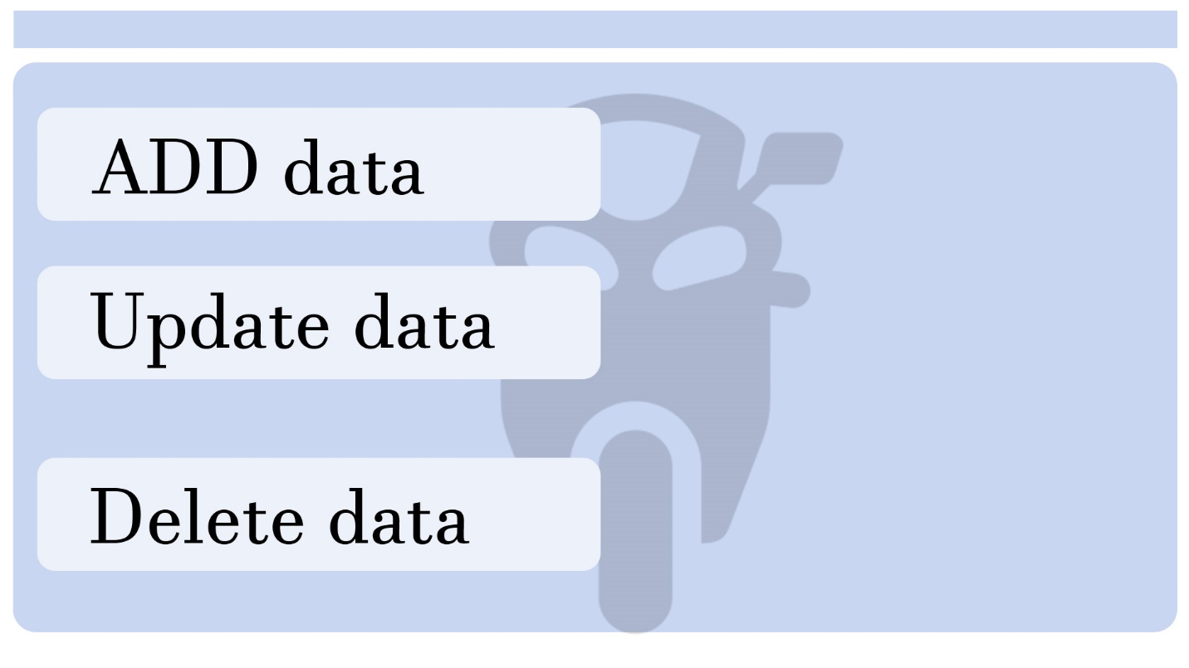

1. It should be possible to see all the details of other sponsors from the grant institution and to change the data, add new data and delete the data.

This will take you to a name page and display that data.

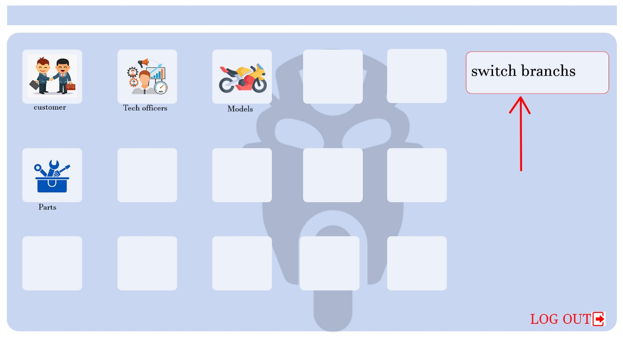

**CHAPTER 3**

**Analysis**

1. **Introduction**

System analysis refers to the process of gathering data, interpreting information, identifying issues and using the result to recommend or develop possible system improvements. During this stages, companies may also evaluate future business needs and how improvements may answer them. Leading to the identification and recording of the characteristics of the new intended, information system.

1. **Feasibility Study**

A feasibility study is a preliminary investigation of the proposed project or its merits an viability. Sufficient information should be provided to make reasonable estimate of the proposed project. Users should be informed about how the system fits the organization.

A feasibility is a preliminary exploration of a proposed project or undertaking to determine its merits and viability. A Feasibility study aims to provide an independent assessment that examines all aspects of a proposed project, include technical, economic, operational, financial environmental considerations.

There are,

* Technical feasibility study

Technical feasibility evaluates the technical complexity of the expert system and often involves determining whether the expert system can be implemented with state of the art techniques and tools.

* Operational feasibility study

Operational feasibility is the measure of how well a proposed system problems and takes advantage of the opportunities identified during scope definition and how it satisfies the requirements identified in the requirement analysis phase of system development. Technical evaluations should confirm whether the existing system can be improved to use the new technology and whether the organization has the expertise to use it.

* Financing feasibility study
* Operating Cost: Hardware cost, Software Cost, Employee fee and Other(Internet fee, Traveling).
* Cost Estimation: Development cost, Software Licensing, Hardware Procurement, Training cost, Testing & QA.

1. **Existing System**

The existing method is a manual system method. Manual of information books, stock and scale the system triers to simplify the handling difficulties. In this case, details of sales, books and stock are stored in one or more documents. The existing manual system requires a large task force and the process takes time.

1. **Explanation of the Proposed System**

The main objective of the proposed method is to overcome the shortcomings of the existing manual method avoidance. A lot of computerizations of the system helps to save time. Manual maintenance of all details of the report very difficult also-referring to a particular report leads to spending more time the manual system corrects many of these deficiencies.

The system provides knowledge of spare parts history to effectively manage motorcycle spare parts, sell spare parts, update and maintain spare parts quantity. The system is mainly divided into four roles namely Admin, User, Supplier and Customer. Finally, Admin and User manages this system.

**CHAPTER 4**

**Design**

* 1. **Introduction**

Welcome to the introduction of our comprehensive Inventory Management and Billing System. This robust system is designed to streamline and optimize the intricate processes associated with inventory control and seamless billing transactions. By integrating cutting-edge technology, our solution aims to enhance efficiency, reduce errors, and provide real-time insights to empower businesses of all sizes. From inventory tracking to generating accurate invoices, our system is tailored to meet the dynamic needs of modern businesses, ensuring a seamless and reliable management experience.

* 1. **System Methodology**
     1. **Introduction**

Welcome to the System Methodology introduction for our Software Requirements Specification (SRS) document, following the Waterfall model. The Waterfall model is a linear and sequential approach to software development, where each phase must be completed before moving on to the next. This systematic methodology is characterized by its structured progression through well-defined stages, offering clarity and predictability in the development process.

In the context of our SRS document, the Waterfall model ensures a methodical exploration of requirements and their subsequent transformation into a fully functional system. Beginning with comprehensive requirements gathering, the process flows seamlessly through system analysis, design, implementation, testing, deployment, and maintenance.

By adopting the Waterfall model, we aim to provide a disciplined framework that facilitates thorough documentation, clear project milestones, and effective collaboration between stakeholders. This approach is particularly advantageous when dealing with projects where requirements are well understood and stable, enabling us to deliver a robust and reliable software solution aligned with the specified objectives. Join us on this structured journey as we navigate through each phase, ensuring a systematic and successful realization of our software

**System Methodology (Waterfall)**

* Requirements Gathering:

Gather initial requirements through interviews, surveys, and document analysis.

Define the scope of the project and establish clear boundaries for functionality.

* System Analysis:

Break down gathered requirements into detailed specifications.

Create use cases, analyze workflows, and document functional and non-functional requirements.

* System Design:

Develop a high-level system architecture based on analyzed requirements.

Create detailed system specifications, including database design, interface design, and data flow diagrams.

* Implementation:

Translate design specifications into executable code.

Develop and integrate modules, ensuring adherence to design principles and coding standards.

* Testing:

Conduct unit testing to ensure individual components meet specifications.

Perform system testing to validate that integrated modules work together seamlessly.

* Deployment:

Release the system for beta testing or limited use to gather user feedback.

Address any issues identified during beta testing and prepare for full deployment.

* Maintenance:

Implement any necessary updates or changes based on user feedback.

Provide ongoing support, addressing issues and ensuring system stability.

* Documentation:

Maintain comprehensive documentation throughout each phase of the Waterfall model.

Update documentation as the system evolves, ensuring accuracy and clarity.

Note: Each phase is completed before moving on to the next, emphasizing a linear and structured approach to software development. The Waterfall model is suitable for projects with well-defined and stable requirements.

* + 1. **Comparative study on Development Methodology**

**Waterfall Methodology**

* Sequential Approach

Waterfall follows a linear and sequential model, where each phase must be completed before moving on to the next.

* Detailed Planning

Extensive planning is done at the beginning of the project, including a comprehensive SRS document. Changes are difficult once the project is underway.

* Documentation Emphasis

Places a strong emphasis on documentation, making it suitable for projects with well-defined requirements.

* Rigidity

Less adaptable to changes during the development process. Any modifications may require revisiting previous stages.

**Agile Methodology**

* Iterative and Incremental

Agile breaks the project into small iterations, each delivering a functional part of the software. It allows for flexibility and changes throughout the development.

* Collaborative Approach

Encourages constant communication and collaboration between the development team and management. Requirements can evolve based on feedback.

* Adaptability

Agile is more adaptable to changing requirements, making it suitable for projects where specifications may evolve during development.

* Reduced Upfront Planning

Focuses on working software over extensive documentation. SRS documents are often more flexible and evolve as the project progresses.

* Flexibility

Agile is more flexible and adaptive, accommodating changes during development, whereas Waterfall is rigid and changes are challenging.

* Client Involvement

Agile involves continuous client feedback, ensuring the delivered product aligns with client expectations. Waterfall may have less client involvement until the final product is ready.

* Risk Management

Waterfall's upfront planning may reduce risks early in the project, but it can be less equipped to handle unforeseen issues. Agile identifies and mitigates risks throughout the development process.

* Delivery Time

Agile often delivers a minimum viable product sooner due to its incremental nature, while Waterfall may take longer to produce a complete product.

In conclusion, the choice between Waterfall and Agile for developing an SRS document depends on the project's nature, level of uncertainty in requirements, and the desired balance between upfront planning and adaptability. Waterfall suits well-defined projects with stable requirements, while Agile is preferable for dynamic projects with evolving specifications.

* + 1. **Development Tools**

If you're working with NetBeans, Java, and MySQL for your software development, here’s a set of development tools and technologies relevant to creating and managing a Software Requirements Specification (SRS) document in this context:

**Document Editors**

* Microsoft Word: A widely used word processing tool for creating and formatting textual content, including SRS documents.
* Google Docs: A cloud-based collaborative platform for creating and editing documents in real-time, facilitating team collaboration on SRS. for a SRS document (netbeans,Java,mysql)

**Integrated Development Environment (IDE)**

* NetBeans: An IDE that supports Java development, providing features like code editing, debugging, and project management. It can be used for coding components mentioned in the SRS.

**Programming Language**

* Java: The primary programming language for your project. The SRS may include details about how Java will be used in the development of specific functionalities.

**Database Management System**

* MySQL: A relational database management system. The SRS should outline how MySQL will be utilized, including data models, database schema, and interaction with the Java application.