**PROPER GLOVE: EFFICIENT DEFECT MANAGEMENT USING BIG DATA AND MACHINE LEARNING FOR LATEX PRODUCTS**

Project ID: 20_21-J 17

Project Proposal Report

Fernando W. M. N. A

Bachelor of Science (Hons) in Information Technology

Specialization in Data Science

Department of Information Technology

Sri Lanka Institute of Information Technology

Sri Lanka

July 2020

**PROPER GLOVE: EFFICIENT DEFECT MANAGEMENT USING BIG DATA AND MACHINE LEARNING FOR LATEX PRODUCTS**

Project ID: 20_21-J 17

Project Proposal Report

Fernando W. M. N. A: IT17175012

Supervisor: Mr. Jesuthasan Alosius

Bachelor of Science (Hons) in Information Technology

Specialization in Data Science

Department of Information Technology

Sri Lanka Institute of Information Technology

Sri Lanka

July 2020

# DECLARATION OF THE CANDIDATE & SUPERVISOR

We declare that this is our own work and this proposal does not incorporate without acknowledgement any material previously submitted for a degree or diploma in any other university or Institute of higher learning and to the best of our knowledge and belief it does not contain any material previously published or written by another person except where the acknowledgement is made in the text.

|  |  |  |
| --- | --- | --- |
| Name | Student ID | Signature |
| Fernando W. M. N. A | IT17175012 |  |

The above candidates are carrying out research for the undergraduate Dissertation under my supervision.

--------------------------------- --------------------------------

Signature of the supervisor: Date

Mr. Jesuthasan Alosius

--------------------------------- --------------------------------

Signature of the co-supervisor: Date

Ms. Dilani Kavendri

# DEDICATION

I humbly dedicate this research proposal to the MIDAS SAFETY company.

To our supervisor Mr. Jesuthasan Alousis & co-supervisor Ms. Dilani Kavendi for their inevitable guidance and support.

Finally, I would like to dedicate this research to fellow students; how are willing to carry on this research further.

# ACKNOWLEDGEMENTS

I appreciate all the support received from the academic staff for the advice and guidance provided. Special thanks go to Mr. Jesuthasan Alosius, our project supervisor and Ms. Dilani Kavendri for their guidance and support. Thank you Mr. Gihan Kuruppu and Mr. Hanifa Nushman, from MIDAS SAFETY for providing necessary details on the research objectives. Also, we would like to thank everybody for filling our survey, its data was crucial for our success.

# ABSTRACT

The meaning of safety hand glove refers to an external wearable, which protects hands from hazards. MIDAS SAFETY is leading private label supplier, which manufacture safety gloves for workers across different industries. The main aspect which should be considered during the manufacturing process is the glove quality. Given that, quality of a glove is affected due to the defects happened through manufacturing process. Currently the quality checking process of the safety glove is performed manually.

“Proper Glove” is a system implemented with novel solutions to optimize the efficiency of gloves manufacturing in four different approaches. This paper addresses the plant and environmental parameters related to ongoing supported glove manufacturing process. Main concepts focused in this paper are big data analysis, machine learning, and statistical analyzing. The expected objective is to optimize supported glove manufacturing by discovering existing co-relation between plant parameters during dipping process and train a machine learning model to optimize the production using real time data.

Although there are applications with some of the technologies, significance of this research is the methodologies of data science and computer networking are gathered into one platform. “Proper Glove: The glove manufacturing system”, then optimize the efficiency in glove manufacturing of MIDAS SAFETY.

***Key Words***

* Machine Learning, Statistical Analyzing, Real time data, Data Science, Computer networking, Big data

TABLE OF CONTENTS

DECLARATION OF THE CANDIDATE & SUPERVISOR i

DEDICATION ii

ACKNOWLEDGEMENTS iii

ABSTRACT iv

LIST OF FIGURES vii

LIST OF TABLES viii

LIST OF ABBREVIATIONS viii

1. INTRODUCTION 1

**1.1** **Background** 1

**1.2** **Literature Survey** 1

**1.3** **Research Gap** 4

**1.4** **Research Problem** 6

2. OBJECTIVES 7

**2.1 Main Objective** 7

**2.2 Specific Objective** 7

3. METHODOLOGY 8

**3.1 System Overview** 8

**3.1.1 System overview diagram** 8

**3.1.2 Development** 10

**3.1.3 Dataset** 10

**3.1.4 Data preprocessing** 10

**3.1.5 Correlation analyze** 10

**3.1.6 Machine Learning** 11

**3.2 Requirement Specification** 12

**3.2.1 User requirements** 12

**3.2.2 System requirements** 12

**3.3 Work Break Down Structure** 14

14

4. DESCRIPTION OF PERSONAL AND FACILITIES 16

5. BUDGET AND BUDGET JUSTIFICATION 17

6. CONCLUSION 18

REFERENCES 19

# LIST OF FIGURES

Page

Figure 1.1.1 Glove manufacturing process 1

Figure 1.1.2 Gloves dipping in latex tank 2

Figure 1.1.3 Penetration defect 3

Figure 1.1.4 Over dipping defect 3

Figure 1.2.1 Before and After states of conducting the six-sigma project 4

Figure 1.2.2 Variation of the thickness of the deposit with immersion speed 5

Figure 1.2.3 Variation of the thickness of the deposit with dwell time 5

Figure 1.2.4 Variation of the thickness the deposit with withdrawal speed 5

Figure 3.1.1.1: Overall system diagram of “Proper Glove” 10

Figure 3.1.1.2 System overview diagram for dipping process defect 11

optimization

Figure 3.1.5.1 Hypothetical scenarios in which continuous variable is 13

Plotted

Figure 3.1.6.1 Simplified optimization problem illustration 13

Figure 3.3.1 Gantt chart depicting the timeline of the project 16

Figure 3.3.2 Gantt chart depicting the timeline of the project 17

# LIST OF TABLES

Page

Table 1.3.1 Comparison between existing system and proposed system 7

Table 4.1 Description of personals associated to the system 18

Table 5.1 Estimated Budget 19

# LIST OF ABBREVIATIONS

Abbreviation Description

RPM Revolutions Per Minutes

DMAIC Define, Measure, Analyze, Improve and Control

RVNRL Radiation-vulcanized natural rubber latex

NR Natural Rubber

K-NN K Nearest Neighbors

# 1. INTRODUCTION

## **Background**

Safety glove is a protective wear, which is designed to protect the skin specially the hands from hazards including cuts, chemical burns, punctures, and impact injuries and to provide comfort to those who wear. In general, one of the most vital concerns for the rubber gloves manufacturing industry is the reduction of common quality defects [1]. Therefore, delivering flawless product is important not only because of it generates profits but also because it helps to increase business competitiveness though customers’ satisfaction [1].

Given that the safety gloves manufacturing process, generally includes seven steps as shown in Figure 1.1.1. For the high quality of the safety gloves, it is used continuous engineering processes.

Figure 1.1.1: Glove manufacturing process

The glove manufacturing process is performed under the environmental condition and external parameters of the factory. Time duration, compound viscosity, RPM, plant chain speed, oven temperatures, outer humidity, outer temperature, former parameters, compound related parameters can be identified as some of the parameters and conditions involved with manufacturing process. Latex viscosity is an important factor in manufacturing of latex dipped goods [5]. It is essential to maintain above mentioned parameter and conditions within the required levels to ensure the manufacturing process is happening smoothly.

MIDAS SAFETY is a leading private label supplier, which manufactures safety gloves for workers across different industries. A supported glove, which consist a base layer and a latex layer on top of the base layer is one of a key product of the company. The glove base is stitched using yarn. It is known as the shell. Then to apply latex layer on the shell, shell is dressed into a former and the former is dipped in latex compound.

A milky white liquid known as latex, which is harvested from rubber tree trunk, is a key mixture involved in gloves manufacturing process. Dipping step can be identified as a crucial process step in gloves manufacturing process. Before proceeding in this step there are several criteria which must be satisfied initially. The glove molds must be cleaned to ensure the dirt is removed. Then it must dry and then dipped in coagulant tank. After enough drying, the dipping step is carried out. As the name implies, when the glove is beginning to be shaped, the glove formers are dipped into a latex compound tank as shown in Figure 1.1.2, to form a latex layer on the glove. Both coagulant and compound latex tanks must properly checked for their properties and condition [3]. The dip molding process normally performed in set of steps, which various from a manufacture to manufacture. Generally, a complete dipping cycle consist 4 to 50 parallel dipping steps.

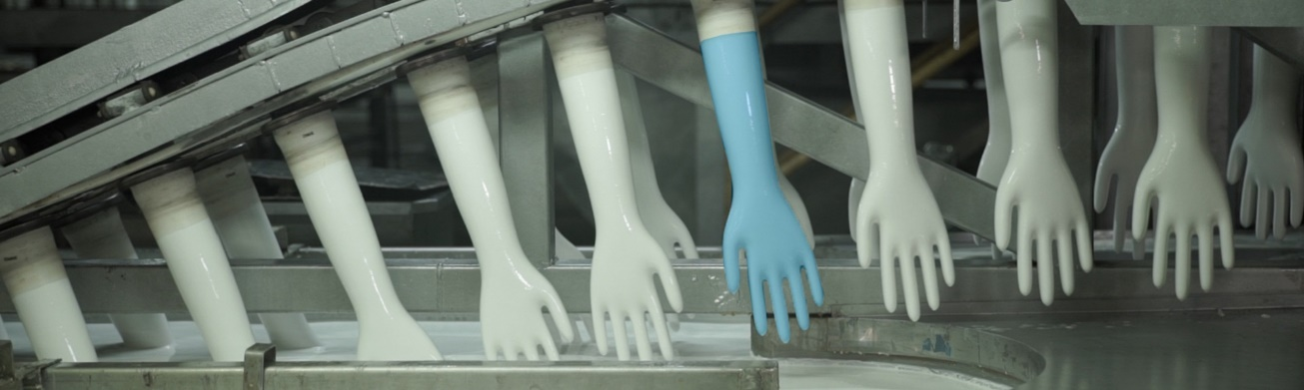

Figure 1.1.2: Gloves dipping in latex tank

When the glove mold is dressed in glove shell and it goes through above mention process to produce support glove. During that production process due to the uncontrollable variations (sudden changes),in plant parameters, it caused for major defects occurrence which affects the quality of final product and some of those defects caused to reject a whole batch of supported gloves which were produced. Some of those quality defects are:

* CD : Clinker defect
* DF : Dressing fault defect
* DM : Dirty mark defect
* JF : Joint finger defect
* LG : Long glove defect
* OD : Over dipping defect
* PD : Poor dipping defect
* PF : Processing finger defect
* PH : Pin hole defect
* PT : Penetration defect
* HD : Hand defect
* SD : Shell damage defect
* WEB : Webbing defect
* WR : Wrinkle defect

Penetration defect as shown in Figure 1.1.3, occurred by leaking latex coating into the inside layers of the glove (coat touching the glove former). Over dipping occurred due to the glove former over dipped in compound. If a glove finger is completely covered with latex mixture as shown in Figure 1.1.4, it is identified as an over dipped glove. Also, if a less surface of glove finger is covered than required surface, it is identified as a Poor dipped glove. It is mainly happened due to the improper alignment in the former and due to the over balance in former. Shell damage occurred if a shell is hit in a surface during the production process due to improper alignments of former. Pin holes are the tiny holes in produced glove which may cause for penetration.

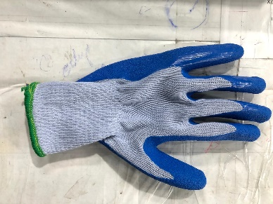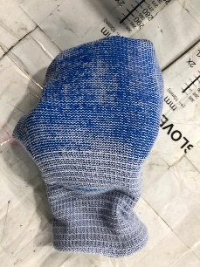

Figure 1.1.3: Penetration defect Figure 1.1.4: Over dipping defect

(Coating has leaked into inner (Whole finger is covered)

layers)

Since the above-mentioned defects directly affects the glove quality, it will invariably affects the glove manufacturing line. At present Plant 13 at MIDAS SAFETY doesn’t have the required capabilities to detect and identify the plant parameters which directly caused for the above-mentioned defects. Due to the unawareness of the defect occurrence patterns, the top management of the company must bear huge losses in gloves production line. In order to control those unwanted quality defects, there is a need of to identify the external parameters, which directly connects and contributes in dipping step.

The main objective of this research is to build a machine learning model, which can effectively control the latex dipping, with the changes in external plant parameters. The final goal of this research is to control defects which occurred during ongoing production process. Therefore, the system requires a statistical approach which analyze un-structed big data to identify any existing co-relations between plant parameters and environmental conditions. Machine learning models will be constructed to optimize the defect occurrence and to optimize supported glove rejection.

## **Literature Survey**

Researches have been conducted to detect the factors which caused in defects occurred during latex product manufacturing. According to the several studies [1],[2],[3],[4], it implies the quality is the key element in glove manufacturing industry. Therefore, many manufactures are facing the challenge of developing quality glove with the minimum cost possible.

#### **1.2.1 A Six Sigma and DMAIC application for the reduction of defects in rubber gloves manufacturing process [1]**

This research paper discussed six sigma principle which can be apply to rubber glove manufacturing process to reduce the defects. The two major defects addressed in this study are leaking defect (penetration) and dirty glove. The Six Sigma and DMAIC include five stages. Six Sigma identifies and eliminates defects, mistakes or failures that may affect processes or systems [1].

In define stage it defines the boundaries and scope of the project. In measure stage establish reliable metrics to monitor progress which is the reducing number of defects in rubber glove manufacturing process. Defect data was collected for 20 days and categorized them according to the defect type. In analyze stage DMAIC model involves analyzing and identify ways to reduce the gap between current output and desired output. According to the analysis carried out it was identified oven temperature and conveyor’s speed has significant impact on above mentioned defects. In improvement stage solutions have been identified to reduces defects. The provided solution was to maintain oven temperature in 230 ℃ and conveyor’s speed as 650 RPM. As for the last stage, control stage DMAIC process ensure the improvements in the process is achieved. The below Figure 1.2.1 shows a significant change in defect occurrence in manufactured gloves after applying six sigma principles.

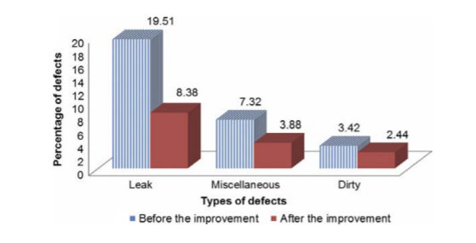

Figure 1.2.1: Before and After states of conducting the six-sigma project

Source: Adapted from [1]

#### **1.2.2 Studies on the Dipping Characteristics of RVNRL and NR Latex Compounds [6]**

The study is conducted t identify the relationship between thickness of the latex film deposited on the former and several factors such as, latex compound properties, type and temperature of the former, concentration and nature of the coagulant, the rate of withdrawal, and dwell time of the former. In this study the dipping characteristics of RVNRL and NR latex compounds were compared with a laboratory-model semiautomatic dipping [6]. The below charts show the variation of thickness.

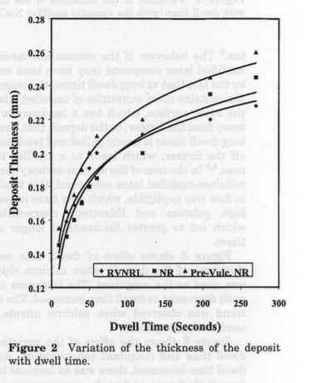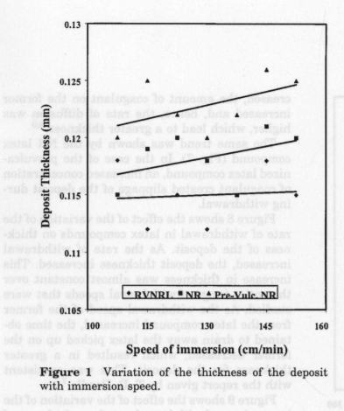

Figure 1.2.2: Variation of the thickness of Figure 1.2.3: Variation of the thickness

the deposit with immersion speed of the deposit with dwell time

Source: Adapted from [6] Source: Adapted from [6]

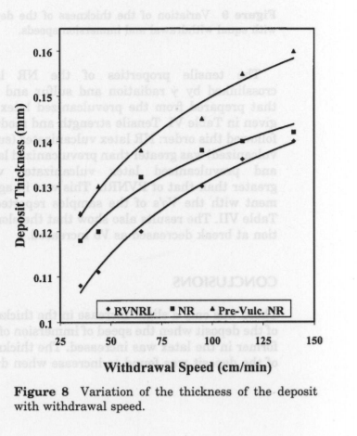

Figure 1.2.4: Variation of the thickness of

the deposit with withdrawal speed

Source: Adapted from [6]

By performing several experiments for above mentioned factors, it shows a variation of thickness with the speed of immersion as the speed increase from 109 to 144 cm/min, the thickness was increased slightly. And, with the increase in dwell time, viscosity, concentration of coagulant, withdrawal rate, it shows an increase in thickness of the deposit.

#### **1.2.3 Current Trend In Latex Dipped Products Manufacturing [7]**

In this conference paper, it has identified threats from synthetic materials such as fabrics used for latex dipped products caused challenges in manufacturing process. Therefore, using NR latex with those materials can affect for defect occurrence. As the solution, it has suggested RVNRL as new technology.

#### **1.2.4 An Update on Automation Technology For Latex Dip Molded Products and Coatings [8]**

In this conference paper, it mainly focused on automating latex product manufacturing process to cost reduction, to increase margin and gain, to optimize the production and to face industrial competition. It has mentioned latex products continue to grow between 4% to 10% annually due to the increase in population, due to the awareness increase in healthcare and disease prevention and due to the increase in usage in health and protection. This paper’s intent is to report on present automation trends in the industry and on specific types of technology that are currently the focus of attention for many of the world’s top manufacturers of latex dip moldings and latex coated products [8]. Asian countries such as Malaysia, Thailand, China, Vietnam, Sri Lanka has identified as glove and condom manufacturing countries where automation trend is strong as firms seek for technology solutions. The mentioned solution techniques in this paper are false bottom technology and automated technologies to optimize latex circulation at dip molding and dip coating area.

## **Research Gap**

So far, the researches which has been conducted for latex product manufacturing has mainly focused on the manufacturing of 100% natural latex products only. But in this research, it is discussed the production of supported gloves, a product consists a yarn shell which is coated with latex layers. Therefore, there is a clear gap between the above-mentioned literature reviews and the topic discussed here, as glove manufacturing process, its associated factors and defects, itself differed according to the product.

Also, another significant gap founded during the literature review is the latex product which mentioned in those literature reviews is the final manufactured product (end product) and the issues related with it. But in this research, it is discussed about the ongoing supported glove manufacturing process and the defects happened during that process. The main advantage of conducting such research is if external parameters associated with the process such as plant wind speed, outer humidity changed unexpectedly, by having a proper identification and analyze technique it helps in controlling dipping process for new parameters which ultimately reduce and control the defects in supported gloves and there won’t be huge loss to be bare.

|  |  |  |
| --- | --- | --- |
| **Features** | **Proposed System** | **Existing System** |
| Conducted for supported glove | ✔ | ✖ |
| Conducted for ongoing manufacturing process | ✔ | ✖ |
| External parameter identification | ✔ | ✔ |
| Co-relation analyze between external plant parameters and defects in dipping process | ✔  (For all identified parameters) | ✔  (Only done for limited parameters) |
| Machine learning models with existing data | ✔ | ✖ |
| Optimized model by feeding real time data | ✔ | ✖ |
| Desktop Application | ✔ | ✖ |

Table 1.3.1: Comparison between existing system and proposed system

## **Research Problem**

## 

Defect occurrence during ongoing manufacturing process is a common problem in any manufacturing field. Due to this problem, the top management of the company must bear a huge loss annually.

The main problem addressed in this research is the defects occurred due to the variations in external plant parameters and environmental conditions. If there is a mechanism to control the plant parameters when environmental conditions got changed, will help to control, and reduce the number of defected gloves produced during manufacturing. At present number of defects are identified as the defects occurred due to the variations in plant parameters.

At present, MIDAS SAFETY has identified the viscosity and former oven temperature are root parameters which causes for those defects. If the viscosity of the mixture changed, then when the glove shell is dipped in the latex compound the coating will leak into inner side and will touch the former. It is one major defect in ongoing process. Also, when dipped glove is going through the chain of ovens mainly there are incidents to be seen which the coated latex layer has evaporated due to high temperature or the coated layer is still in liquid form (not dried) due to the low temperature. Since there are many other parameters affecting for those defects which has not been identified so far, the supported gloves manufacturing with defects is major drawback. Also dipping defect can be visible as two incidents. If a whole finger in the shell is covered with coating it is known as over dipped glove or if a required area of the shell finger doesn’t coated with latex, it is known as poor dipped glove. The both dipped defects caused due to parameter changes and the company has not yet identified any patterns to eliminate it.

To reduce above-mentioned defects, planned to perform a co-relation analysis. The goal is to identify existing relations between each parameters and environmental condition. Then for identified parameters the system provides machine learning model which can predict defect occurrence under measured plant parameters and environmental conditions.

# 2. OBJECTIVES

## **2.1 Main Objective**

The long-term goal of this research is to increase the glove production by controlling the defects which occurred during production process and generate defect less gloves through the ongoing manufacturing process.

## **2.2 Specific Objective**

* To analyze existing big data of the plant to identify the external parameters which contributes in supported glove manufacturing.
* To analysis statistical co-relations between the related plant parameters and environmental parameters to identify the parameters directly affect for the production.
* To develop a machine learning model to optimize defect occurrence due to parameter variations.

# 3. METHODOLOGY

“Proper Glove” is a system implemented with the goal of optimizing the supported glove manufacturing process. This section contains the detailed procedure of how the main objective mentioned in this research is carried out. The main target is to control the ongoing manufacturing defects which occurred due to the unexpected changes in external plant parameters.

## **3.1 System Overview**

### **3.1.1 System overview diagram**

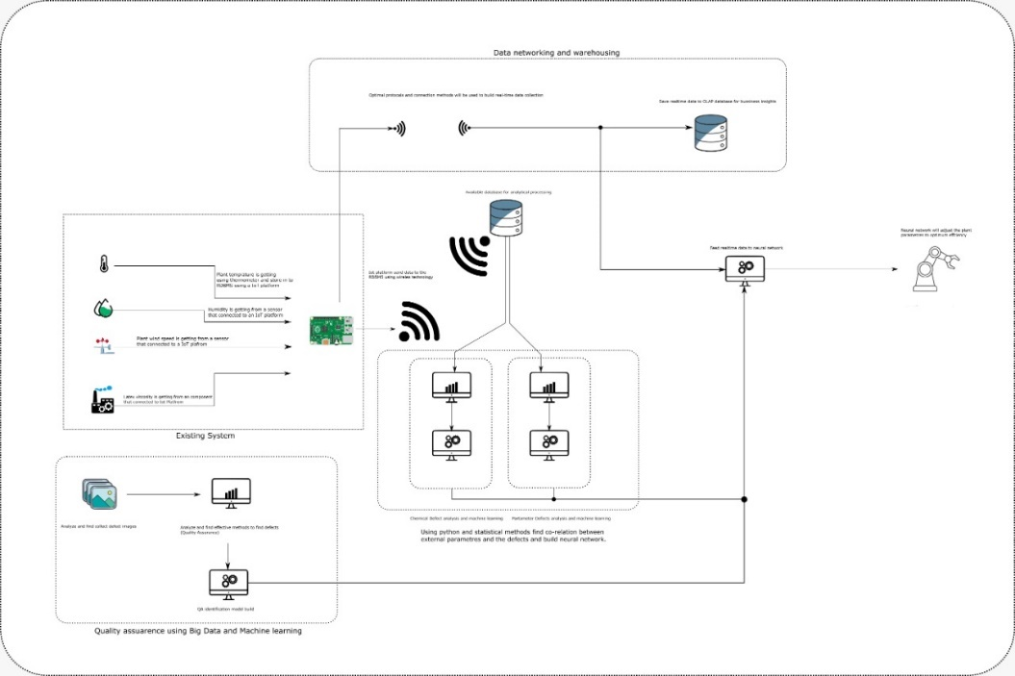

Figure 3.1.1.1: Overall system diagram of “Proper Glove”

Click [here](https://drive.google.com/file/d/1_a_l_u4mslZj38H7tNtHDWfP3d-4tZWq/view?usp=sharing) for a full resolution image.

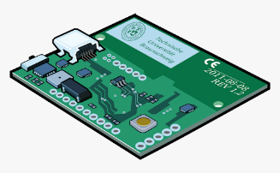

Supported Glove Plant data gathered through manufacturing process sensors

Centralized Data Base



Data preprocessing



Co-relation analysis Machine Learning Model (ODBC is used to import data from to optimize supported glove

SQL Server to R Studio.) manufacturing.

Figure 3.1.1.2: System overview diagram for dipping process defect optimization

### **3.1.2 Development**

The incremental model is selected as the suitable development model for this research. The main reasons for selecting incremental model is because, in incremental the identified requirements can be prioritized. For each requirement the development, design and testing can be performed separately. Also, in incremental model newly coming requirements doesn’t affect for the ongoing developments. Therefore, Incremental Model is the most suitable model.

### **3.1.3 Dataset**

Currently there is an existing mechanism in this company which gathered data during manufacturing of supported gloves using sensors. The collected data is stored in a database.

### **3.1.4 Data preprocessing**

Data is loaded using python and in preprocessing stage data goes through several processing stages. It includes;

* + - Data cleaning: This step is conducted for incomplete, noisy and inconsistence data. Data can be incomplete due to malfunctions in sensors or due to not considering certain data as important. Noise data can be stored due to transmission problems, technology limitations. Therefore, after studying the data properly data cleaning is performed.
    - Data transformation: This step is performed to smooth data and to constructed relevant new attributes from given attributes.
    - Data reduction: This is performed to reduce size of data since complex data analysis takes a long time to run. Clustering and regression is used for reduction.

### **3.1.5 Correlation analyze**

One main objective in this research is to identify existing co-relations between plant parameters and environmental parameters. Before proceeding in co-relation analysis, it is essential in identifying related plant parameters which contributes in supported glove dipping process. For the identified plant parameters, co-relation analysis is performed. It is the process of studying the strength of that relationship with available statistical data [10]. This technique is strictly connected to the linear [regression analysis](https://www.sciencedirect.com/topics/neuroscience/regression-analysis) that is a statistical approach for modeling the association between a dependent variable, called response, and one or more explanatory or independent variables [10].

Pearson Product Moment Correlation Coefficient is denoted by ‘r’. Based on the range of ‘r’ strengthen between two variable is defined as strong positive/ weak positive likewise. The figure given below shows a hypothetical scenarios where variable is plotted.

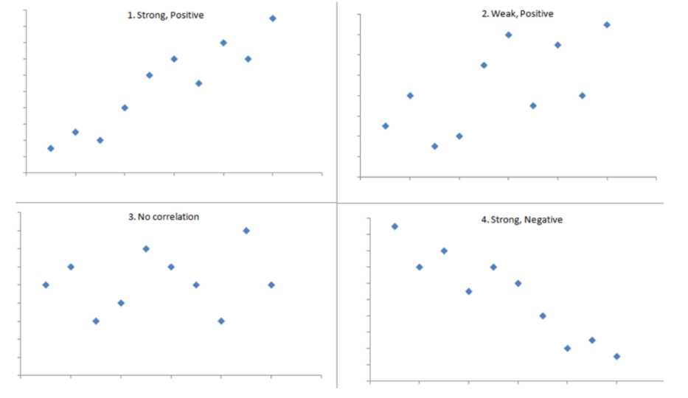

Figure 3.1.5.1: Hypothetical scenarios in which continuous variable is plotted

Co-relation is analysis with **Pearson, Kendall, Spearsman and Point Biserial Correlation**.

### **3.1.6 Machine Learning**

Depending on the data, machine learning models are built as supervised machine learning models or as unsupervised machine learning models. The optimization in any manufacturing process is a complex task, where large number of parameters affects in production line, in which many different parameters must be adjusted to find the best combinations in parameters.

#### 

Figure 3.1.6.1: Simplified optimization problem illustration

Source: Adapted form [9]

In the above figure, it shows two controllable parameters affects in production: “variable 1” and “variable 2”. The optimization problem is to find the optimal combination of these parameters in order to maximize the production line [9].

#### **3.1.6.1 Supervised machine learning**

In supervised machine learning it required a high-level involvement in input data, model training and defining, choosing best algorithm, and visualization. The main goal is to construct a mapping function with a level of accuracy which predict output according to the given inputs. The mostly used learning approaches are **Classification and Regression**.

Since the existing data collection mechanism consist with sensors, **Regression** can be identified as a suitable supervised machine learning model. For regression, commonly used machine learning algorithm is **Linear Regression**.

#### **3.1.6.2 Unsupervised machine learning**

Unsupervised machine learning it suitable if the outcome is unknown and information describing the data is also lacking (no labels in data). The mostly used learning approach is **Clustering**.

Clustering can be used to reduce noise (irrelevant parameters) in existing data. Commonly used clustering types are **Hierarchical, K-mean**.

Therefore, depending on the existing data most suitable machine learning mechanism will be selected to proceed in the research.

## **3.2 Requirement Specification**

### **3.2.1 User requirements**

* Identify the external plant parameters, which contributes in dipping process.
* Co-relations between plant parameter and environmental parameters.
* Machine learning model to optimize defect occurrence.
* Optimize the supported glove production by controlling conditions which causes for defects occurred during ongoing production.

### **3.2.2 System requirements**

#### **3.2.2.1 Functional requirements**

Software and Technologies

* + - Python
    - TensorFlow
    - Keras
    - MySQL
    - R Studio
    - Anaconda

Development Environments

* + - Windows 10
    - Git Version Controlling

#### **3.2.2.2 Non-functional requirements**

Product Requirements

* + - Reliability
    - Usability
    - Performance
    - Availability

External Requirement

* + - Company ethics
    - Company regulations

## **3.3 Work Break Down Structure**

## 

Figure 3.3.1: Gantt chart depicting the timeline of the project

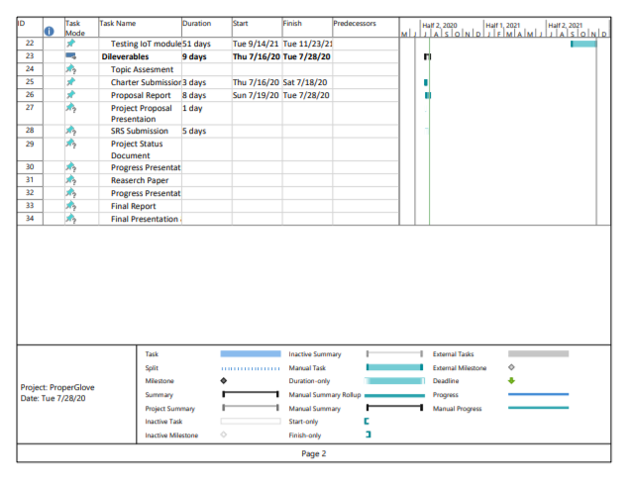

Figure 3.3.2: Gantt chart depicting the timeline of the project

Click [here](https://drive.google.com/file/d/1ss8XPQDmvgOj5xZLojSWQVBKpjJlQYzB/view?usp=sharing) for clear chart.

# 4. DESCRIPTION OF PERSONAL AND FACILITIES

|  |  |
| --- | --- |
| Personal | How they are associated |
| 1. Department Heads 2. Engineers MIDAS 3. Consultants SAFETY 4. Assistant Managers staff | They are the main personals involved with the “Proper Glove” system. They will be used to gather information related to supported glove manufacturing process. Also, they will be the primary users of this system. |
| 1. Developers | Persons who will be developing the system. |
| 1. Researcher | Those who interest in this research and who are planning to develop this research further. |

Table 4.1: Description of personals associated to the system

# 5. BUDGET AND BUDGET JUSTIFICATION

|  |  |  |  |  |  |
| --- | --- | --- | --- | --- | --- |
| Budget Item | Quantity | No of Days | Unit Price (LKR) | Price  (LKR) | Details |
| Transportation | 04 | 20 | 200.00 | 16,000.00 | Field visit MIDAS SAFETY in Biyagama Industrial Zone A for data collection. |
| Transportation | 04 | 1 | 200.00 | 800.00 | Product testing |
| Other | - | - | - | 5,000.00 | Other expenditures |
| **TOTAL** | - | - | - | 21,800.00 | - |

Table 5.1: Estimated Budget

# 6. CONCLUSION

Rising awareness of the protection of workers in different industries has fueled the industrial glove market. **Global Industrial Safety Gloves Market**size was worth over USD 5 billion in 2018 and will witness CAGR over 7% up to 2025 [11]. Therefore, it is essential in optimizing supported glove manufacturing process to control ongoing manufacturing defects which is a major drawback in production line. The ultimate goal of this research is to control defects related to glover former dipping process with the use of machine learning and other related techniques in data science. It is highly expected that this system will helps MIDAS SAFETY to automate supported glove manufacturing process.

# REFERENCES

[1] P. Jirasukprasert, J.A. Garza-Reyes, V. Kumar, Ming K. Lim. (2014, February). “A Six Sigma and DMAIC application for the reduction of defects in rubber gloves manufacturing process” International Journal of Lean Six Sigma [Online]. vol. 5, issue 1, pp. 2-21. Available: [https://www.researchgate.net/publication/263418063_A_Six_Sigma_and_DMAIC_application_for_the_reduction_of_defects_in_a_rubber_gloves_manufacturing_process.pdf](https://www.researchgate.net/publication/263418063_A_Six_Sigma_and_DMAIC_application_for_the_reduction_of_defects_in_a_rubber_gloves_manufacturing_process.pdf%20%20%20)

[2] K. Singh. (2016, July). “Defects Reduction Using Root Cause Analysis Approach in Gloves Manufacturing Unit” International Research Journal of Engineering and Technology (IRJET) [Online]. vol. 3, issue 7, Available: [https://d1wqtxts1xzle7.cloudfront.net/54527416/IRJET-V3I733.pdf?1506327927=&response-content-disposition=inline%3B+filename%3DDefects_Reduction_Using_Root_Cause_Analy.pdf&Expires=1595227514&Signature=CvhM4zTgBLMAEipRrtuB2n9mYzztdWhaL1FzMB4ncMTYsh15ojX0OKPzirEufuCREXR7QzjPRp6HtZGQgsFyEgsqwSZ2DHMj36MeLEQ-GOpbMj4THNeUDTE9JmP3UgQ3Kn8Hi6fBGZq1hFCeOGM-0xMZqtqSJl1DLrMJmNjKpWitbjlyiJ61tyVFypO0NwJwPoU~o4DgIyUOhuicG3-PNzaJHofZ7xHBskkcvVXNOn8PXNIAxBcNWZNYXrdfC~V-JVVfMxv9B2RtZNC-oMcO05QWhF4fc9XCuvEBiY6ZNBJDSXfUB6jHEThkFI0uvY7CvCbTt4v7pMod09ExZndOSA__&Key-Pair-Id=APKAJLOHF5GGSLRBV4ZA.pdf](https://d1wqtxts1xzle7.cloudfront.net/54527416/IRJET-V3I733.pdf?1506327927=&response-content-disposition=inline%3B+filename%3DDefects_Reduction_Using_Root_Cause_Analy.pdf&Expires=1595227514&Signature=CvhM4zTgBLMAEipRrtuB2n9mYzztdWhaL1FzMB4ncMTYsh15ojX0OKPzirEufuCREXR7QzjPRp6HtZGQgsFyEgsqwSZ2DHMj36MeLEQ-GOpbMj4THNeUDTE9JmP3UgQ3Kn8Hi6fBGZq1hFCeOGM-0xMZqtqSJl1DLrMJmNjKpWitbjlyiJ61tyVFypO0NwJwPoU~o4DgIyUOhuicG3-PNzaJHofZ7xHBskkcvVXNOn8PXNIAxBcNWZNYXrdfC~V-JVVfMxv9B2RtZNC-oMcO05QWhF4fc9XCuvEBiY6ZNBJDSXfUB6jHEThkFI0uvY7CvCbTt4v7pMod09ExZndOSA__&Key-Pair-Id=APKAJLOHF5GGSLRBV4ZA)

[3] M.C. Ng, H. Ab-Samat, S. Kamaruddin. (2013, June). “Reduction of Defects in Latex Dipping Production: A Case Study in a Malaysian Company for Process Improvement” The International Journal Of Engineering And Science (IJES) [Online]. vol. 2, issue 6, Pp. 1-11. Available: <http://www.theijes.com/papers/v2-i6/Part.2/A026201011.pdf>

[4] L. Than, S.W. Phang, K.N. Ho, “Coagulant Dipping Time and Temperature Optimisation for Latex Glove Uneven Coating Investigation” in Conf. of Material Science, 2018 Selangor, Malaysia [Online]. Available: <https://www.semanticscholar.org/paper/Coagulant-Dipping-Time-and-Temperature-Optimisation-Than-Phang/53931b71376196367603d0c5a2674492e31f4382>

[5] S. Amdur, “VISCOSITY ENHANCED NATURAL RUBBER LATEX DIPPING MEDIA AND DIPPED ARTICLES OF GREATER THICKNESS PREPARED THEREFROM,” U.S. Patent 2002/0156159 A1, 24 Oct. , 2002

[6] K. K. Sasidharan, R. Joseph, G. Rajammal, P. V. Pillal, K. S. Gopalakrishnan. (2001, July). “Studies on the Dipping Characteristics of RVNRL and NR Latex Compounds”. Applied Polymer Science [Online]. vol. 81, issue 13, Pp. 3141-3148. Available: <https://www.researchgate.net/publication/230290172_Studies_on_the_dipping_characteristics_of_RVNRL_and_NR_latex_compounds>

[7] W.S.C.Wong. “CURRENT TREND IN LATEX DIPPED PRODUCTS MANUFACTURING”, Malaysia, 1996, pp. 145-148.

[8] B. Howe. “An Update on Automation Technology For Latex Dip Molded Products and Coatings,” in Conf. of International Latex, USA, 2009, pp. 1-19.

[9] V. Folvik. “How to use machine learning for production optimization.” Towardsdatascience.com. <https://towardsdatascience.com/machine-learning-for-production-optimization-e460a0b82237>

[10] M. Franzese, A. Luliano, “Correlation Analysis**,**”Encyclopedia of Bioinformatics and Computational Biology, vol. 1, p. 706-721, January 2019. [Abstract]. Available: <https://www.sciencedirect.com/science/article/pii/B9780128096338203580> .

[11] Global Market Insights. (2019, Sep.). Industry Trends [online]. Available: <https://www.gminsights.com/industry-analysis/industrial-safety-gloves-market>