

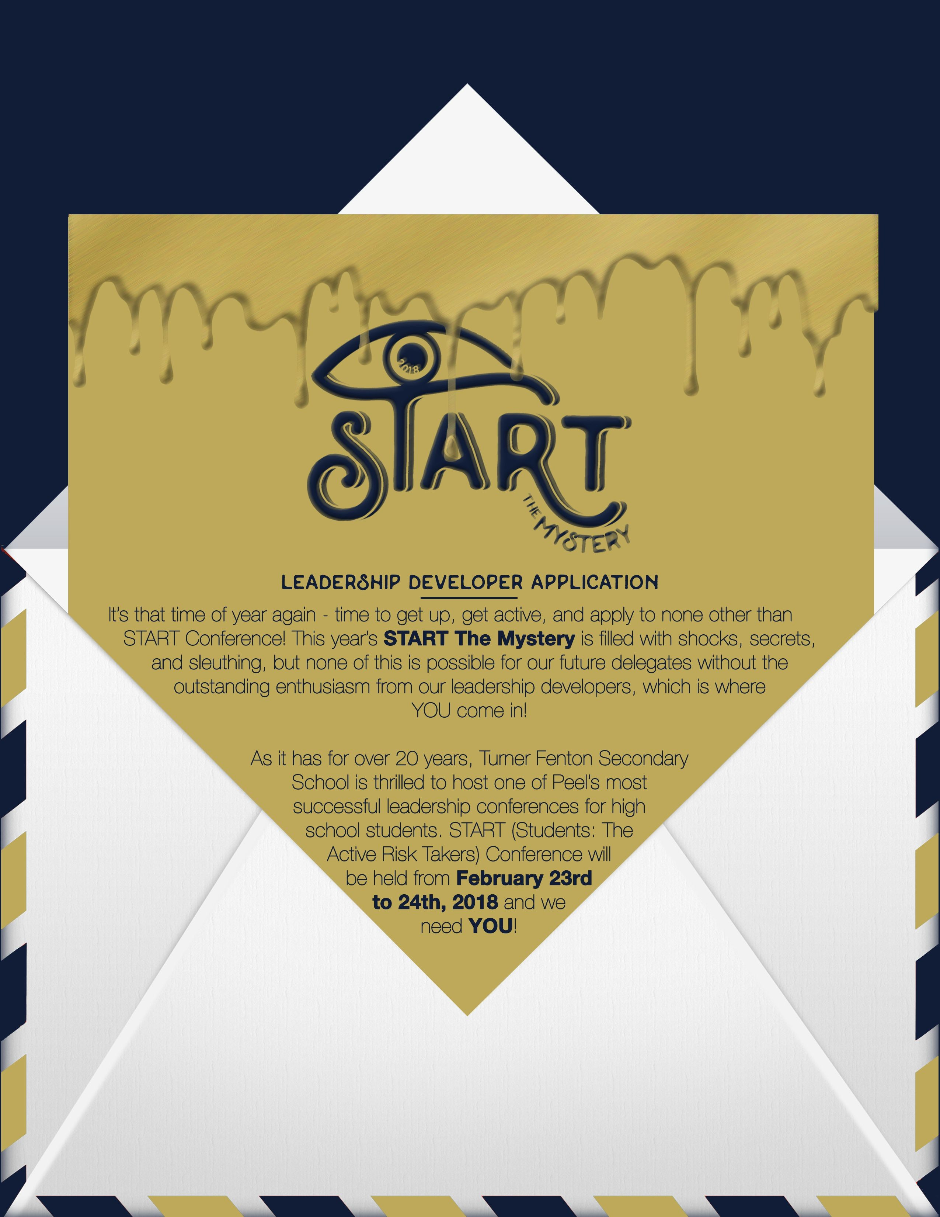

**COST OF CONFERENCE TO BE PAID ONCE ACCEPTED: $50.00**

All Turner Fenton students MUST pay through School Cash Online.

Non-Turner Fenton Students will also pay through School Cash Online at a later date.

Please keep in mind all essential information (personal information, questions) will be checked for completion by the teacher supervisors. Essential information will be censored for all MLD’s during the selection process. Please **DO NOT** include any personally identifying information in any answer. Failure to do so will result in **an automatic withdrawal of your application** from the selection process. Further questions and concerns can be directed to contactSTART2018@gmail.com

**Your START 2018 Chairs and Ministers of Leadership Development,**

Tanzim Pathan, Maanav Dalal, Agrata Pradhan, Eeshita Nalawade,

Malavika Patel, Sheshank Suresh

**Personal Information**

**Name:** _____________________________________________ **Grade:** __________ **Gender:** M F Other

**School:** ___________________________________________________________________________

**Student #:** _______________________________ **Program:** ________________________________

**Home Phone #**: __________________________ **Cell Phone #:** ____________________________

**Address:**__________________________________________________________________________

**City:** _________________________________ **Postal Code:** _______________________________

**Email:** ____________________________________________________________________________

**Health Card #:** ____________________________________________________________________

**Doctor’s Name:** ___________________________________________________________________

**Doctor’s Phone #:** _________________________________________________________________

**Health Concerns/ Allergies:** _________________________________________________________

**Do you carry an epipen?** ☐ YES ☐ NO

**Circle one of the following:**

T-Shirt Size: S M L XL

Dietary Concerns: NONE VEGETARIAN VEGAN OTHER:

**Emergency Contact Information:**

1. **Name:** ______________________________________ **Relation:** __________________________

**Telephone Number(s):** ______________________________________________________________

2. **Name:** ______________________________________ **Relation:** __________________________

**Telephone Number(s):** ______________________________________________________________

Student Declaration

I, ________________________________, declare that the above information is correct. I am enthusiastic about being a Leadership Developer at the 2018 START Leadership Conference, and that I will be available for all the trainings and the weekend of the conference, and will follow all rules and regulations put in place for this conference. I will not leak any START information such as lists, planned activities and executive data.

**Student Signature:** ________________________________ **Date:** _______________________

Parent/Guardian Declaration

I declare that the information that my son/daughter, ________________________________, has provided in his/her application is correct and that they have my permission to take part in this activity. I am willing to pick up my son/daughter or pay their transportation expenses if they are required to leave during the duration of the conference. I hereby permit the reproduction or display of photographs/films/recordings of my child for future START promotional purposes.

**Parent/Guardian Signature:** _________________________ **Date:** ________________________

**Teacher References (2)**

Please submit each reference (cut out) in an enclosed envelope with your teacher’s signature on the seal alongside your application.

Student’s Name ___________________ Teacher’s Name___________________________

Please circle in PEN, the number which most represents the student: **(1= Lowest, 7= Highest)**

|  |  |  |  |  |  |  |  |
| --- | --- | --- | --- | --- | --- | --- | --- |
| **Leadership** | **1** | **2** | **3** | **4** | **5** | **6** | **7** |
| **Responsibility** | **1** | **2** | **3** | **4** | **5** | **6** | **7** |
| **Maturity** | **1** | **2** | **3** | **4** | **5** | **6** | **7** |
| **Enthusiasm** | **1** | **2** | **3** | **4** | **5** | **6** | **7** |

Comments: __________________________________________________________________________________________________________________________________________________________________________________________________________________________________________________________________________________________________________________________

Signature:___________________________

Student’s Name ___________________ Teacher’s Name___________________________

Please circle in PEN, the number which most represents the student: **(1= Lowest, 7= Highest)**

|  |  |  |  |  |  |  |  |
| --- | --- | --- | --- | --- | --- | --- | --- |
| **Leadership** | **1** | **2** | **3** | **4** | **5** | **6** | **7** |
| **Responsibility** | **1** | **2** | **3** | **4** | **5** | **6** | **7** |
| **Maturity** | **1** | **2** | **3** | **4** | **5** | **6** | **7** |
| **Enthusiasm** | **1** | **2** | **3** | **4** | **5** | **6** | **7** |

Comments: __________________________________________________________________________________________________________________________________________________________________________________________________________________________________________________________________________________________________________________________

Signature:___________________________

**Leadership Developer Questions**

**Student Number:** ________________

# Please **DO NOT** include any personally identifying information (Name, age, gender, school etc.) beyond. Failure to do so will result in an automatic withdrawal of your application from the selection process.

# **General Questions**

1. List three previous leadership experiences and explain how one ​of them ​has made you a better leader. (100 words)
2. If you were ever arrested for a crime, what would it be for? (150 words)

**Leadership Developer Questions:**

1. You have just finished your three hundred page autobiography. Please submit a paragraph from page 217. (150 words)
2. Earth. Fire. Wind. Water. Avatar supposes that the world is made up of these four elements. What do you think are the four elements that compose START? Explain. (200 words)
3. It’s the day of the conference and you’ve met all your great delegates, except they aren’t all that great. You have one delegate that’s loud, one that practically doesn’t want to be there and one that’s super shy. Which delegate would you spend most of your time with throughout the conference and why? (200 words)
4. It’s the day of START and things are getting hectic. All of your delegates suddenly want to go use the washroom, but the toilet paper has run out. You decide to look in the shady dark storage room. BUT WAIT, as you enter you realize that you’re not alone… something else is in there with you. The only problem is, IT’S INVISIBLE! You realize that you walked into the wrong room and the invisible troublemaker in the room can now escape since you left the door open. The invisible troublemaker is blocking the door so you’re unable to close it! WHO KNOWS WHAT KIND OF TERROR IT WILL CAUSE IF IT ESCAPES! How would you use **at least 5** of the items on the following page to trap the invisible troublemaker and save the day? (300 words)

|  |  |  |  |
| --- | --- | --- | --- |
| Sheshank’s  lens cleaner spray | The toilet paper that you came for | A green water gun, that’s empty | Maanav’s hair wax |
| A caramel onion | A half, used bar of dove soap for sensitive skin | Agrata’s red and black plaid shirt | A missing delegate from the wrong conference |
| A used toothbrush from START 2016 2.0 | Eeshita’s yellow toy truck | A crusty old scarf | A red balloon |
| Tanzim’s baking soda | A dark angry soul | A half eaten sandwich | Malavika’s sparkling water |

**Additional Information**

* All LD applications are due Monday November 13th, 2017 @ 3:00 pm.
* For all TFSS students, all interviews will be held between November 27th to 29th, 2017
* For students not attending TFSS, interviews will be held on November 28th, 2017  
  Please check your emails and all START social media accounts regularly to be notified of interview times
* Keep in mind that all trainings are MANDATORY and LD training dates will be mentioned upon acceptance.

**If you wish to drop off your application outside of Turner Fenton, please contact us by either calling or messaging us at the numbers below.**

**Agrata Pradhan: Eeshita Nalawade: Malavika Patel: Sheshank Suresh:**

(647) 724-8379 (647) 625-7197 (647) 997-5275 (647) 832-7686

4 Parklawn Dr. 25 Garfield Cres. 61 Newington Cres. 23 Grover Rd.

Brampton, ON Brampton, ON Brampton, ON Brampton, ON

L6Y 2H4 L6V 1V7 L6P 3G1 L6Y 5R3

**- ONLY APPLIES TO APPLICANTS OUTSIDE TURNER -**

In an effort to aid the START executive team and the conference, we ask that you bring **ONE** teacher from your school to be a teacher supervisor at Turner Fenton Secondary School during the START conference. This will allow us to ensure the safety and well-being of all students, including yourself. Please refer to the schedule below and have a teacher pick a time shift during which he/she wishes to supervise, as well as sign the declaration below. Teachers are allowed to supervise for more than one shift if interested, but a minimum of one is mandatory.

Please note that an on-site daycare at Turner Fenton Secondary School will be provided during all shifts for any teacher supervisors who require its services.

|  |  |
| --- | --- |
| **Date** | **Time** |
| Friday February 23rd, 2018 | 4:00pm to 8:00pm |
| Friday February 23rd, 2018 | 8:00pm to 12:00am |
| Saturday February 24th, 2018 | 12:00am to 8:00am |
| Saturday February 24th, 2018 | 8:00am to 12:00pm |
| Saturday February 24th, 2018 | 12:00pm to 5:00pm |
| Saturday February 24th, 2018 | 5:00pm to 10:00pm |

**Teacher Declaration**

I hereby declare that in the case (Student’s Name) _______________________ is selected to be a leadership developer at START 2018, I (Teacher’s Name) _____________________ will be available to supervise the conference on (Date) ____________________ during the hours of (Time) ________________.

Contact Email: ______________________________________________________________

Teacher Signature: _______________________________ Date: ______________________