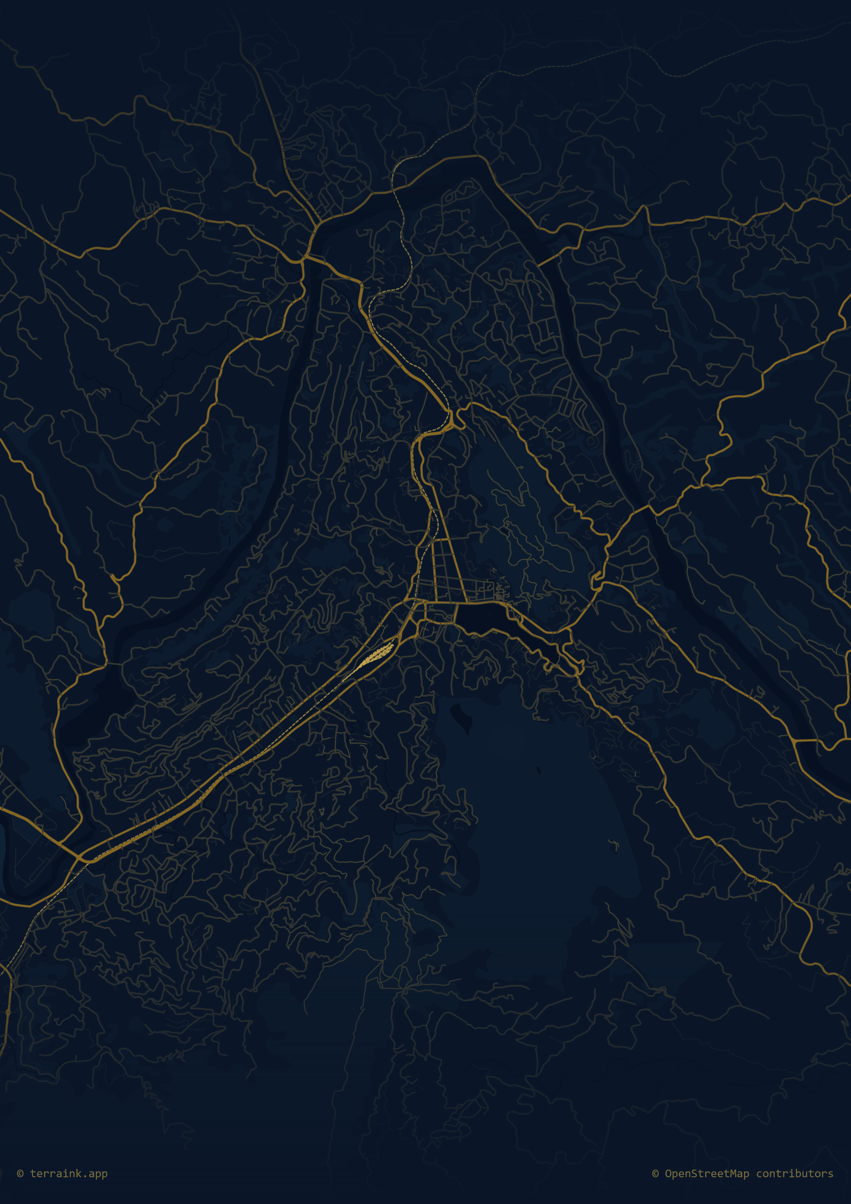

🚌 BusGo: Elite Production-Ready User Manual

Welcome to the **BusGo** ecosystem, Sri Lanka's most advanced integrated bus management solution. This comprehensive manual covers every module, database interaction, and intelligent feature within the production environment.

📋 Technical Table of Contents
- [Core Architecture & Security Layers](#1-core-architecture--security-layers)
- [Identity & Access Management (IAM)](#2-identity--access-management-iam)
3. [Passenger Experience (BusGo Client)](#3-passenger-experience-busgo-client)
4. [Driver Operations & GPS Streaming (BusGo Drive)](#4-driver-operations--gps-streaming-busgo-drive)
5. [Conductor & Scanning (BusGo Scanner)](#5-conductor--scanning-busgo-scanner)
6. [The Neo Engine: AI & Predictive Intelligence](#6-the-neo-engine-ai--predictive-intelligence)
7. [🚨 Emergency Alert & Incident Response System](#7-emergency-alert--incident-response-system)
8. [Administrative Governance & Analytics (BusGo Admin)](#8-administrative-governance--analytics-busgo-admin)
9. [Database Schema & Data Integrity](#9-database-schema--data-integrity)

1. Core Architecture & Security Layers
BusGo is built on a high-performance Node.js/Express backend. To maintain "Production-Ready" status, we employ multiple security layers:
- **Helmet.js:** Configures 15 HTTP security headers.
- **CORS:** Strict whitelist-based origin filtering.
- **Rate Limiting:** 10 req/15 min on Auth; 100 req/min general API.
- **Zod Validation:** Every request body is parsed and validated against strict schemas.

2. Identity & Access Management (IAM)
Our security layer utilizes JWT with dual-token rotation.

2.1 Multi-Step Registration
- **Verification:** All users must verify their phone number and email.
- **Membership:** Types include `standard`, `premium`, and `corporate`.

[ ADD PHONE SCREENSHOT HERE ]
Figure: Registration & MFA Interface

2.2 Secure PIN Reset
- Uses a 3-step verification flow with SHA-256 hashed reset tokens and bcrypt-hashed 6-digit PINs.

3. Passenger Experience (BusGo Client)
Designed with Flutter and Provider for elite state management.

3.1 Real-Time Route Discovery
- **Nearby Stops:** Uses Haversine geometry (radius = 0.5km) to identify the closest stops.
- **Live Tracking:** Subscribes to the `bus-locations` Supabase broadcast channel for sub-second GPS updates.

[ ADD PHONE SCREENSHOT HERE ]
Figure: Real-time Bus Tracking Map

3.2 Trip Lifecycle
- **Boarding:** Scan the bus QR or select manually.
- **Fare Engine:** Automated LKR calculation based on boarding/alighting `stop_id` and the `fare_lkr` constant.

4. Driver Operations & GPS Streaming (BusGo Drive)
The backbone of our real-time data flow.

4.1 Shift Initialization
- Drivers must log in and bind to a specific `bus_id`.
- **Location Broadcasting:** Constant PUT requests to `/buses/:id/location` stream GPS and heading data.

[ ADD PHONE SCREENSHOT HERE ]
Figure: Driver Dashboard & GPS Status

5. Conductor & Scanning (BusGo Scanner)
Ensuring revenue integrity through QR technology.

5.1 QR Validation
- Scans the user's `qr_token`. The backend auto-regenerates tokens if the 30-second TTL expires.
- **Exit Scan:** Triggers the completion of the `trip` record and calculates final fares.

[ ADD PHONE SCREENSHOT HERE ]
Figure: Conductor QR Scanner Interface

6. The Neo Engine: AI & Predictive Intelligence
Our intelligence layer, built with Scikit-learn, XGBoost, and LightGBM.

6.1 ETA Estimation Pipeline
Calculates arrival times using a complex multi-feature model:
- **Features:** `total_distance_to_target_m`, `peak_traffic_index`, `is_raining`, and `dwell_at_last_stop_s`.
- **Formula:** `eta_seconds = (exp(prediction) - 1) * distance_km`.

6.2 Sentiment & Rating Engine
Analyzes passenger tags and comments to generate an aggregate Driver Rating, using a custom calibrator and vectorizer (`vectorizer_v5.pkl`).

7. 🚨 Emergency Alert & Incident Response System
The most critical module for passenger safety.

7.1 Two-Stage Prediction Pipeline
- **False Alert Detector (XGBoost + TF-IDF):** Filters likely noise or gibberish alerts with 1.00 F1 accuracy.
- **Priority Scorer (LightGBM + SBERT):** Assigns a priority score (2-5) using Sentence-BERT semantic embeddings.

7.2 Priority Scale & Action
| Score | Label | Action |
|-------|-----------|------------------------------------------|
| 5 | 🔴 CRITICAL | Dispatch immediately — call 119/118 |
| 4 | 🟠 HIGH | Urgent response required |
| 3 | 🟡 MEDIUM | Monitor and prepare response |

[ ADD PHONE SCREENSHOT HERE ]
Figure: Emergency SOS & Incident Reporting

8. Administrative Governance & Analytics (BusGo Admin)
Full system oversight via the React/TypeScript dashboard.

- **Route Management:** Manage the `bus_routes` and `route_stops` tables.
- **Analytics:** Visualize `ratings`, `trips`, and `revenue` data via Chart.js/Recharts.

9. Database Schema & Data Integrity
BusGo maintains 12 core PostgreSQL tables with strict RLS (Row Level Security).

- **Triggers:** `enforce_max_recent_searches()` maintains exactly 5 entries per user.
- **Indexes:** 20+ custom indexes ensure sub-100ms response times for geographic queries.

