**Name: Nimya Satheesh**

**Roll No: 26**

**Batch: B**

**Date:08-04-2022**

**ADVANCED DBMS LAB**

**Experiment No.: 1**

**Aim**

To familiarize DDL Commands- ALTER, DROP, TRUNCATE, RENAME

**Questions**

1.Create a table emp with attributes empno number (4) as primary key, ename char (10), hiredate, salary, commission

insert 5 rows of data

|  |  |  |  |  |
| --- | --- | --- | --- | --- |
| 101 | Ramesh | 17-Jan  1980 | 5000 |  |
| 102 | Ajay | 05-Jul  1985 | 5000 | 500 |
| 103 | Ravi | 12-Aug  1981 | 1500 |  |
| 104 | Nikesh | 03-Mar  1983 | 3000 | 700 |
| 105 | Ravi | 05-jul  1985 | 3000 |  |

2.Modifying the structure of tables

a. Add new columns: sal number(7,2)

b. Dropping a column from a table: sal

c. Modifying existing column :ename varchar2(15)

d. Renaming the tables: emp to emp1

e. truncating the tables:emp1

f. Destroying tables:emp

3.Create a table stud with sname varchar2(20) primary key, rollno number(10) not null,dob  date not null

4.Create a table student as regno number (6), mark number (3) check constraint (mark >=0 and  mark  <=100));

5.Create a table cust with (custid int(6) constraint unique, name char(10)

**Procedure**

create database EMP;

use EMP;

**1.**CREATE TABLE emp (EMPNO INT (4) PRIMARY KEY, ENAME CHAR (10), HIREDATE DATE, SALARY INT (5), COMMISSION INT (5));

INSERT INTO emp (EMPNO, ENAME, HIREDATE, SALARY) VALUES (101,'RAMESH','1980-01-17',5000), (102,'AJAY','1985-07-05',5000), (103,'RAVI','1981-08-12',1500), (104,'Nikesh','1983-03-03',3000), (105,'Ravi','1985-07-05',3000);

select * from EMP;

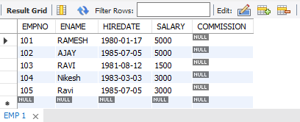

**2. a**. ALTER TABLE emp ADD sal int;

select * from EMP;

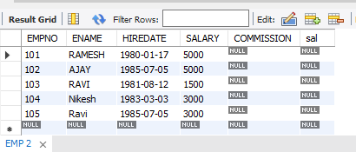

**b.**ALTER TABLE emp DROP COLUMN sal;

select * from EMP;

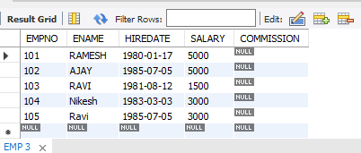

**c.** ALTER TABLE emp MODIFY ename VARCHAR (15);

select * from EMP;

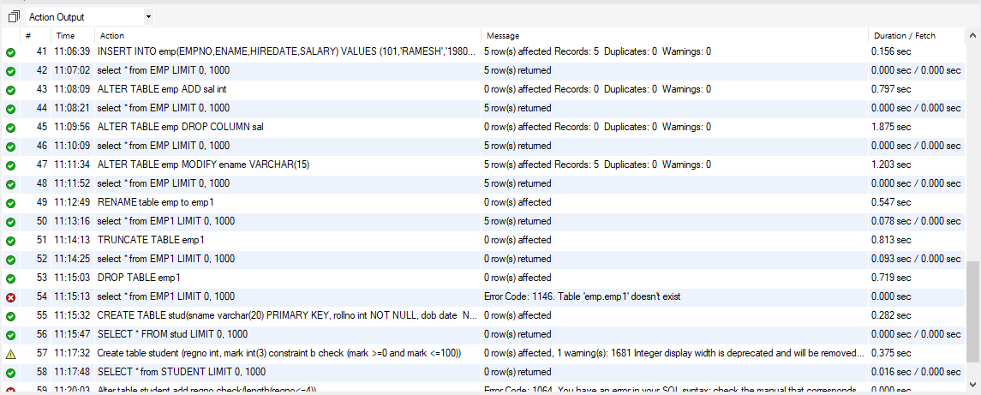

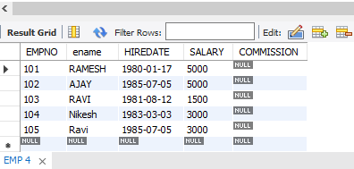

**d.** RENAME table emp to emp1;

select * from EMP1;



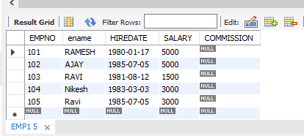

**e.** TRUNCATE TABLE emp1;

select * from EMP1;

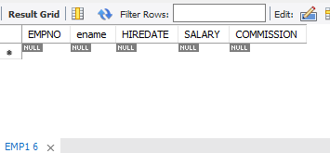

**f.** DROP TABLE emp1;



**3.**CREATE TABLE stud (sname varchar (20) PRIMARY KEY, rollno int NOT NULL, dob date NOT NULL);

SELECT * FROM stud;

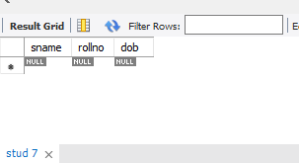

**4.**Create table student (regno int, mark int (3) constraint b check (mark >=0 and mark <=100));

SELECT * from STUDENT;

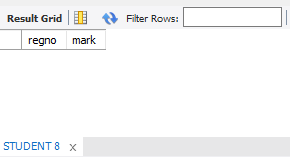

**5.**CREATE TABLE cust (custid int (6) UNIQUE, name char(10));

select * from cust;

