**Name: Nimya Satheesh**

**Roll No: 26**

**Batch: B**

**Date: 06-05-2022**

**ADVANCED DBMS LAB**

**Experiment No.: 7**

**Aim**

To familiarize with Group by and Having clause

**Questions**

1.List the branches having sum of deposit more than 5000.

2.List the branches having sum of deposit more than 500 and located in city BOMBAY

3.List the names of customers having deposited in the branches where the average deposit is

more than 5000.

4.List the names of customers having maximum deposit

5.List the name of branch having highest number of depositors?

6.Count the number of depositors living in NAGPUR.

7.Give names of customers in VRCE branch having more deposite than any other customer in

same branch

8.Give the names of branch where number of depositors is more than 5

9.Give the names of cities in which the maximum number of branches are located

10.Count the number of customers living in the city where branch is located

**Procedure**

USE DDL;

**1:** SELECT D.BNAME FROM DEPOSIT D, BRANCH B WHERE D.BNAME=B.BNAME AND B.CITY='BOMBAY' GROUP BY D.BNAME HAVING SUM(D.AMOUNT)>5000;

**Output Screen**

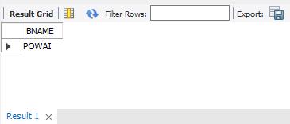

**2:** SELECT D.BNAME FROM DEPOSIT D, BRANCH B, CUSTOMER C WHERE D.BNAME=B.BNAME AND C.CITY="BOMBAY" GROUP BY D.BNAME HAVING SUM(D.AMOUNT)>500;

**Output Screen**

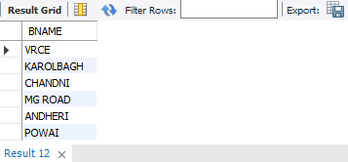

**3:** SELECT CNAME from deposit where AMOUNT=(select AVG(Amount) from DEPOSIT GROUP BY BNAME having AVG(Amount)>5000);

**Output Screen**

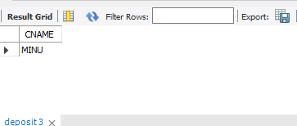

**4:** SELECT MAX(AMOUNT),CNAME FROM deposit;

**Output Screen**

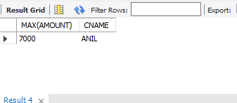

**5:** SELECT D1.BNAME FROM DEPOSIT D1 GROUP BY D1.BNAME HAVING COUNT(D1.CNAME) >= ALL (SELECT COUNT(D2.CNAME) FROM DEPOSIT D2 GROUP BY D2.BNAME)

**Output Screen**

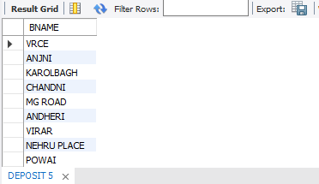

**6:** SELECT COUNT(DEPOSIT.CNAME)FROM DEPOSIT,CUSTOMER WHERE CUSTOMER.CITY='nagpur';

**Output Screen**

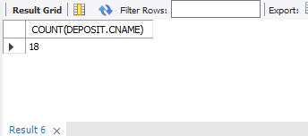

**7:** SELECT CNAME FROM DEPOSIT WHERE BNAME='VRCE' AND AMOUNT=(SELECT MAX(AMOUNT) FROM DEPOSIT WHERE BNAME='VRCE');

**Output Screen**

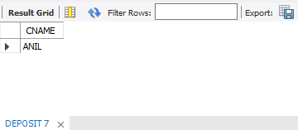

**8:** SELECT BNAME from deposit GROUP BY BNAME HAVING COUNT(BNAME)>5;

**Output Screen**

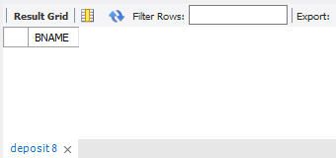

**9:** SELECT C.CNAME ,COUNT(B.BNAME) FROM CUSTOMER C INNER JOIN BRANCH B ON C.CNAME=B.BNAME GROUP BY C.CNAME ORDER BY COUNT(B.BNAME) DESC;

**Output Screen**

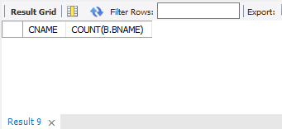

**10:** SELECT COUNT(b1.BNAME) FROM DEPOSIT d1 , BORROW b1 , CUSTOMER c1 WHERE c1.CNAME=d1.CNAME AND d1.CNAME=b1.CNAME AND c1.CITY IN (SELECT CITY FROM CUSTOMER);

**Output Screen**

