**Name: Nimya Satheesh**

**Roll No: 26**

**Batch: B**

**Date: 06-06-2022**

**NETWORKING & SYSTEM ADMINISTRATION LAB**

**Experiment No.: 27**

**Aim**

Cmake

**Procedure**

1. **Sudo apt install cmake g++ make : To install cmake , g++ and make using the apt command.**

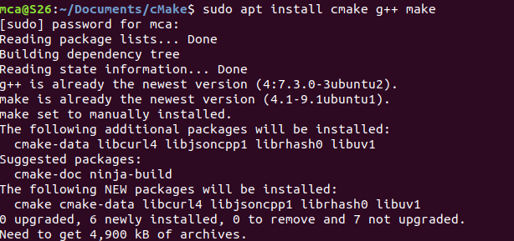

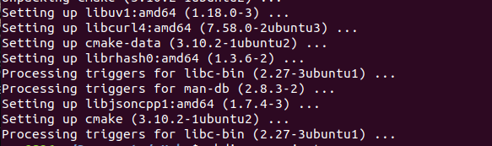

1. **mkdir myproject :** creating a different directory for our project using the [mkdir](https://www.linuxfordevices.com/tutorials/linux/the-mkdir-command-in-linux) and [cd](https://www.linuxfordevices.com/tutorials/linux/cd-command-in-linux) commands.



1. Now create a C++ source file named Hello_world.cpp and add the following :



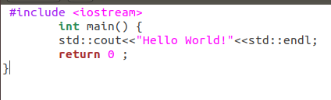

1. Create a CMakeLists.txt file(with this exact capitalization) which is required by Cmake:



The CMakeLists.txt file for this project will only contain these three lines:

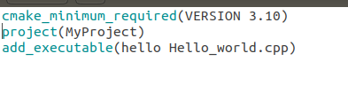

1. Build directory for executables :



1. To run cmake we need to change into the build directory:

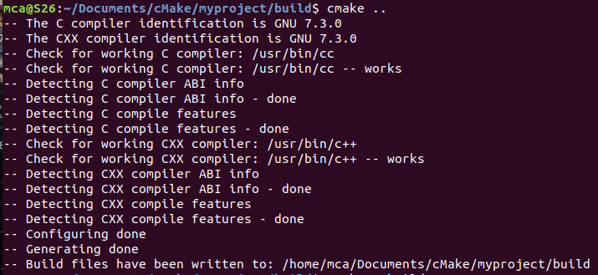

1. **cmake –build :** To generate the executable simply by typing:

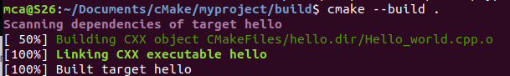

1. **./hello :** Run the executable by typing:

