**NETWORKING&SYSTEM ADMINISTRATION LAB**

**Name: Nimya Satheesh**

**Roll No: 26**

**Batch: B**

**Date: 21-04-2022**

**Experiment No.: 7**

**Aim**

Familiarization of Linux Commands

**Procedure**

**1. read**

To read a content of a line to a variable.

Syntax:- **read variable_name**



**2. echo $variable_name**

The command will display the stored input from the variable.

Syntax:- **echo $variable_name**



**3. locate**

To locate a particular file or directory in any location.

Syntax:- **locate filename**



**locate -i**

Ignore case distinctions when matching patterns.

Syntax:- **locate -i filename**



**4. grep**

**grep :** grep command will let you search through all text in a given file.

Syntax:- **grep word filename**

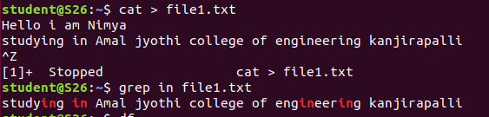

Syntax:- **cat filename|grep word**



**grep -A1 :** Prints searched line and nlines after the result.

Syntax:- **grep -A1 word filename**

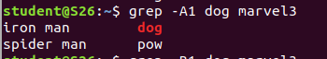

**grep -B1 :**Prints searched line and n line before the result.

Syntax:- **grep -B1 word filename**

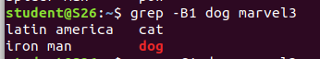

**grep -C1 :**Prints searched line and n lines after before the result.

Syntax:- **grep -C1 word filename**

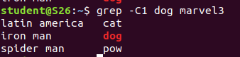

**grep -v :**Used for an inverted search

Syntax:- **grep -v word filename**

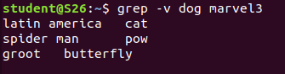

**grep -i :**used for case insensitive search.

Syntax:- **grep -i word filename**



**5.df**

Is used to get a report of system disc space usage.

Syntax:- **df**

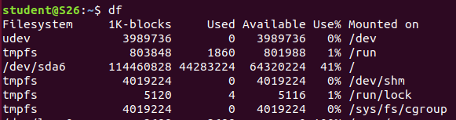

Used to report disc space in mega byte.

Syntax:- **df -m**

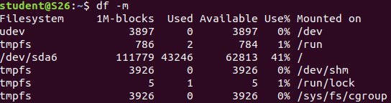

**6.du**

To check how much space a corrent directory takes.

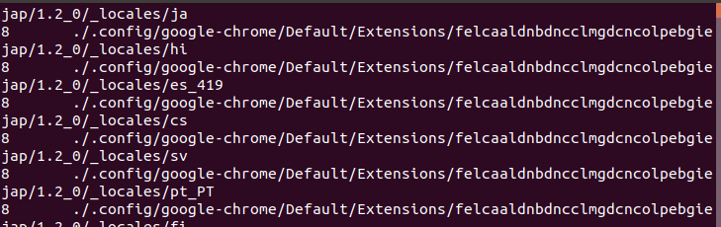

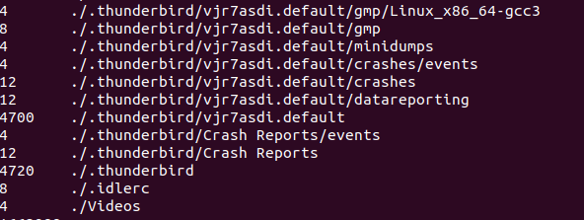

**7.wc**

**wc -l :**The command used to find the number of lines in a file

Syntax:- **wc -l filename**



The command used to find the number of words in a file

Syntax:- **wc -w filename**



The command used to find the count of bytes in a file

Syntax:- **wc -c filename**



The command used to find the count of character in a file

Syntax:- **wc -m filename**



**8. Find**

Used to find a particular file from particular directory.

Syntax:- **find filename**

