**Name: Nimya Satheesh**

**Roll No:26**

**Batch:B**

**Date:**

**NETWORKING & SYSTEM ADMINISTRATION LAB**

**Experiment No.: 2**

**Aim**

Familiarization of Hardware Components

**Procedure**

**1.****Motherboard**

The motherboard is the piece of computer [hardware](https://www.lifewire.com/computer-hardware-2625895) that can be thought of as the "backbone" of the PC, or more appropriately as the "mother" that holds all the pieces together.Popular motherboard manufacturers include ASUS, AOpen, Intel, ABIT, MSI, Gigabyte, and Biostar.

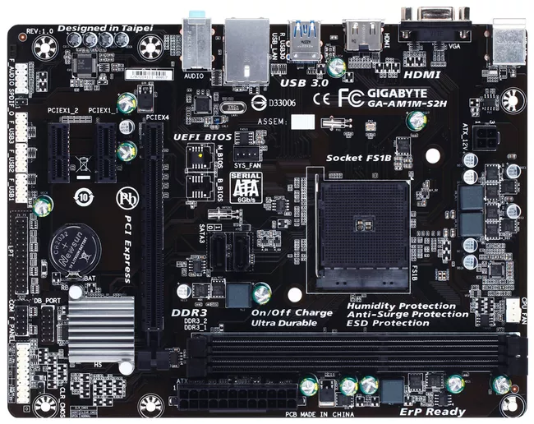

**2.Random Access Memory(RAM)**

Random Access Memory, or RAM (pronounced as ramm), is the physical hardware inside a computer that temporarily stores data, serving as the computer's "working" memory.Additional RAM allows a computer to work with more information at the same time, which usually has a considerable effect on total system performance.Some popular manufacturers of RAM include Kingston, PNY, Crucial, and CORSAIR.

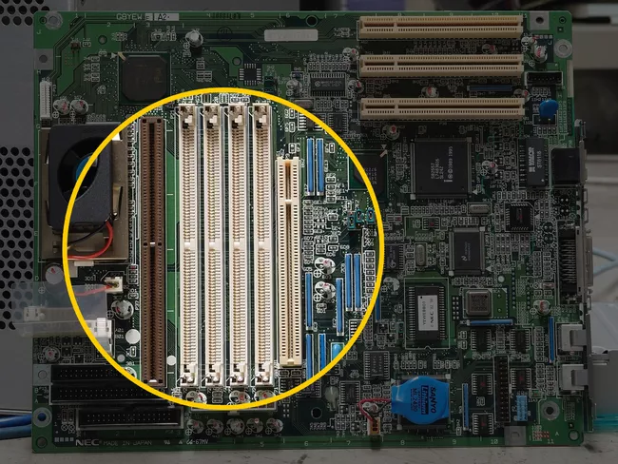

**3. power supply unit**

The power supply unit is the piece of [hardware](https://www.lifewire.com/computer-hardware-2625895) that converts the power provided from the outlet into usable power for the many parts inside the computer [case](https://www.lifewire.com/what-is-a-computer-case-2618149).It converts the alternating current from your wall outlet into a continuous form of power called direct current that the computer components require. It also regulates overheating by controlling [voltage](https://www.lifewire.com/voltage-definition-3134824), which might change automatically or manually depending on the power supply.

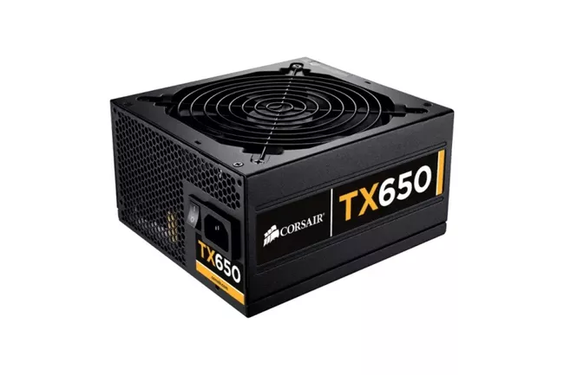

**4.****Video Card**

The video card is an expansion card that allows the computer to send graphical information to a video display device such as a [monitor](https://www.lifewire.com/what-is-a-monitor-2618155), TV, or projector.Some other names for a video card include graphics card, graphics adapter, display adapter, video adapter, video controller, and add-in boards (AIBs).

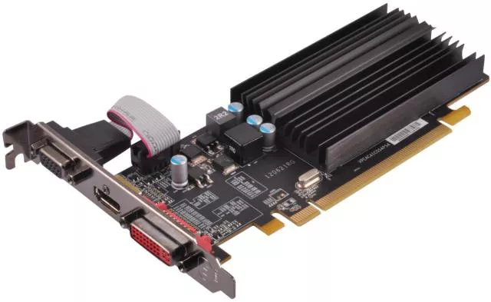

**5.****Hard Disk Drive**

The hard disk drive is the main, and usually most substantial, data storage [hardware](https://www.lifewire.com/computer-hardware-2625895) device in a computer. The [operating system](https://www.lifewire.com/operating-systems-2625912), software titles, and most other [files](https://www.lifewire.com/what-is-a-file-2625878) are stored in the hard disk drive.The hard drive is sometimes referred to as the "[C drive](https://www.lifewire.com/what-is-a-c-drive-5222296)" because Microsoft Windows, by default, designates the "C" drive letter to the primary [partition](https://www.lifewire.com/what-is-a-partition-2625958) on the primary hard drive in a computer.

**6.****Solid State Drive (SSD)**

Solid state refers to electronic circuitry that is built entirely of semiconductors. The term was originally used to define those [electronics](https://www.lifewire.com/how-electronics-work-819000), such as a transistor radio that used semiconductors rather than vacuum tubes in its construction.

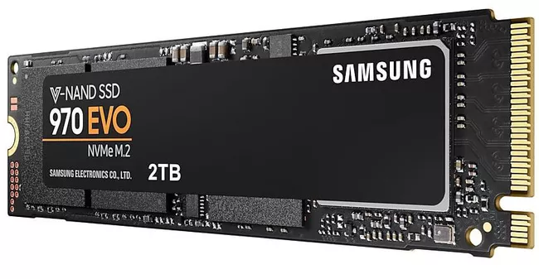

**7.****Optical Disk Drive**

Optical drives retrieve and/or store data on optical discs like CDs, DVDs, and BDs ([Blu-ray](https://www.lifewire.com/what-is-blu-ray-1846537) discs), any of which hold much more information than previously available portable media options like the [floppy disk](https://www.lifewire.com/what-is-a-floppy-drive-2618151).The optical drive normally goes by other names like a disc drive, ​ODD (abbreviation), CD drive, DVD drive, or BD drive.Some popular optical disc drive makers include [LG](https://www.lg.com/us/burners-drives), [ASUS](https://www.asus.com/us/Motherboards-Components/Optical-Drives/All-series/), Memorex, and [NEC](https://www.nec.com/).

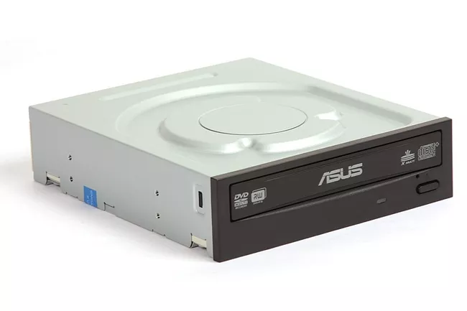

**8.****Monitor**

A monitor is a piece of [computer hardware](https://www.lifewire.com/computer-hardware-2625895) that displays the video and graphics information generated by a connected computer through the computer's [video card](https://www.lifewire.com/what-is-a-video-card-2618161).Monitors are similar to TVs but usually display information at a much higher [resolution](https://www.lifewire.com/what-is-resolution-2767449). Also unlike televisions, monitors typically sit atop a desk rather than being mounted on a wall. A monitor is sometimes referred to as a screen, display, video display, video display terminal, video display unit, or video screen.

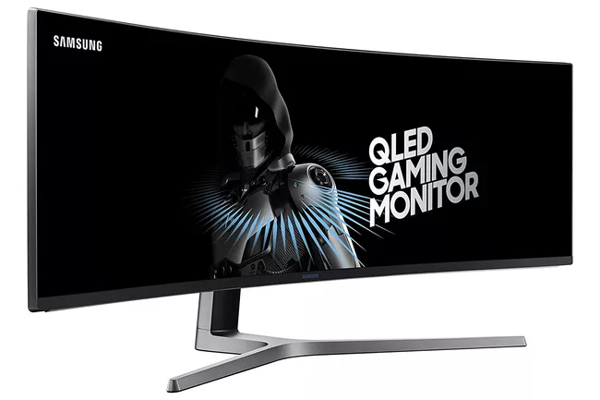

**9.****Keyboard**

The keyboard is the piece of [computer hardware](https://www.lifewire.com/computer-hardware-2625895) used to input text, characters, and other commands into a computer or similar device.Even though the keyboard is an external [peripheral device](https://www.lifewire.com/peripheral-device-2625951) in a desktop system (it sits outside the main [computer housing](https://www.lifewire.com/what-is-a-computer-case-2618149)), or is "virtual" in a tablet PC, it is an essential part of the complete computer system.



**10.****Mouse**

The mouse, sometimes called a pointer, is a hand-operated input device used to manipulate objects on a computer screen.Whether it uses a laser or ball, or the [mouse is wired or wireless](https://www.lifewire.com/wired-or-wireless-mouse-2640091), a movement detected from the mouse sends instructions to the computer to move the cursor on the screen in order to interact with [files](https://www.lifewire.com/what-is-a-file-2625878), windows, and other software elements.

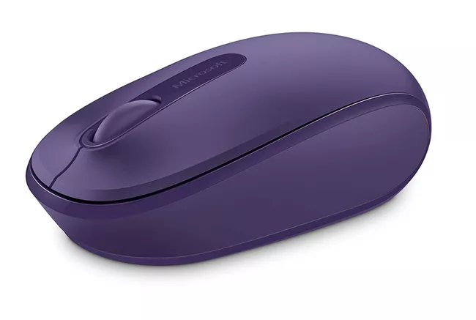

**11.uninterruptible power supply (UPS)**

A battery backup, or uninterruptible power supply (UPS), is primarily used to provide a backup power source to important desktop [computer hardware](https://www.lifewire.com/computer-hardware-2625895) components.In most cases, those pieces of hardware include the main [computer housing](https://www.lifewire.com/what-is-a-computer-case-2618149) and the [monitor](https://www.lifewire.com/what-is-a-monitor-2618155), but other devices can be plugged into a UPS for backup power, depending on the size of the UPS.

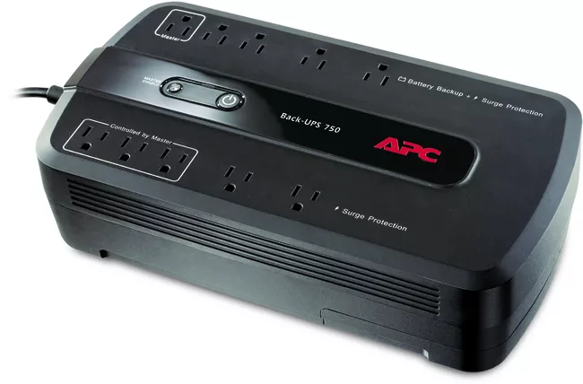

**12.****Flash Drive**

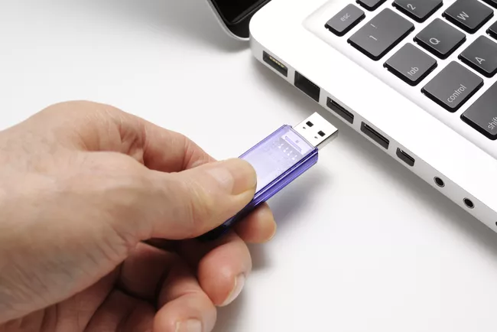A flash drive is a small, ultra-portable storage device which, unlike an [optical drive](https://www.lifewire.com/what-is-an-optical-disc-drive-2618157) or a traditional [hard drive](https://www.lifewire.com/what-is-a-hard-disk-drive-2618152), has no moving parts.Flash drives connect to computers and other devices via a built-in [USB Type-A](https://www.lifewire.com/usb-type-a-connector-2626032) or [USB-C](https://www.lifewire.com/usb-c-4149490) plug, making one a kind of combination [USB](https://www.lifewire.com/universal-serial-bus-usb-2626039) device and cable.

**13.****External Hard Drive**

An external drive is just a [hard drive](https://www.lifewire.com/what-is-a-hard-disk-drive-2618152) (HDD) or [solid-state drive](https://www.lifewire.com/solid-state-drive-833448) (SSD) connected to a computer on the outside rather than on the inside. Some external drives draw power over their data cable, which of course comes from the computer itself, while others may require an AC wall connection to derive power on their own.

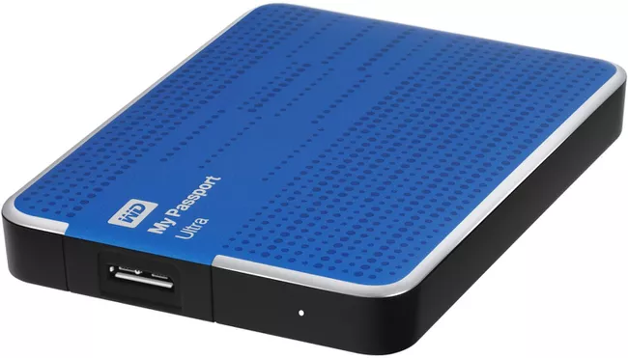

**14.****CPU ( Central Processing Unit )**

A CPU, or central processing unit, is the brain of a computer. The CPU processes information and runs programs.It functions as a control unit that executes programs according to instructions in its program memory.The CPU contains elements such as registers, an arithmetic logic unit (ALU), and control logic for sequencing instructions.